We usually tend to think or are more confident to think that changes in earth as a actual problem or if we remember something else, we think of the last three centuries, starting around the industrial revolution but humans have been transforming the planet for millennials but let me focus on this time.

Earth have 510,1 millions km² (square kilometers) and are distributed as seen below.

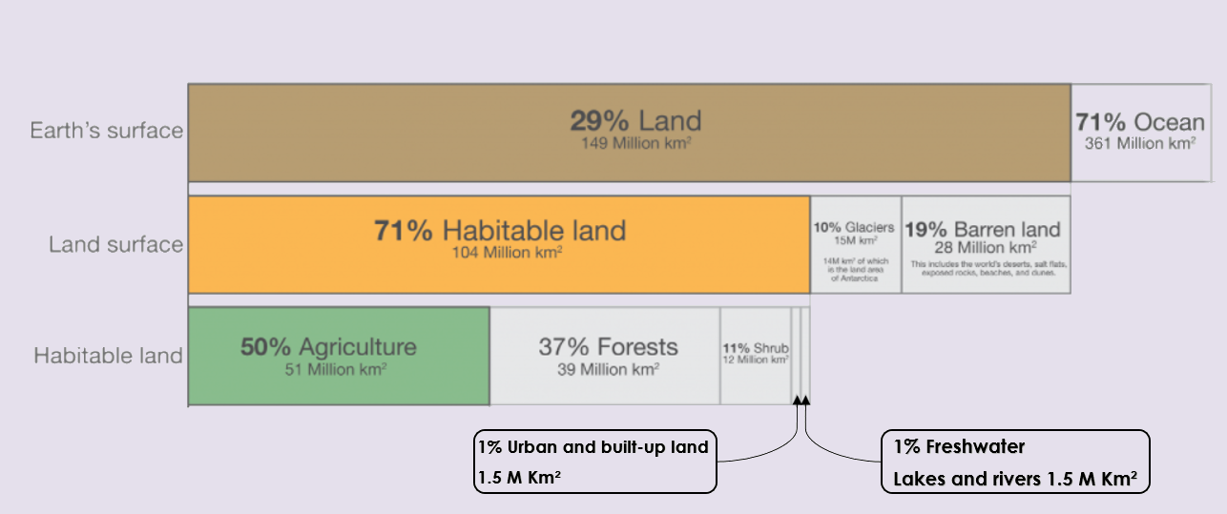

We have around 150 million of km² (square kilometers) approximately the 30% of land and the rest 70% are Oceans.

Of this 30% only the 70% is habitable and in the actually we use more than 50% of this 70% (about 51 million of square quilometers) we are transform and use for agricultural.

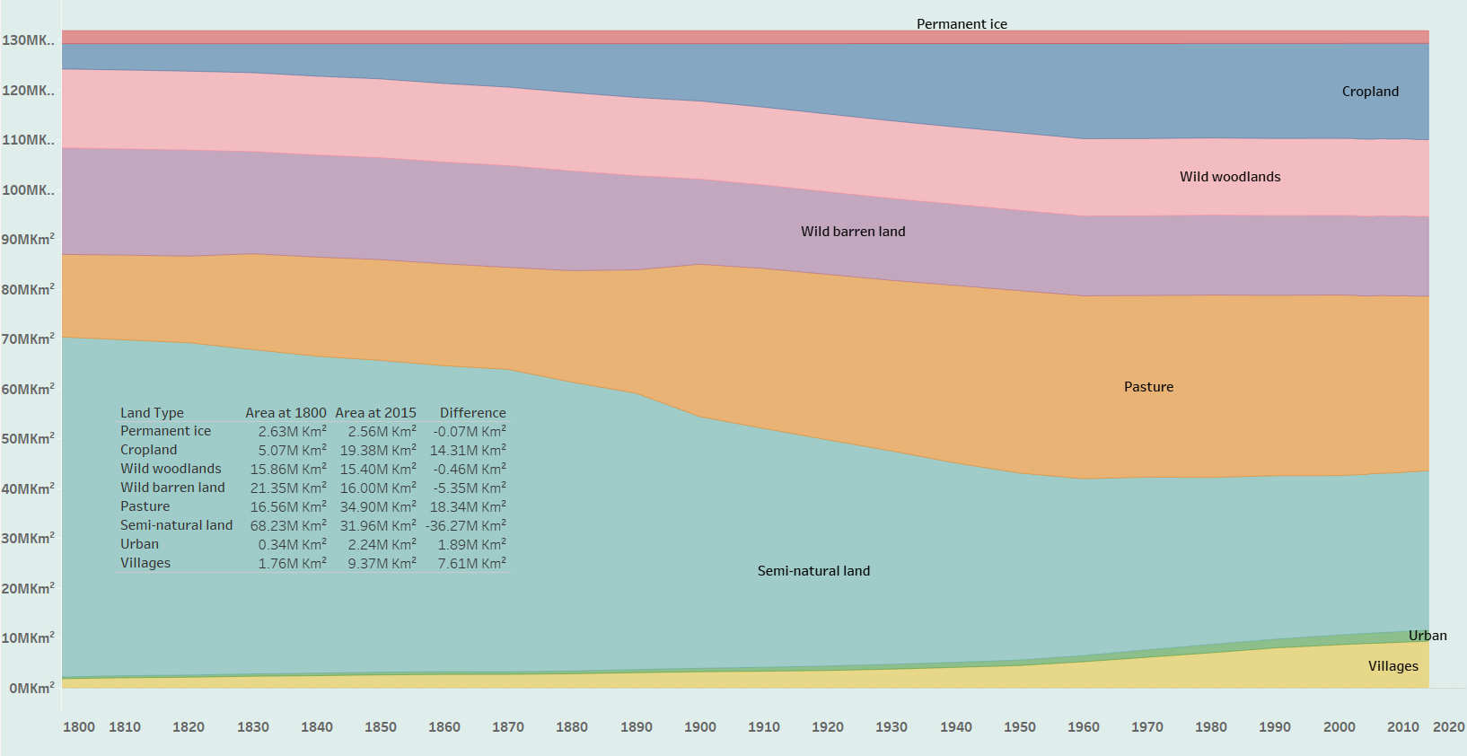

I like to focus in the major changes humans did in Earth and who we can see in the next chart this starting just before Industrial Revolution (1760).  
I like to say as that human was a dominant land user, around the year 900 we are iniatially using about5% of land, at 10% around 1700, the 25% by 1880 and up to half of all land today.

If you sum cropland 19.38+ pasture 34.9+urban 2.24+villages 9.37 we have an amount of 65.89 millions of square kilometers and remember we have about 104 million of square kilometer.

*POPULATION--Now I like to see how humans poblation grow up, here we can view a table with the difference by countries , I like to focus that in only the 15 top the last starting with a increment of 5607.22% of his population.

I like to ask you:  
Are YOU thinking humans was the principal cause of the changes?  
Let me show some charts and we can continue.

The Most land of world was wilderness: forests, grasslands and shrubbery dominated its landscapes but how I can see in the last few centuries, this has changed dramatically: wild habitats have been squeezed out by turning it into agricultural land, remember about 51millions km² actually.  
In 2016 the lands distributions was 1.57 billion hectares of Cropland, 3.29 billion hectares of Grazing and a 57.5 (fifty seven point five) million hectares in Built-up-areas.

You can see here the increment per Countries in agricultural since 1800

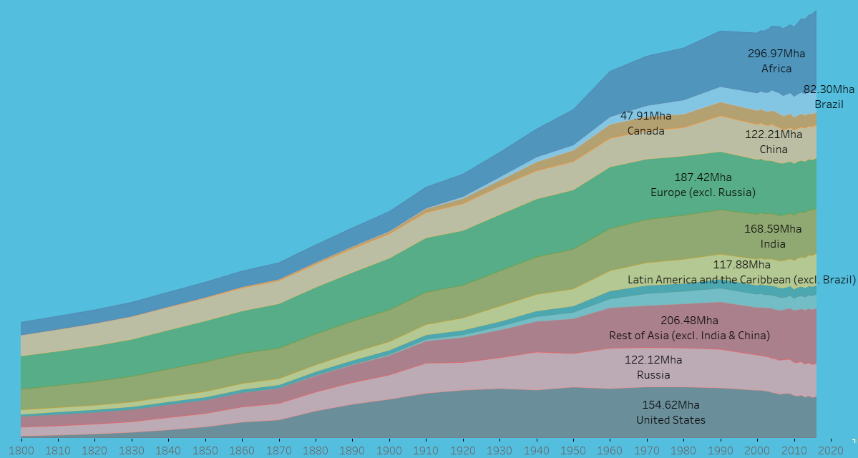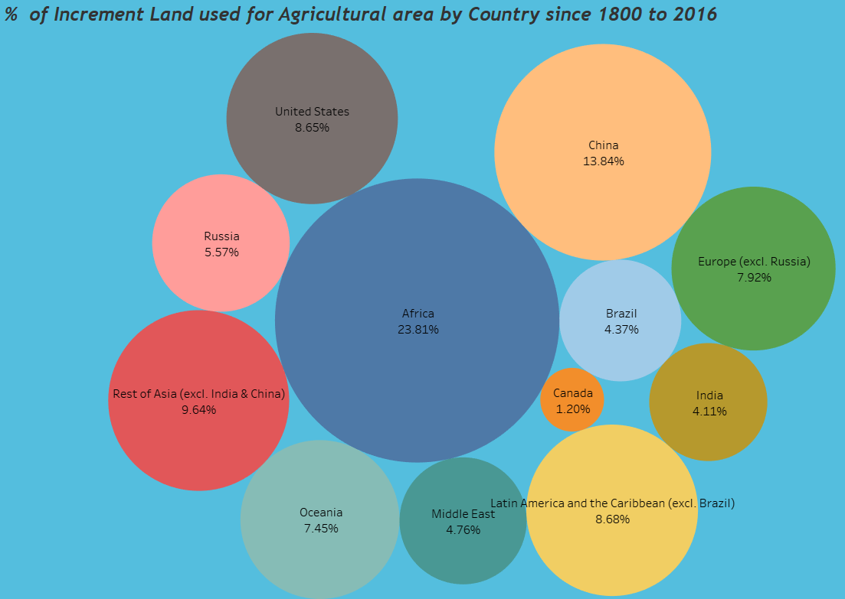

**This visualization shows total land used for agriculture (which is a combination of cropland and grazing land) over the long-term, measured in hectares.**

The rate of forest loss changed a lot. From 1700 to 1850, 19 million hectares were being cleared every decade. That’s around half the size of Germany. From 1850(eighteen fifty) to 1920, losses were around 50% higher at 30 million hectares per decade. Moving into the 20th century there was a stepwise change in demand for agricultural land and energy from wood. Deforestation rates accelerated. From the 1920s through to the 1980s, decadal losses quadrupled to almost 120 million hectares. That’s equivalent to the area of South Africa.

And 47 million hectares in the last decade.

This changes in lands propiciated the extinction of a lot of species.

This number is a little representation (sample) about the species evaluated for the study.  
In 2020, it had assessed only 6% of described species.

According to IUCN (ai-you-ci-en) red list more than 37.400 species are threatened with extinction at this moment.