
Microorganisms have long been perceived to consist of harmful bacteria, virus, and a host of other toxic foreign bodies that destroy human health. Contrary to this notion, however, is the definition of microorganisms, according to Lita Proctor of the National Institute of Health (NIH), as bacteria which help support our health, digest our food and provide many kinds of protective mechanisms for human health. Microorganisms number into millions in the cells of humans.
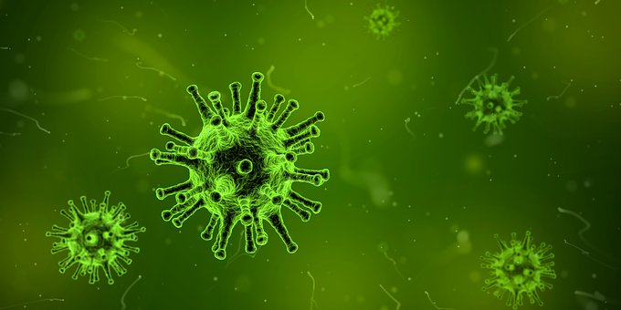
According to a recent NIH estimate, 90% of cells in the human body are bacterial, fungal or otherwise non-human. Thus, scientists theorize that of about 100 trillion cells in humans, micro-organisms make up the largest. In other words, humans have more microorganisms than cells. Humans have a relationship with microorganisms. This kind of relationship is classified as symbiotic because while the body (host) provides shelter and food, microorganisms help balance and promote good health. Species of microorganisms include bacteria, virus, fungi, etc.

ARE BACTERIA BENEFICIAL?
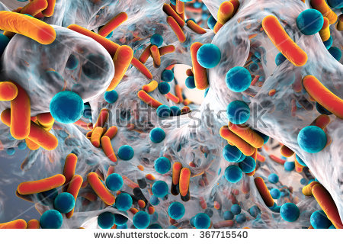
The answer is an unequivocal yes. In what sense are bacteria beneficial to the body? One may ask. It is significant to note that although some bacteria are pathogenic ― harmful to the body ― there are ‘good’ bacteria called probiotics which are beneficial.

WHAT THEN ARE PROBIOTICS?
“Probiotic” has its root from the Latin pre-word “pro,” which is interpreted to mean “for” while “biotic” is a Greek word which means “bios” or “life”, consequently, the word "probiotic" could be said to mean “for life”. This term was used to define substances produced by one microorganism that stimulated the growth of others [1]. “Probiotics” was a term used to describe tissue extracts that stimulated microbial growth and animal feed supplements, exerting a beneficial effect on animals by contributing to their intestinal flora balance. Simply put, it means “live microbial feed supplements which beneficially affect the host animal by improving microbial balance” [2].
Although the notion of probiotics is not a recent development in the field of microbiology, however, further studies are still on-going to ascertain the extent to which some bacteria play prominent roles in maintaining health. However, there is no cause to debate the fact that good bacteria, probiotics, in particular, contribute in no small measure to a healthy human life. As a result, there has been unprecedented consumer awareness about the relationship between health and nutrition, thereby creating a need for food or food ingredients exhibiting beneficial effects on consumers’ health incomparably beyond their nutritional value [3].
There are many species of bacteria common in probiotics; among them include, Lactobacillus, Lactobacillus acidophilus, Bifidobacterium, Lactobacillus rhamnosus, Streptoccocus, etc. Lactobacillus and Bifidobacterium are groups of bacteria that are widespread. It is utmost important to emphasize at this juncture, that not all probiotic strains are viable for industrial application. For this reason, some basic properties necessary for the viability of probiotics are discussed in the next section [4].
BASIC PROPERTIES IN VIABLE PROBIOTICS
For a potential probiotic strain to be able to exert its influential benefit, it is expected to exhibit certain desirable properties [4]. This is feasible through in vitro tests ―test conducted in a laboratory setting is used to discover ailments and made use of to keep watch on a patient`s health status, making use of body samples such as tissues, blood, cells etc. These in vitro tests are carried out to determine the following:

- Acid and bile tolerance which is essential,
- Pathogenic bacteria against antimicrobial activity,
- Bile salt hydrolase activity.
The Food and Agriculture Organization/World Health Organization guidelines recommend that potential probiotic strains must have gone through the following:
- Determination of antibiotic resistance patterns,
- Assessment of certain metabolic activities,
- Assessment of side effects during human studies.
If the strain under test belongs to a species that is a known toxic producer, it must be evaluated for possible toxin production [5].

Probiotics are derived from a number of natural food products which are then processed into healthy diets for consumers’ use. Common sources of probiotics are discussed in the succeeding section.

SOURCES OF PROBIOTICS
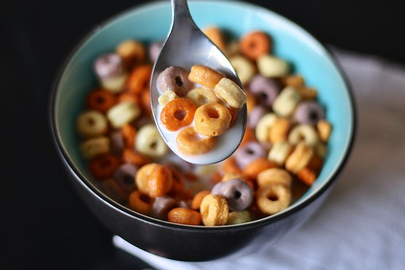
Food products which contain strains of probiotics vary and are still the preoccupation of researchers. The major source of probiotics is dairy products such as milk, buttermilk, cheese, ice cream, yogurts, etc. It is believed that yogurts account for the largest share of dairy-based products consumed. This may be attributed to several nutritional values present in them [5].
Non-dairy food products such as nutrition bars, soy-based food, cereal and fruit extracts also contain strains of probiotics. They can also be found in dietary supplements and beverages as well.
Probiotics play vital roles in the development of a healthy human body. Scientific studies have unearthed two of such necessary roles played by probiotics in human digestive and immune systems.
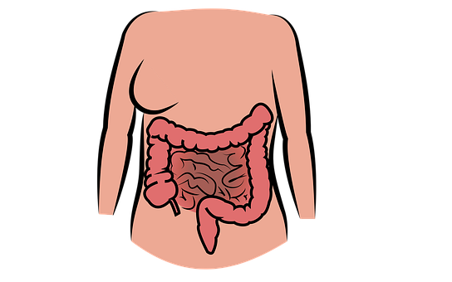

ROLES OF PROBIOTICS IN HUMAN BODY
The Pasteur Institute singled out an important probiotic bacterium called bifidobacterium which is dominant in the intestinal flora of breastfed babies. It was also discovered that bacteria have certain advantages to the human body in cases such as the administration of treatment to babies who have diarrhea due to the displacement of proteolytic bacteria that were causing the disease. Since then, several other health benefits associated with probiotics such as cancer prevention, reduction of serum cholesterol, treatment, and prevention of infectious diarrhea, etc, have been accepted by medical experts [6].
According to the National Center for Complementary and Integrative Health, studies have been conducted on probiotics to find out areas in which they are beneficial. Probiotics help prevent digestive disorders such as diarrhea caused by infections, antibiotic-associated diarrhea, irritated bowel syndrome and inflammatory bowel diseases.
Others include:
- Allergic reactions, e.g., hay fever and eczema,
- Tooth decay and other oral health conditions,
- Colic in infants,
- Liver diseases,
- Reduction of coronary heart diseases,
- Common cold, etc.
It is pertinent to note that while probiotics have been generally considered beneficial, they are in no way substitutes for drugs which may be used for more acute or chronic diseases. To this end, it is advised that probiotics are recommended by nutritionists or medical experts to certain groups of consumers with certain types of conditions.
Some side effects of probiotics are discussed in the next section.

SIDE EFFECTS ASSOCIATED WITH PROBIOTICS


As with all researchable concepts, studies on probiotics are still being carried out to theorize the overall safety of its consumption. However, cases of side effects are usually linked to those who have underlying medical conditions. General side effects reported are:
• Temporary increase in gas and bloating,

• Headaches

• Infections

In healthy people, though, probiotics have little (mild digestive irritation) or no side effects at all.

NEW DEVELOPMENT/RESEARCH ON PROBIOTICS
Researchers are avidly interested in studying how far the benefits of probiotics extend beyond what has been mentioned in this article. There is no doubt that as modern medicine advances, there will be an increase in the role of probiotics in both nutrition and medicine within few decades.

CONCLUSION
From the foregoing, it is observed that while a number of people view microorganisms as toxic to human health, studies have shown that contrary to pathogenic microorganisms, “good” bacteria such as probiotics are indeed beneficial. It is however advised that the use of probiotics should follow a doctor`s prescription because its benefits do not take away the fact that it has its side effects. Research continues on probiotics, as it remains an interesting field of study for scholars and medical practitioners.

REFERENCES
[1] Potential of Probiotics as Biotherapeutic Agents Targeting Innate Immune System (2005, February). African Journal of Biotechnology.
[2] Fuller, R.(1999). Probiotics in Man and Animals. Journal of Bacteriology, 66 (5), 365-378.
[3] Hempel, S., Newberry, S., Renelaz, A., Et al (2011). Safety of Probiotics to Reduce Risk and Prevent or Treat Disease. Agency for Healthcare Research and Quality, 200 (11).
[4] Kechagia, M., Et al (2013). Health Benefits of Probiotics: A Review. Retrieved from https:// www.Hindawi .com/journal/isrn/2013/481651.
[5] Joint FAO/WHO Working Group Report on Drafting Guidelines for the Evaluation of Probiotics in Food (2002).

