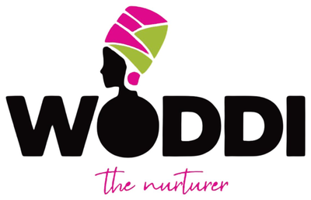 | COUNTRY ACTIVITY TRACKER  Track every activity, outcome, and impact — all in one place | WODDI – The Nurturer

Country / Region: | Enter country or region | Country Rep: | Enter full name | Year: ________

STATUS KEY: | PLANNED | = Scheduled | IN PROGRESS | = Ongoing | COMPLETED | = Done | DELAYED | = Behind | CANCELLED | = Dropped | ON HOLD | = Paused

TAB 1 — MASTER ACTIVITY LOG (ALL ACTIVITIES THIS YEAR)

# | Date | Activity / Initiative | Type / Category | Strategic Obj. | Location | Format | People Reached | Women | Youth | Status

* Type / Category examples: Community Meeting | Workshop | Training | Outreach | Partnership | Advocacy | Event | Media | Other
* Format examples: In-Person | Virtual | Hybrid

TAB 2 — PARTNERSHIP & STAKEHOLDER TRACKER

# | Organisation / Partner | Type of Partner | Contact Person | Date Engaged | Nature of Partnership | Status | Value / Contribution | Next Steps / Notes

* Partner Type examples: Government | NGO | Corporate | Faith-Based | Academic | Media | Community Group | International

TAB 3 — MEMBERSHIP & BENEFICIARY TRACKER

# | Full Name | Community / Area | Age | Phone / Contact | Date Joined / Reached | Programme / Activity | Membership Status | Follow-Up Date | Notes

* Membership Status examples: Active Member | New Member | Beneficiary | Volunteer | Leader | Alumni

TAB 4 — EVENTS & MEETINGS LOG

# | Date | Event / Meeting Name | Type | Venue / Platform | Facilitator | Total Att. | Female | Youth | Partners | Key Outcomes / Decisions

TAB 5 — MEDIA & COMMUNICATIONS LOG

# | Date | Content / Campaign Title | Platform / Channel | Type of Content | Posted By | Reach / Impressions | Engagements | Link / Reference | Notes / Outcomes

* Content Type examples: Post | Video | Story | Reel | Article | Press Release | Interview | Podcast | Live | Newsletter

TAB 6 — BUDGET & EXPENDITURE TRACKER

# | Date | Activity / Budget Item | Category | Budgeted (₦/$) | Actual (₦/$) | Variance (₦/$) | Paid By / Source | Receipt? | Notes
TOTALS

TAB 7 — MONTHLY SUMMARY SCORECARD

KPI / Metric | Jan | Feb | Mar | Apr | May | Jun | Jul | Aug | Sep | Oct | Nov | Dec | ANNUAL TOTAL
Activities Completed
Events / Meetings Held
Total People Reached
Women Reached
Youth Reached
New Members Recruited
Partners Engaged
Trainings / Workshops Run
Media Posts Published
Total Reach (Social Media)
Budget Spent (₦/$)
Fundraising Raised (₦/$)

 | WODDI | The Nurturer | Country Activity Tracker | Update regularly. Track consistently. Grow boldly.

