Project 2
Ruiyang Hu
2025-11-16

Function
Step 1 set a function
Step 2 Process
Step 3 merge
## # A tibble: 6 × 7
## date co pm25 o3 year month month_label
## <date> <dbl> <dbl> <dbl> <dbl> <dbl> <ord>
## 1 2018-01-01 0.2 7.5 0.037 2018 1 Jan
## 2 2018-01-02 0.7 8.95 0.034 2018 1 Jan
## 3 2018-01-03 0.9 15.2 0.032 2018 1 Jan
## 4 2018-01-04 0.2 9.7 0.035 2018 1 Jan
## 5 2018-01-05 0.2 7.75 0.036 2018 1 Jan
## 6 2018-01-06 0.2 7.6 0.036 2018 1 Jan

Plot
- Plot 1 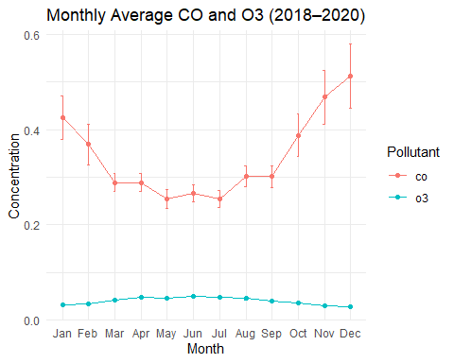
- Plot 2 