SPECIFICATION DOCUMENTATION

LINK TO Github Repository

https://github.com/RexinaD/JavaAssessment.git

STEPS TO RUN THE PROTOTYPE:

1. Pull the main.java file from the repository in a new folder
2. In the folder (line 11), replace the url with the url of the folder on which you wish to perform the operations.
3. In the folder, right click open terminal.
4. Execute the following commands
“ javac main.java” for compiling.
“Java main” to run the file.
5. Now you will see the home page along with the menu and choose the action you want to perform.

PROJECT DETAILS:

The product prototype is built to have 3 basic functions:

1.Retrieving the file names in an ascending order

2.Business-level operations:
a)Option to add a user specified file to the application
b)Option to delete a user specified file from the application
c)Option to search a user specified file from the application
d)Navigation option to close the current execution context and return to the main context

3.Option to close the application.

APPEARANCE:

This project Prototype is a based and put up in a terminal, the prototype will display the project name, i.e, virtual key for your repository , followed by the developer details.
This will be followed by the menu to choose the operations to be performed.

USER INTERACTION:

User input is taken via keyboard to provide the user with the requested functions.
The user can retrieve all the files in ascending order, perform business level operations(add a file, delete a file, search for a file and navigate back to the main menu) and exit the application.

DEVELOPER DETAILS:
Name: REXINA D

SCRUM PLAN FOR PROTOTYPE

Number of Sprints Required:1
Sprint duration:1 day

Sprint 1:

Tasks to be performed: (achieved successfully)

1.Home page of Prototype containing the application and developer details.

2.To return the details of the user interface such as options displaying the following:
a)Add a file to the existing directory list.
b)Delete a user specified file from the existing directory list.
c)Search a user specified file from the main directory.
d)navigate back to the main context.

3.Provide necessary documentations along with it and push it to the repository.

4. Option to exit application prototype.

Provide necessary documentations along with it and push it to the repository.

FLOWCHART
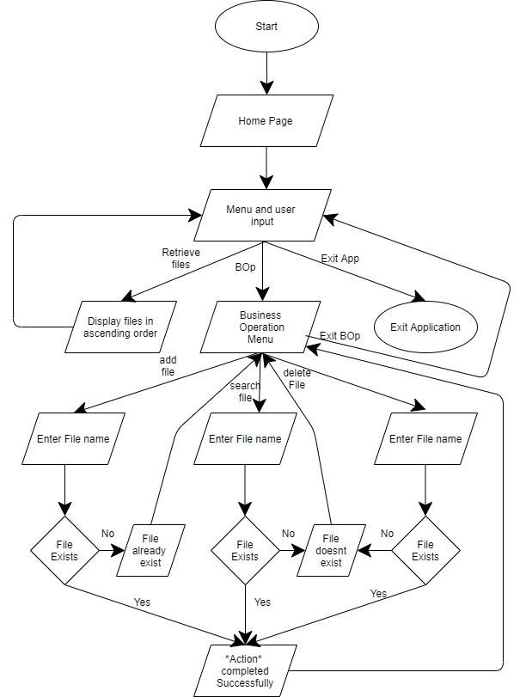

CORE CONCEPTS USED IN PROJECT:

1.Files: We use a file concept Files.list() to Iterate over all files and sub-directories. It Iterates over a directory and gets the List<File> using Files.list() method.

2.Classes: Classes are used to provide shortcuts and helps throughout programming. In user defined classes, we then add functions (known as methods) to that user class for common things that users might need to do.

3.Objects: Objects are used because they can be created to call a non-static function which are not present inside the Main Method but present inside the Class and also provide the name to the space which is being used to store the data.

4.Loops (do while): The Java do-while loop is used to iterate a part of the program repeatedly, until the specified condition is true. If the number of iteration is not fixed and you must have to execute the loop at least once, it is recommended to use a do-while loop.

Java do-while loop is called an exit control loop. Therefore, unlike while loop and for loop, the do-while check the condition at the end of loop body. The Java do-while loop is executed at least once because condition is checked after loop body.

5.Switch: The Java switch statement executes one statement from multiple conditions. It is like if-else-if ladder statement. The switch statement works with byte, short, int, long, enum types, String and some wrapper types like Byte, Short, Int, and Long. Since Java 7, you can use strings in the switch statement.

In other words, the switch statement tests the equality of a variable against multiple values.

6.Exception Handling : Exception Handling is a mechanism to handle runtime errors such as ClassNotFoundException, IOException, SQLException, RemoteException, etc.

Java try block is used to enclose the code that might throw an exception. It must be used within the method. If an exception occurs at the particular statement in the try block, the rest of the block code will not execute. So, it is recommended not to keep the code in try block that will not throw an exception. Java try block must be followed by either catch or finally block.

Java catch block is used to handle the Exception by declaring the type of exception within the parameter. The declared exception must be the parent class exception ( i.e., Exception) or the generated exception type. However, the good approach is to declare the generated type of exception.
The catch block must be used after the try block only. You can use multiple catch block with a single try block.

CONCLUSION:

This application prototype is based out on terminal, if front end is added along, better user interface could be provided.
The unique selling points include, the time saved in scourging for files, in our application all you have to do is type out the name to find it, it also makes adding and deleting files easier. And the listing of all the files in ascending order makes our application an added bonus.

