**AZURE ADF FILTER:**

**Steps:**

1. Create a **Resource Group**
2. Create a **Storage account**
3. Create a **Container** within the Storage account
   1. Container 1 –
      1. Upload the file Student_Score_Table
   2. Container 2 – for output
4. Create ADF
   1. Create linked services
   2. Create dataset
   3. **Create dataflow**
   4. Create Pipeline
   5. Debug to execute.

**Create a dataflow for the Filter:**

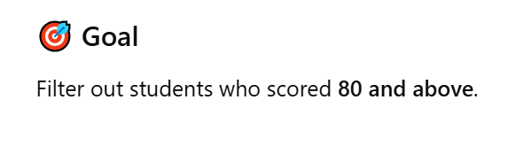

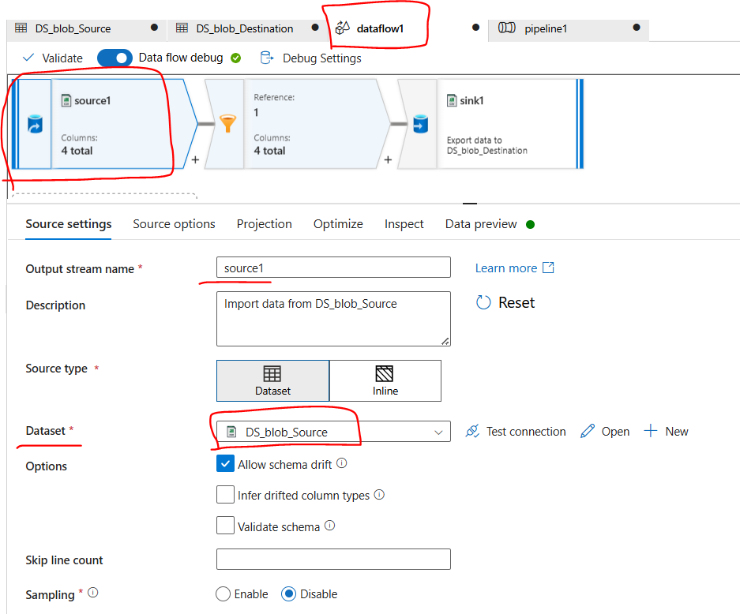

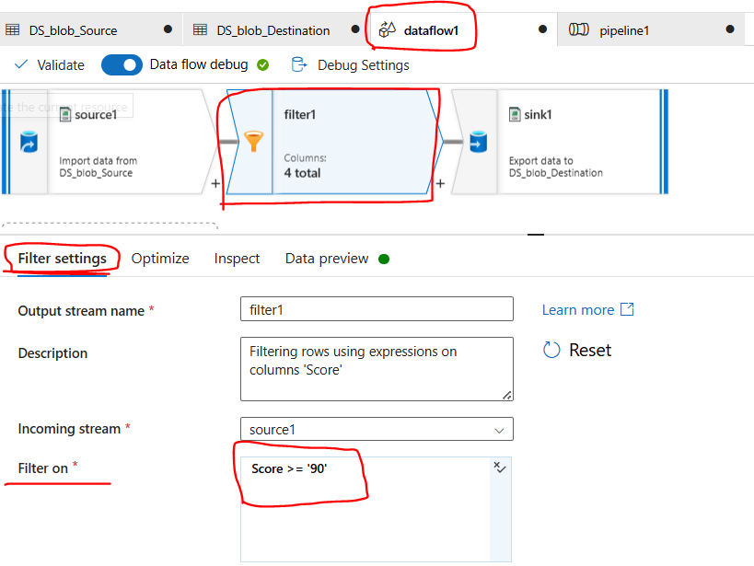

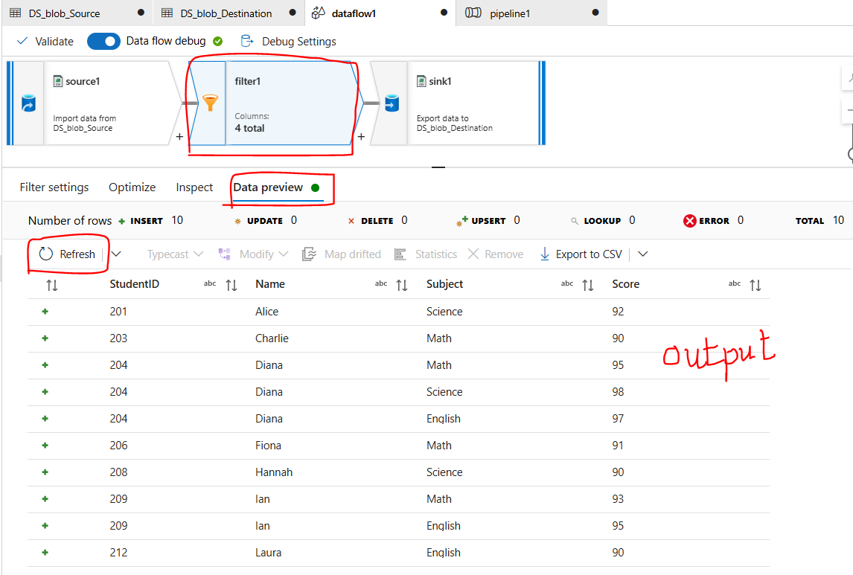

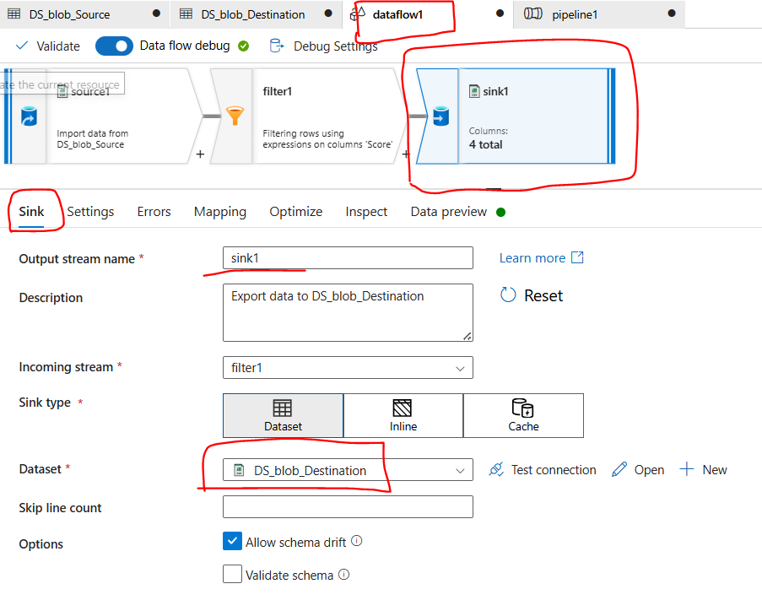

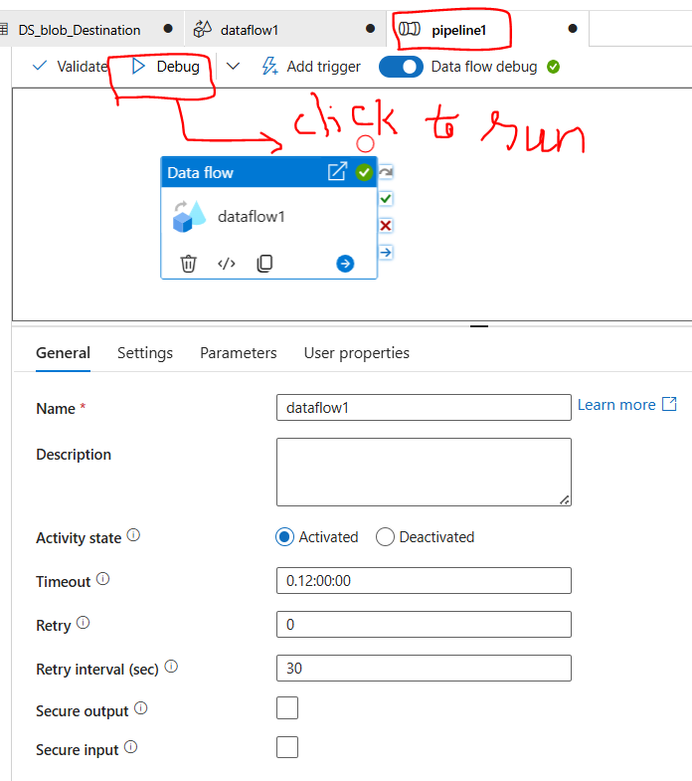

**OUTPUT:**

