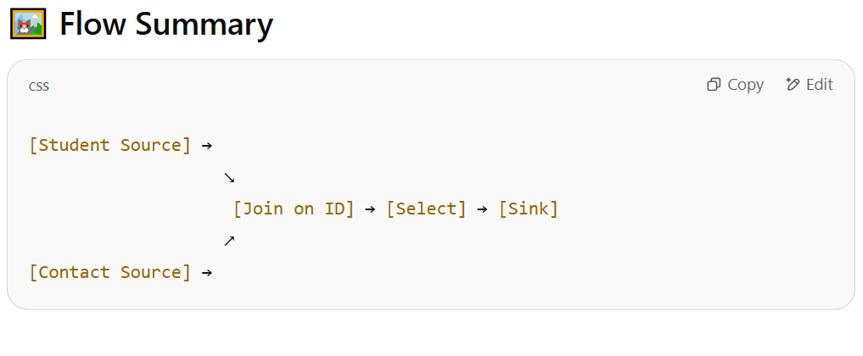

**🔧 ADF Data Flow Steps**

**✅ Step 1: Add Data Flow**

1. Go to **Author > Data Flows > New mapping data flow**.
2. Name it something like JoinStudentContact.

**✅ Step 2: Add Student Source**

1. Click **+ Add Source**, name it Student.
2. Choose the dataset that holds your student table.

**✅ Step 3: Add Contact Source**

1. Click **+ Add Source**, name it Contact.
2. Choose the dataset that holds your contact table.

**✅ Step 4: Add Join Transformation**

1. Click the **+** after one of the sources (e.g., Student) and choose **Join**.
2. It will prompt you to select the second stream → choose Contact.

**✅ Step 5: Configure Join**

Go to **Join settings** tab:

| **Setting** | **Value** |
| --- | --- |
| Join Type | Inner (or Left Outer, as needed) |
| Join Conditions | Student.ID == Contact.ID |

📌 You can also use **Left Outer** if you want **all students**, even if they don’t have contact info.

**✅ Step 6: Select Columns (Optional)**

Use **Select transformation** after Join to choose only the fields you need, like:

* Student.Name
* Contact.Phone
* Contact.Email

**✅ Step 7: Add Sink**

Write the output to a sink (CSV, SQL table, etc.).

**🖼️ Flow Summary**

css

CopyEdit

[Student Source] →

↘︎

[Join on ID] → [Select] → [Sink]

↗︎

[Contact Source] →

**🧪 Sample Output (Inner Join)**

| **ID** | **Name** | **Age** | **Phone** | **Email** |
| --- | --- | --- | --- | --- |
| 1 | Alice | 20 | 1234567890 | alice@mail.com |
| 2 | Bob | 21 | 9876543210 | bob@mail.com |

