**Azure ADF 🡪 copying files from SQL(all tables) to Blob(as files).**

* LookUp is used for this Activity.

SELECT TABLE_NAME

FROM INFORMATION_SCHEMA.TABLES

WHERE TABLE_TYPE = 'BASE TABLE'

The above query returns the table count and the list of all tables that we have in our SQL database.

If we want to select the specific tables, below query I used.

SELECT TABLE_NAME

FROM INFORMATION_SCHEMA.TABLES

WHERE TABLE_NAME IN (

'Student_Scores_Table',

'Students_Activity',

'TopOrderPerCustomer'

)

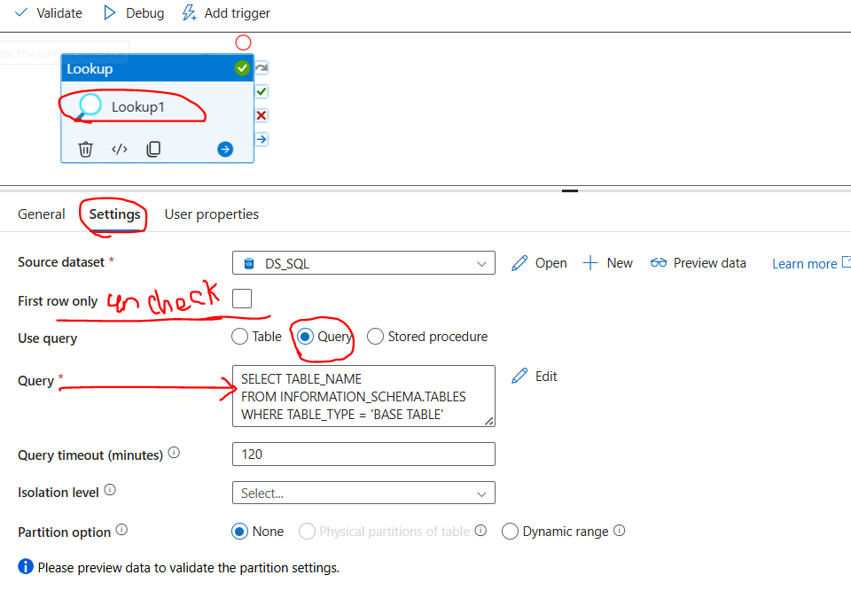

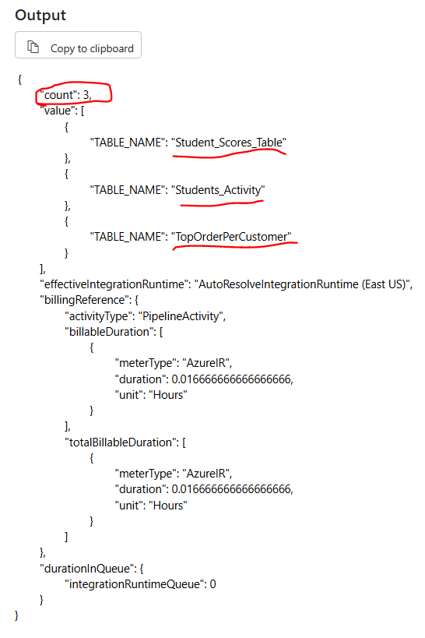

**NOTE:**

**Create 2 linked services.**

**Create three datasets**

1. **For Lookup**: This Dataset will have SQL but without parameters. Then we will get all the tables inside the SQL Database

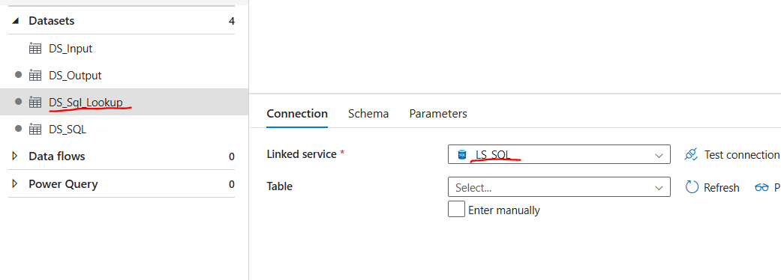

2 . **For Source**: Use the Dataset with Parameter

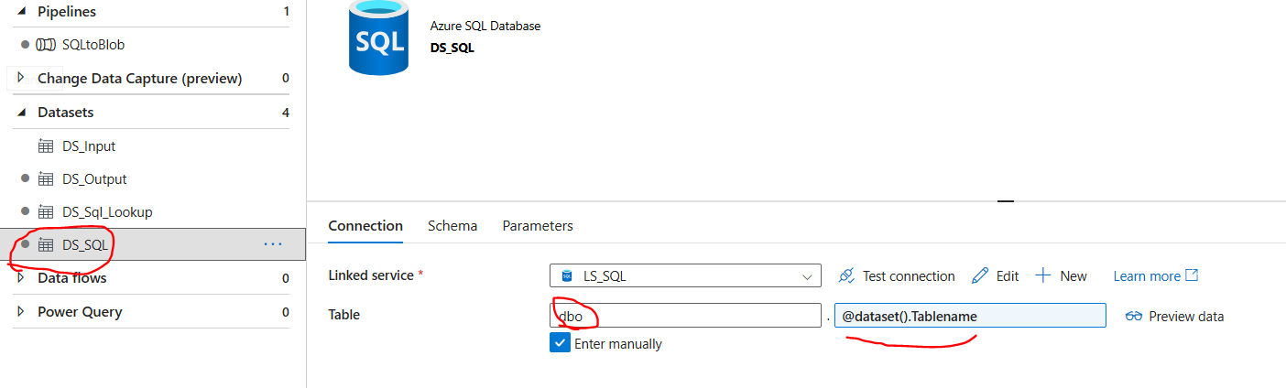

3. For Sink :This contains the destination details

Foreach – pipeline

