**AZURE ADF PIVOT & UNPIVOT:**

**AZURE ADF PIVOT**

In Azure Data Factory (ADF), when you're using the Pivot transformation in a Data Flow, the expression you provide depends on what you want to use as:

* Pivot key (column whose values will become column headers)
* Value column (values to populate the pivoted columns)

Basic Pivot Syntax in ADF

In ADF’s **Pivot transformation**, you define:

1. **Group by:** Columns to group by (like primary key or ID).
2. **Pivot key:** Column whose values become new columns.
3. **Value:** Expression to get values for each pivoted column.

**Steps:**

1. Create a **Resource Group**
2. Create a **Storage account**
3. Create a **Container** within the Storage account
   1. Container 1 –
      1. Upload the file Student_Score_Table
   2. Container 2 – for output
4. Create ADF
   1. Create linked services
   2. Create dataset
   3. **Create dataflow**
   4. Create Pipeline
   5. Debug to execute.
      1. **Create a dataflow to pivot**

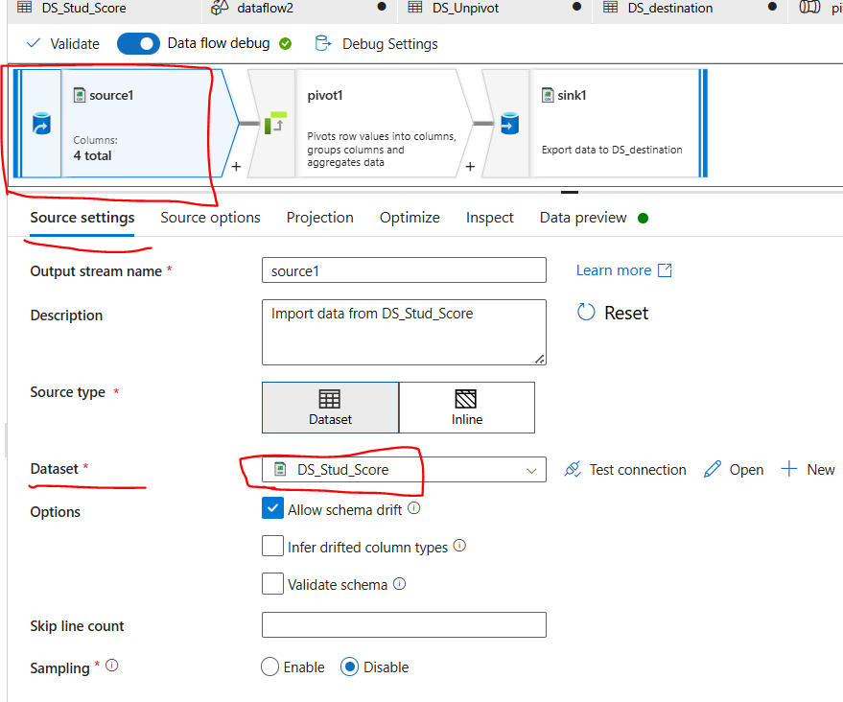

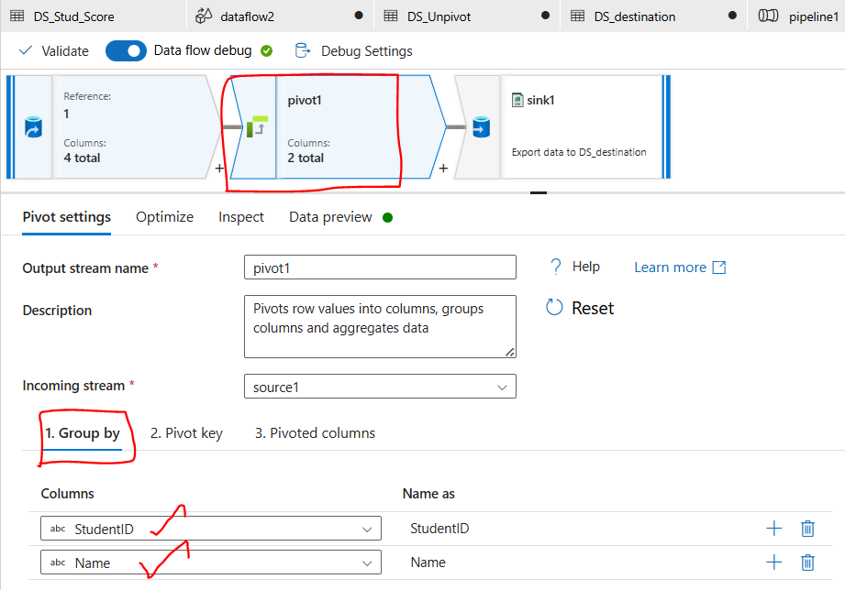

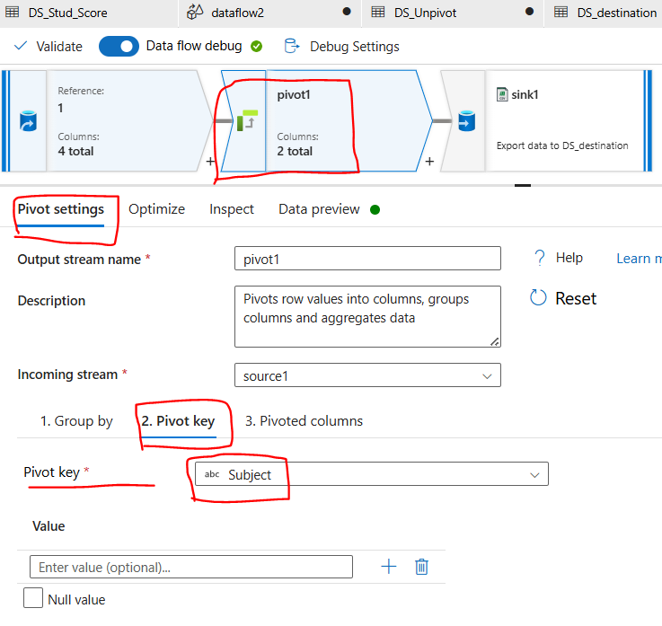

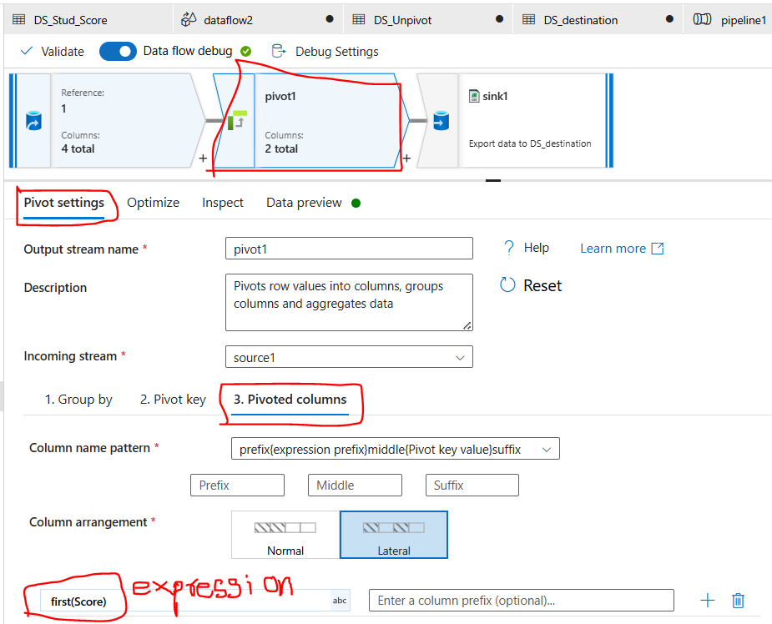

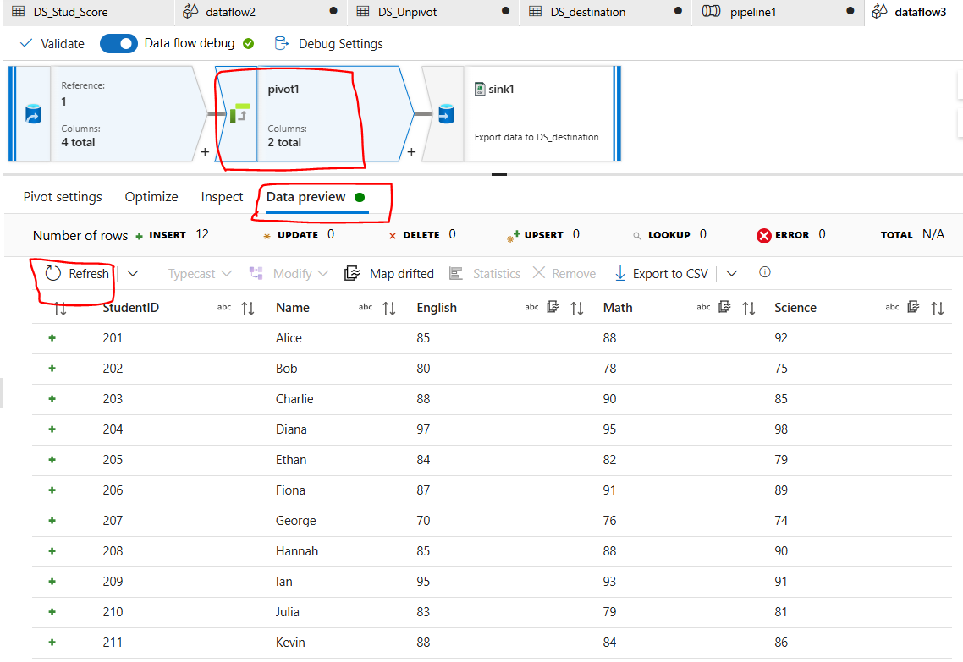

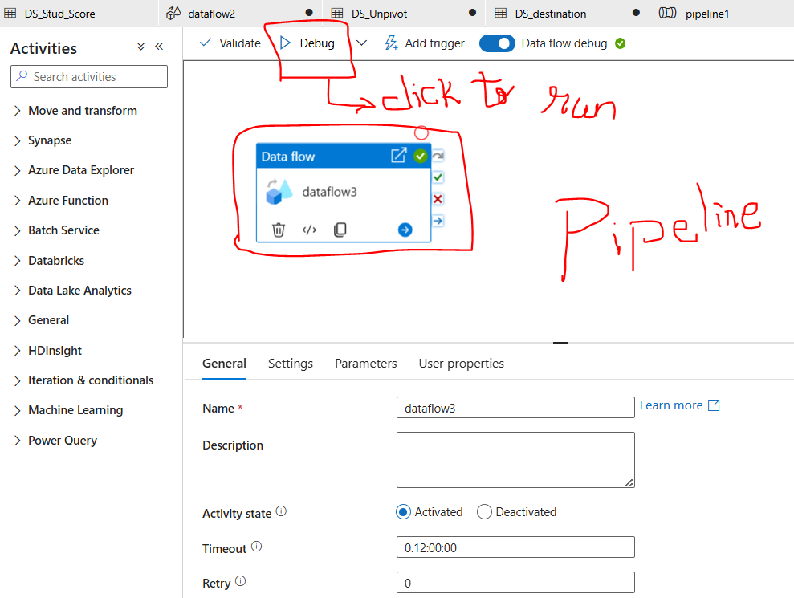

**Output:**

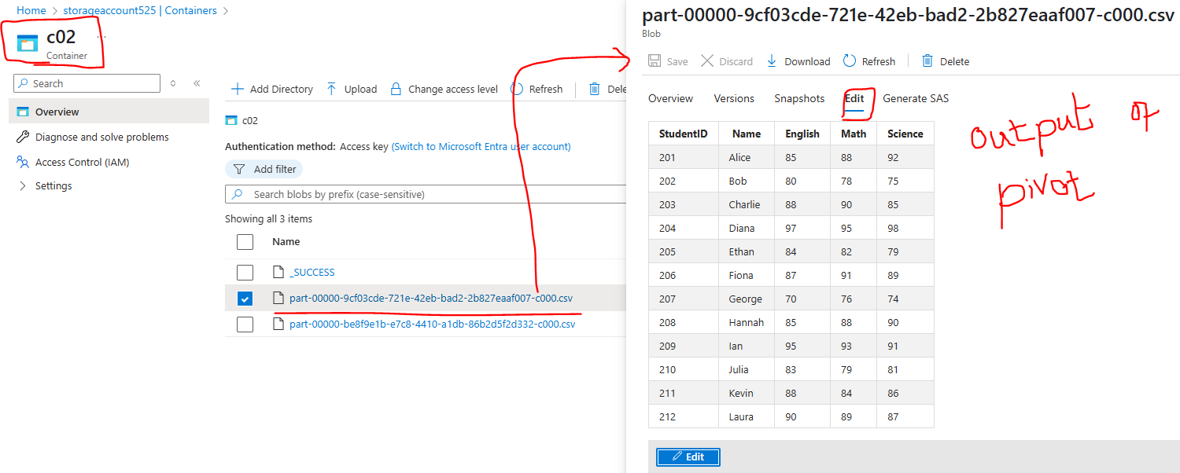

* + 1. **Create a dataflow to unpivot**

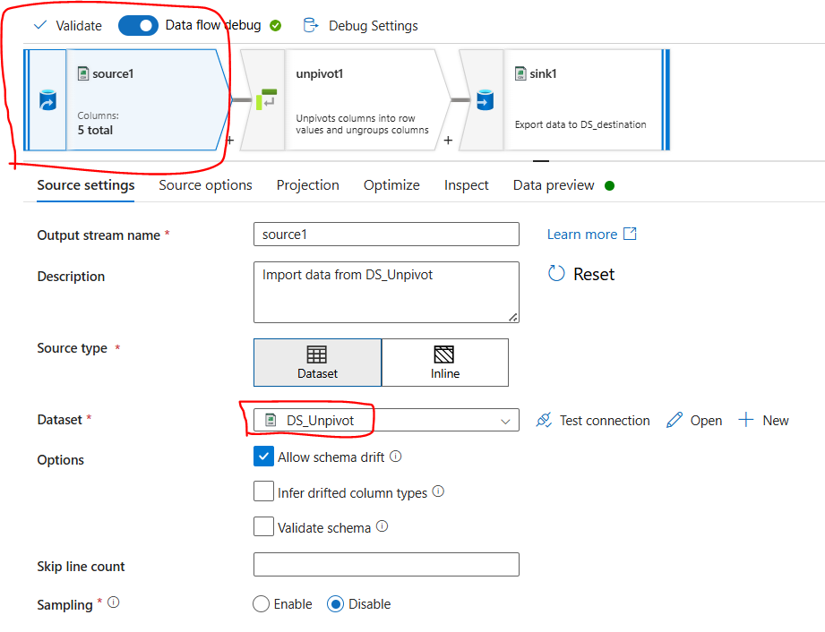

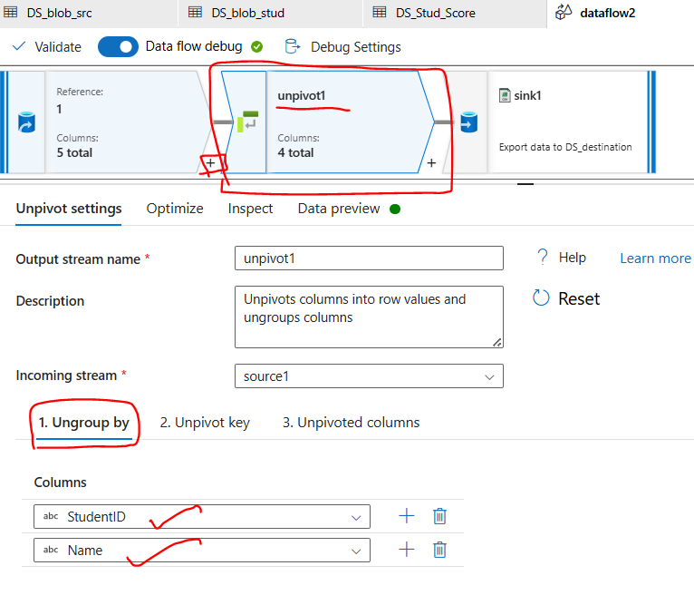

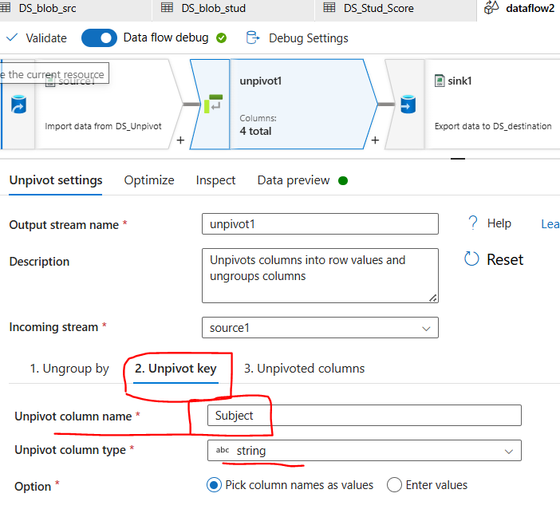

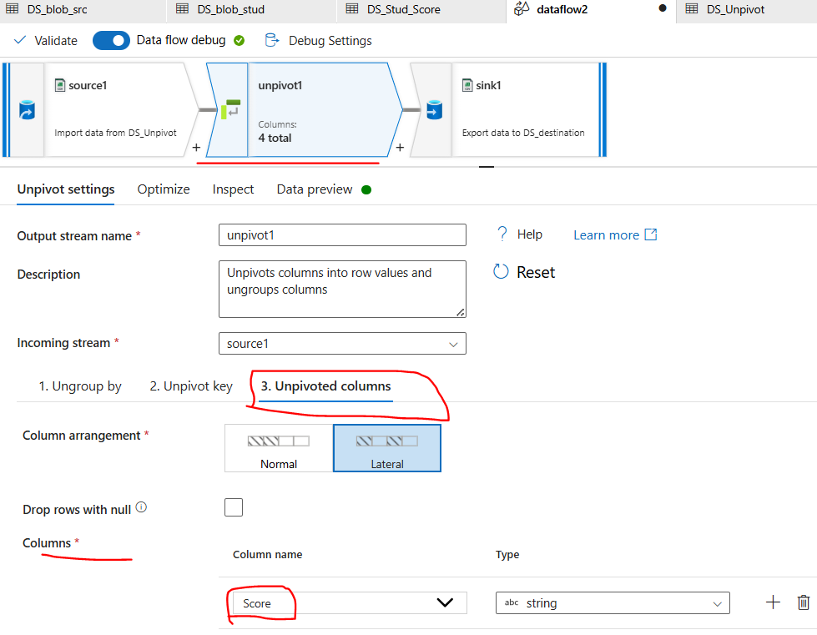

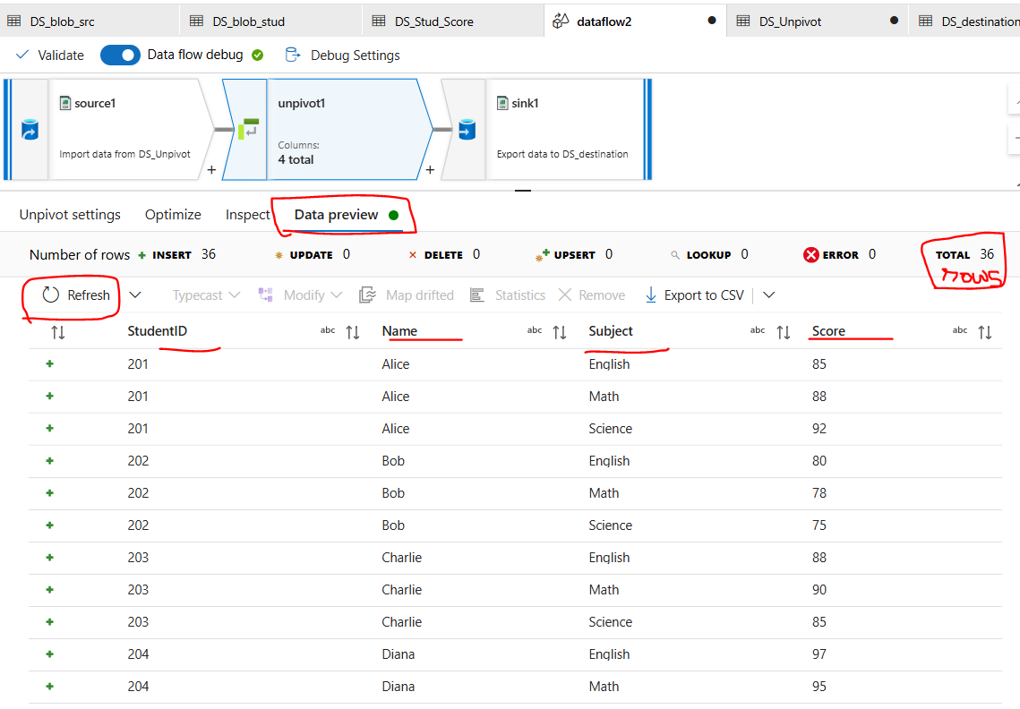

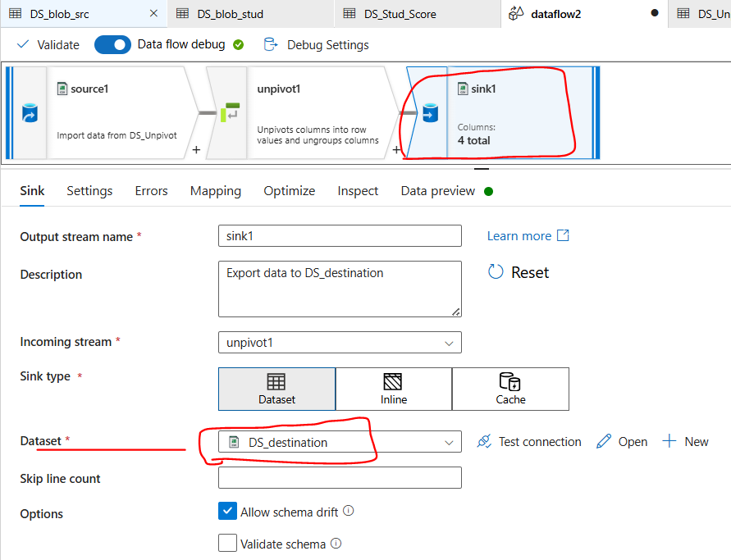

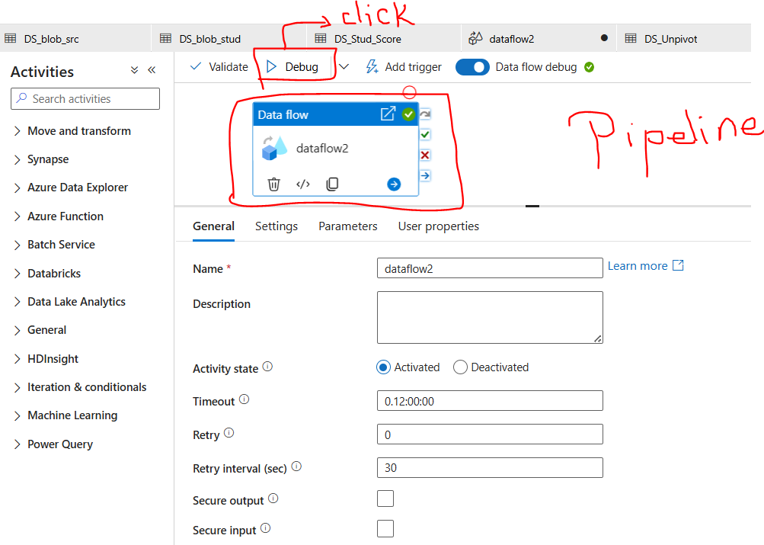

**Output:**

