**Stored procedure Practice**

**Steps to create a Stored Procedure:**

1. Create **Resource Group**
2. Create **SQL Database & Server**
3. Create a **Table**
4. Create a **Stored Procedure**

* Create procedure sp_delete_Emp @id int as
* begin
* delete from Employee where ID=@id
* end
* exec sp_delete_Emp @id=1

1. Create an **ADF (AZURE DATA FACTORY)**
2. Create a **Linked Services**
3. Create a **Data Set**
4. Create a **Pipeline using a Stored Procedure**

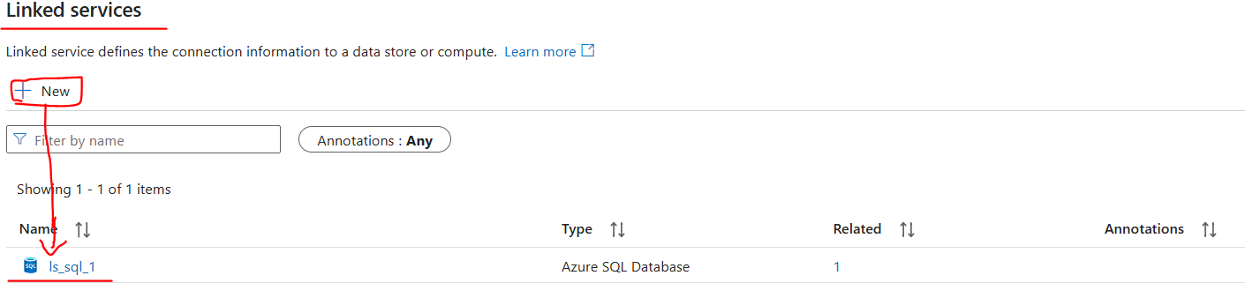

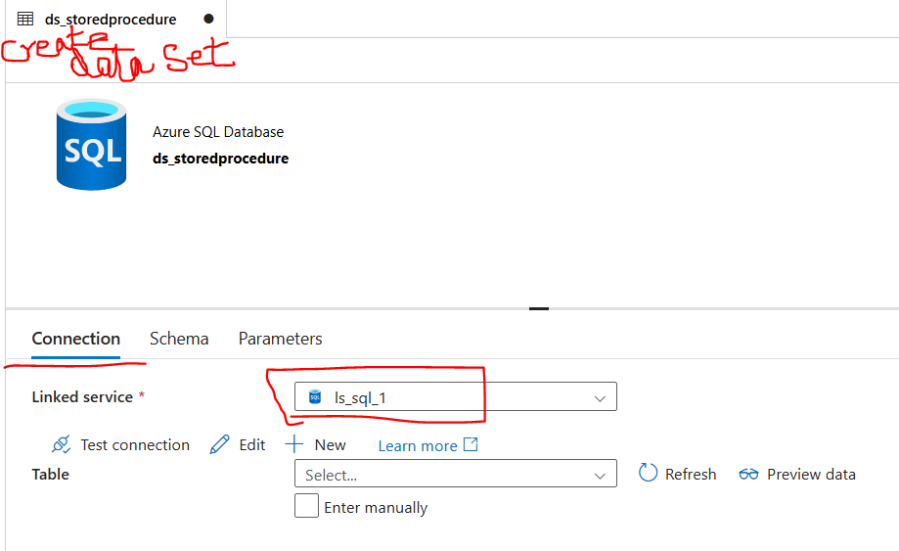

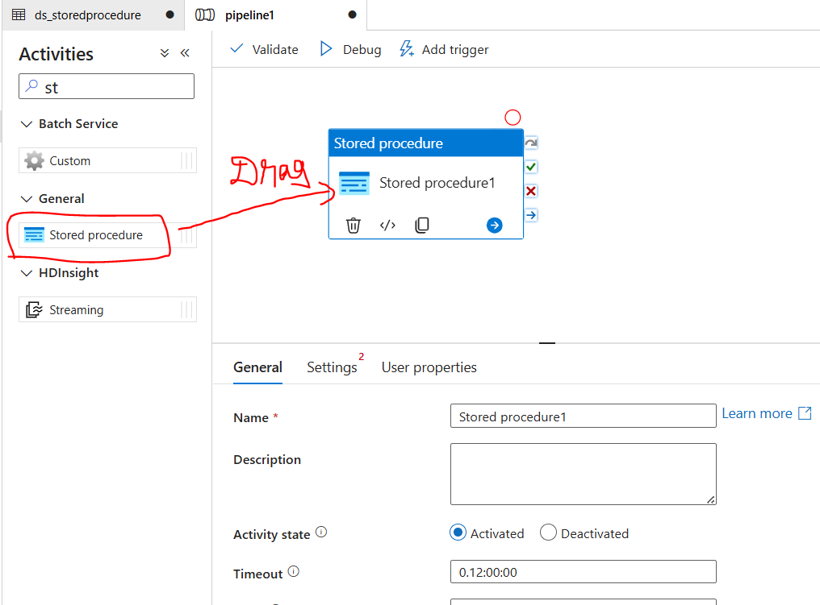

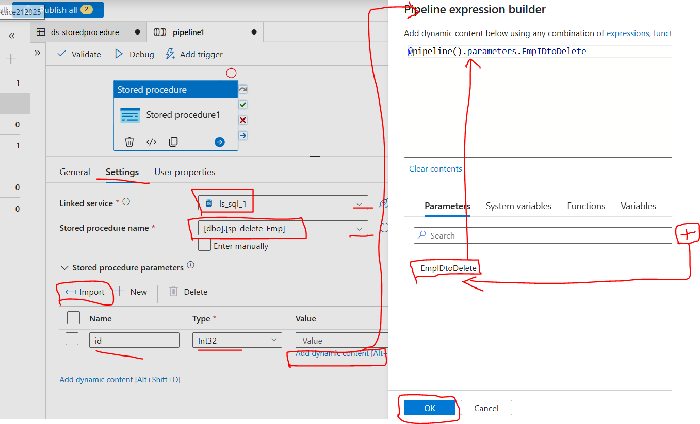

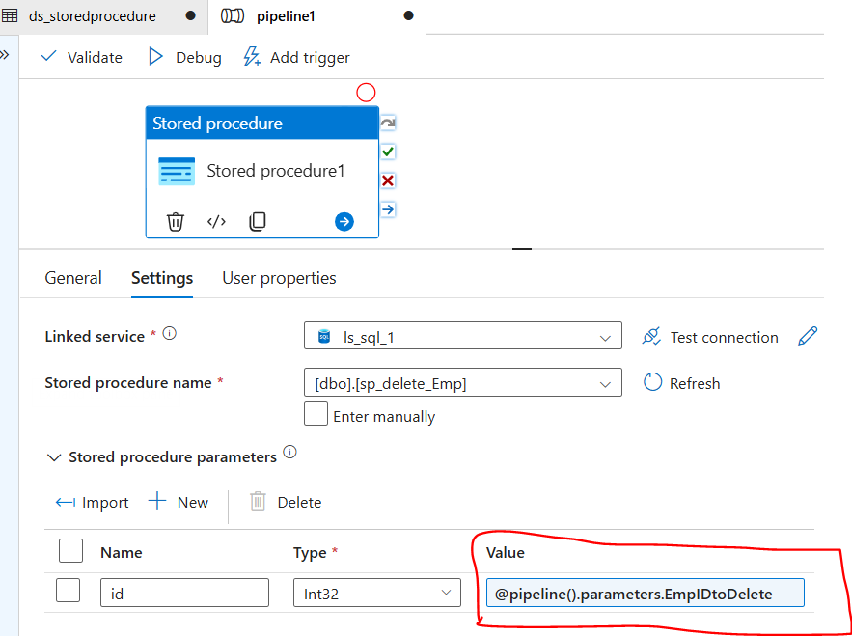

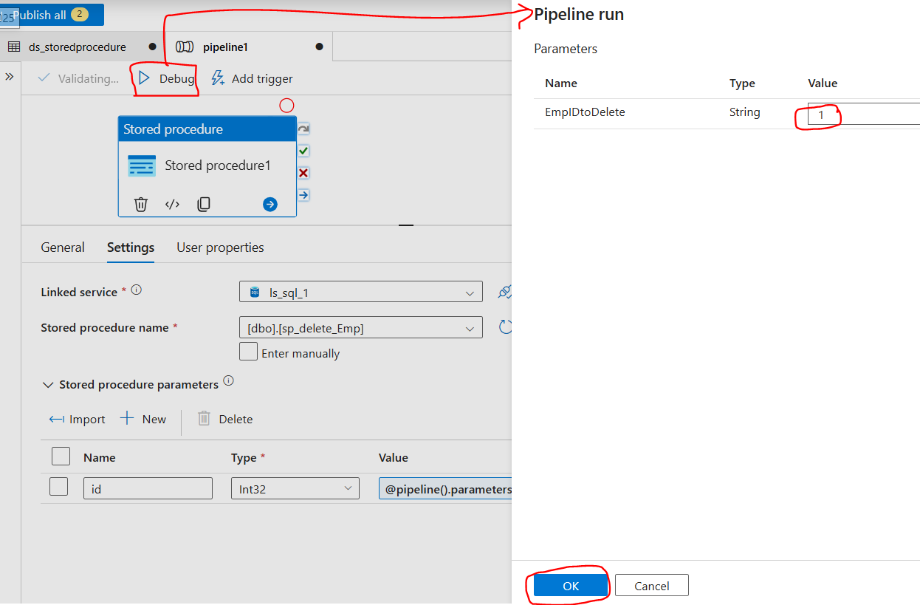

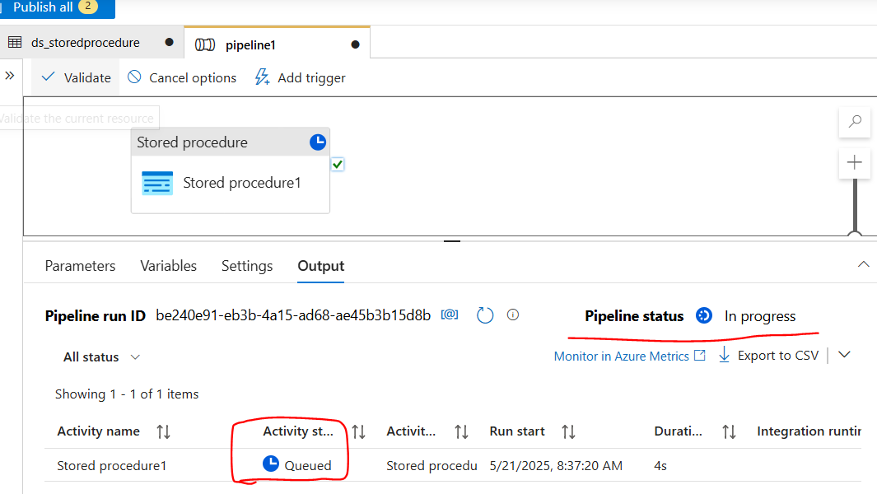

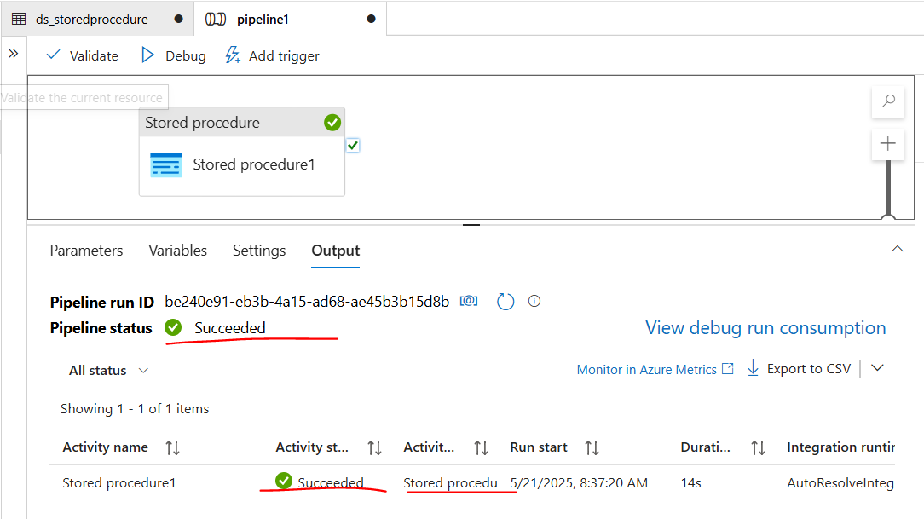

**Connect the SSMS 🡪 select all rows from the table. Here it will displays the records after deleting the value ID=1.**

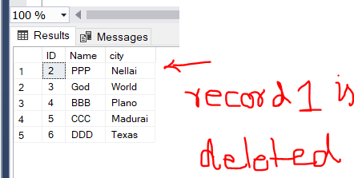

**Stored procedure Practice with Lookup and Foreach**

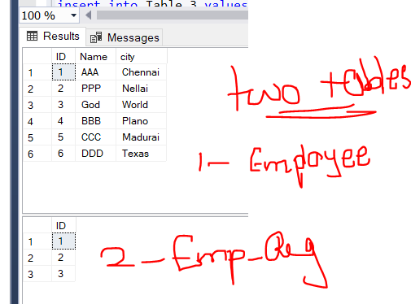

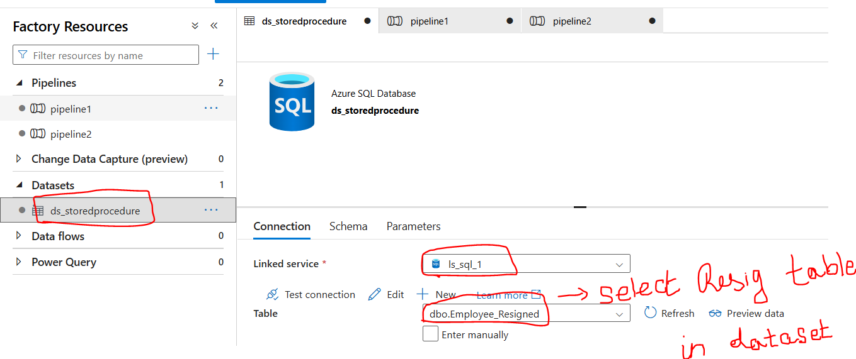

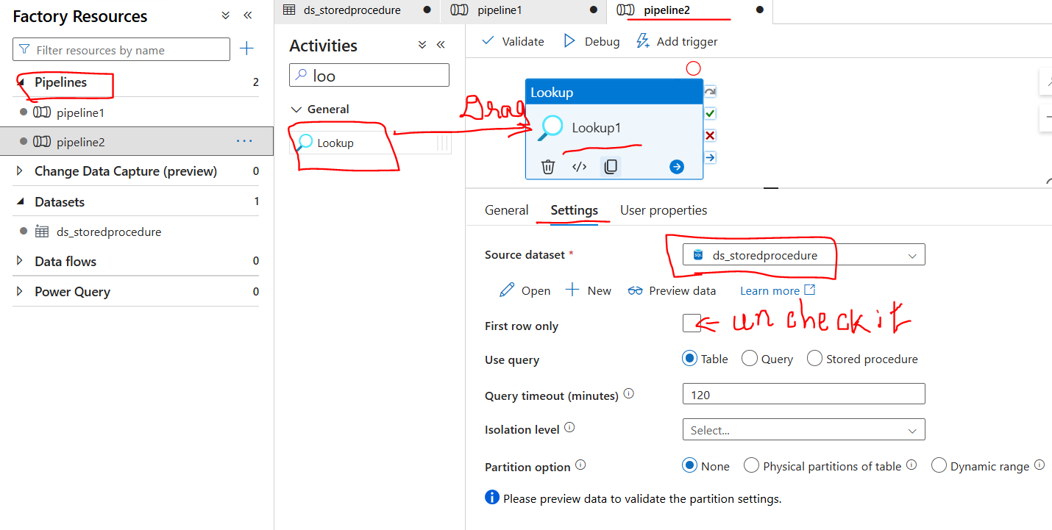

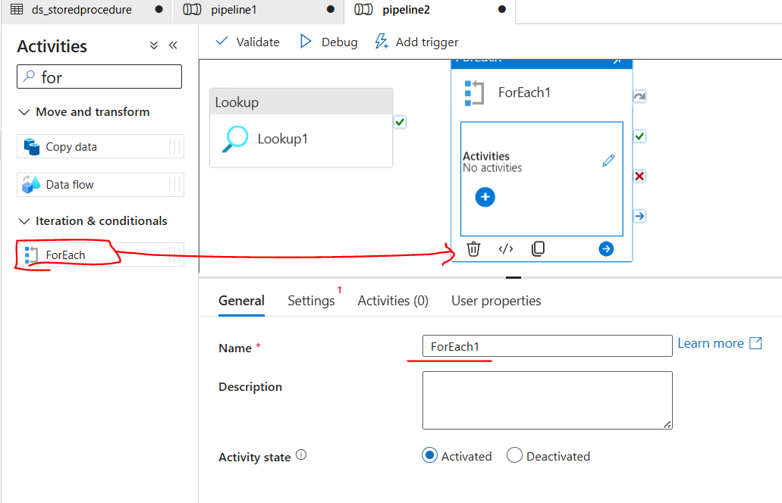

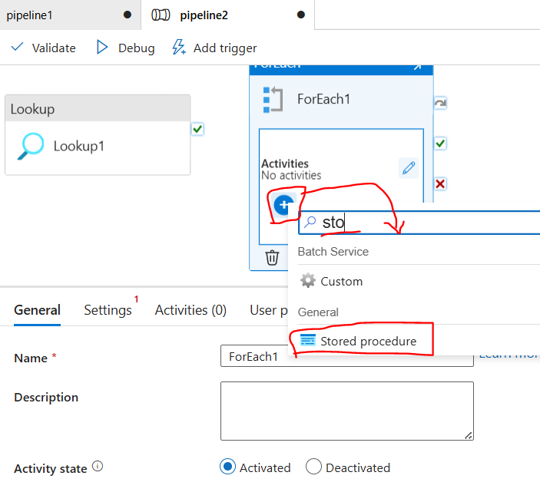

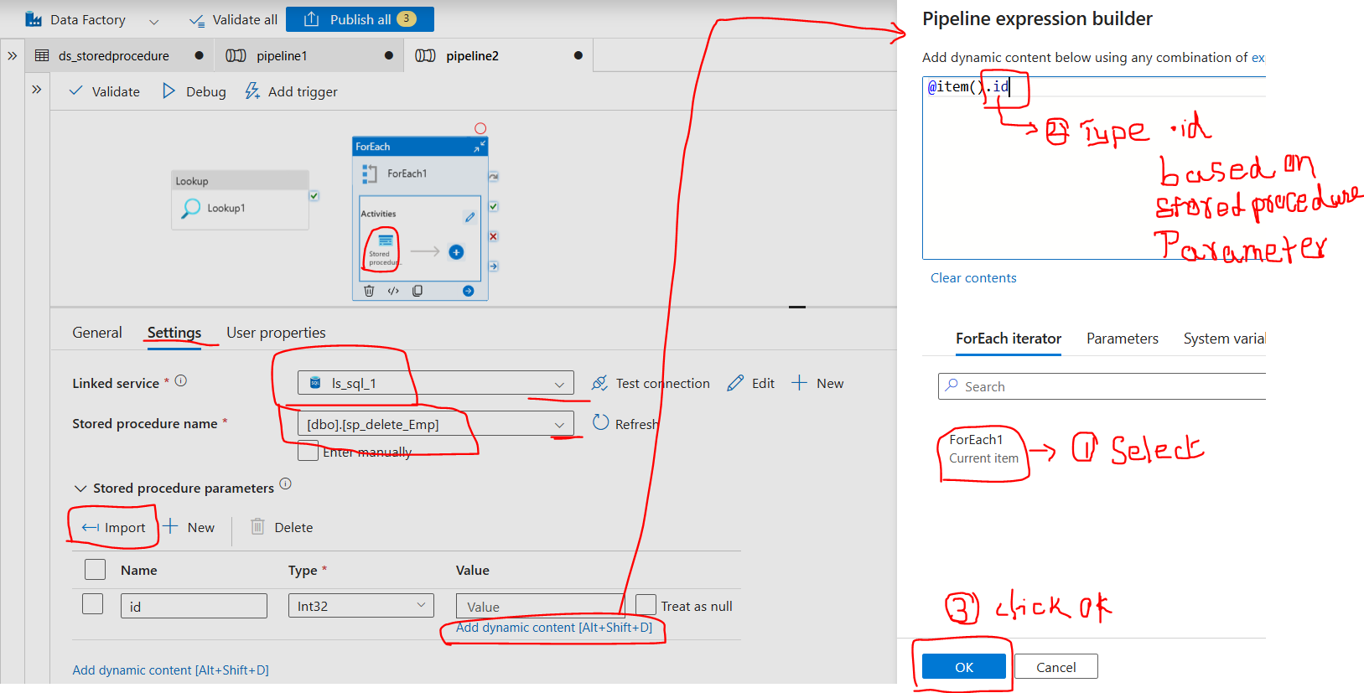

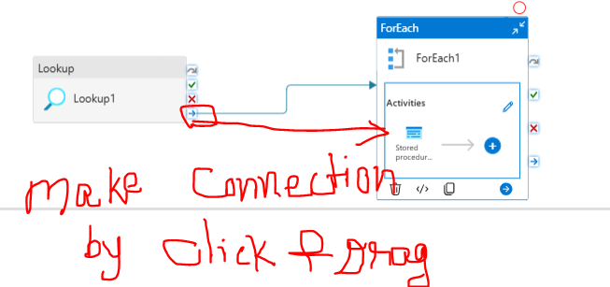

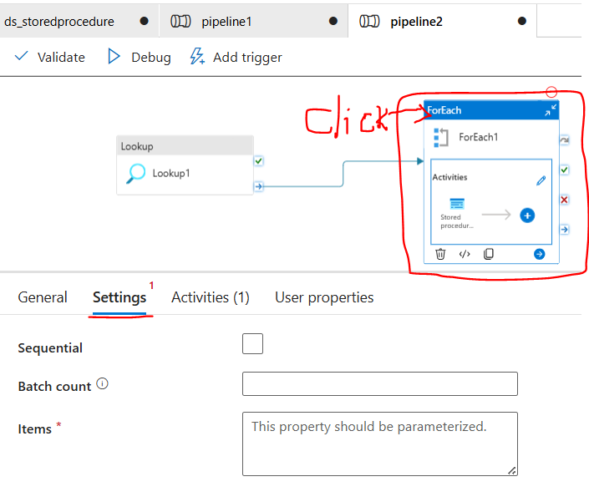

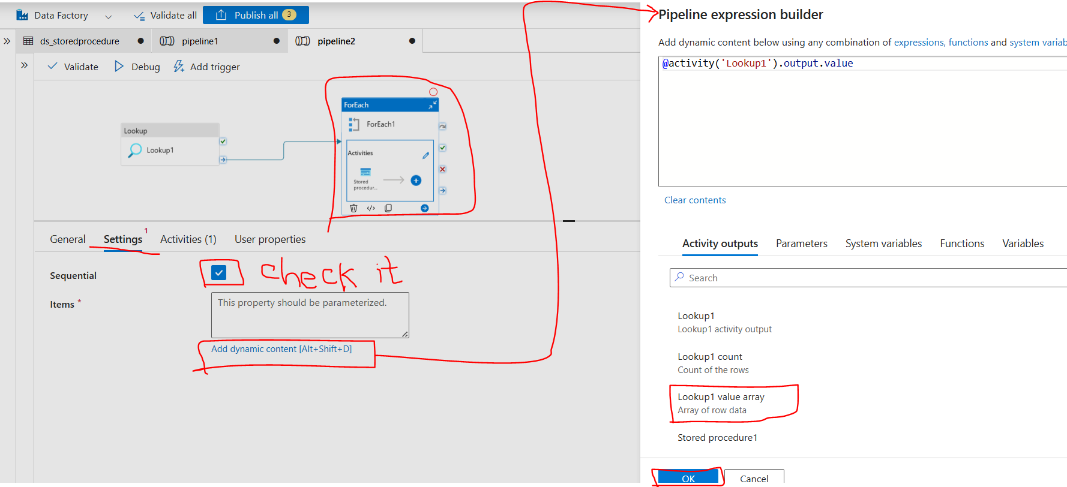

**Lookup** 🡪 **tells which Database**.

**For each** 🡪 Activities

**Stored Procedure** 🡪 given inside the foreach activities.

