Tugas 3

Andri Martin

Pemrograman WEB

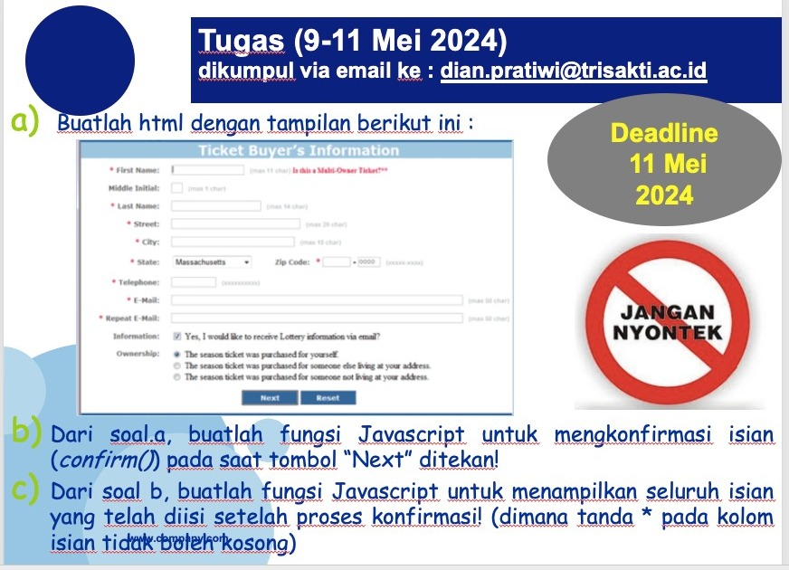

Screenshot hasil

|  |
| --- |
| 1. Tampilan awal      1. Saat mengisi yang kosong      1. Klik “Next”      1. Menampilkan isian user dengan metodr ”CAROUSEL” |

Code:

|  |
| --- |
| 1. index.html   <!DOCTYPE *html*>  <html *lang*="en">  <head>  <meta *charset*="UTF-8">  <meta *name*="viewport" *content*="width=device-width, initial-scale=1.0">  <title>Tiket Buyer's Information</title>  <link *rel*="stylesheet" *href*="style.css">  <link *rel*="stylesheet" *href*="https://unpkg.com/swiper/swiper-bundle.min.css">  </head>  <body>  <h2>Tiket Buyer's Information</h2>  <form *action*="#" *method*="post" *id*="buyerForm">    <label *for*="firstname">First Name:<span *style*="color:red">*</span></label><br>    <input *type*="text" *id*="firstname" *name*="First Name" *required*><br><br>    <label *for*="lastname">Last Name:<span *style*="color:red">*</span></label><br>    <input *type*="text" *id*="lastname" *name*="Last Name" *required*><br><br>    <label *for*="street">Street:<span *style*="color:red">*</span></label><br>    <input *type*="text" *id*="street" *name*="Street" *required*><br><br>    <label *for*="city">City:<span *style*="color:red">*</span></label><br>    <input *type*="text" *id*="city" *name*="City" *required*><br><br>    <label *for*="state">State:<span *style*="color:red">*</span></label><br>    <select *id*="state" *name*="State" *required*>      <option *value*="">Select State</option>      <option *value*="IND">Indonesia</option>      <option *value*="SG">Singapura</option>      <option *value*="MLY">Malaysia</option>      <option *value*="THAI">Thailand</option>      <option *value*="JP">Japan</option>  *<!-- Tambahkan opsi untuk negara bagian lain di sini -->*    </select><br><br>    <label *for*="zip">Zip Code:<span *style*="color:red">*</span></label><br>    <input *type*="text" *id*="zip" *name*="Zip" *required*><br><br>    <label *for*="telephone">Telephone:<span *style*="color:red">*</span></label><br>    <input *type*="tel" *id*="telephone" *name*="Telephone" *required*><br><br>    <label *for*="email">Email:<span *style*="color:red">*</span></label><br>    <input *type*="email" *id*="email" *name*="Email" *required*><br><br>    <label *for*="repeatemail">Repeat Email:<span *style*="color:red">*</span></label><br>    <input *type*="email" *id*="repeatemail" *name*="Repeat Email" *required*><br><br>    <label *for*="info">Information:</label><br>    <input *type*="checkbox" *id*="info" *name*="Information" *value*="Yes, I would like to receive lottery information via email.">    <label *for*="info">Yes, I would like to receive lottery information via email.</label><br><br>    <label *for*="ownership">Ownership:</label><br>    <input *type*="radio" *id*="ownership1" *name*="Ownership" *value*="The season ticket was purchased for yourself.">    <label *for*="ownership1">The season ticket was purchased for yourself.</label><br>    <input *type*="radio" *id*="ownership2" *name*="Ownership" *value*="The season ticket was purchased for someone else living at your address.">    <label *for*="ownership2">The season ticket was purchased for someone else living at your address.</label><br>    <input *type*="radio" *id*="ownership3" *name*="Ownership" *value*="he season ticket was purchased for someone not living at your address.">    <label *for*="ownership3">The season ticket was purchased for someone not living at your address.</label><br><br>    <input *type*="submit" *value*="Next" *id*="submitButton">    <input *type*="reset" *value*="Reset">  </form>  *<!-- Container for carousel -->*  <div *id*="carousel-container"></div>  <script *src*="script.js"></script>  <script *src*="https://unpkg.com/swiper/swiper-bundle.min.js"></script>  </body>  </html>   1. script.js   *// Mengambil elemen form*  const form = document.getElementById('buyerForm');  *// Mengambil elemen input yang memerlukan validasi (memiliki tanda bintang)*  const requiredInputs = document.querySelectorAll('[required]');  *// Menambahkan event listener untuk form submission*  form.addEventListener('submit', function(event) {  *// Mencegah form untuk melakukan pengiriman default*      event.preventDefault();  *// Validasi apakah semua input yang memerlukan validasi diisi*      let isValid = true;      requiredInputs.forEach(function(input) {          if (!input.value.trim()) {              isValid = false;  *// Membuat popup untuk menampilkan pesan error*              const errorPopup = document.createElement('div');              errorPopup.classList.add('error-popup');              errorPopup.textContent = `Please fill in ${input.previousElementSibling.textContent.replace('*', '')}`;              document.body.appendChild(errorPopup);  *// Menghilangkan popup setelah beberapa detik*              setTimeout(() => {                  errorPopup.remove();              }, 3000);          }      });  *// Jika semua input yang memerlukan validasi diisi, tampilkan konfirmasi*      if (isValid) {  *// Membuat popup untuk menampilkan konfirmasi*          const confirmPopup = document.createElement('div');          confirmPopup.classList.add('confirm-popup');          const confirmText = document.createElement('p');          confirmText.textContent = 'Are you sure you want to proceed?';          const confirmButtons = document.createElement('div');          confirmButtons.classList.add('confirm-buttons');          const yesButton = document.createElement('button');          yesButton.textContent = 'Yes';          yesButton.addEventListener('click', function() {  *// Jika pengguna mengonfirmasi, tampilkan seluruh isian dari pengguna dalam carousel*              const carouselContainer = document.getElementById('carousel-container');              carouselContainer.innerHTML = ''; *// Bersihkan konten sebelumnya*              const formData = new FormData(form);              const carouselWrapper = document.createElement('div');              carouselWrapper.classList.add('swiper-container');              const carouselSlides = document.createElement('div');              carouselSlides.classList.add('swiper-wrapper');              for (const [key, value] of formData.entries()) {                  const slide = document.createElement('div');                  slide.classList.add('swiper-slide');                  slide.textContent = `${key}: ${value}`;                  carouselSlides.appendChild(slide);              }              carouselWrapper.appendChild(carouselSlides);              carouselContainer.appendChild(carouselWrapper);  *// Inisialisasi Swiper*              const swiper = new Swiper(carouselWrapper, {                  loop: true,                  autoplay: {                      delay: 5000, *// Setel delay sesuai kebutuhan Anda*                  },              });  *// Menghilangkan popup konfirmasi setelah menampilkan carousel*              confirmPopup.remove();          });          const noButton = document.createElement('button');          noButton.textContent = 'No';          noButton.addEventListener('click', function() {  *// Jika pengguna membatalkan, cukup hilangkan popup konfirmasi*              confirmPopup.remove();          });          confirmButtons.appendChild(yesButton);          confirmButtons.appendChild(noButton);          confirmPopup.appendChild(confirmText);          confirmPopup.appendChild(confirmButtons);          document.body.appendChild(confirmPopup);      }  });   1. style.css   body {      background-image: linear-gradient(to bottom, #F2A0C0, #F2C87E); */* Gradient dari atas ke bawah */*  }  *.confirm-popup* {      position: fixed;      top: 50%;      left: 50%;      transform: translate(-50%, -50%);      background-image: linear-gradient(to bottom, #FFF1E4, #AB7261); */* Gradient dari atas ke bawah */*      border: 1px solid #ccc;      box-shadow: 0 0 10px rgba(0, 0, 0, 0.5);      padding: 20px;      z-index: 1000;  }  *.confirm-buttons* {      margin-top: 10px;      text-align: center; */* Pusatkan tombol */*  }  *.confirm-buttons* button {      margin-right: 10px;      cursor: pointer;      background-image: linear-gradient(to bottom, #AB7261, #F2C87E); */* Gradient dari atas ke bawah */*      color: #fff; */* Warna teks */*      border: none;      padding: 8px 16px; */* Padding tombol */*      border-radius: 5px; */* Border radius tombol */*      transition: background-color 0.3s; */* Efek transisi saat hover */*  }  *.confirm-buttons* button*:hover* {      background-color: #F2C87E; */* Warna tombol saat hover */*  }  *.confirm-buttons* button*:last-child* {      margin-right: 0;  }  *.swiper-container* {      width: 100%;      height: 100%;  }  *.swiper-slide* {      text-align: center;      font-size: 18px;      background-image: linear-gradient(to bottom, #E7DBA9, #969D7B); */* Gradient dari atas ke bawah */*      border: 1px solid #ccc;      padding: 20px;  }  form {      width: 50%;      margin: 0 auto;      padding: 20px;      border: 1px solid #ccc;      border-radius: 15px; */* Tambahkan curve pada kotak form */*  }  input[*type*="text"],  input[*type*="email"],  input[*type*="tel"],  select {      border: 1px solid #ccc;      border-radius: 5px; */* Tambahkan curve pada kotak isian */*      padding: 8px 12px;      width: calc(100% - 24px); */* Sesuaikan lebar dengan padding */*      margin-bottom: 10px;  }  input[*type*="checkbox"],  input[*type*="radio"] {      display: inline-block; */* Atur agar checkbox dan radio button berada dalam satu baris dengan teks */*      vertical-align: middle; */* Posisikan checkbox dan radio button di tengah teks */*      margin-right: 5px; */* Beri sedikit jarak dari teks */*  }  input[*type*="submit"],  input[*type*="reset"] {      display: block;      margin: 0 auto 10px;      background-color: #969D7B;      color: #fff;      border: none;      padding: 8px 16px;      border-radius: 5px;      transition: background-color 0.5s;      cursor: pointer;      text-align: center;      font-size: 16px;  }  */* Atur jarak antar tombol */*  input[*type*="submit"] {      margin-right: 10px; */* Tambahkan margin-right */*  }  */* Tombol reset tidak memiliki margin kanan */*  input[*type*="reset"] {      margin-right: 0; */* Hapus margin-right */*  }  */* Hindari merubah desain untuk bagian checkbox dan radio button */*  h2 {      text-align: center; */* Pusatkan teks */*      margin-top: 20px;      padding: 10px; */* Tambahkan padding */*  }  *#carousel-container* {      width: 50%;      margin: 20px auto;      padding: 20px;      overflow: hidden;  }  */* Tambahkan efek hover untuk tombol */*  input[*type*="submit"]*:hover*,  input[*type*="reset"]*:hover* {      background-color: #AB7261; */* Warna tombol saat hover */*  }  */* Atur posisi tombol di tengah */*  input[*type*="submit"],  input[*type*="reset"] {      display: block; */* Membuat tombol menjadi blok */*      margin: 0 auto 10px; */* Menengahkan tombol dan memberikan jarak 10px dari bawah */*      background-color: #969D7B; */* Warna tombol */*      color: #fff; */* Warna teks */*      border: none;      padding: 8px 16px; */* Padding tombol */*      border-radius: 5px; */* Border radius tombol */*      transition: background-color 0.5s; */* Efek transisi saat hover */*      cursor: pointer;      text-align: center;      font-size: 16px;  }  */* Atur jarak antar tombol */*  input[*type*="submit"] {      margin-right: center;  }  */* Tombol reset tidak memiliki margin kanan */*  input[*type*="reset"] {      margin-right: center;  } |