MEMO
To: Studio Director, Xtrim Studios
From: Data Analyst (contract)
Date: 14 September 2026
Re: Where the money is going, and whether the ads work (data: January 2023 – June 2025)

The short answer
- Revenue grew 31% in naira, from ₦7.07B in 2023 to ₦9.24B in 2024, but the dollar went from an average of ₦895 to ₦2,492, so that revenue was worth $8.0M in 2023 and only $3.6M in 2024.
- ₦5.96B (30%) of the production work booked since January 2023 had not reached Completed when the data was exported, including ₦1.60B on 175 jobs from 2023–2024 still marked Invoiced.
- Postponed work has more than doubled, from 5.9% of revenue in 2023 to 13.8% in the first half of 2025.
- Studio Rental loses money on crew cost alone (-5.3% margin; 83 of 186 jobs), and across the business 182 jobs cost ₦140M more in crew than they earned.
- The ₦860M spent on ads brought back ₦0.35 of tracked web-shop revenue per ₦1; they pay for themselves only if at least 6.7% of the ₦6.56B of bookings credited to Google, Instagram and TikTok came from a paid ad, and no system records whether they did.
- Crew, ads and merch stock take only 17.1% of 2024 revenue, so the missing cash sits in what these systems do not record (dollar-priced kit and software, rent, salaries, tax) and in unpaid invoices, which is where finance should look first.
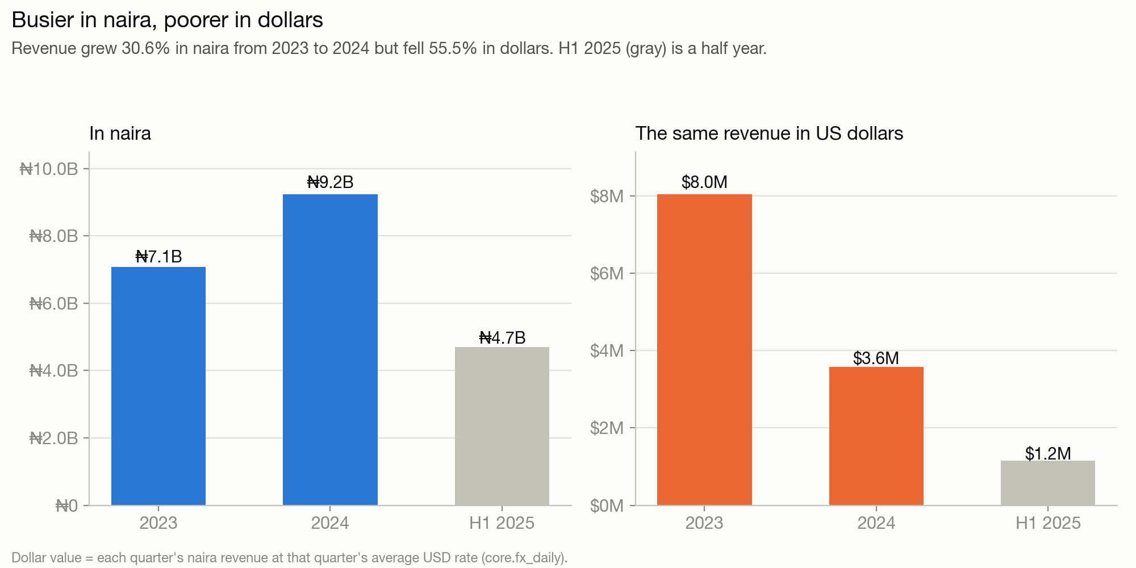

What is behind those numbers
The work that pays. Commercial / TVC and Music Video bring in 51% of production revenue from 21% of jobs, with over 90% left after crew. Weddings are the most frequent job (423 jobs) but 13% of revenue. Studio Rental is 9% of jobs and 1% of revenue; Photoshoot is 18% of jobs, 5% of revenue, and 66 of its 380 jobs lose money on crew.
The currency. The 316 jobs billed in dollars or pounds were worth ₦4.35B in naira; ₦3.46B of that (79%) is purely the weaker naira. Billing in a hard currency protected those jobs; every naira-priced job lost value in real terms.
Capacity. December and November are the busiest months (114 and 110 jobs a year on average, against 22 in January). Crew are never short on paper (peak week 20% of crew-days), but crew were logged on two jobs on the same day 824 times, 33% of them in November and December. That is where the studio breaks.
Merch. Merch is healthy but small: ₦1.38B after refunds (6.6% of revenue), 61% left after stock cost, and no collection lost money. Refunds run at 9.5% of sales, spread across reasons; no single product drives them.
Advertising. 11% of website visits were bots, which the analytics tool did not filter. Of 3,851 recorded sales, only 68% link to a real order, and those that do are a median 254 days away from the visit. Channel-level returns are therefore rough: Meta looks best (₦0.71 per ₦1) and YouTube worst (₦0.17); ₦130M of influencer spend cannot be measured at all.

Recommendations
- Collect before you grow. Chase the ₦1.60B of 2023–2024 invoices this quarter, take a deposit at booking, and charge for postponements.
- Price in dollars where you can. Quote Commercial, Music Video and international clients in USD or with an exchange-rate clause; it is the one lever that grew in value as the naira fell.
- Fix or drop loss-making jobs. Set a minimum price or a crew cap for Studio Rental and Photoshoot so no job costs more in crew than it earns.
- Test the ads before spending more. Add 'which ad?' and tracked links to the booking form, give influencers codes, and pause YouTube and Email (the weakest measured returns, ₦294M of spend so far) for eight weeks to see whether bookings move.
- Book November–December crew in September. Double bookings cluster in the peak; confirm freelancers early.

Caveats that could change the answer
- No rent, equipment, salary, tax or bank data was provided. The cash explanation is an inference from what is missing, not a measurement; the bank statement would confirm or overturn it.
- Job status is a snapshot from mid-2025. 'Invoiced' is read as billed but unpaid; if finance marks paid invoices differently, the uncollected figure falls.
- 6.9% of revenue (₦1.44B) is touched by data problems that could not be resolved, mostly 107 non-cancelled jobs with no service type. ₦3.87B of bookings have no lead source.
- Merch revenue counts Pending orders (₦302M); if they never ship, merch revenue is that much lower.
Technical appendix, SQL, data quality report and dashboard are attached separately. All figures in naira (₦) unless stated; dollar values use the daily exchange rate.

