

Undergraduate Programme

Date Sent: 24/03/2023

Module Title: Financial Optimisation

Module Code: IB3K2

Date/Year of Module: 2023

Submission Deadline: 24/03/2023

Number of Pages: 5

Assignment Question: Q1a, Q1b, Q1c,Q2

Question 1(a):
- All parameters are known, money borrowed from t to t+1 at fixed rate, any amount can be borrowed and needs to be paid back in next period
Parameters:
i:= 1, 2, …, n, securities i under consideration, only with 1, 2, 3, and 4-year maturities
t := 1, ..., T, time period t, which T=4
C_{t}: Future cash requirements in year t
p_{i}: Current market price of security i ; q_{i}: Annual coupon payment for security i; F_{i}: Principal of security i paid out at maturity
f_{it}: Cash flow arising from asset i at time t in a n x T matrix, where for each row of security, it receives coupon payment q_{i} at time t until its maturity time, where an additional principal payment F_{i} will be received
b_{t}: annual rate in % from year t to t+1 for t=0, ...,3
r_{t}: annual interest rate in % from year t to t+1 for t=0, ...,3
λ: Budget of portfolio investment
α: Trade off weight between two objectives, a value between 0 and 1
Decision Variables:
x_{i}: amount of asset i purchased
B_{t}: amount borrowed at time t and repaid at time t+1 with b_{t} for t=0, ...,4, no borrowing at t=0 and t=4
Loan_{t}: money received from loan at time t and repaid at time t+1 with r_{t} for t=0, …,4, no loan at t=0 and t=4
z_{t}: Cash in hand at time t=0, 1, …,T, where T=4
Liner Programming Formulation:
Max. $α*z_{4}-(1-α)\sum_{i=1}^{n}{x_{i}*}p_{i}$ (Maximise final cash in hand and minimises portfolio cost)
s.t. z₀=0 (Initials at time 0)
$z_{t-1}-z_{t}+\sum_{i=1}^{n}{x_{i}*}f_{it}+B_{t}+{Loan}_{t}≥C_{t}+(1+b_{t-1})*B_{t-1}+({1+r_{t-1})*Loan}_{t-1}$, for t=1, ...,4 (Cash inflow pays cash outflow)
$\sum_{i=1}^{n}{x_{i}*}p_{i}≤λ$ (Budget upper limit on portfolio cost )
B₀=0, B₄=0, Loan₀=0, Loan₄=0 (No borrowing and loan at beginning and final time)
$x_{i}≥0$ , for i=1, ..., n ; $z_{t}≥0$ , $B_{t}≥0,$ ${Loan}_{t}≥0,$for t=0, ...,4 (Non-negativity)

Question 1(b):
- Random borrowing rate ${\tilde{b}}_{t}$ and interest rate ${\tilde{r}}_{t}$ following a known distribution represented in the scenario tree with certain probability. They are denoted as $b_{t,k}$ and $r_{t,k}$ representing borrowing and interest rate from t-1 to t in scenario k=1,…,S_{t}, where S_{t} is the maximum number of scenarios at t. Any amount can be borrowed and needs to be paid back in next period
Parameters:
i:= 1, 2, …, n, securities i under consideration, only with 1, 2, 3, and 4-year maturities
t := 1, ..., T, time period t, which T=4
C_{t}: Future cash requirements in year t
p_{i}: Current market price of security i; q_{i}: Annual coupon payment for security i; F_{i}: Principal of security i paid out at maturity
f_{it}: Cash inflow arising from asset i at time t in a n x T matrix, where for each row of security, it receives coupon payment q_{i} at time t until its maturity time, where an additional principal payment F_{i} will be received
$P_{t,k}$: Probability of scenario k at stage t
$b_{t,k}$: Annual rate in % from t-1 to t for scenario k=1,…,S_{t}
$r_{t,k}$: Annual interest rate in % from t-1 to t for scenario k=1,…,S_{t}
Decision Variables:
x_{i}: Amount of asset i purchased
B_{t,k}: Amount borrowed at time t for scenario k=1,…,S_{t}, no borrowing at t=0 and t=4
Loan_{t,k}: Amount received from loan at time t for scenario k=1,…,S_{t}, no loan at t=0 and t=4
$z_{t}^{k}$: Cash in hand at time t=0, 1, …,T in scenario k, where k=1,…,S_{t}
λ: Budget of portfolio investment
α: Trade off weight between two objectives, a value between 0 and 1
Scenario Based Linear Programming Formulation:
- Practically in AMPL, the dual objective is achieved by setting α=0 to get a minimised portfolio cost for λ first. Then set α=1 and use λ from first run to get maximum final cash in hand, while the investment cost is bounded by λ.
Max. $α*\sum_{k=1}^{S_{4}}{P_{4,k}*z_{4}^{k}}-(1-α)\sum_{i=1}^{n}{x_{i}*}p_{i}$ (Maximise expected final cash in hand and minimises portfolio cost)
s.t. $z_{0}^{k}$ = 0 ∀ k=1,…,S₀, where S₀=1 (Initials)
$z_{t-1}^{k}-z_{t}^{k}+\sum_{i=1}^{n}{x_{i}*}f_{it}+B_{t,k}+{Loan}_{t,k}≥C_{t}+(1+b_{t})*B_{t-1,k}+({1+r_{t})*Loan}_{t-1,k}$, for t=1, ...,4, k=1,…,S_{t} (Cash inflow pays cash outflow)
$\sum_{i=1}^{n}{x_{i}*}p_{i}≤λ$ (Upper limit on portfolio cost)
B_{0,k}=0, B_{4,k}=0, Loan_{0,k}=0, Loan_{4,k}=0 ∀ k=1,…,S_{t} (No borrowing and loan at beginning and final time)
$x_{i}≥0$ , for i=1, ..., n ; $z_{t}^{k}≥0$ , $B_{t,k}≥0,$ ${Loan}_{t,k}≥0,$for t=0, ...,4, k=1,…,S_{t} (Non-negativity)

In additional to part (a), I need to add $P_{t,k}$ to denote different probability to go to node (t,k) on the scenario tree. Adding additional dimension k for borrowing / interest rates $b_{t,k}$ and $r_{t,k}$ to describe different value for each scenario. As well as additional dimension k for decision variables borrowing / loan amount B_{t,k} and Loan_{t,k} to describe different borrowing decision according to scenario k.

Question 1(c):
- Face value is 100 for all bonds and bonds are assumed to be redeemed at par, all of their principals equal to 100. Scenario tree and sample data are generated below:
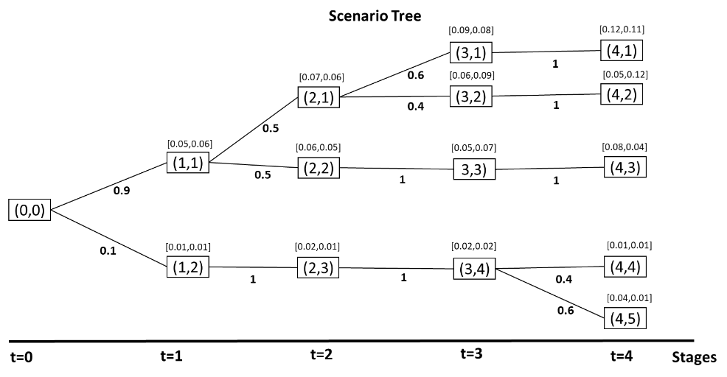
As the scenario tree shows, at each node (t,k), there is a set containing annual rate of borrowing and interest for loan from t-1 displayed above.
The minimum portfolio cost is 68254 by setting α=0 with allocation of security x₂= 95.995, x₆= 149.835 and x₁₀= 427.836. Amount borrowed B_{3,(2,3,4,5)}= 17433 for time 3 scenario 2,3,4,5, amount from loan Loan_{3,1}=17433 for time 3 scenario 1.
Using $λ=68254$,the maximum final cash in hand by setting α=1 is $z_{4}^{k}=$ (0, 1046.88, 1221.44, 1745.09, 1745.09), thus by considering probability (0.27, 0.18, 0.45, 0.04, 0.06) for each scenario, the expected final cash in hand is 912.60. With similar allocation of security x₂= 95.9915, x₆= 149.721 and x₁₀= 427.954. Additional borrowing is made at stage 2 where B_{2,(2,3,4,5)}= Loan_{2,1}= 11.0497, and B_{3,2}= 17444, Loan_{3,1}= 17444.2, Loan_{3,3}= 17443.9, Loan_{3,(4,5)}= 17443.5
The model choose to invest heavily in security 10 as it generates the most cashflow, as since there is no security provide cost-efficient cash inflow in time 3, amount is borrowed from the source with the lower cost of borrowing.

Question 2:
- Random parameters follow a known distribution at each stage, a finite set of possible realisation for random outcome is considered, and is described using an scenario tree
Parameters:
w₀: =70000, initial wealth
u: = {1,2,3}, set of 3 stocks namely, BT, Shell and Sainsbury
t: = 1, …, 9, time stage of the investment
G: =120000, objective value to achieve at the end
b: =5%, cost of borrowing
$r_{t,k}^{u}$: Rate of return for stock u at stage t in scenario k, for k=1,…,S_{t}
$P_{t,k}$: Probability of scenario k at stage t
Decision Variables:
$x_{0}^{u}$: Amount invested in stock u at time t=0
$x_{t,k}^{u}$: Amount invested in stock u at time t=3,6,9, for scenario k= 1,…,S_{t}
$w_{k}$: Final wealth at time t=9 for scenario k=1,…,S₉
$B_{k}$: Amount of borrowing at time t=9 for scenario k, where k=1,…,S₉
Scenario-Based Model Formulation:
Max. $\sum_{k=1}^{S_{9}}{P_{9,k}}$*${(w}_{k}-$b*$B_{k}$)
s.t. $\sum_{u=1}^{3}{x_{0}^{u}}=$ w₀ , initial wealth
$\sum_{u=1}^{3}{x_{3,k}^{u}}=\sum_{u=1}^{3}{{(x}_{0}^{u}}*\prod_{t=1}^{3}{(1+r_{t,k}^{u})) }$ ,t=1,..,3, for each k$∈$S_{t}
$\sum_{u=1}^{3}{x_{6,k}^{u}}=\sum_{u=1}^{3}{{(x}_{3,k}^{u}}*\prod_{t=4}^{6}{(1+r_{t,k}^{u})) }$ ,t=4,..,6, for each k$∈$S_{t}
$\sum_{u=1}^{3}{x_{9,k}^{u}}=\sum_{u=1}^{3}{{(x}_{6,k}^{u}}*\prod_{t=7}^{9}{(1+r_{t,k}^{u})) }$ , t=7,..,9, for each k$∈$S_{t}
$\sum_{u=1}^{3}{x_{9,k}^{u}}=w_{k}$, final wealth for each k$∈$S_{t}
$w_{k}+B_{k} ≥G$, for each k$∈$S_{t}
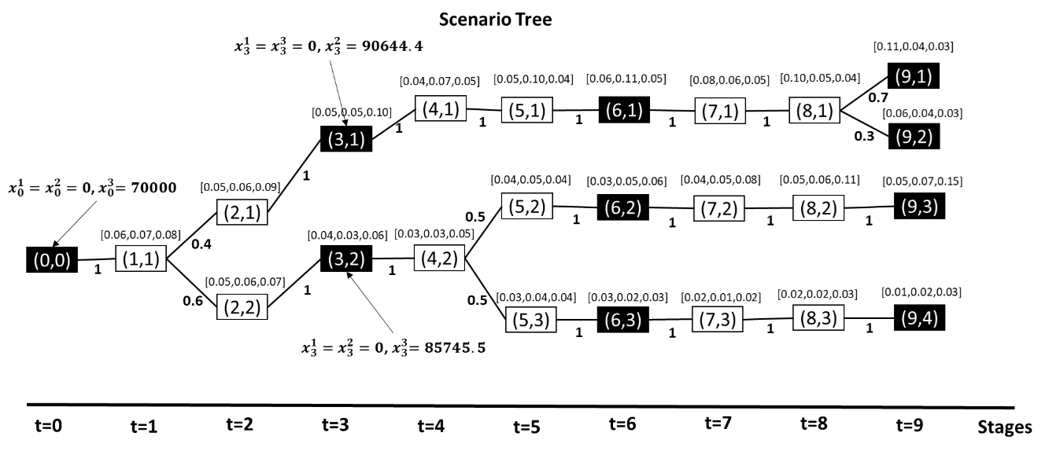
As the sample scenario tree above shows, at each node (t,k), there is a set containing rate of return for stock{1,2,3} from t-1 displayed above. Decision variables $x_{0}^{u}$ and $x_{t,k}^{u}$ are decided at stage 0, and stage t=3, 6, 9 at scenario k$∈$S_{t}, for stock u={1,2,3}, such stages are highlighted in black in the scenario tree above, and optimal decisions at first two stages are included. Investment decisions made on stage 3,6 and 9 are subjected to budget of wealth accumulated between previous decision stage for each scenario. Note that since investment beyond stage 9 is not considered, investment decisions at stage 9 equals to final wealth w for each scenario S₉=1,2,3,4.
Formulate and solve in AMPL, the optimal expected solution is 133745, with first stage decision $x_{0}^{3}=70000$ at stage t=0, which can be explained by the fact that stock 3 has highest rate of return for all scenarios before stage 3. Similar observation can be found for decisions at stage 3 and 6, where stock with highest rate of return between present decision stage and next decision stage will be invested
Final wealth w_{k} =(156164, 149129, 136831, 104363) for k$∈$S₉=1,2,3,4. Corresponding B_{k}=(0, 0, 0, 15637). Three scenarios at stage 9 meets the goal of 120k without borrowing, 4th scenario has generally low rate of return, thus requires an amount of borrowing at the end to meet the goal. Therefore the expected solution is calculated by ($0.28*156164+0.12*136831+0.3*136831+0.3*(104363-0.05*15637))=133745$, in which the solution is penalized with 0.05 at scenario 4 due to borrowing. The expected value of lump sum cash she has left at the end of planning horizon will be $133745-120000=￡13745$.

