Datu Puti: Calculating acetic acid within a vinegar
ATOM COUNT CARD

PRODUCT IDENTITY BASE QUANTITATIVE DATA
QUANTITY

PRODUCT
- Datu Puti, Vinegar 1L

COMPOUND
- Acetic acid, CH₃COOH (molecular formula C₂H₄O₂).

WHY IT MATTERS
- Acetic acid is the main component of vinegar apart from water, and it gives vinegar its sour taste and pungent smell.

STUDENT

Net content
Concentration | 4.5% w/w | Kibbutz Online Grocery &  Cooperative Store, n.d. | 2 s.f (limiting)
Density | 0.987 g/mL | Evangelista et al., 2012 | 3 s.f
Atomic masses C,H,O | 12.011, 1.008, 15.999 g/mol | CIAAW (2024) | Not limiting
Avogadro constant, NA | 6.022 140 76 × 10²³ mol⁻¹ | BIPM (2019) | Exact
Formula C₂H₄O₂ | Subscripts 2,4,2 | PubChem (NCBI, n.d.) | Exact counts

VALUE SOURCE PRECISION

1L Product label Nominal, Not Limiting

- Rey Ivan B. Guevara (Chemistry For Engineers).

MOLAR MASS BUILD-UP
Assumptions: Acidity (4.5 %) comes from a retailer’s description read as w/w, while the printed standardized label for it says its 5% research says its a rounded value; Temperature not reported.

THE MOLE MAP: 1L bottle

ELEMENT

C H
O

ATOMS

2
4
2
G/MOL (EACH)
12.011
1.008
15.999

G/MOL

24.022
4.032
31.998

% BY MAss

40.002
6.714
53.284

1000
mL solution

x4.5/100

45
mL AcOH

x0.987 g/mL

4.4415 _{X} 10¹
g AcOH

÷60.052

0.7
mol AcOH

xN_{A}

C₂H₄O₂ 8
60.052
100.000
Exacted from mL solution to mL AcOH,

1.7 _{X} 10²⁴
x4 H atoms per molecules

4.2 _{X} 10²³

ADDITION RULE: EACH CONTRIBUTION HAs 3 DECIMAL PLACEs
rounded from g AcOH up to the final process
molecules C₂H₄O₂
molecules C₂H₄O₂

Molar mass of C₂H₄O₂

MOLE CONVERSION CALCULATIONS
Percent composition + two-route check

2(12.011) + 4(1.008) + 2(15.999) = 60.052 g/mol

Label bridge: volume → mass of AcOH

(hydrogen)
4.032 g/mol
%H = 60.052 g/mol x 10000% = 6.714%

1000 mL sol x 4.5 mL AcOH
100 mL sol
= 45 mL AcOH x
0.987 g
1 mL AcOH
Route A: 44.415 g x 0.06714 = 2.982 g
4 mol H

= 44.415 g = 4.4415 x 10¹ g AcOH

Mass → moles
1 mol
Route B: 0.7396 mol AcOH x 1 mol AcOH
2.9584 mol H x 1.008 g = 2.982 g
1 mol H
Both routes → 2.9 x 10⁰ g H ✔
= 2.9584 mol H

44.415 g x
60.052 g
= 0.7396 mol = 7.4 x 10⁻¹ mol AcOH

Reverse: from % composition to the formula

Moles → molecules
In 1000g: C 40.002 ÷ 12.011 = 3.3304 mol; H 6.714 ÷ 1.008 = 6.6607

0.7396 mol x N_{A} molecules
1 mol
= 4.5 x 10²⁴ molecules
= 4.4540 x 10²⁴
mol; O 53.284 ÷ 15.999 = 3.3305 mol
÷ 3.3305 → 2.000 : 4.000 : 2000 → C₂H₄O₂

Reverse: how much solution in one mole?

Atoms of one element inside the formula
1.00 mol x 60.052 g x
1 mol
1 mL AcOH
0.987 g
x 100 mL soln
4.5 mL AcOH
= 1352.07 mL

4.4540 x 10²⁴ molecules x

= 1.8 x 10²⁵ H atoms
4 H atoms
1 molecule
= 1.7816 x 10²⁵
→ 1.3 x 10³ mL solution
In % composition of hydrogen atoms 10000% was used as an equivalent of 100

SCALE-UP: FROM ONE BOTTLE TO A RESTAURANT

ONE BOTTLE ONE RESTAURANT, ONE
YEAR
ONE HUNDRED RESTAURANT, ONE YEAR

REVERSE

1000 mL of 4.5% solution
0.7 mol AcOH
4.2 x 10²³ molecules
Assuming the restaurant consumes 50 bottles/year
3.7 x 10¹ mol
50 x 0.7396 mol
= 36.98 mol = 2.2 kg AcOH
For 100 restaurants averaging the same per year
3.7 x 10³ mol
5000 x 0.7396 mol = 3698
mol = 222 kg AcOH
One mole of AcOH is in
1.3 x 10³ mL
of solution, almost ⅓ more than the bottle


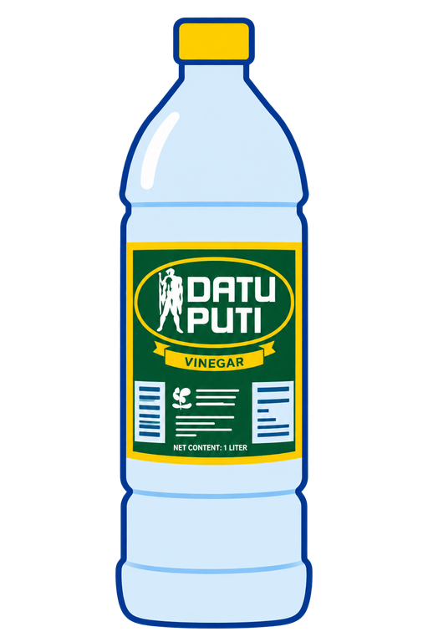



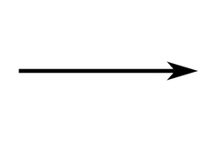
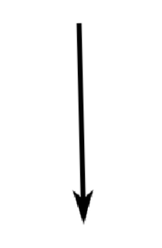
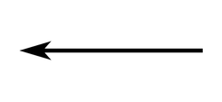



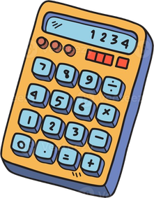



SIGNIFICANT-FIGURE
- 1000 mL - Ambiguous
- 4.5% - 2 s.f (numbers taken from source only contained 2 digits)
- 0.7 mol - 2 s.f {rounded} calculator = 0.7396090055 mol
- (% by mass values)
40.052 ; 6,714 ; 53.284 {rounded to 3 s.f decimal points}
calculator:
40.00199827
6.714181043
53.28382069
- 2.9 x 10⁰
- 1.3 x 10³ mL - 2 s.f {rounded}

Most result values in this atom count card infographic are rounded to utmost 4 decimal points

ONE-NUMBER TAKEAWAY
One whole 1 L bottle of Datu Puti holds about 4.5 × 10²S molecules of acetic acid, which is still less than one mole, meaning it would take about 1.3 × 10S mL of vinegar to collect just 6.022 × 10²S, which is simply a mole of acetic acid and yet acetic acid remains as the main component of a vinegar.

AI DISCLOSURE
The specific AI used for this exercise are Claude and ChatGPT wherein ChatGPT was used merely to generate the vinegar image and Claude was used for citaitions and scan them for information needed before the actual calculation and it was also used to select the acetic acid compound which has similar properties to the compound example of the exercise criteria and instruction files.

CITATIONS
- National Center for Biotechnology Information. (n.d.). PubChem compound summary for CID 176, acetic acid. Retrieved October [day], 2026, from PubChem. (2019). Acetic acid. Nih.Gov; PubChem. https://pubchem.ncbi.nlm.nih.gov/compound/Acetic-acid
- Evangelista, D. K. O., Gotuato, G. B., Ocbina, J. B., & Padua, J. A. H. (2012). Determination of total acidity of vinegar [Unpublished laboratory report]. Philippine Normal University. Studylib. File. (2016, March 10). Studylib.Net. https://studylib.net/doc/9584923/file
- Bureau International des Poids et Mesures. (2019). The International System of Units (SI) (9th ed.). SI brochure - BIPM. (2026). BIPM. https://www.bipm.org/en/publications/si-brochure
- Kibbutz Online Grocery & Cooperative Store. (n.d.). Datu Puti vinegar 1 liter. Kibbutz. Retrieved October 17, 2026, from https://kibbutz.ph/product/datu-puti-vinegar-1-liter/

