PRODUCT AND LABEL PHOTO

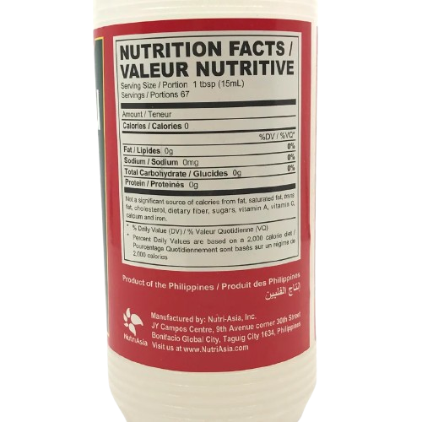
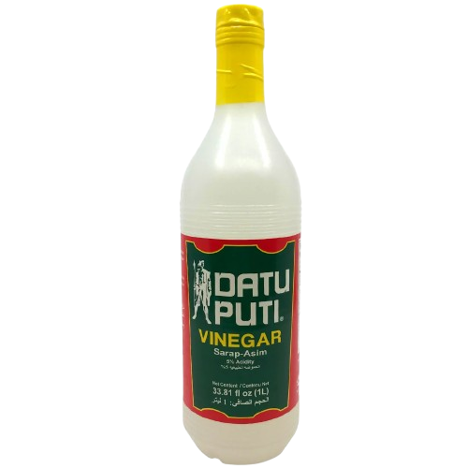
PRODUCT NUTRITION FACTS
PRODUCT LABEL

NOTES:
Most information used in the actual infographic came from researches to ensure liability of the information, the product label didnt state acetic acid however acidity was used on similar terms. Informations were however still taken from the bottles label such as the (L/Liter) and in addition the product picture above isn’t taken directly by the author of the infographic but rather came from a site

PHOTO CITATION:
Pinoy Groseri. (n.d.). Datu Puti vinegar 1 liter. https://pinoygroseri.com/products/datu-puti-vinegar-1-liter

