**Hello World RESTful Web Service**

**Directroy:**  
spring-learn/

├── pom.xml

├── src/

│ ├── main/

│ │ ├── java/

│ │ │ └── com/

│ │ │ └── cognizant/

│ │ │ └── springlearn/

│ │ │ ├── SpringLearnApplication.java

│ │ │ │ └── HelloController.java

│ │ └── resources/

│ │ ├── application.properties

**Code for HelloController.java:**

package com.cognizant.springlearn.controller;

import org.slf4j.Logger;

import org.slf4j.LoggerFactory;

import org.springframework.web.bind.annotation.GetMapping;

import org.springframework.web.bind.annotation.RestController;

@RestController

public class HelloController {

    private static final Logger LOGGER = LoggerFactory.getLogger(HelloController.class);

    @GetMapping("/hello")

    public String sayHello() {

        LOGGER.info("Received request to say hello");

        return "Hello,from Spring Boot!";

    }

}

**Code for SpringLearnApplication.java:**

package com.cognizant.springlearn;

import org.slf4j.Logger;

import org.slf4j.LoggerFactory;

import org.springframework.boot.SpringApplication;

import org.springframework.boot.autoconfigure.SpringBootApplication;

@SpringBootApplication

public class SpringLearnApplication {

   private static final Logger LOGGER = LoggerFactory.getLogger(SpringLearnApplication.class);

    public static void main(String[] args) {

        SpringApplication.run(SpringLearnApplication.class, args);

        LOGGER.info("Spring Application started successfully");

    }

}

**Output:**

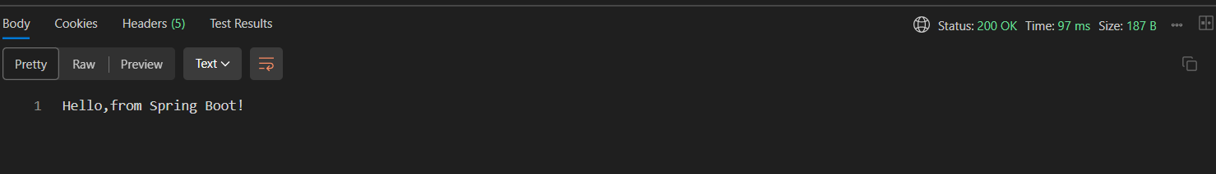

**REST - Country Web Service**   
  
**Directroy:**  
spring-learn/

├── pom.xml

├── src/

│ ├── main/

│ │ ├── java/

│ │ │ └── com/

│ │ │ └── cognizant/

│ │ │ └── springlearn/

│ │ │ ├── SpringLearnApplication.java

│ │ │ │ └── CountryController.java

│ │ │ │ └── Country.java

│ │ └── resources/

│ │ ├── application.properties

│ │ ├──country.xml

**Code for country.xml:**

<?xml version="1.0" encoding="UTF-8"?>

<beans xmlns="http://www.springframework.org/schema/beans"

xmlns:xsi="http://www.w3.org/2001/XMLSchema-instance"

xsi:schemaLocation="http://www.springframework.org/schema/beans

https://www.springframework.org/schema/beans/spring-beans.xsd">

<bean id="country" class="com.cognizant.springlearn.Country">

<property name="code" value="IN" />

<property name="name" value="India" />

</bean>

</beans>

**Code for CountryController:**

package com.cognizant.springlearn.controller;

import com.cognizant.springlearn.Country;

import org.slf4j.Logger;

import org.slf4j.LoggerFactory;

import org.springframework.context.ApplicationContext;

import org.springframework.context.support.ClassPathXmlApplicationContext;

import org.springframework.web.bind.annotation.RequestMapping;

import org.springframework.web.bind.annotation.RestController;

@RestController

public class CountryController {

private static final Logger LOGGER = LoggerFactory.getLogger(CountryController.class);

@RequestMapping("/country")

public Country getCountryIndia() {

LOGGER.info("START getCountryIndia()");

ApplicationContext context = new ClassPathXmlApplicationContext("country.xml");

Country country = (Country) context.getBean("country", Country.class);

LOGGER.debug("Country: {}", country);

LOGGER.info("END getCountryIndia()");

return country;

}

}

**Output:**

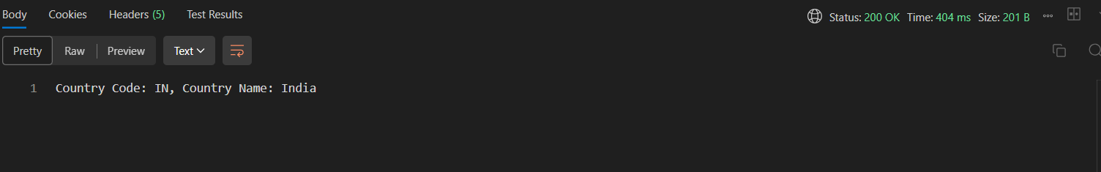

**REST - Get all countries**   
  
  
**Directroy:**  
spring-learn/

├── pom.xml

├── src/

│ ├── main/

│ │ ├── java/

│ │ │ └── com/

│ │ │ └── cognizant/

│ │ │ └── springlearn/

│ │ │ ├── SpringLearnApplication.java

│ │ │ │ └── CountryController.java

│ │ │ │ └── Country.java

│ │ └── resources/

│ │ ├── application.properties

│ │ ├──country.xml

**Code for country.xml:**

<?xml version="1.0" encoding="UTF-8"?>

<beans xmlns="http://www.springframework.org/schema/beans"

       xmlns:xsi="http://www.w3.org/2001/XMLSchema-instance"

       xsi:schemaLocation="http://www.springframework.org/schema/beans

                           https://www.springframework.org/schema/beans/spring-beans.xsd">

    <bean id="in" class="com.cognizant.springlearn.Country">

        <property name="code" value="IN" />

        <property name="name" value="India" />

    </bean>

    <bean id="us" class="com.cognizant.springlearn.Country">

        <property name="code" value="US" />

        <property name="name" value="United States" />

    </bean>

    <bean id="de" class="com.cognizant.springlearn.Country">

        <property name="code" value="DE" />

        <property name="name" value="Germany" />

    </bean>

    <bean id="jp" class="com.cognizant.springlearn.Country">

        <property name="code" value="JP" />

        <property name="name" value="Japan" />

    </bean>

    <bean id="countryList" class="java.util.ArrayList">

        <constructor-arg>

            <list>

                <ref bean="in"/>

                <ref bean="us"/>

                <ref bean="de"/>

                <ref bean="jp"/>

            </list>

        </constructor-arg>

    </bean>

</beans>

**Code for CountryController:**

package com.cognizant.springlearn;

import java.util.List;

import org.slf4j.Logger;

import org.slf4j.LoggerFactory;

import org.springframework.context.ApplicationContext;

import org.springframework.context.support.ClassPathXmlApplicationContext;

import org.springframework.web.bind.annotation.GetMapping;

import org.springframework.web.bind.annotation.RestController;

@RestController

public class CountryController {

    private static final Logger LOGGER = LoggerFactory.getLogger(CountryController.class);

    @GetMapping("/countries")

    public List<Country> getCountry() {

        LOGGER.info("START getAllCountries()");

        ApplicationContext context = new ClassPathXmlApplicationContext("country.xml");

        List<Country> countries = context.getBean("countryList", List.class);

        LOGGER.debug("Countries: {}", countries);

        LOGGER.info("END getAllCountries()");

        return countries;

    }

}

**Output:**

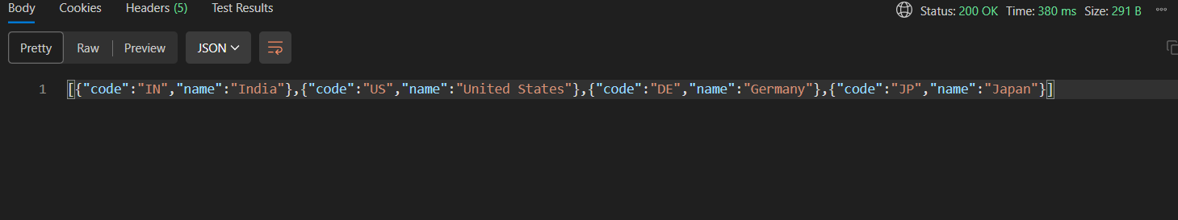

**REST - Get all countries**   
  
  
**Directroy:**  
spring-learn/

├── pom.xml

├── src/

│ ├── main/

│ │ ├── java/

│ │ │ └── com/

│ │ │ └── cognizant/

│ │ │ └── springlearn/

│ │ │ ├── SpringLearnApplication.java

│ │ │ │ └── CountryController.java

│ │ │ │ └── Country.java

│ │ └── resources/

│ │ ├── application.properties

│ │ ├──country.xml

**Code for country.xml:**

<?xml version="1.0" encoding="UTF-8"?>

<beans xmlns="http://www.springframework.org/schema/beans"

       xmlns:xsi="http://www.w3.org/2001/XMLSchema-instance"

       xsi:schemaLocation="http://www.springframework.org/schema/beans

                           https://www.springframework.org/schema/beans/spring-beans.xsd">

    <bean id="in" class="com.cognizant.springlearn.Country">

        <property name="code" value="IN" />

        <property name="name" value="India" />

    </bean>

    <bean id="us" class="com.cognizant.springlearn.Country">

        <property name="code" value="US" />

        <property name="name" value="United States" />

    </bean>

    <bean id="de" class="com.cognizant.springlearn.Country">

        <property name="code" value="DE" />

        <property name="name" value="Germany" />

    </bean>

    <bean id="jp" class="com.cognizant.springlearn.Country">

        <property name="code" value="JP" />

        <property name="name" value="Japan" />

    </bean>

    <bean id="countryList" class="java.util.ArrayList">

        <constructor-arg>

            <list>

                <ref bean="in"/>

                <ref bean="us"/>

                <ref bean="de"/>

                <ref bean="jp"/>

            </list>

        </constructor-arg>

    </bean>

</beans>

**Code for CountryController:**

package com.cognizant.springlearn;

import java.util.List;

import org.slf4j.Logger;

import org.slf4j.LoggerFactory;

import org.springframework.context.ApplicationContext;

import org.springframework.context.support.ClassPathXmlApplicationContext;

import org.springframework.web.bind.annotation.GetMapping;

import org.springframework.web.bind.annotation.RestController;

import com.cognizant.springlearn.Country;

import org.springframework.web.bind.annotation.PathVariable;

@RestController

public class CountryController {

    private static final Logger LOGGER = LoggerFactory.getLogger(CountryController.class);

    @GetMapping("/countries/{code}")

    public Country getCountry(@PathVariable String code) {

        LOGGER.info("START getAllCountries()");

        ApplicationContext context = new ClassPathXmlApplicationContext("country.xml");

        List<Country> countries = context.getBean("countryList", List.class);

for (Country country : countries) {

        if (country.getCode().equalsIgnoreCase(code)) {

            LOGGER.debug("Found country: {}", country);

            LOGGER.info("END getCountryByCode()");

            return country;

        }

    }

        LOGGER.warn("Country with code {} not found", code);

        LOGGER.info("END getCountryByCode()");

        return null;

    }

}

**Output:**

