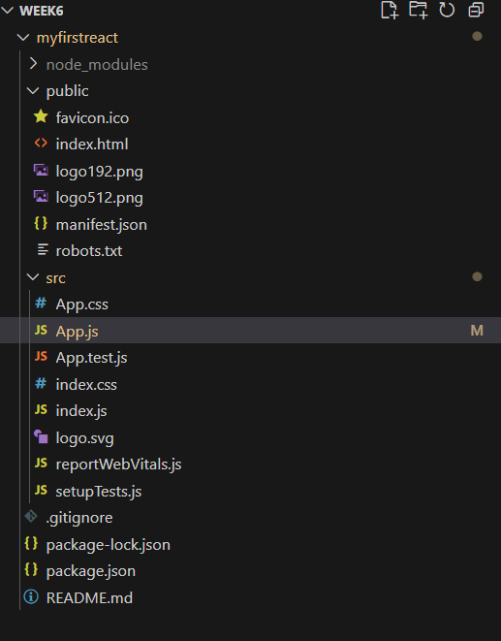Directory:

**Code for App.js:**

import './App.css';

function App() {

  return (

<h1>

  Welcome the first session of React!

</h1>

  );

}

export default App;

Output:

