amira elqady

Ziad Tarek 4169

Reyad Hussein 4184

Ziad Magdy 3992

Amira Kamal 4143

Esraa Sherif 5004

Submitted to:

Dr Hisham Elmongui

Database final project

Hotel resevation

**Tables:**

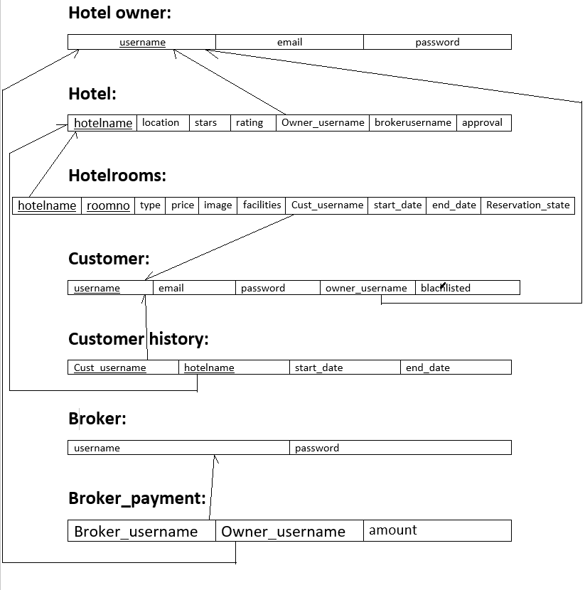

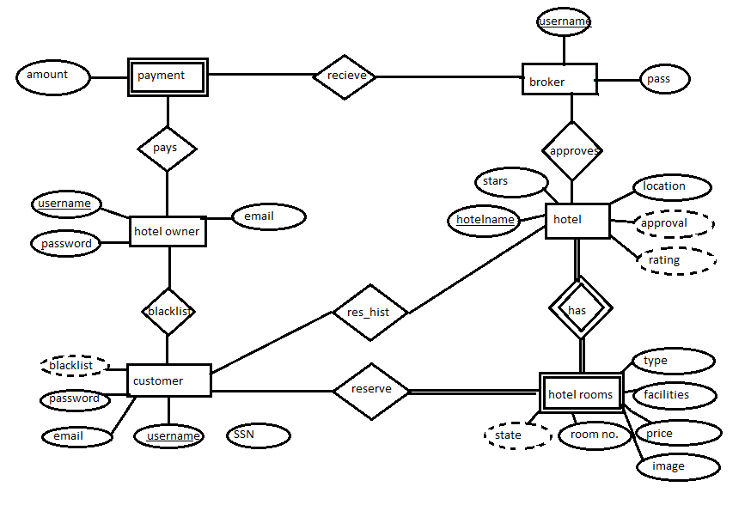

**Implemented features:**

The program supports a plenty of features where the hotel owner must register first in the system with a username and password once he is registered and has an account he can add his hotel(s) to the system by entering its features (name, stars, rating, location) along with the features of the rooms where each type is entered at a time with their count in the hotel image for each type of rooms in a specific hotel, facilities and price. Each hotel is added in a table for hotels and there is an attribute in this table approval that specify if this hotel is approved by the broker after this the rooms of the hotel is added to the tables of room where owner enter the number of rooms for each type of hotel and the program loop upon this count generating distinct room numbers for the rooms of each hotel if the owner already inserted a type of rooms we get the last room number added and increments from this point adding all the features of this type of room.

Then we have the customer, the customer should also register first to the system creating an account for himself upon having an account he can search in the given hotels and reserve a room where he enters the data he wants to search with (location only, location and stars, rating and stars, etc) whatever he desired from 5 inputs (location, stars, rating, room type, price) and the program will get the data performing a create table query which is the join between the hotel table and hotel room table and retrieve the data upon the entered input and after the search is complete this table is deleted and the searching results are displayed the customer then enters the data resulted from search to reserve the room if its available where each room has a reservation state indicating whether this room is reserved or not if it is not the hotel approves this reservation and then the reservation is added to the customer history of reservation. If the customer come in time the hotel owner will pay 9% of the price of the room to the broker if the customer didn’t, he will get blacklisted which is a driven attribute in customer table.