Assessment of Artificial Light Intensity in Dhaka City: Addressing Light Pollution
and Mitigation Strategies
Author Details:
Name:

Abstract

As time progresses, the use of Artificial Light and the intensity of Light Pollution has increased. While Artificial Light is essential, its overuse has led to severe light pollution. Properly managing artificial light can mitigate light pollution by reducing unnecessary brightness. In previous research, some solutions to Light Pollution have been discovered. But in the era of Artificial Intelligence, we are here to introduce how the use of Artificial Intelligence can diminish Light Pollution. We include several ways of solving Light Pollution such as the Use of special glass in windows, Changing the Angle and height of Lights, Lamp Post Covering, Changing the color of Light, Headlight system changes in vehicles and lamppost management by AI, Storing waste energy and advancing the schedule. We measured light intensity in hospitals, shops, and roads using a lux meter(which identifies luminous intensity in specific surfaces) to identify areas for light reduction. Our research involves measuring light levels in various urban settings and analyzing the data to identify areas with excessive illumination. After that, we measure light intensity by implementing our solution on how they reduce illumination. Our research was conducted in Dhaka, Bangladesh. Dhaka is ranked 4th most dense city globally, so it has a great population that requires much more Artificial Light than normal. so the threat of light pollution in this city is much greater. By conducting our research, The findings of this study can inform the development of targeted interventions to combat Light Pollution and improve both environmental and human well-being.

Key Words: Light, Pollution, Lux, Lux-Meter, Lumens

1. Introduction

Imagine a day you stay under an open sky excluding artificial light.

Light pollution is the human-made alteration of outdoor light levels from those occurring naturally (Dark Sky International [1]). When an excessive quantity of light is emitted from a more than sufficient source, it is also defined as light pollution. The source can be Lampposts, Headlights of vehicles, LED Grow Lights etc. These are also called Artificial Lights which we use for Safety at Night, Dispel the Darkness and Illuminate Houses. Artificial Lights have a massive impact on our socio-economic life. However, improperly using artificial lights becomes a necessary evil. It affects the human body and our atmosphere.

According to an article in ( Sky & Telescope magazine [2]), disruption of the circadian rhythm has been linked to sleep disorders like insomnia and delayed sleep-phase syndrome, as well as depression, hypertension, attention deficit disorder, obesity, diabetes, and heart disease. Studies show that light pollution also impacts animal behaviors, such as migration patterns, wake-sleep habits, and habitat formation. Because of light pollution, sea turtles and birds guided by moonlight during migration get confused, lose their way, and often die (National Geographic[3], 2024).

Significance of Study
In (VIIRS country statistics [4],2023), Among 230 countries and territories, 154 countries are increasingly emitting more light than in previous years. Despite knowing about the adverse effects of light pollution, most countries of the world look forward to becoming more modernized by using more Artificial Light. More than 80 percent of humanity is affected by Light Pollution and each year it gets worse (Scientific American[5],2013). In the modern world and globalization era, it is badly necessary to discuss and research it. That is how we are here to represent the most concerning issue nowadays.

Study Objective and Strategy
In this research paper, we have discussed various effective solutions to prevent light pollution. In this case, we have measured the amount of light in different sectors of Dhaka, the most light-polluted area of Bangladesh, with the help of a lux meter. After analyzing the obtained data, compare it with the prescribed light tolerance level (the level at which light will not be considered harmful). In this case, we have created a model miniature with ideal light levels. In this model, the light level has been kept at a tolerable level by adjusting the position of the lamp post, the nature of the light, the color and brightness. Later, we measured the light level of this model with the help of a lux meter and showed how to keep the light level at a tolerable level. With this, we have analyzed our proposed solutions to light pollution. Thus we have proposed effective solutions to light pollution in urban areas through this research.
Previous Studies
Previously many scientists and researchers have discussed solutions and theories related to Light Pollution. GIS modelling and the Garstang model have reached the matter of Light Pollution at a unique level. But country-based research is made less and which we focussed on. Determining which sectors and categories(Hospitals, Offices, Educational Institutions etc.) impact Light Pollution is necessary. We have researched how mitigation strategies lessen the intensity of Light and how we can save energy with new solutions. This research will make people, as well as local, national, and international administrations, conscious.

2. Methodology

2.1.Study Area
The research has been conducted all over Bangladesh, especially in both rural and urban areas. We have looked at different sectors of these areas and the LED lighting structures in these areas. In Particular, We consider 10 different sectors for our research work including Hospitals, Roads, Food and restaurants, Fashion, Education Institutions, buildings and Apartments, Mobile and Accessories, Variety shops, Cars and Transportation, Super Shop and Convention Halls. Furthermore, Bangladesh is experiencing an increasing trend in terms of being polluted by overusing artificial light. As per (VIIRS country statistics, Bangladesh [6],2023) Bangladesh has a positive trend of (+5.52%). This means that the average sum of radiance per 1,000 population has increased (3.3 rad / 1kPop, 2023) over the specified period. This suggests a growing trend of light pollution in Bangladesh. As this is the most dense country in the world, the more light pollution there is, the more it will badly and widely affect all animals and humans.
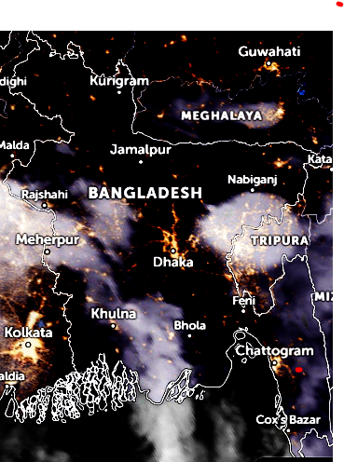
Figure 1:Night View of Bangladesh (23 August 2024,19:30)

Figure 1 shows the illumination of city lights in Bangladesh (Zoom Earth[7]). The rising prevalence of light pollution highlights the need for thorough research in Bangladesh.

2.2. Measure Lux
Lux is the SI unit of Illuminance( International Bureau of Weights and Measures [8],2019) . Lux means how much lumens are on a particular surface. So, the Equation of Lux is:

How much amount of light emitted from a light source is called Lumens. Suppose on a particular surface we get 500 lx, It means in a 1m² area 500 Lumens are on a surface. So From the equation, Lumens and Lux are proportional to each other (International Bureau of Weights and Measures [9],2019). If we have a high value of Lumens of Light source, the Lux value will go higher (Area is Constant). So the value of Lux enables us how bright our surface will be. The lux reading from a lamp usually represents the highest light intensity, found at the center of the light beam. It permits us to determine the total visible light and the level of brightness on a surface(any -lamp. com[10]).

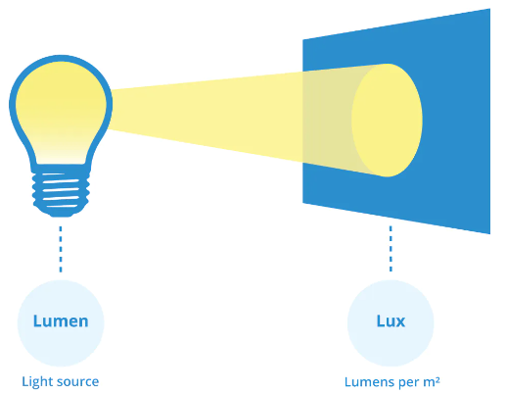
Figure 2: Lumens Vs Lux

Lux measurements provide a valuable tool for evaluating light pollution. Higher-than-standard lux readings point to areas with excessive light pollution.
2.3.Using -Lux Metre
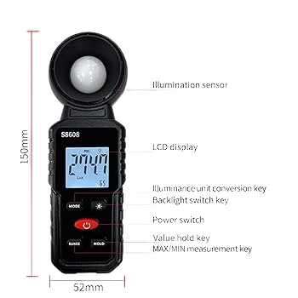
We utilized a light meter (Digital Illuminometer S8608) to measure lux levels.
This device has a round, white sensor at one end, which is covered by a lid when not in use. Below the sensor, there is a display screen and a set of buttons to operate the meter. Once the light meter is powered on, the screen displays:
- The current lux measurement.
- The highest and lowest lux values were recorded since the meter was turned on (after pressing the ‘Range’ button).
To measure the lux, the light meter was held at an optimal distance from the light source or area of interest. This distance represents typical human activity zones. The sensor was positioned to face the light source, and as the light hit the sensor, the lux value was displayed on the screen.
Measurements were taken by varying the meter's position over a specified time period to capture fluctuations in light intensity. For each location, three key lux values were recorded:
- Highest Lux: Automatically registered by the meter since it was powered on.
- Lowest Lux: Same as the highest lux, automatically registered by the meter since it was powered on.
- Average Lux: Either the average of observed lux values or the mode from the data.
2.4.Data Collection
Data from different sectors (described in section 2.1 - Study Area) were compiled into sector-wise tables. Each table includes the location’s address, the color of the light used, and the corresponding highest, average, and lowest lux values. To facilitate easier data visualization, charts were also generated, with average lux values plotted along the y-axis and the respective locations along the x-axis (the bar charts are described in section 2.5).
Additionally, lux levels were measured using a developed model that incorporated methods to mitigate light pollution. The results from this model were also presented in tables and bar charts.
2.5.Comparison with Standard Values
The collected lux data were compared with the The NZ Building Code and AS/NZS 1680 series of standards[11] and Illuminance: recommended light levels by The Engineering Toolbox[12].
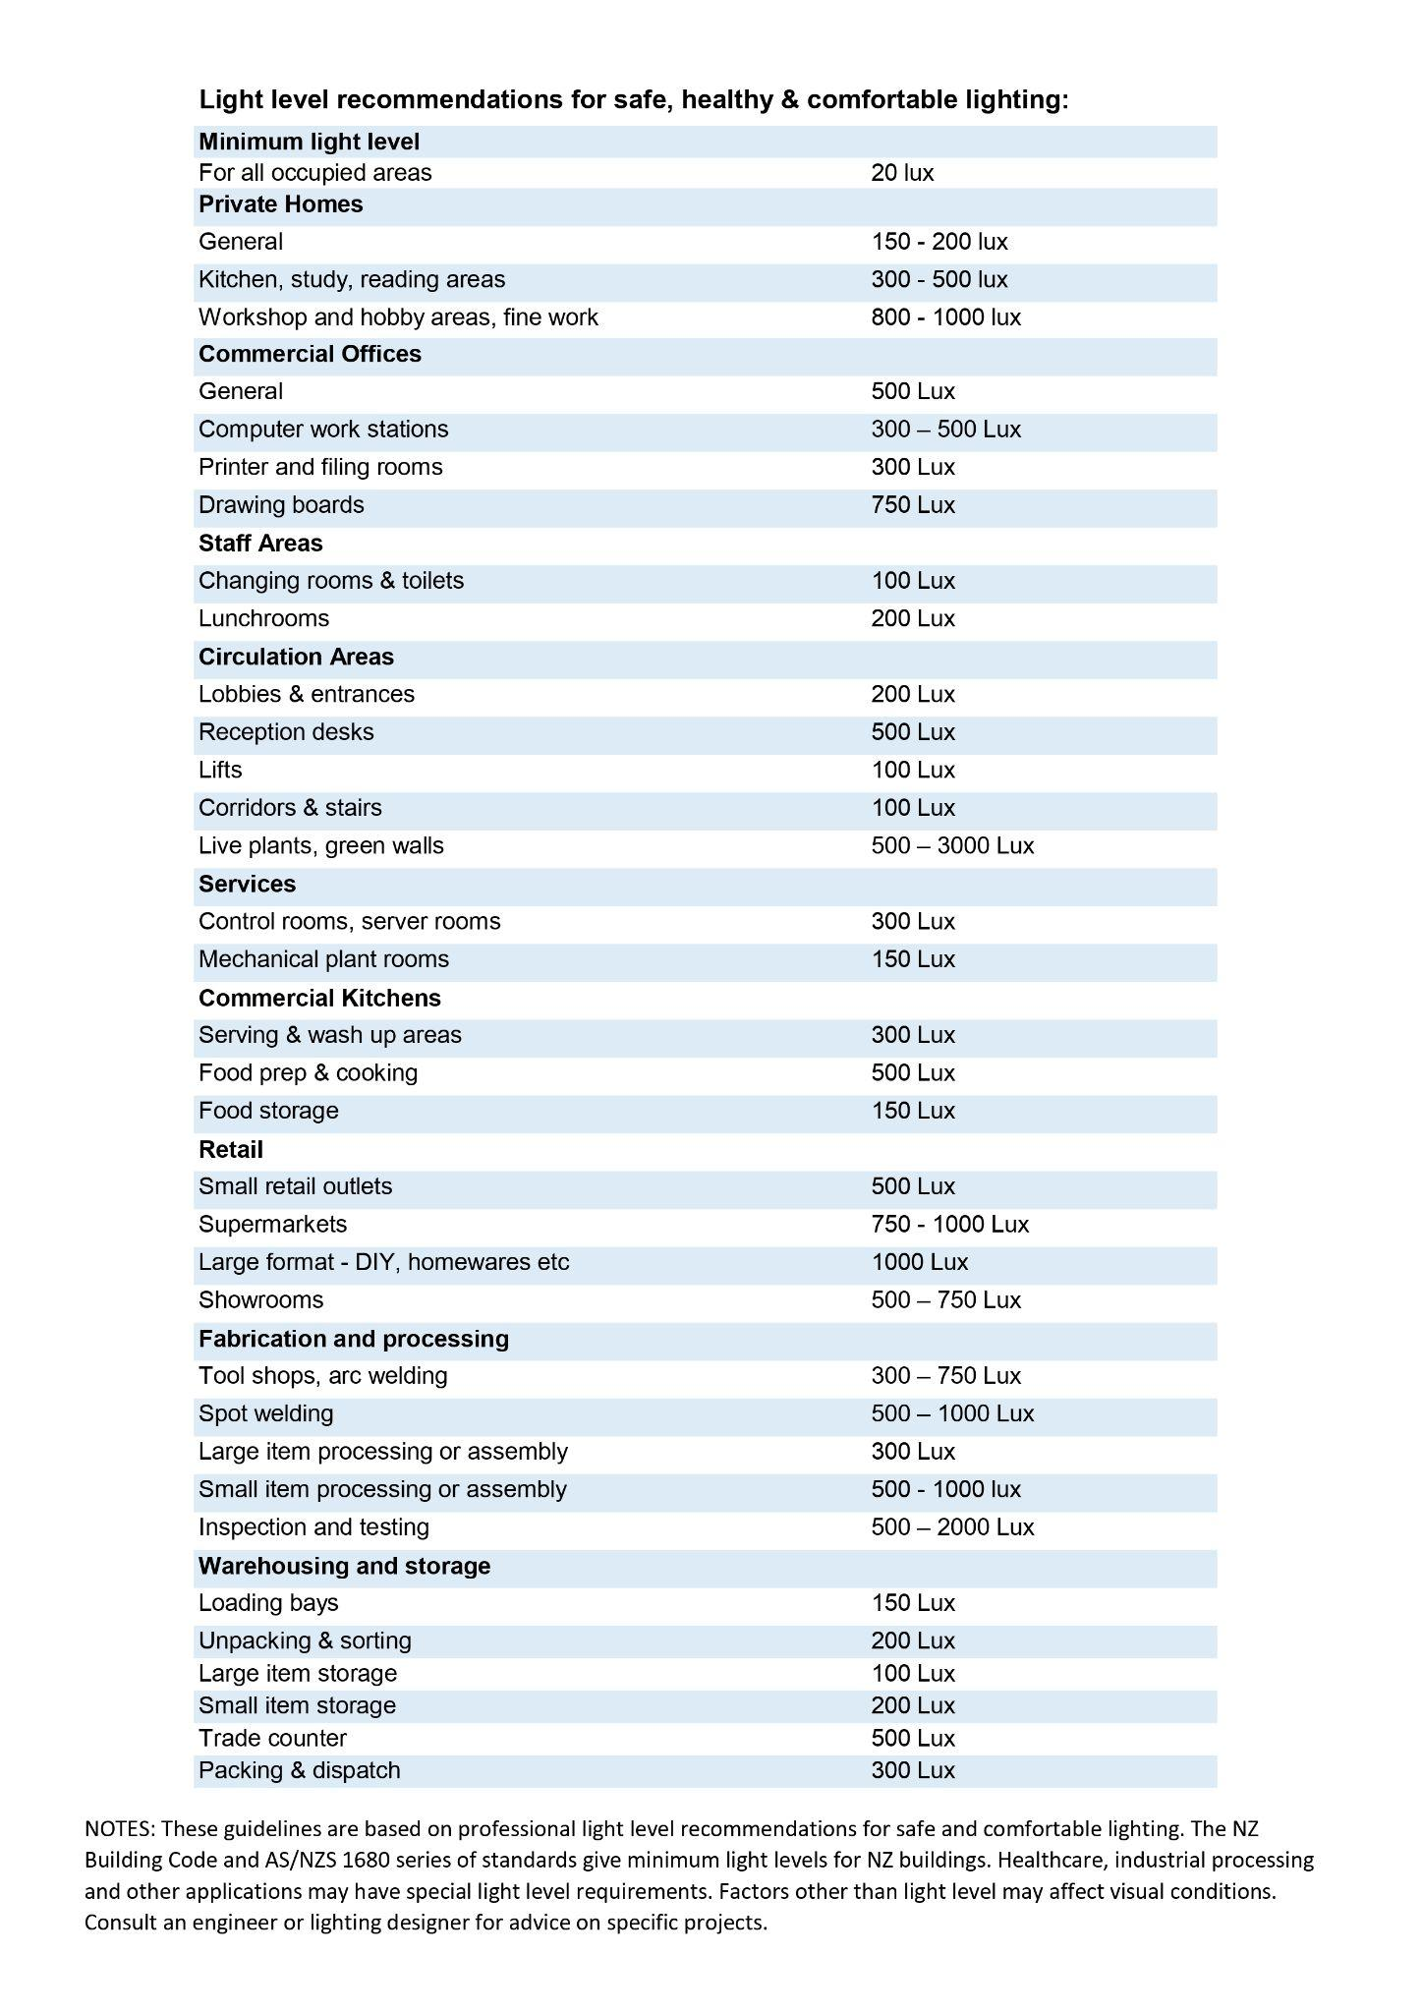
Figure 2.4: Standard Value of Sectors
This comparison helps determine whether the lux levels in a given sector are within tolerable limits or if they contribute to light pollution. We took data from the table in section 2.4 and divided it into bar charts for each sector. At the end of this section, there is a bar chart that illustrates all the average values taken from each chart. The charts are designed by Microsoft PowerPoint.

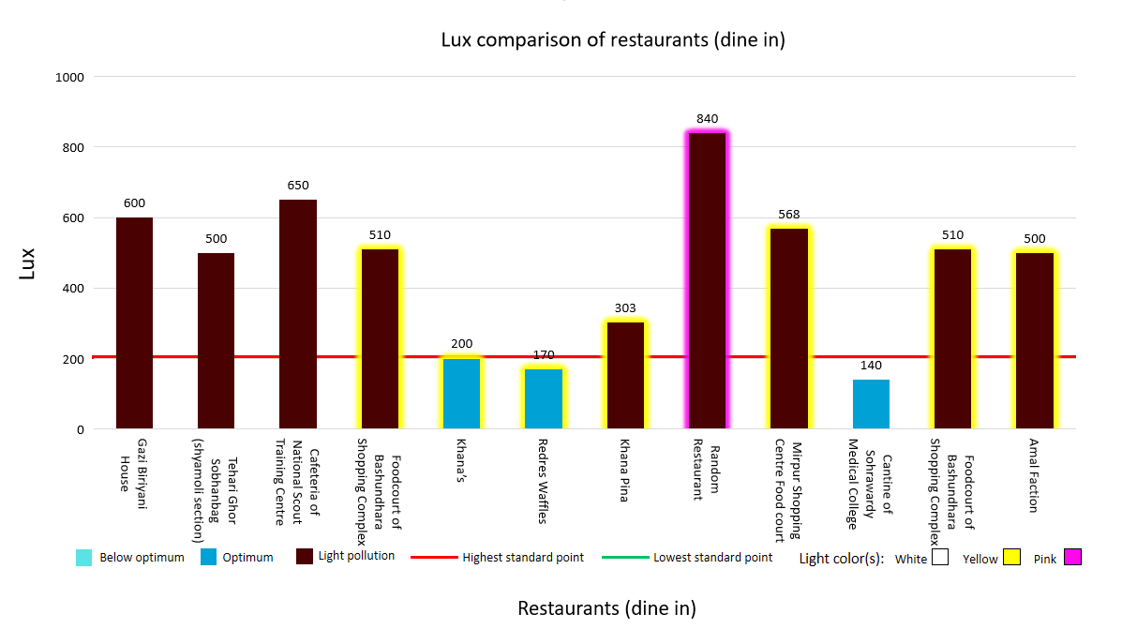Figure 3.1:
In Figure 3.1, the optimum light range for dine-in restaurants is 0-200 lux, but only 3 restaurants comply with this rule. 75% of restaurants use extra lights to attract customers' attention which causes light pollution.

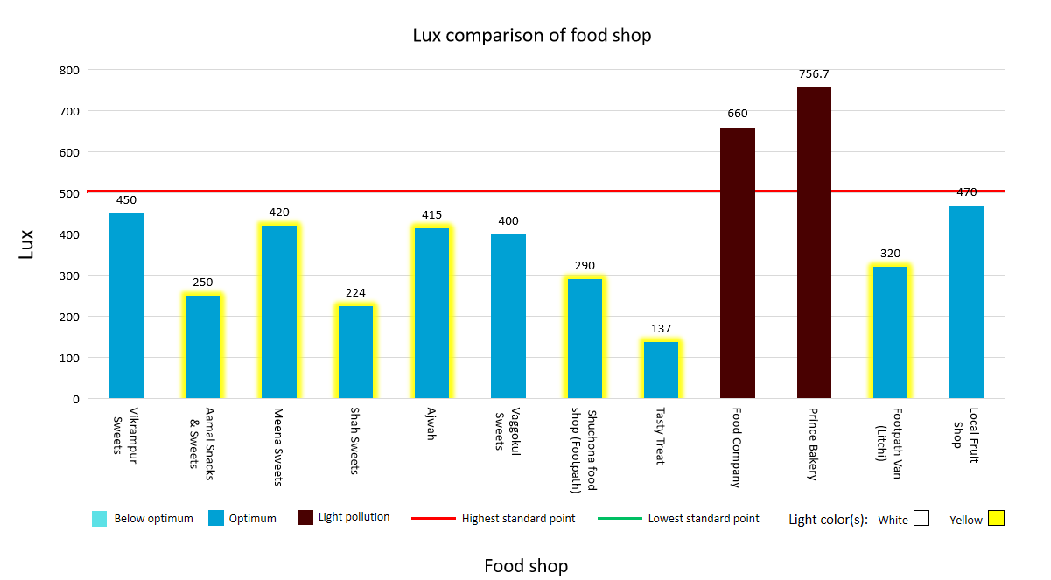
Figure 3.2 :
In figure 3.2, out of 12 food shops, only 2 shops did not maintain standard lighting (0-500 lux).
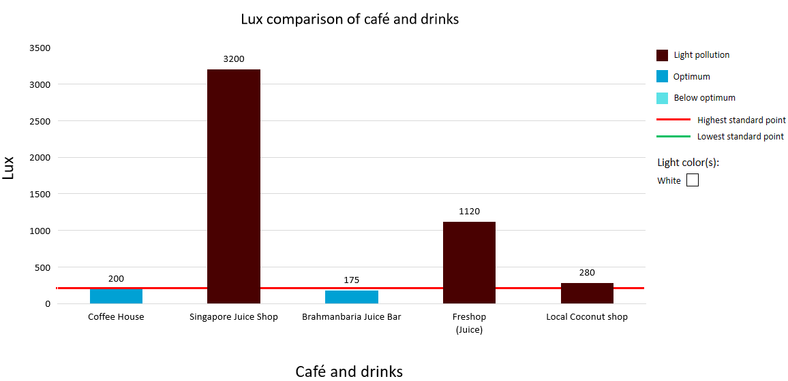
Figure 3.3:
It is recommended to maintain a maximum of 200 lux lighting in cafes and beverage shops,
but most of them do not follow it. Singapore Juice Shop uses about 3200 lux lighting which is excessively harmful.
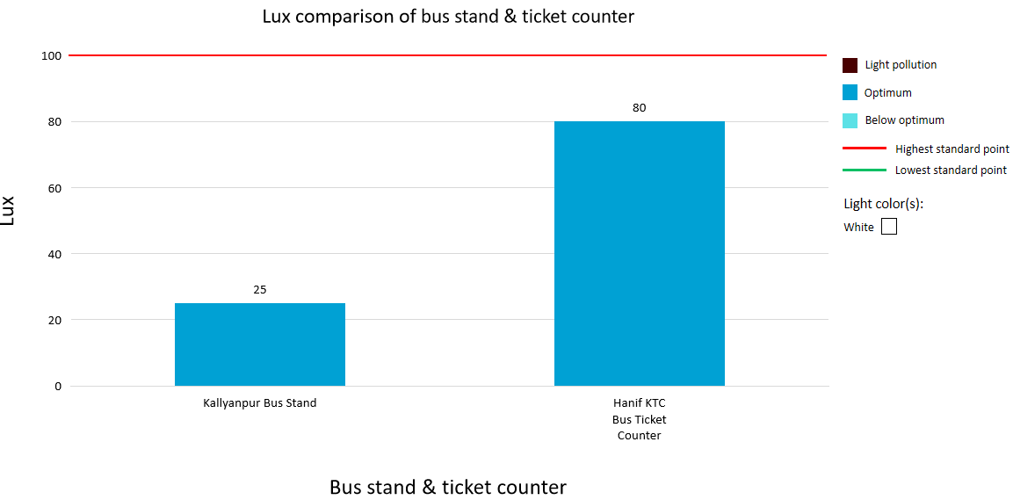
Figure 3.4:
Lighting standards are being followed at our monitored bus ticket counters and stations.
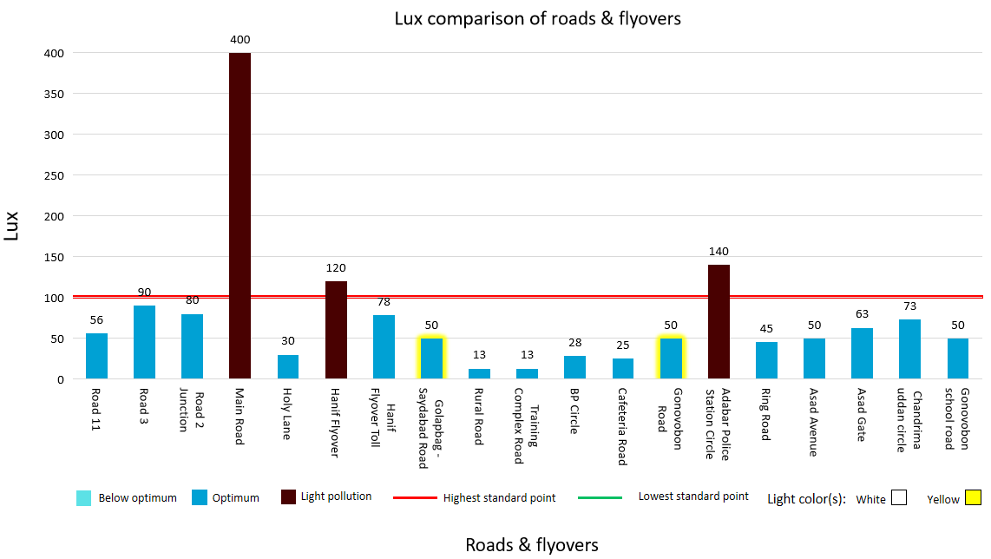
Figure 3.5:
Based on the survey conducted on 13 roads in different areas of Bangladesh, it can be said that most of the roads are using limited lighting

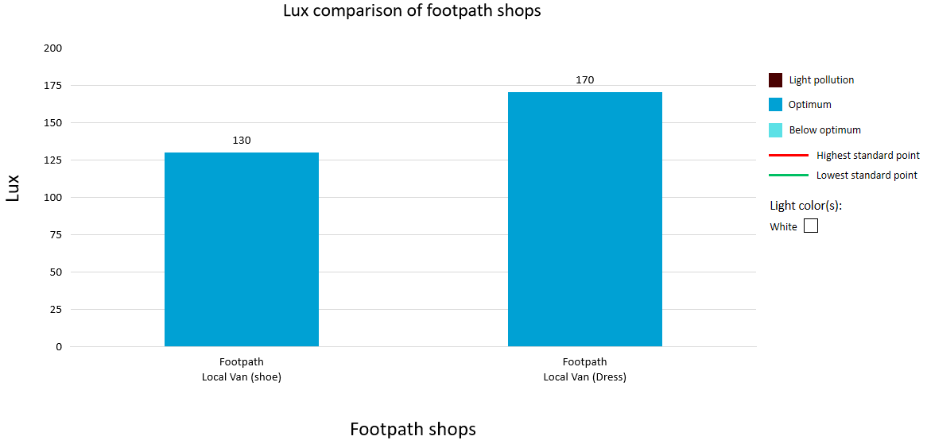
Figure 3.6:

Standards are being maintained in some observed local footpath shops.

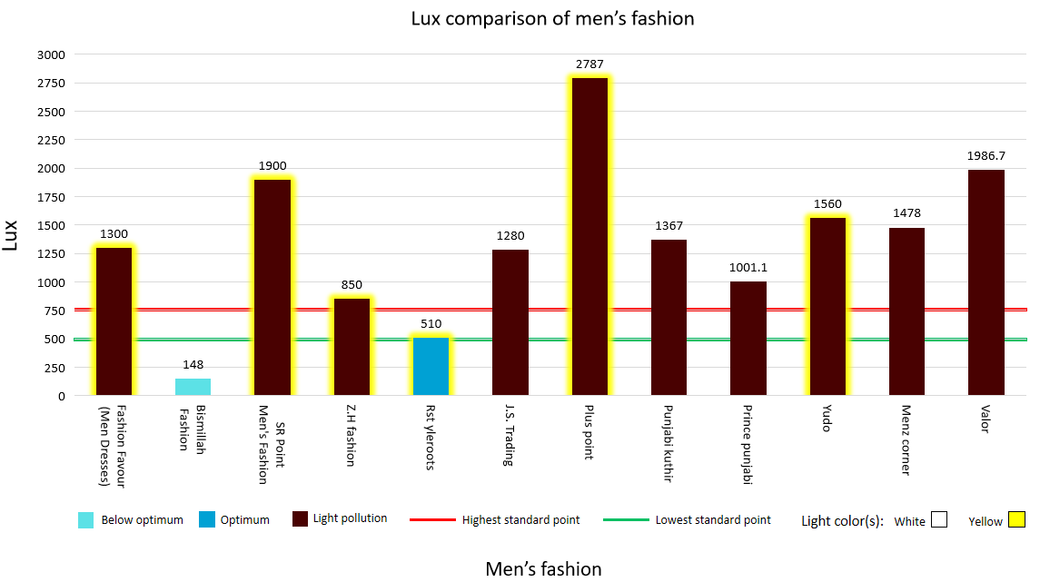
Figure 3.7:
Where the fashion shop standard is 500-750 lux, only 1 out of 12 shops are maintaining it. Even though 1 store is using only 148 lux, using less than standard lighting is harmful to the eyes.

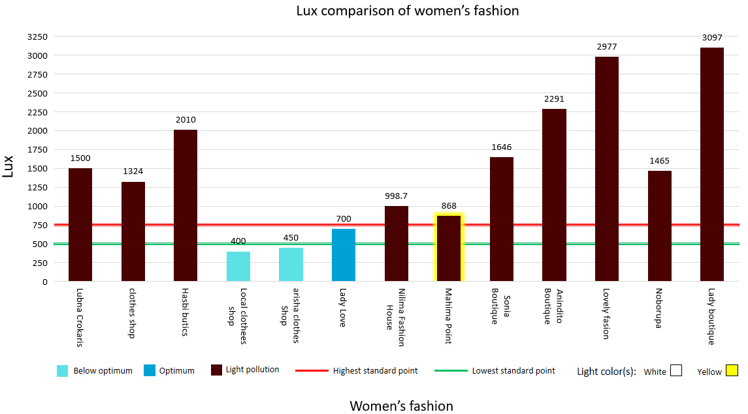

Figure 3.8:
75% of observed women's clothing outlets are responsible for light pollution. But few shops are not using even minimum lighting. It should be noted that women's fashion stores are more light pollution generators than men's fashion stores.

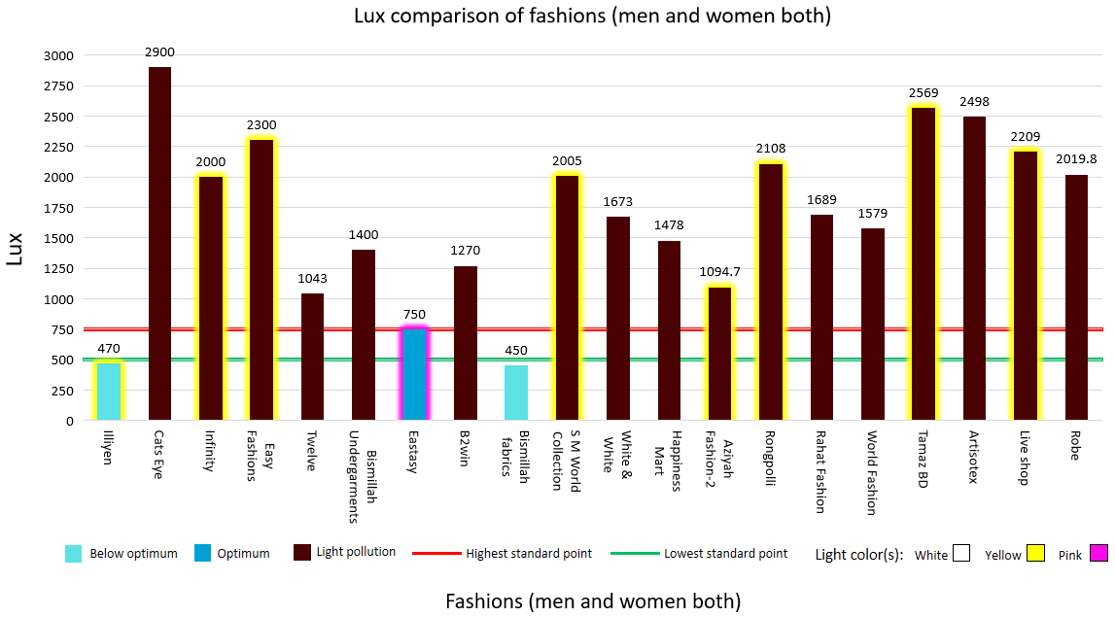
Figure 3.10:
Boutiques that carry both men's and women's fashion items have the most light pollution on average. Here, 2 shops use low light and 1 shop uses standard light, but the remaining 16 shops are causing severe light pollution.

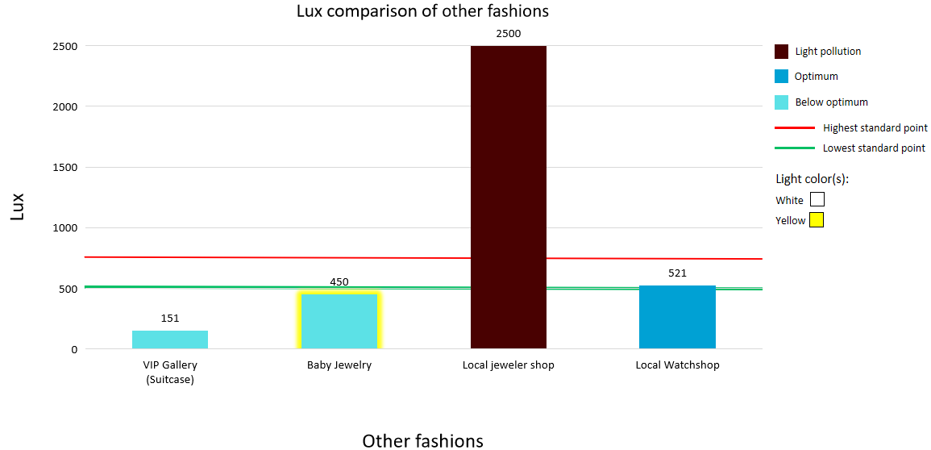
Figure 3.10:
Most of the other Styling outlets need to follow proper lighting laws.

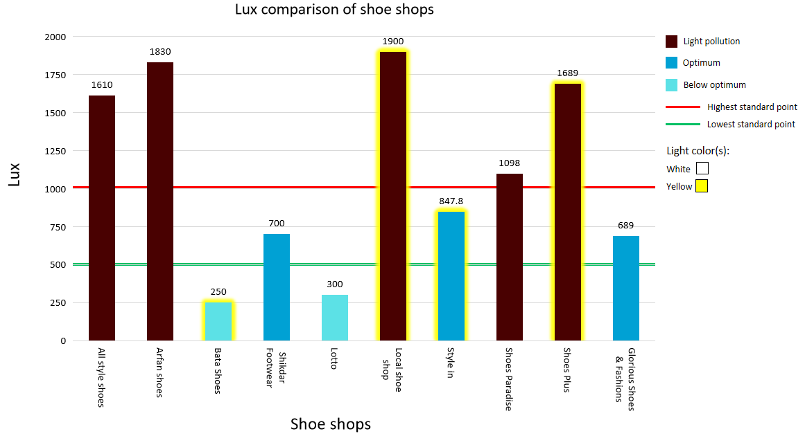
Figure 3.11:
Most of the local shoe outlets don't have perfect lighting levels. Branded shoe shops seem to lack light, but the reason is that the light readings were taken from outside the shop.

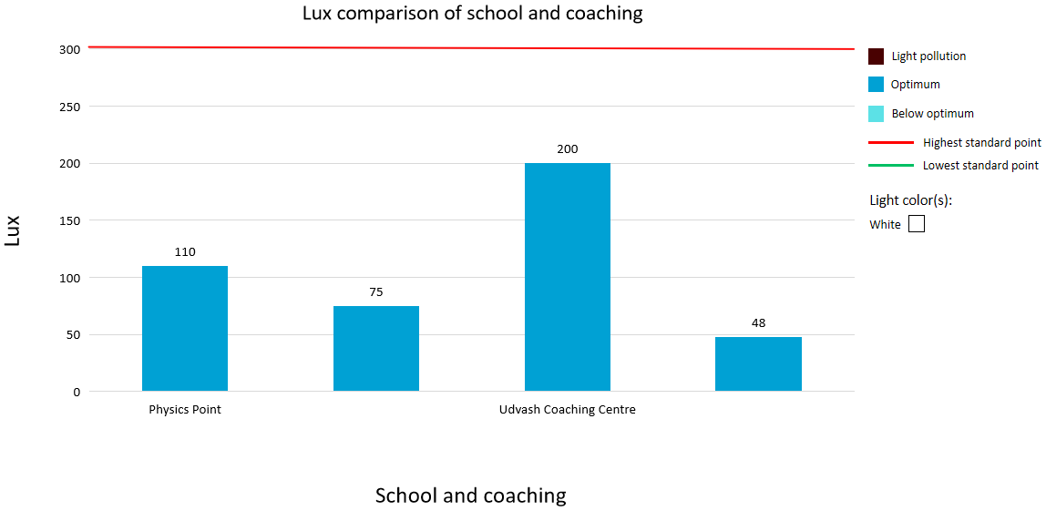
Figure 3.12:
Observed schools are using the proper lighting to provide education.

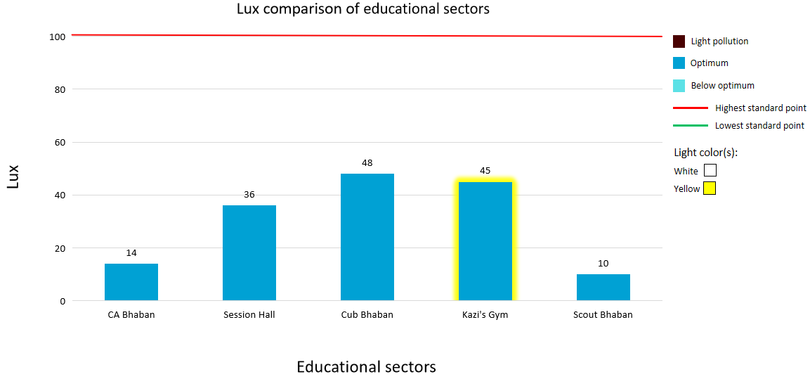
Figure 3.13:
Other Institutions that teach extracurriculars are also using healthy lighting systems.

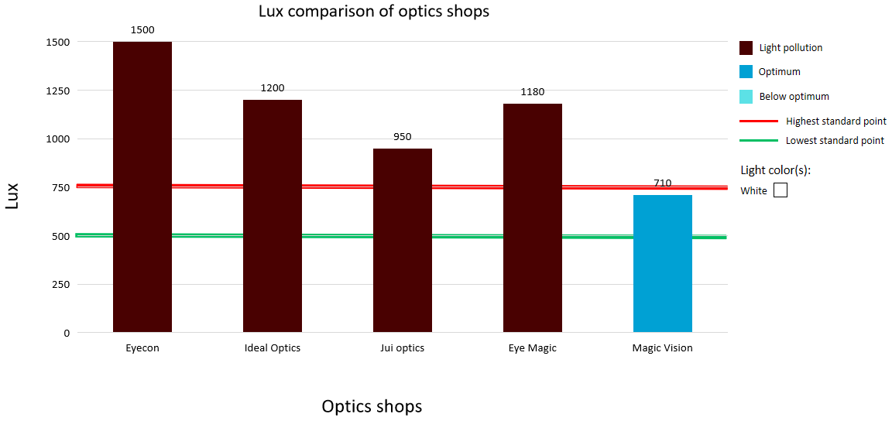
Figure 3.14:
Stalls, where Glasses & Lenses are sold, don’t preserve suggested light limits in most of the cases.

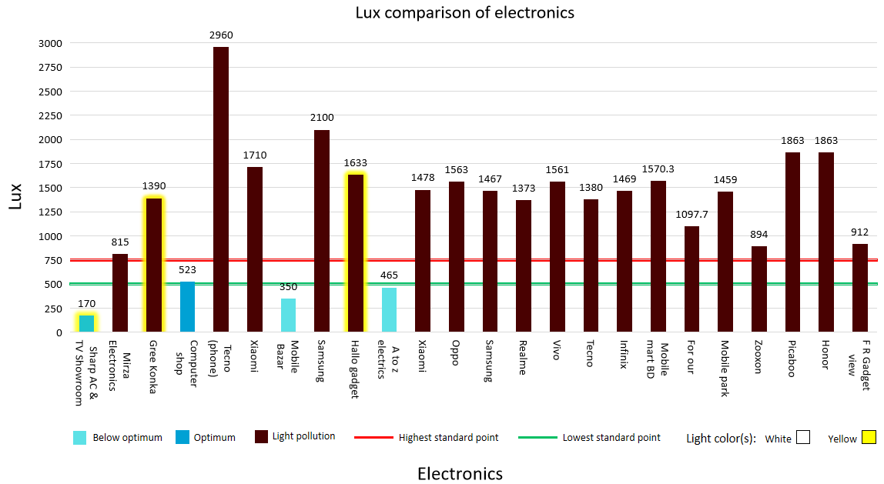
Figure 3.15:
The 24 shops and showrooms we observed were selling various electrical items including mobiles, and computers. Only 1 shop sustains optimum light, while 3 shops are at low light. 83.3% of showrooms are still completely ignorant about light pollution.

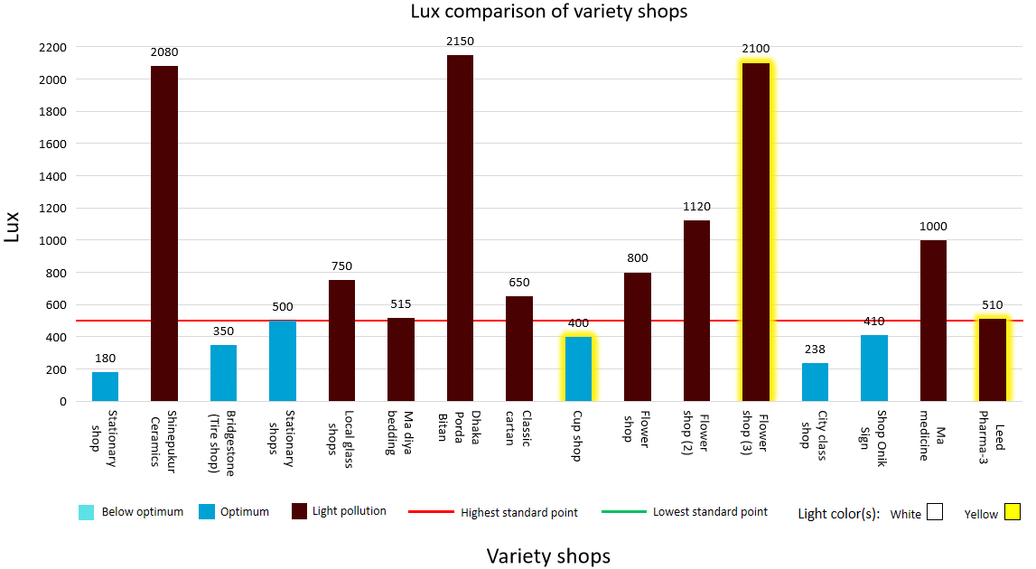
Figure 3.16:
In this graph, we are seeing shops selling various items where only 37.5% of shops are aware of light pollution. Some Other outlets are using even 4 times more lights than the highest optimum value of lighting.

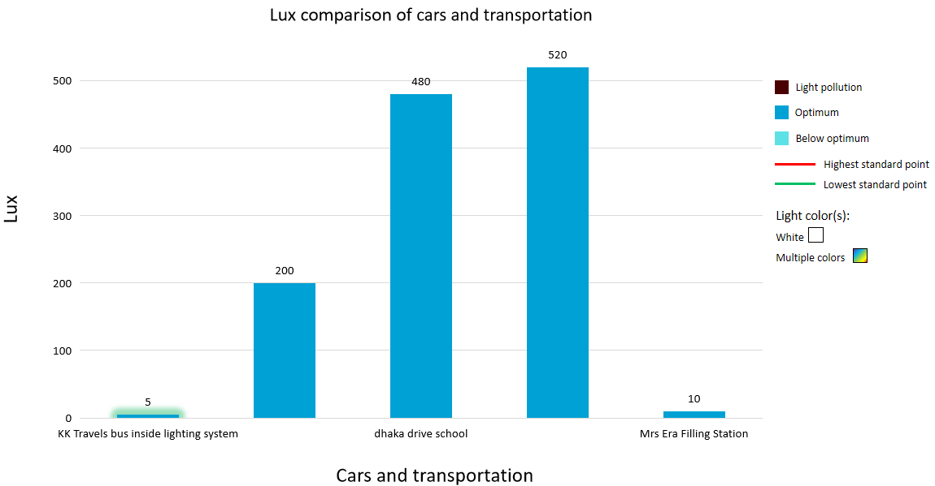
Figure 3.17:

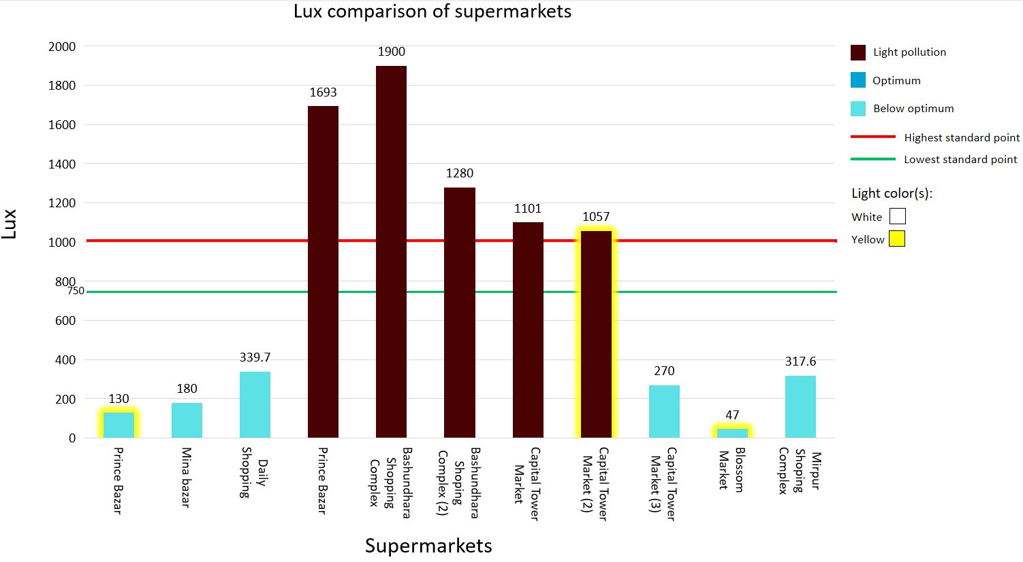
Figure 3.18:
It appears that none of the observed supermarkets maintain low light pollution standards. 50% of them are below standard which is not good and 50% are causing serious light pollution.

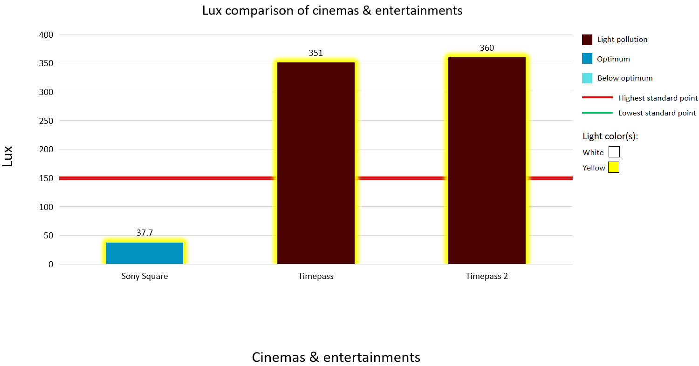
Figure 3.19:
The graph shows that the light intensity is higher in the inner Timepass zone except the entrance of the cinema hall called Sony Square.

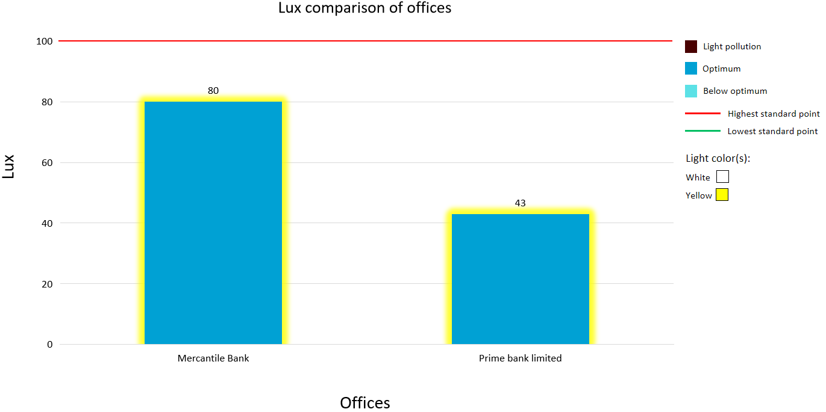
Figure 3.20:
The light intensity levels are taken from the outdoor areas of the banks. A review of the graph shows that the light intensity here is tolerable.

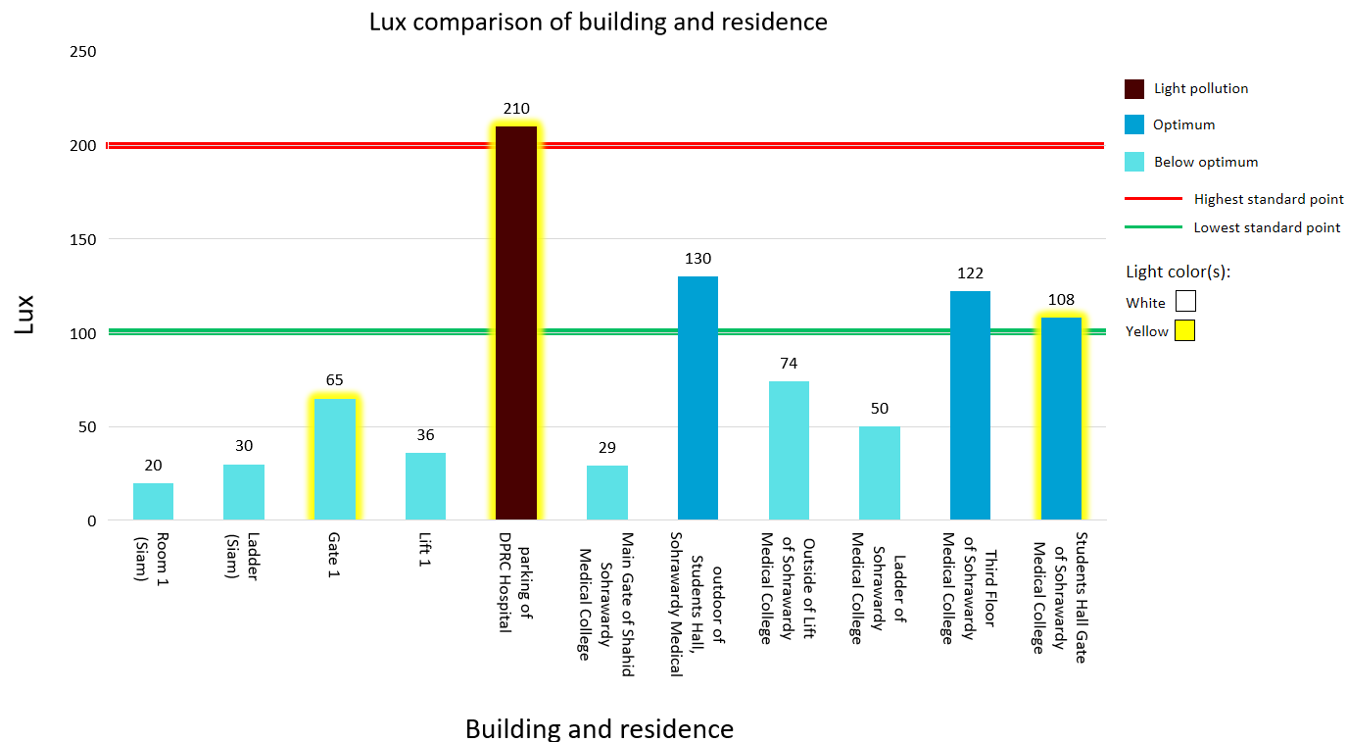
Figure 3.21:
From the graph, we can see that most places in the building and residence category have acceptable light intensity except the DPRC hospital parking lot.

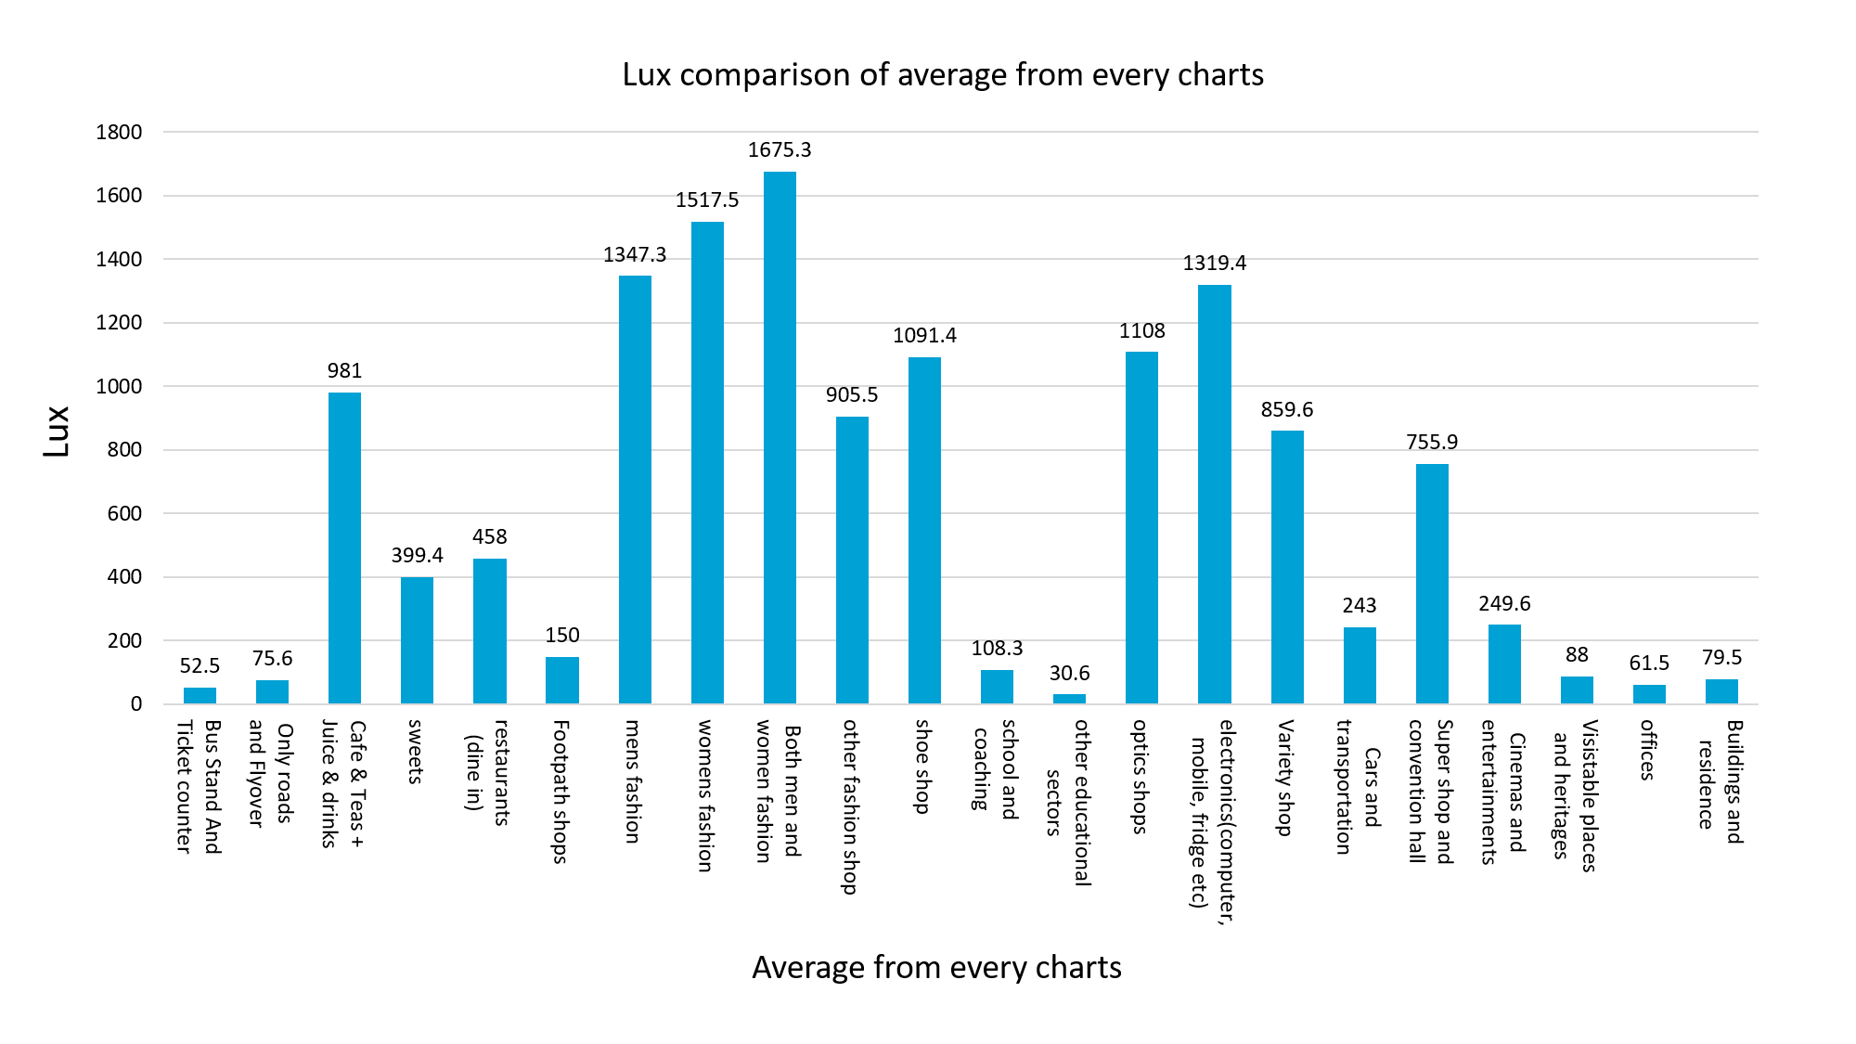
4. Result

5. Discussion
According to our previous section and data, some sectors and institutes use light more excessively than the standard level. so, these are not only creating Light pollution problems but also responsible for excessive electrical energy wastage. We can minimize light pollution and optimize energy consumption by employing innovative approaches.so, it will deal with our environment together with the economic problems of the country.

4.1.Lamppost management by AI and Sensor:
There are many roads with less traffic. But the street lights are on all the time from the evening until the morning. As a result, the light is distorted. We have to make such a system so that when the car arrives in a certain area the lamppost will be activated, otherwise, it will be off. The weight of the car is important. Each lamp post will have a specific area. The lamp post will turn on when a certain amount of weight comes there. As soon as the weight is removed, the lamp post will be turned off. In that case, the PIR motion sensor is the best way to deal with it. It saves energy by approximately 80% (Benefits of Motion Sensor Street Lighting, n.d.[13]). We also can add AI technology which will analyze and interpret data from sensors. By that, we can gather information on how much light intensity is needed to be used in certain areas by street light.
4.2.Reduce Power of Lamppost:
The line of the lamppost has to be divided into two ways through the diode. By dividing the main line into 2 parts through the diode, one part will go to the battery (which can be charged regularly) and the other part will go to the lamp post. At each time, different monitoring will be done as to how many watts of electricity will go in a line. For example, at 6 pm lamp post is at 70% and 30% battery; at 10 pm lamp post is at 100%; at 6 am lamp post is at 20% and 80% battery. This will allow us to know how much electricity will be stored in the battery every day. So we can charge the battery. This battery will later reduce the pressure on coal or uranium, which causes air pollution, nuclear pollution, and water pollution. At the same time, this battery will connect the lamp post in 0.1 seconds during the blackout, so that the road will not be darkened and there will be no accident. This will reduce electricity consumption and reduce pollution.

4.3.Use of Special Glass in Window:
At night, the lights are on in all our houses. But the use of ordinary glass in windows causes the light to reflect 4% while refracting 96%. This causes light pollution. Nowadays, if you go out for a walk at 10 pm in Dhaka city, you can see the world is illuminated by the light of the window. However, there are special types of glass that reflect light on one side (35%) and are anti-reflective on the other side(reflects very little,40% less than other normal glasses). Although these glasses are 35% more expensive than ordinary glass, on the one hand, they are anti-pollution or anti-fading, beautiful to look at, and at the same time, the same amount of light is available in 20-22 watts, which is available in the room at 30 watts in ordinary glass. As a result, light pollution is almost reduced.
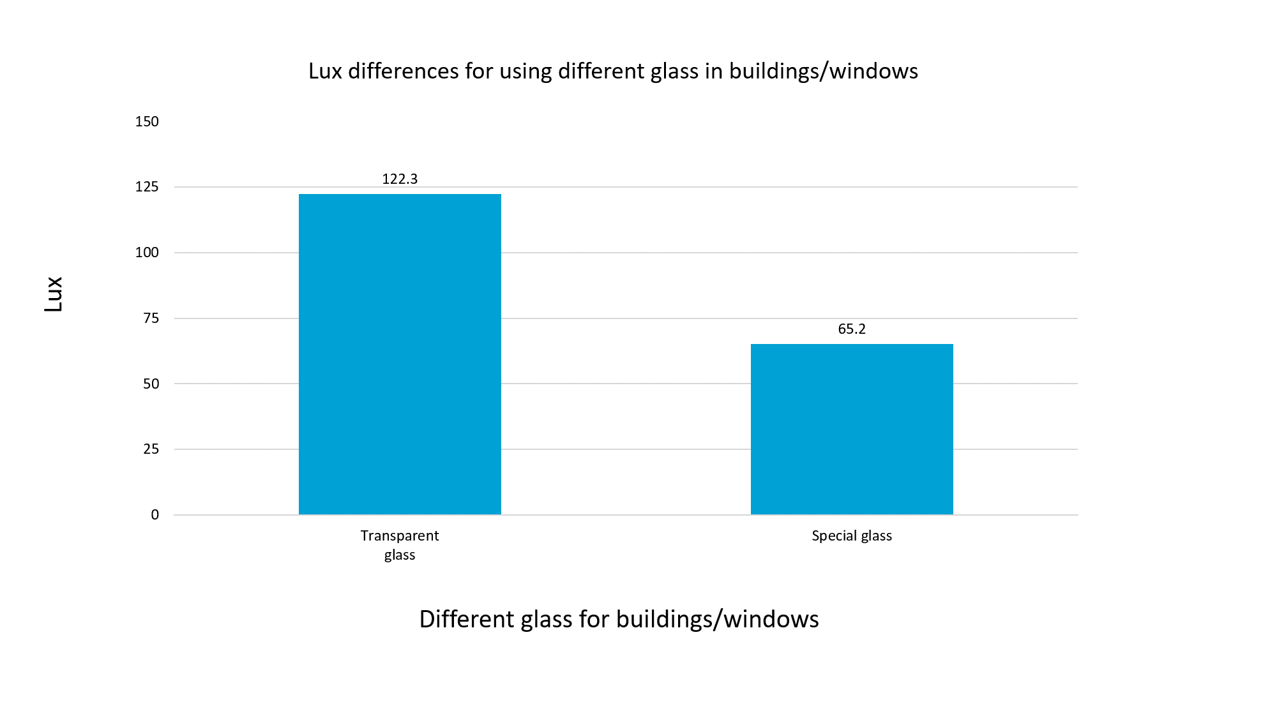

4.4.Angle and Height of the Light:
Light pollution can be reduced by changing the height and angle of street lamp posts. The higher the height of the street lamp post, the more light it can spread. Also the more the light is towards the ground. If the height of the street lamp is lower, then area coverage will be wrinkled(Elsahragtya & Kimb 479-488, 2015, [14]).
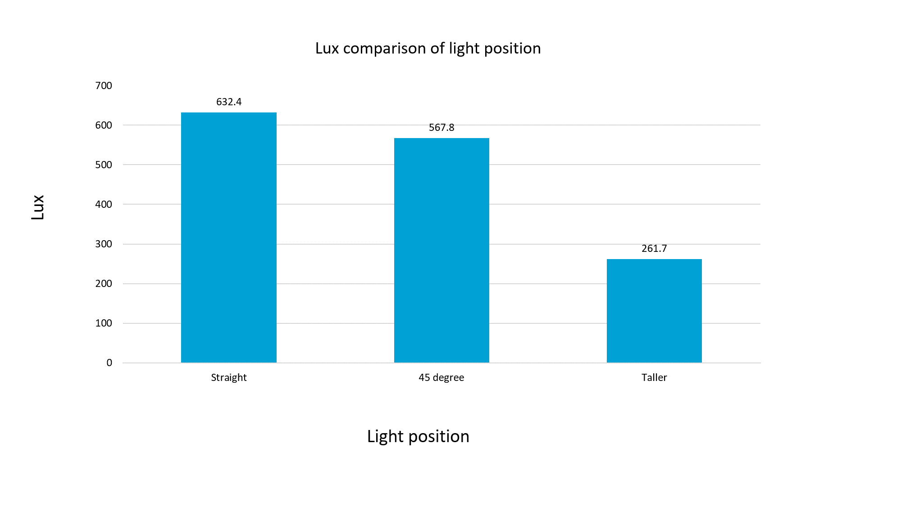

4.5.Lamppost Covering:
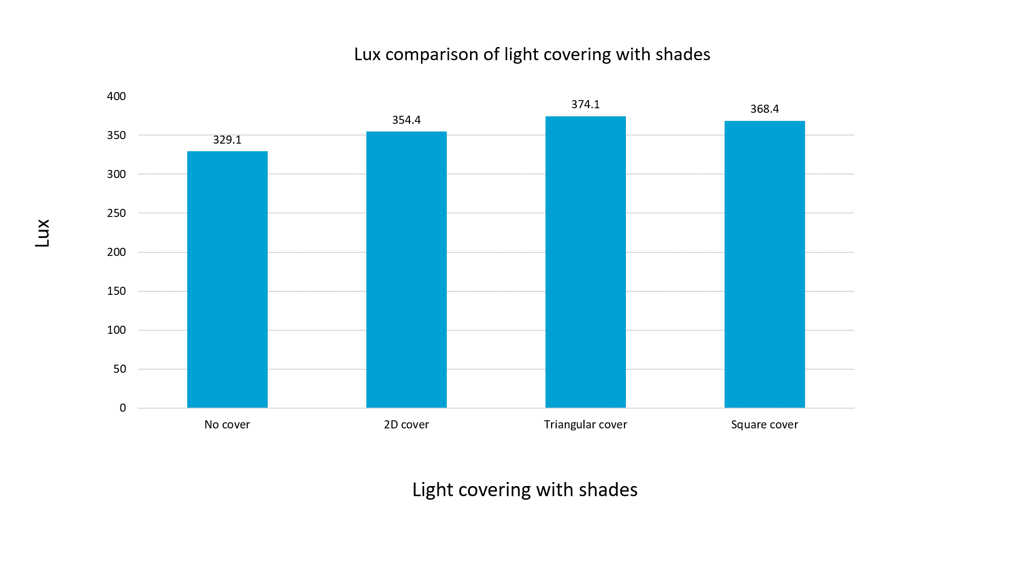
Light pollution can be reduced by covering street lamp post lights. Covering should be done in such a way that the light of the lamppost falls on the required place on the road. In this case, if only the parallel-shaped cover is used, then a lot of light pollution occurs through the side beams of the light source. Again, if there is a cover on the top and sides, the effective area is reduced because the light cannot spread, even without light pollution. For these reasons, a triangular cover is best. In this case light can spread to the maximum extent and light pollution does not occur. Also, we recommend using a reflective material on the inside of the cover. Any amount of light that would otherwise have been lost is reflected and increases the light intensity.

4.6.Car Headlight Wattage Modification:
The ideal power requirement of a Car Headlight is (a low beam of 50 watts and a high beam of 60 watts) (Elert, n.d.[16]). Sometimes a car does not need much light on the road due to having sufficient street lights. But occasionally many drivers use a high beam even though they have adequate light. Despite driving a car in low beam, it gives extra illumination than a requirement. So, the requirement of Car headlight illumination varies depending on the place. But in our country, most cars do not have any function to modify Car Headlights Wattage. By that, we are using and costing extra energy.
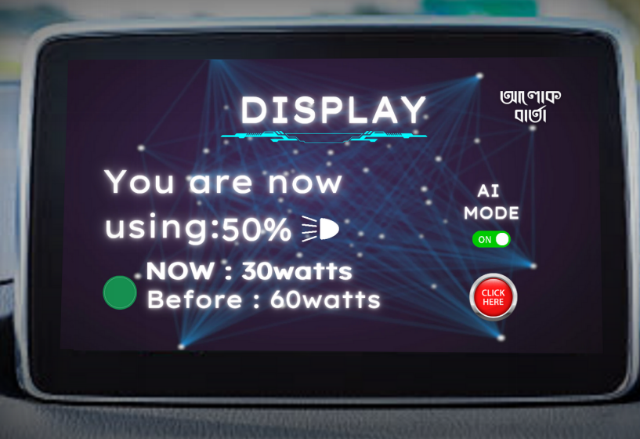
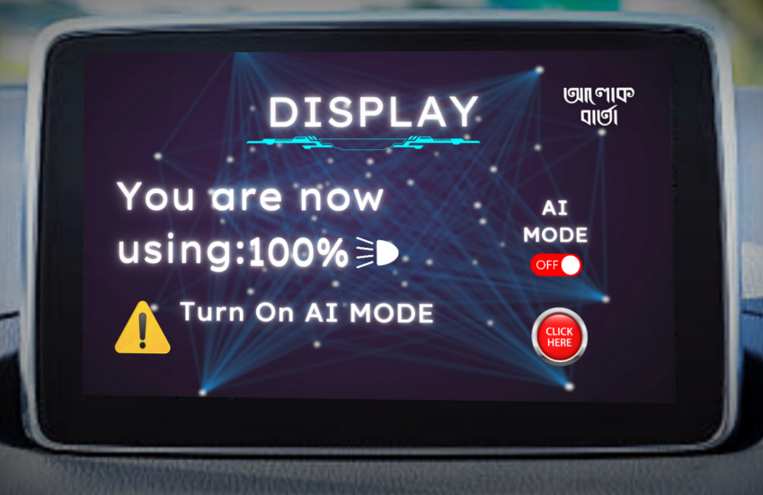

Figure 3:Car Headlight Monitoring Figure 3.1.: Suggesting proper wattage

In (Figure 3) we use a car monitor which has a Car Headlight Monitoring System. It will show how much percentage of wattage is used in HeadLight.If the Car Headlight is using extra wattage than the requirement, it will suggest clicking AI mode. (Figure 3.1.) By Clicking AI mode Car headlight will use sufficient wattage that is required. By this function, we can save energy as well as Light Pollution.

4.6.2:Energy Consumption and Saving (Normal Mode vs Sensor Mode):
Research suggests no significant difference in noise levels between morning and evening peak times in cities of Bangladesh (Hoque et al., 2020, 41-46[17]). It clarifies that roads are busy at an equal rate in the morning and evening. We can assume that 50% of vehicles drive at night.

According to statistics of BRTA (“Number-of-registered-Vehicles-in-Whole-BD - বাংলাদেশ সড়ক পরিবহন কর্তৃপক্ষ-গণপ্রজাতন্ত্রী বাংলাদেশ সরকার”, n.d.[18]), Total numbers of Registered car is 53,59,582 (Fifty-three Lakh Fifty Nine Thousand Five hundred Eighty Nine) from upto 2010-upto August-2024. (Excluding which vehicle does not have Headlight).12% of Cars, 4% of motorcycles, 39 % of buses, 32% of trucks, and 5% of Others have accidents in these years which will be excluded from the Total registered Cars[18]. 50% of vehicles drive at night. So, an estimated 50% of total registered cars excluding accidents and other issues 26,79,792 vehicles travel at Night and have to use Headlights for driving.
Considering energy consumption in normal mode, the total headlight of a car wattage consumed (High beam+ low beam) is equal to(50+60) 2 which is 220 watts. So, total energy consumption at night will be p=n*pº /t(where n is total cars, pº watts per car headlights, and t is duration)
P,total watts/hr =(26,79,792*220/1)=589.554 MW/hr(Normal Mode)
In wattage suggestive mode, it will suggest min 60% of normal mode which will be ( 220 watts of 60%) = 132 watts. So, total energy consumption will be p=n*pº(where n is total cars, pº is watts per car headlights, and t is duration) p, total watts/hr =(26,79,792*162/1)=353.73MW/hr(AI Mode)
So, Energy Saving will be, (Normal Mode-AI Mode)=253.824 MW/Hr.

Mode | Total Vehicles | Car Headlight  (Total Watts) | Time(hr) | Energy consumption(MW/hr) | Saving  (MW/hr)
Normal | 26,79,792 | 220W | 1hr | 589.554MW/hr | 235.824 MW/hr
AI | 26,79,792 | 132W | 1hr | 353.73.MW/hr | 235.824 MW/hr
Table: Energy Comparison Normal mode vs AI mode

Rooppur Nuclear Model produces 2400 Megawatts per hour including two units (Rooppur Nuclear Power Plant, n.d.[19]). With Our suggestive system, Energy savings will be 14.07% of the total power of the Rooppur Nuclear Plant per hr. It also means that in 10 days the energy saving will be reached at the power of the Rooppur plant per hr. So, this solution will make a big impact on energy savings which will be very helpful to our economy.

4.7.Advancing Schedule:
In Bangladesh, the relevant institution of government, suggests that generally shops should be opened from 10 a.m.-7 a.m. (9 work hours) (“Opening Hours and Bank Holidays in Bangladesh,” 2024 [20]). But especially in Dhaka, some shopping malls are seen open 9/10 a.m - 7/8/9/10 p.m(>9 hours). The data of some famous shopping malls in Dhaka are given below:

Shopping Malls/Shop | Available/Active | Work Hour(Hr) | Area (sqft) | Extra Lighting (hr)
Basundara shopping complex | 10 A.M- 9 P.M | 11hr | 1,91,200 | 2hr
Jamuna Future Park | 11 A.M- 8 P.M | 9hr | 41,00,000 | 1hr
Dhaka New Market | 10 A.M - 9P.M | 11hr | 5,60,683 | 2hr
Rapa Plaza | 10 A.M - 8 P.M | 10hr | 1,00,000 | 1hr
Average |  | 10.25hr | 1237970.75 | 1.5hr
Table: Current Schedule of Shopping Malls

It is observed that ( Table: ) the suggested schedule is not maintained by these famous shopping complexes. So, it plays a great role in energy loss as well as eventing Light Pollution.

Schedule | Light Requirement  (lumens/sqft) | Energy  Requirement  (watt/sqft) | Avg Area  (sqft) | Time  (Lighting hour) | Consumption  (kw/hr) | Savings  (kw/hr)
Current  (10A.M-8:30P.M) | 69.67728 | 0.753 | 12,37,970.75 | 2.5hr | 2330.4799 | 1398.28  (60%)
Suggesting  (10A.M-7P.M) | 69.67728 | 0.753 | 12,37,970.75 | 1hr | 932.19 | 1398.28  (60%)
Table : Benefits of Advance Scheduling
In table(): Light Requirement refers to how much lumens are sufficient per square foot area. From Figure 2.4 Supermarkets are required 750 lux or Lumens/m² which is divided by 10.76 converted into 69.67728 Lumens/sqft. Nowadays, Most supermarkets use LED bulbs for illumination. According to (Guide, 2024), 1 watt of LED light generally emits 75-110 Lumens which an average is 92.5 used for calculation. So, the area of per square foot energy requirement will be (69.67728/92.5) = 0.753 watts. From table: we get the Average total square foot area of some biggest supermarkets in Bangladesh. By observing their opening and closing times, they do not maintain a proper schedule which is modified by the relevant department of Government. We get a 2.5-hour average when the light is needed to be used by these supermarkets. By implementing w=P*t, we get how much energy is consumed in these extra hours. Then we can measure how much light can be saved if these supermarkets maintain proper schedules. 60% of power can be saved if they maintain the proper schedule.

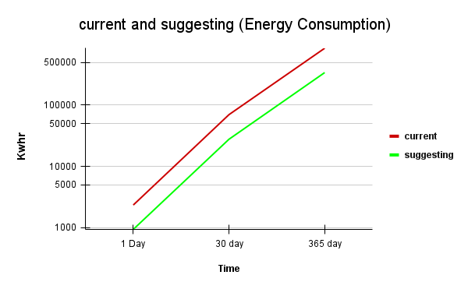
Figure: Comparison Of Energy Consumption
In the following Line graph, clearly shows how much energy is lost by not following suggesting schedule for supermarkets. It also refers to advancing scheduling plays an important role in both energy and reducing Light Pollution.

5. Conclusion

To effectively address this global problem, we must prioritize our proposed mitigation strategies while also considering the significant role of reducing light pollution. The modern world believes in using more and more light as a sign of digitalization. But this belief pushes our world against the curse of Light Pollution. Few countries and societies are realizing this but not in a concerned way. While the short-term effects of artificial light overuse might be less apparent, the long-term consequences can be significant.

To present the nuisance of light pollution in the current world, our research work will be greatly significant. In this paper, we have thoroughly explored various strategies to address the situation. These strategies will make our lives more efficient, environmentally friendly and also modernized. AI-based solutions elevate our approach to a new level.

Not only have we concentrated on potential solutions, but we have also endeavored to assess the comprehensive impact of light pollution on the country. This research allows us to identify the specific locations, sectors, and areas that contribute significantly to light pollution. This information enables us to make informed decisions about where to reduce lighting and where current levels are excessive. Thus, we can easily get rid of Light Pollution.

5.1.Future Direction:
This study represents the first comprehensive investigation of solutions to this issue within Bangladesh. But only one research on this vast and serious topic cannot represent the whole thing, especially in Bangladesh. Country-based research should be done more on that topic because every country is different from others, and the way of solutions is also different from others. This research definitely will inspire those who are interested in the topic. We only restrict to solutions but there are many issues in that topic they can work on. Exploring new technological approaches, such as intelligent lighting systems, could lead to significant reductions in light pollution.

Reference
1. Light Pollution. (n.d.). Dark Sky International. https://darksky.org/.
2. Parks, B. (2011). The battle to control light pollution. Sky & Telescope, 122(3), 30..
3. National Geographic Society, (2024, April,1). Light Pollution. National Geographic.
(para.8)
https://education.nationalgeographic.org/resource/light-pollution/
4. VIIRS country statistics,(2023).Light Pollution map.
https://www.lightpollutionmap.info/LP_Stats/
5.Phil, P.(2013,Jan 31).Light Pollution Is Dimming Our View of the Sky, and It’s Getting
Worse, (para.2)
https://www.scientificamerican.com/article/light-pollution-is-dimming-our-view-of-the-sky-and-its-getting-worse/#:~:text=More%20than%2080%20percent%20of,each%20year%20it%20gets%20worse.
6. VIIRS country statistics,(2023).Bangladesh Stats.
https://www.lightpollutionmap.info/LP_Stats/country.html?country=Bangladesh&type=
7. Zoom Earth,(2024) Live Weather Satellite Map.
https://zoom.earth/maps/satellite/#view=23.728,92.975,6.74z/date=2024-08-23,19:30,+6
8. International Bureau of Weights and Measures (2019-05-20), The International System of Units (SI) (PDF) (9th ed.), ISBN 978-92-822-2272-0, archived from the original on 2021-10-18
9. CIE (2020). CIE S 017:2020 ILV: International Lighting Vocabulary, 2nd edition (2 ed.). CIE.
10. Any-Lamp.Com, Lumens and Lux,
https://www.any-lamp.com/blog/lumen-and-lux#:~:text=Lumens%20are%20how%20much%20light,intensity%20from%20the%20light%20source.
11. The Engineering Toolbox- Illuminance: recommended light levels
https://www.engineeringtoolbox.com/light-level-rooms-d_708.html
12. Benefits of Motion Sensor Street Lighting. (n.d.). Tvilight. Retrieved September 26, 2024, from https://tvilight.com/benefits-of-motion-sensor-street-lighting/
13. Elsahragtya, M., & Kimb *, J.-L. (2015, September 14). Assessment and Strategies to Reduce Light Pollution using Geographic Information Systems. Assessment and Strategies to Reduce Light Pollution using Geographic Information Systems, 118(2015), 479-488. https://doi.org/10.1016/j.proeng.2015.08.458

M. F. Labib, A. S. Rifat, M. M. Hossain, A. K. Das and F. Nawrine, "Road Accident Analysis and Prediction of Accident Severity by Using Machine Learning in Bangladesh," 2019 7th International Conference on Smart Computing & Communications (ICSCC), Sarawak, Malaysia, 2019, pp. 1-5, doi: 10.1109/ICSCC.2019.8843640. keywords: {Road accidents;Machine learning;Roads;Decision trees;Machine learning algorithms;Classification algorithms;Accident Severity;Machine Learning;Supervised Learning Feature Analysis;Road Accident}, https://ieeexplore.ieee.org/stamp/stamp.jsp?tp=&arnumber=8843640&isnumber=8843588

