BUTTER COOKIES

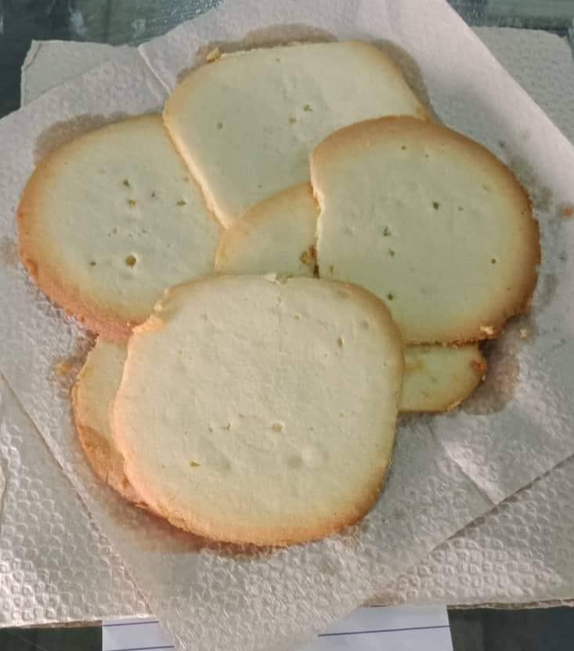

INGREDIENTS

>½ cup unsalted butter

>1/4 cup + 1 tbsp fine sugar

>¼ tsp. salt

>1 tsp. vanilla extract

>1 egg

>1 cup flour

>2 tbsp. cornstarch

PROCEDURE :

>Prepare the ingredients.

>Put ½ cup of unsalted butter in a bowl.

>And slowly mix until creamy, pale, and fluffy.

>Put 1 egg yolk and 1 tsp. vanilla extract .

>Mix until combined.

>Put 1 cup of flour and 2 tbsp. of cornstarch.

>Sift in 2 batches.

>Fold in with a spatula.

>After that put in the disposable pastry bag and put on the baking pan.

>Bake in preheated oven at 170 degrees celcius for 15-18 mins.

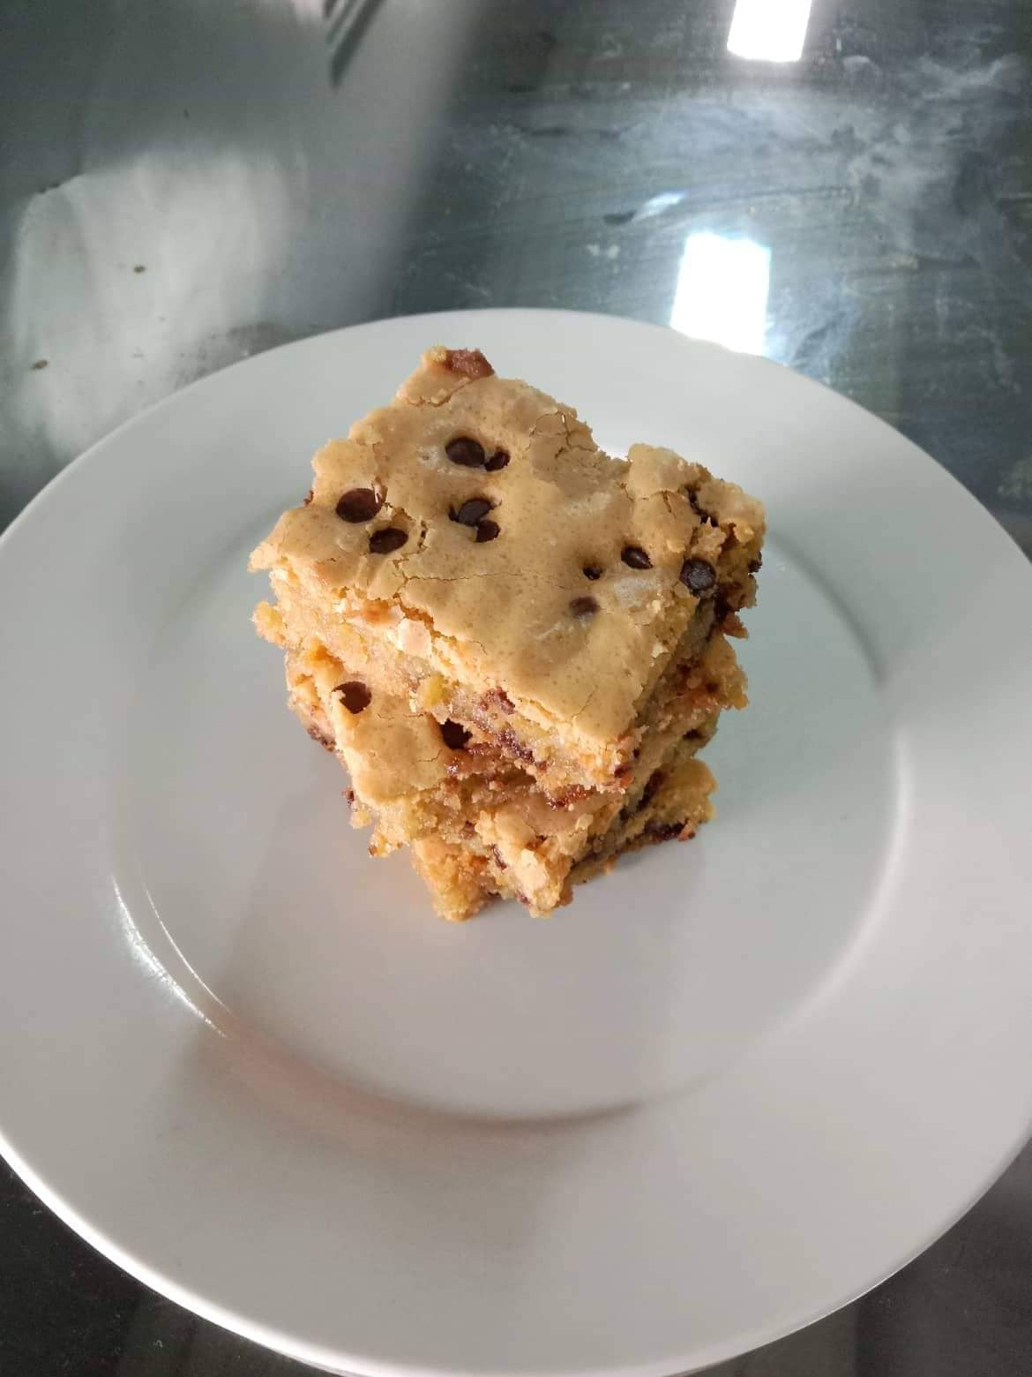COOKIE BARS

INGREDIENTS:

>2 ¼ CUPS PLAIN FLOUR

>2 CUPS DARK CHOCOLATE CHIPS

>¾ CUP MELTED UNSALTED BUTTER

>1 CUP LIGHT BROWN SUGAR

>2/3 CUP WHITE SUGAR

>2 LARGE EGGS

>1 TBSP. VANILLA EXTRACT1 TSP. BAKING SODA

>1TBSP. CORNSTARCH

>1 TSP. SALT

PROCEDURE:

> Prepare the ingredients.

> Sift together the 2 ¼ cups plain flour , 1 tbsp. cornstarch , 1 tsp. baking soda and 1 tsp.salt.

> Mix it and set this aside.

> Add the ¾ cup butter , 1 cup brown sugar , 2/3 white sugar, 1 tbsp. vanilla extract and 2 large eggs.

> Mix them together until incorporated.

> Add in the dry ingredients and mix them together until well combined.

> Add in dark chocolates chips but set aside a handful of it for the toppings and mix them together.

> Put the mixture in the pan and lined with parchment paper , spread it evenly and top it with the remaining chocolate chips.

> Bake these in a preheated oven of 170 degrees celcius for about 35 mins.

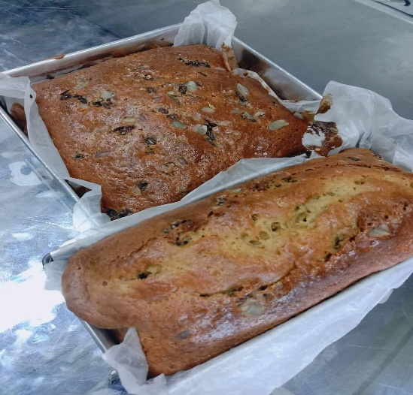BUTTERMILK NUT BREAD

INGREDIENTS:

>2 EGGS

>1 ½ CUPS BROWN SUGAR

>3 ¼ CUPS SIFTED FLOUR

>2 TSP. BAKING SODA

>½ TSP. SALT

>2 CUPS BUTTER MILK

>1 CUPS CHOPPED NUTS

PROCEDURE:

> Beat eggs, add sugar and mix well.

> Sift flour, baking soda and salt together. Alternately add butter milk and egg mixture to dry mixture.

> Add nuts. Pour into to greased loaf pans.

> Bake in slow oven (325 degrees F) 1 hour. Make 2 (8x4 inch.) loaves.

CREAM PUFFS

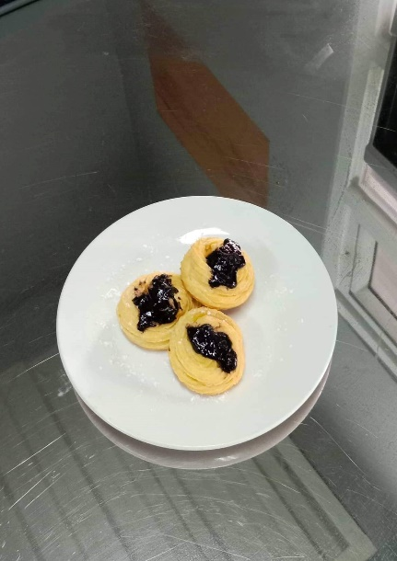

INGREDIENTS:

>½ UNSALTED BUTTER

>½ FRESH MILK

>4 LARGE EGGS

>1 CUP ALL PURPOSE FLOUR

PROCEDURE:

> Put the ½ cup unsalted butter, ½ cup fresh milk, ½ cup water and ¼ tsp. salt.

> Cook over low heat and stir until butter melts completely.

> Put a 1 cup all purpose flour and continue to cook over low heat and stir constantly until it turns doughy.

> Remove from the heat and stir the pastry dough until it cools down.

> Put in the bowl and add eggs one at a time then stir until completely combine.

> After each addition. Transfer the pastry dough in a piping bag, line the baking sheet with parchment paper then put the mixture ingredients in the pan.