Reproducibility Report for MTA Daily Ridership Dataset

Mingzhi Cai (Jason)
CSE5104 – Data Mining
12/05/2025

Motivation
The transportation system in New York is a typical highly complex urban transportation network, and its operation has a significant impact on the city's economy, residents' commuting efficiency, and public safety. After the pandemic, the subway passenger flow and road traffic congestion in New York have shown instability and dynamic changes during the recovery process. Therefore, precise prediction of these traffic indicators is of practical demand for government departments, transportation planners, and public operation institutions.

The dataset used in this project includes daily subway passenger flow, the percentage of road traffic recovery (relative to pre-pandemic), date attributes, and other potential influencing factors. The main motivations for analyzing these data include:
- Understand the trend of traffic recovery after the epidemic
- Provide predictive capabilities for future traffic management
- Identify which factors have the greatest impact on traffic patterns
- Test whether traditional machine learning models can effectively depict the internal patterns of the New York transportation system

Data Description
Dataset:
- Source:
MAVEN ANALYTICS
- Variables:
Date
Subways: Total Estimated Ridership
Subways: % of Comparable Pre-Pandemic Day
Buses: Total Estimated Ridership
Buses: % of Comparable Pre-Pandemic Day
LIRR: Total Estimated Ridership
LIRR: % of Comparable Pre-Pandemic Day
Metro-North: Total Estimated Ridership
Metro-North: % of Comparable Pre-Pandemic Day
Access-A-Ride: Total Scheduled Trips
Access-A-Ride: % of Comparable Pre-Pandemic Day
Bridges and Tunnels: Total Traffic
Bridges and Tunnels: % of Comparable Pre-Pandemic Day
Staten Island Railway: Total Estimated Ridership
Staten Island Railway: % of Comparable Pre-Pandemic Day
- Model Choosing:
Random Forest, SVM
- Dimensionality Reduction:
PCA
- Hyperparameters:
Random Forest: n_estimators = [50, 100, 200, 300, 500]
SVM: regularization strength C = [0.01, 0.1, 1, 10, 100]

Visualizations Test Results
Problem1:
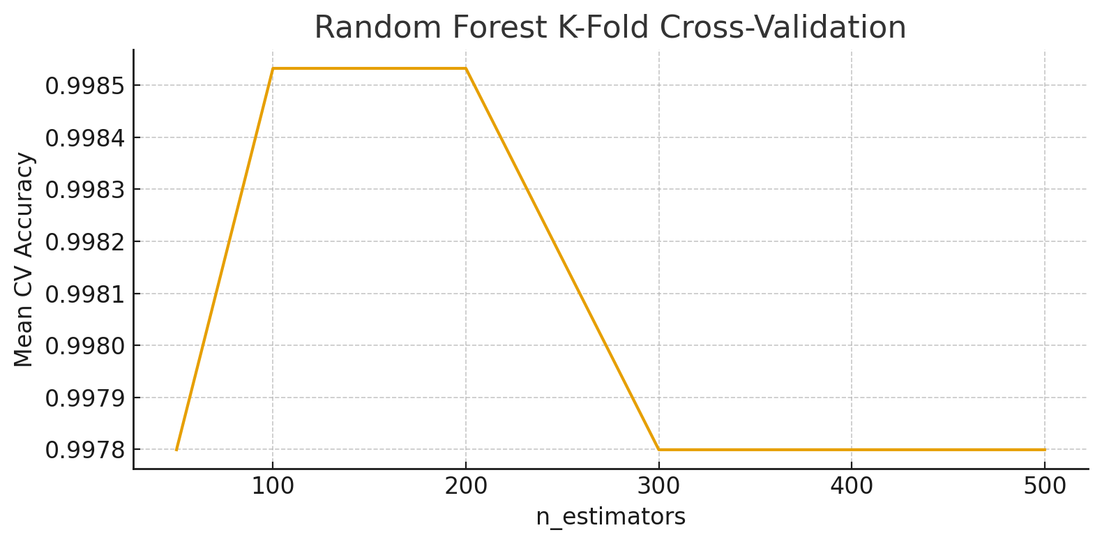
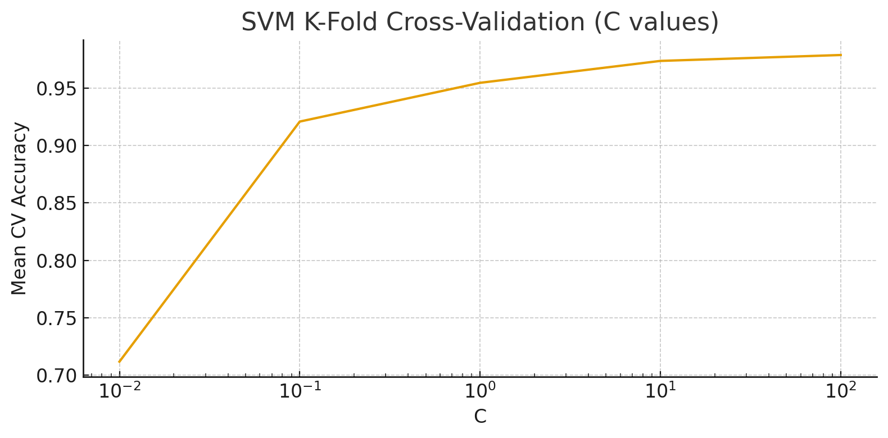
Training Data:
Random Forest: train_acc: 1.0000, train_time: 0.2888, pred_time_train: 0.0094
SVM: train_acc: 0.9971, train_time: 0.0090, pred_time_train: 0.0075

Validation Data:
Random Forest: valid_acc: 1.0000, pred_time_valid: 0.0054
SVM: valid_acc: 0.9766, pred_time_valid: 0.0019

Problem2:
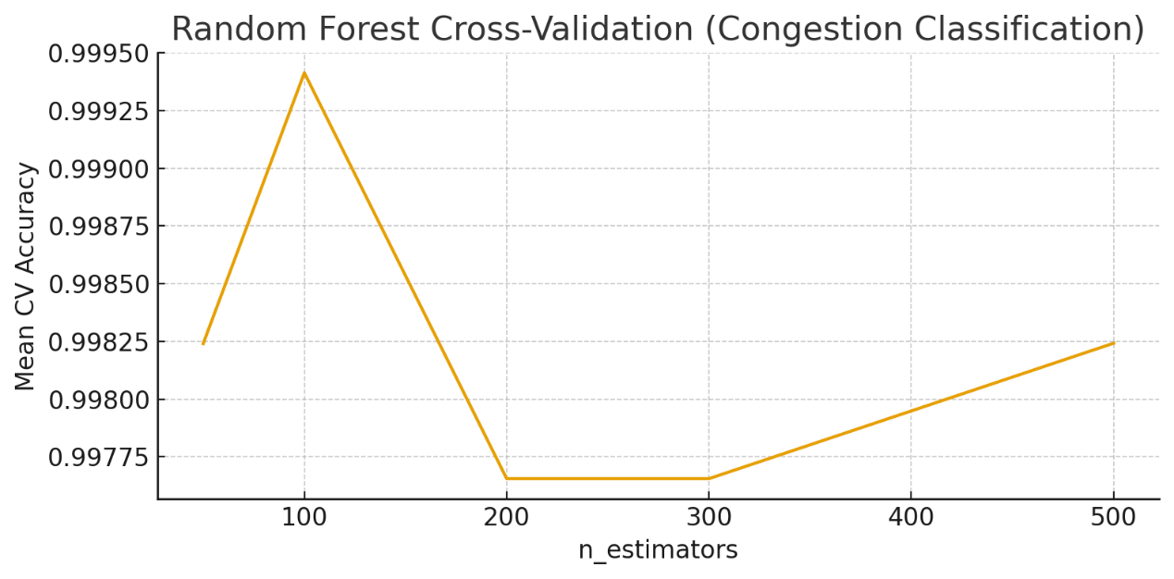
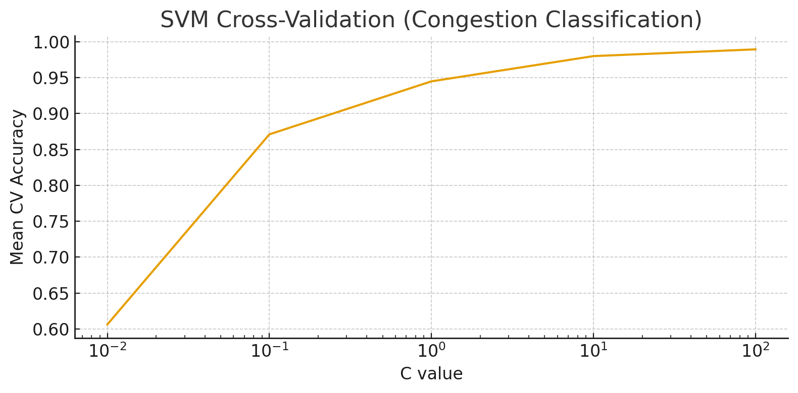
Training Data:
Random Forest: train_acc: 1.0000, train_time: 0.1362, pred_time_train: 0.0055
SVM: train_acc: 1.0000, train_time: 0.0105, pred_time_train: 0.0100

Validation Data:
Random Forest: valid_acc: 0.9971, pred_time_valid: 0.0031
SVM: valid_acc: 0.9942, pred_time_valid: 0.0026

After using PCA:
Problem1:
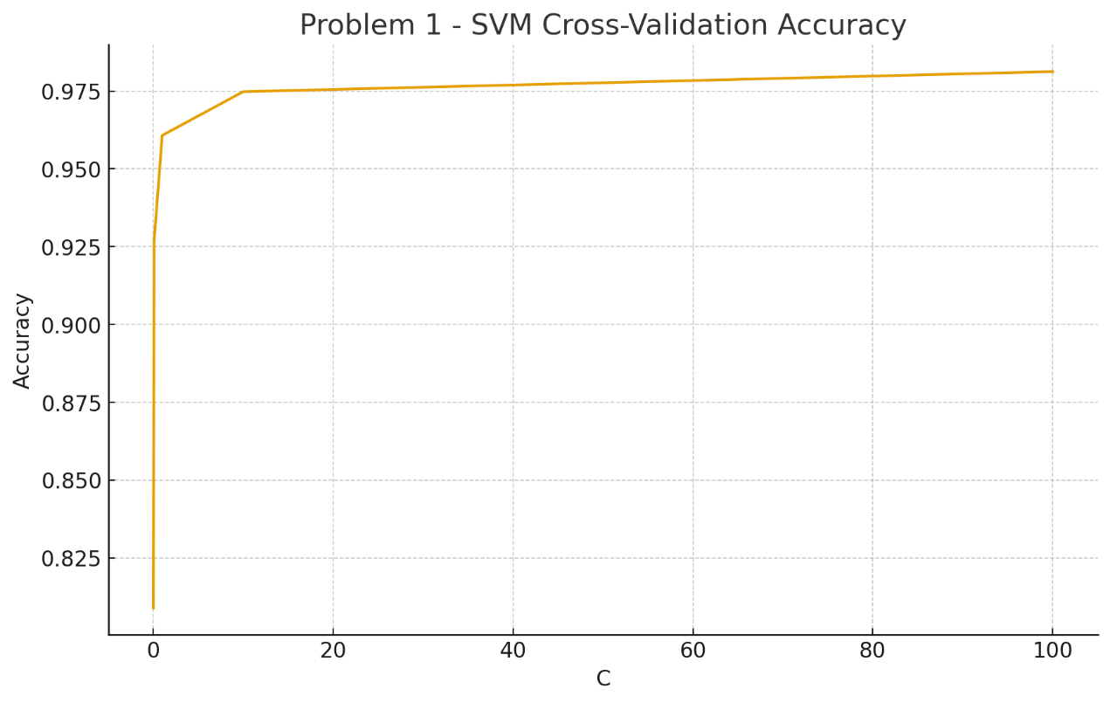
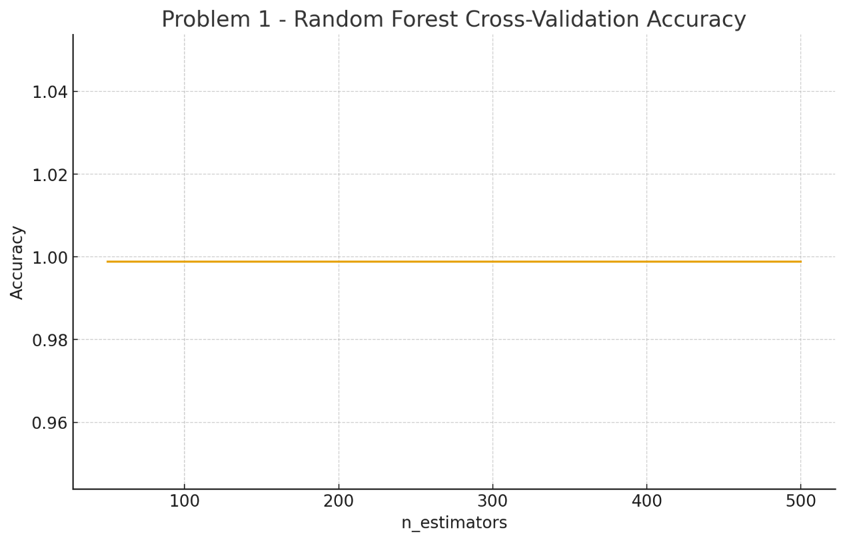

Problem2:
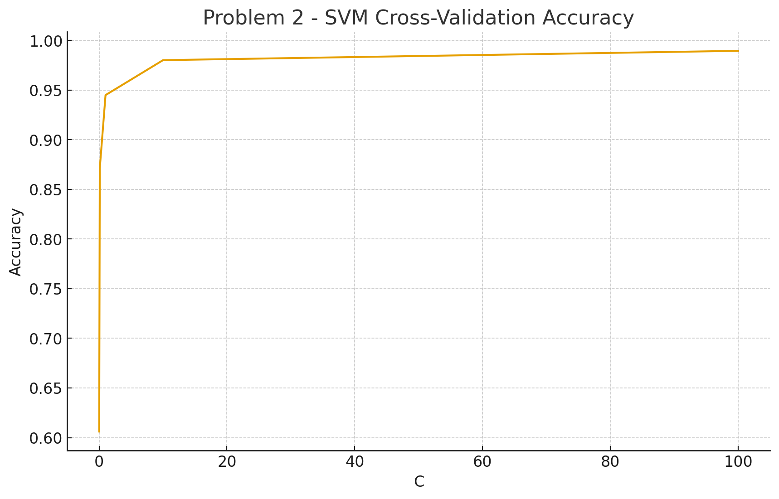
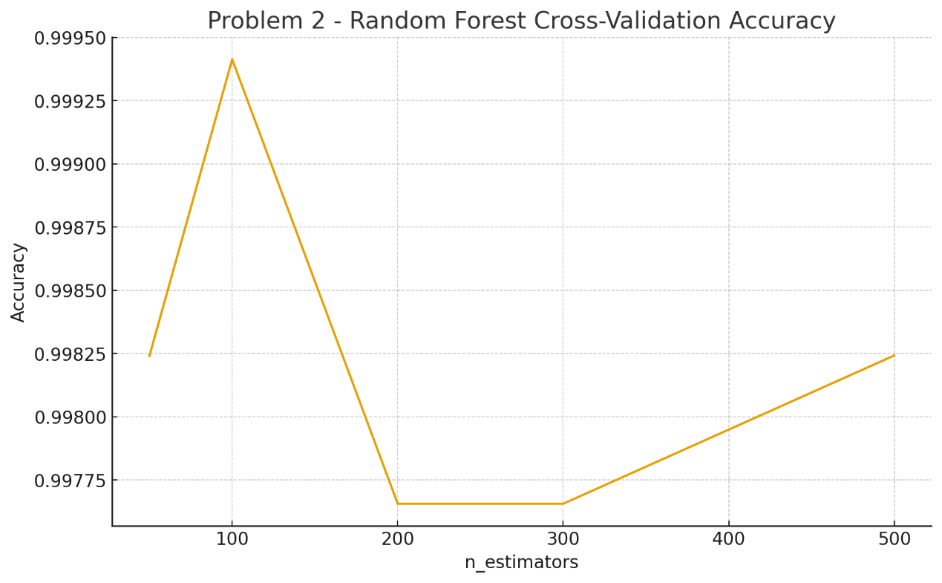

Model Performance & Fitting Results
Distinct Classification Problems:
Problem1: Predict Ridership Level (High / Medium / Low)
- Random Forest (n=200): Validation Accuracy = 1.000
- SVM (C = 100): Validation accuracy = 0.976

Random forests perform better than SVM when the classification boundaries are clearer, indicating that tree models are better at capturing the nonlinear structure of the data.

Problem2: Predict Traffic Congestion Class (Light / Moderate / Heavy)
- Random Forest (n=100): Validation Accuracy = 0.9971
- SVM (C = 100): Validation accuracy = 0.9942

On this issue, the two approaches show basically the same performance, but the random forest still has the best performance.

Results:
Random forest is the best model in both cases, performing almost perfectly. SVM, although slightly inferior, still has extremely high predictive ability.

This indicates that the dataset has a high degree of separability and can be effectively modeled by traditional machine learning methods.

Discussion
Q: Are the two classification problems equally predictable?

Yes.

Based on the data statistics and analysis results, both classification tasks achieved a validation accuracy rate close to 1.0. This clearly indicates:
- The passenger flow levels of the subway are highly predictable.
- The traffic congestion levels are also highly predictable.

This reflects the high degree of correlation among the characteristics of New York’s transportation system and the significant temporal / spatial patterns.

Q: Are all the models equally “good”?

No.

Although the verification accuracy rates were both close to 1.0, when comparing the two models, there were still differences. In all the experiments, the random forest model consistently performed the best (especially in Question 1). Although SVM performs well, it is slightly inferior when dealing with high-dimensional data and complex nonlinear relationships.

From the perspective of advantages and disadvantages, SVM is faster and suitable for real-time predictions; however, random forest is more stable and has a higher accuracy rate. The data in the Dataset has been accumulated over time, so in this regard, random forest can achieve a higher accuracy rate.

Q: Does dimensionality reduction have any meaningful impact?

Yes, and it is a clear influence

After using PCA as a dimensionality reduction method, this operation led to a decline in the performance of all models:
Problem1: The random forest score changed from 1.0000 to 0.9649.
Problem2: The random forest model's accuracy changed from 0.9971 to 0.8918.
SVM shows a smaller decrease after PCA but still has an impact.

Reason:
After PCA compresses the features into principal components, it loses the key information in the original features, such as:
- Clear date characteristics
- Periodic factors
- The precise variation of the recovery percentage
Therefore, PCA is not suitable for this dataset.

Q: What’s your suggestion?

- It is recommended to use the original data instead of PCA.
- Model recommendation: Random Forest (RF) is the primary model, while SVM is the secondary or lightweight model.
- If the goal is for urban traffic prediction applications: Random Forest is more reliable and has better interpretability (it can analyze the tree structure and feature importance).

The traffic data in New York is highly predictable. Traditional models are sufficient to achieve high accuracy, without the need for complex deep learning or dimensionality reduction.

Methods
- Hyperparameter Selection
Problems | n_estimators | C
P1 | 200 | 100
P2 | 100 | 100

Reason:
These hyperparameters achieved the highest validation accuracy in the cross-validation process. Increasing the parameters further does not improve the accuracy (the performance shows a plateau effect). Therefore, the optimal point between performance and training cost is selected.

- Dimensionality Reduction
Choose: PCA
The goal of PCA is to explain the maximum variance using the fewest principal components. The dimension of the feature space is reduced to 50% of its original size, and the original features are mapped to an orthogonal space through a linear transformation.

However, the predictive performance significantly deteriorated after PCA. The model was highly sensitive to the original features (especially the date, passenger flow, and recovery rate), and these pieces of information were partially lost during PCA. Therefore, the final recommendation is: Do not use PCA, and retain the original features.

