Linear Algebra

Laboratory Activity No. 5

Multidimensional Vectors

|  |  |
| --- | --- |
| *Submitted by:* | *Instructor:* |
| Reyes, Carl vincent G. | Engr. Dylan Josh D. Lopez |

November 6, 2020

# Objectives

This laboratory activity aims to put the bar on a higher notch with the fundamental skills taught to the students during the previous lessons by visualizing more vectors in a higher dimension.

# Methods

This activity focuses on vector representationwith 2-Dimension and 3-Dimensional plots. MatPlotLib is very essential in this laboratory activity, because we will be using codes such as plt.quiver(), plt.Show(), plt.x and ylim(), and as well as the numPy for the arrays of vectors that will be placed within the plot. Example of this are:



Figure : Usage of MatPlotLib

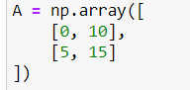

Figure : usage of NumPy for arrays

This code uses NumPy arrays for the vector variables that will be plotted in the graph.

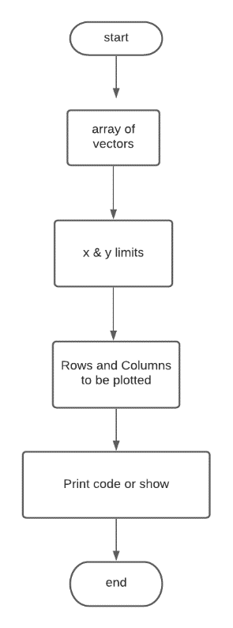

Figure : Flow chart of Task 1

The figure above shows the flowchart on how the code will work and be able to plot the values given by the programmer.

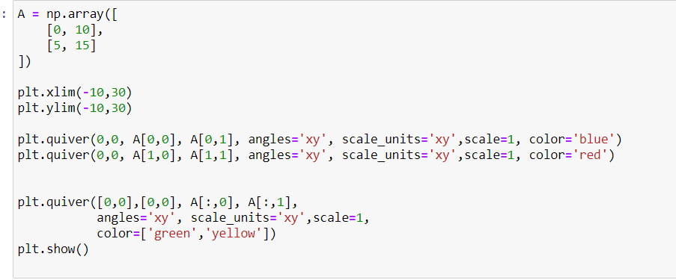

Figure 4: Codes used by the programmer for task1

This are the codes used by the programmer in order to complete the first task. The codes consists of NumPy and MatPlotLib in order for the variables to work and show the graph with accuracy. Plt.quiver A[0,0] is the row in which you want to plot your vector variables, changing it to 1 will produce or show the next row of given variables.

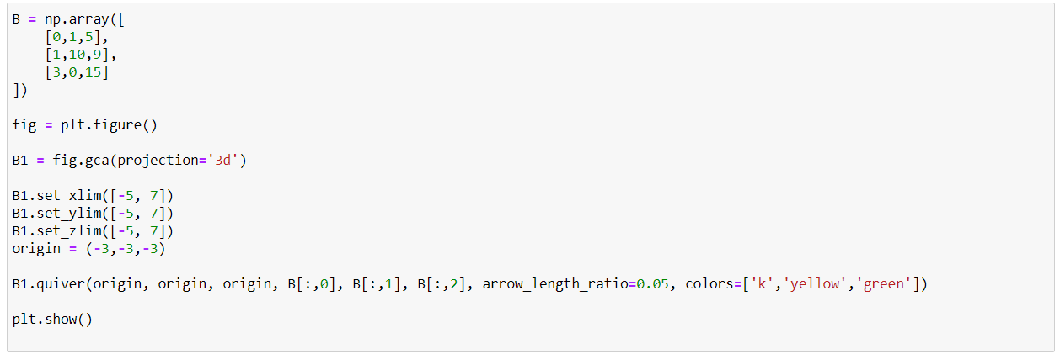

Figure 5: Codes for task 2

This are the codes used for task 2, it is quite similar to the examples in the lab activity 5 because what is needed to find in task 2 is the same which is plotting a 3-Dimensional graph, the only difference is that there are three arrays and 3 axes, which is x,y, and z. Almost everthing is the same, all you need to do is to make 3 variables out of everything, such as the array, the axes, and the quiver on where you place its origin like the other two.

# Results

These are the results of the plot in which the programmer coded in Jupyter-notebook with the tasks given to them.

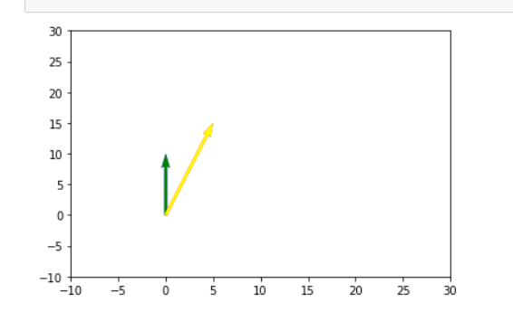

Figure 6: Results of Task 1

Figure 4 shows the result for the first task given to the programmer with its values inputted by him or herself, it also shows the 2-Dimensional representation of the graph with only x and y axis on the plane which was the task given and is possibly correct.

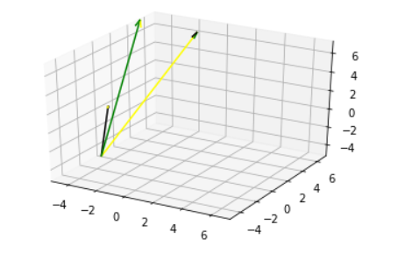

Figure : Result of Task 2

This is the result of the task 2, In which by observing, one can see the difference between the first task, where the first task only consists of a 2-Dimensional plane, and this task is consist of a 3-Dimensional plane and consists of 3 axes and 3 lines instead of 2.

# Conclusion

### What other types of data can be plotted in the 2-D or 3-D plane?

-Other data types that can be plotted in 2-D or 3-D plane are money, prices, stocks, ditstance such as the Eagle tracking software, where you can place in a 2-Dimensional plane the location of the eagle in order to observe its behavioral patterns in the wild, putting it in a 3-dimensional plane would make it more accurate and more efficient.

Is it possible for data to have more than 3 dimensions? If no, why not? If so how can they be visualized? Justify your answer.

Yes, there are some cases where there are 6-Dimensional planes, this could help in observing more difficult data and analyzing the concept more of what’s inside rather than the outside appearance of an object or data. This includes, length, hues, size, depth and even the shape. [1]

Applying the concept of visualizing and representing vectors for business application can give business owners advantage and strategize in an early stage, because they can observe their market’s economical stability with the use of this. They can somehow predict the future in their businesses with this kind of program, since they will know where they are weak or where they are strong with the data they are currently getting in real-time, by using data, statistics and as well as the graphs made in visualizing from the 2-D and 3-D plane, they are able to predict the outcome of their business.

# References

|  |  |  |  |
| --- | --- | --- | --- |
| [2] | [1] D.J.D. Lopez. “Adamson University Computer Engineering Department Honor Code,” AdU-CpE Departmental Policies, 2020.   |  |  | | --- | --- | | [2] | D. (. Sarkar, "The Art of Effective Visualization of Multi-dimensional Data," towards data science, [Online]. Available: https://towardsdatascience.com/the-art-of-effective-visualization-of-multi-dimensional-data-6c7202990c57. [Accessed 06 11 2020]. | |

**Github Repo:**

**https://github.com/ReyesCarl/Lab_Act-5**