Linear Algebra

Laboratory Activity No. 10

Linear Transformations

|  |  |
| --- | --- |
| *Submitted by:* | *Instructor:* |
| Reyes, Carl Vincent G. | Engr. Dylan Josh D. Lopez |

December 27, 2020

# Objectives

This laboratory activity aims to teach the students to be familiar with the role of different matrix operations and as well as to accurately visualize matrix operations upon seeing it and be able to know what to do next in order to prepare them for a higher and an advance way of coding. This could also enhance their knowledge on phyton by becoming more and more adept to the language they are using.

# Methods

In this laboratory, the deliveribales are to perform the given matrix operations which the programmer will do what they are doing for the past couple of months, which is to call ou vectors, and applying linear transformations, in order to carry out Linear transformations, a requirement must first be met, vectors should be linear, thus the title of the laboratory itself and the origin of the vector does not change. The programmer is using the NumPy libraries such as the one we are most familiar with is the np.array() to call out the vectors needed to be placed on the graph, then we have the plt.pyplot which is going to be used for graphing the whole code.

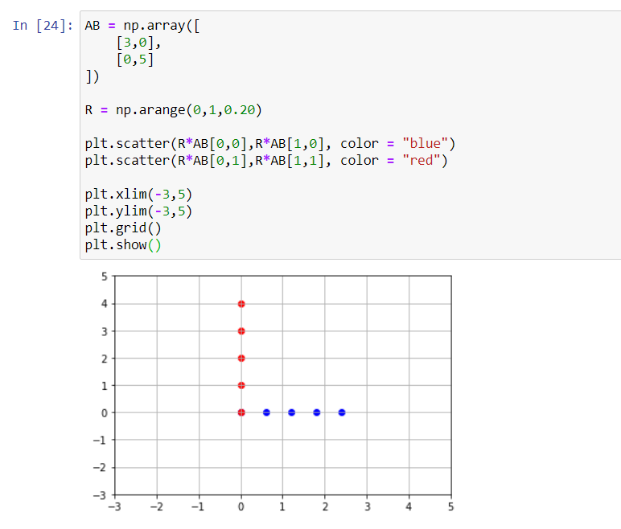

Figure 1: Codes used in the activity

In figure 1, there is a redemblance of the code in laboratory 3, since it also uses the scatterplot and the spanRx and Ry, basing from that laboratory, it is applied it here in linear transformation. Figure 1 also shows that the programmer used a scatterplot which was required for the laboratory.

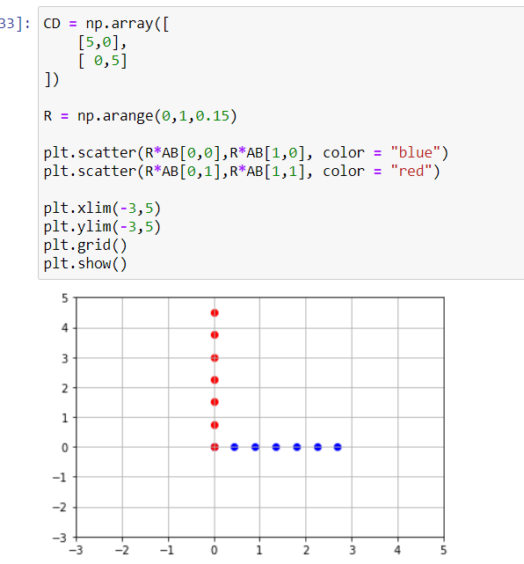

Figure 2: second example

Figure 2 shows that there are a bit of changes in the vectors below but will It change of affect the graph. The codes used are still the same, and there is not much of a difference that was changed .

# Results



Figure 3: Results of the first example

Figure 3 shows the results of the graph with the codes used by the programmer, it shows what kinds of codes that were used which was the np.array for the vectors, the np.arange for the spaces between the scatterplot [1] then we have the plt.scatterplot, so that the graph will use a scatter or the dots instead of the lines, and plt.grid and show in order to show the graph of the code.

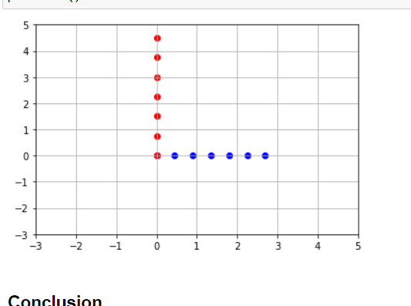

Figure : Result for 2nd Example

As for the second example it is almost the same and the principle of linear matrix was observed since the origin of the graph did not changed despite the varying array of vectors.

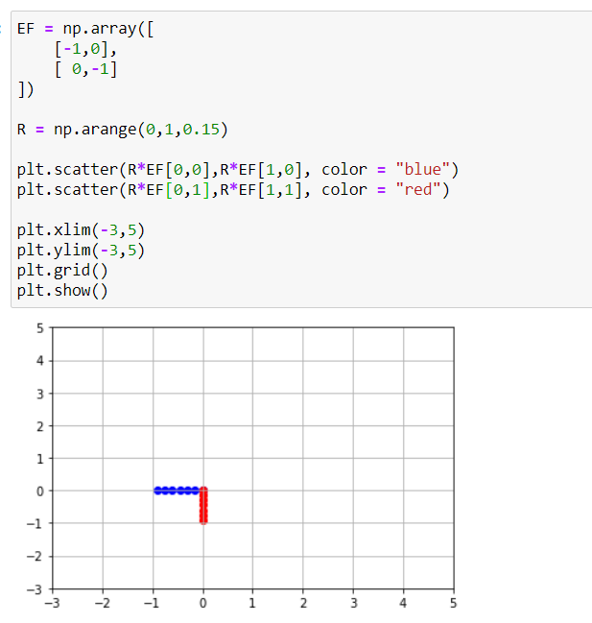

Figure : Example 3

Another example given in figure 5, but in this case the arrays that were given has negative values, but still the same princeiple, the origin did not change only the scatterplot’s direction.

# Conclusion

This activity expands the knowledge of the students in their linear algebra class, thus preparing them for their future subjects that uses linear algebra as one of the foundations in their learning blocks. The essence of linear transformation is that it conducts movements where the input and output are the way it moves, meaning the word transformation merely says a movement or change, now if those movements could be placed in technology this can achieve great things such as motor movements for robots.

When it comes to mechanics as I have said earlier it gives motor movements to technology and machines are a part of it, an example is the claw truck, imagining the way it gets dirt, its claws doesn’t leave the origin only the part below its origin in order to get the dirt, just like linear transformations, I works just like that.

**Github Repository:**

[**https://github.com/ReyesCarl/LinAlg_Lab10**](https://github.com/ReyesCarl/LinAlg_Lab10)

# References

[1] D.J.D. Lopez. “Adamson University Computer Engineering Department Honor Code,” AdU-CpE Departmental Policies, 2020.