Github actions:
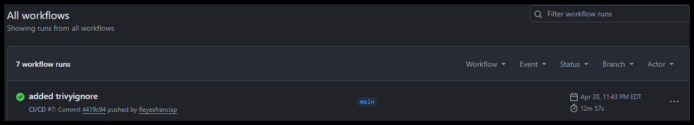

Image on docker:
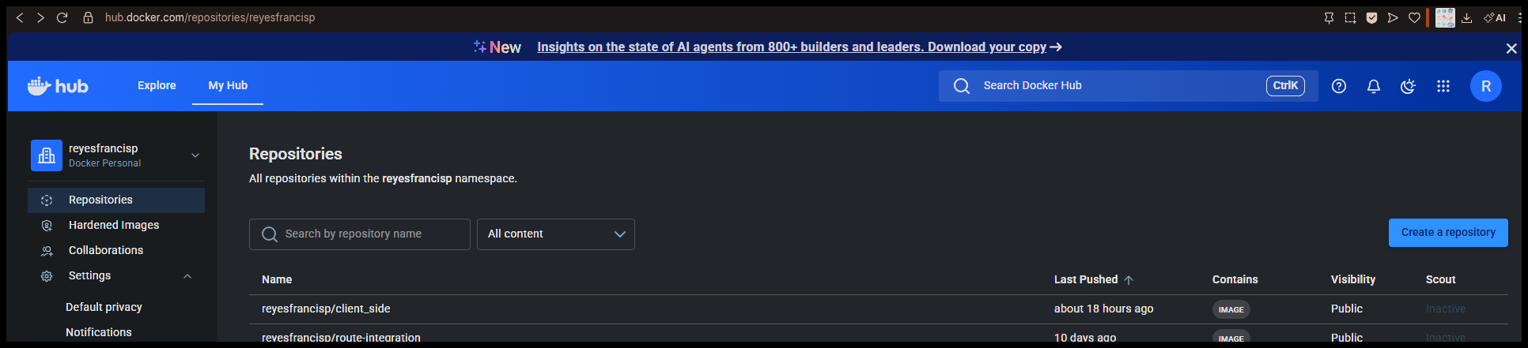

Successful Registration:
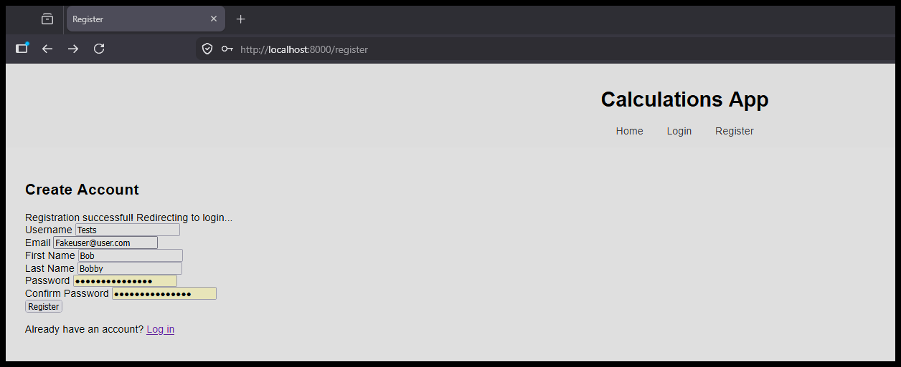

Successful login after registration:
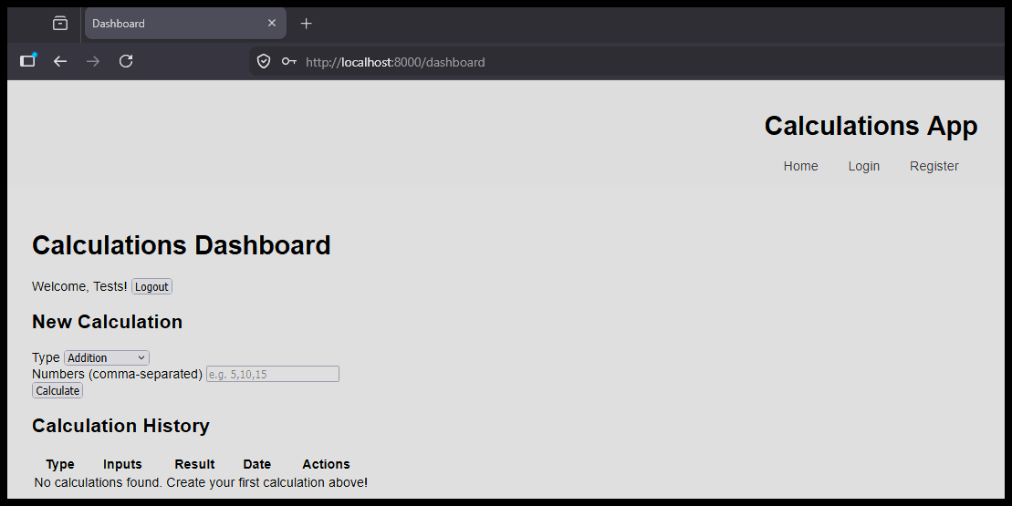

Reflection:
A lot of the issues I had already solved but manually testing this was a bit different from the others since there were a lot of fields to keep track of when it came to implementation of the front end. I ran into some hiccups trying to get the requirements set up and I didn’t spend much time testing the tests this time as it was structurally similar to the other modules I built with docker and it was more about making sure the front end implementation worked.

