Pytest:
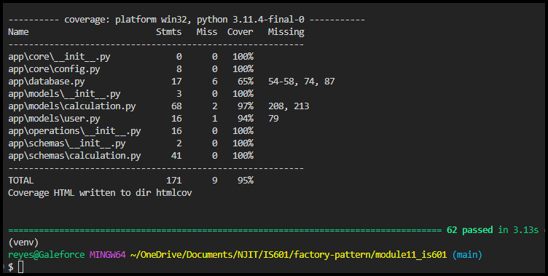
Github Actions when ran:
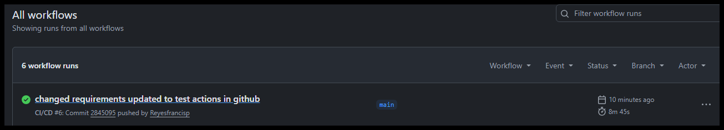
Working Dockerhub repo:
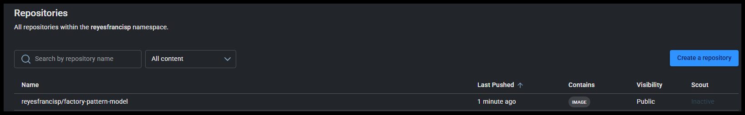
Running locally:
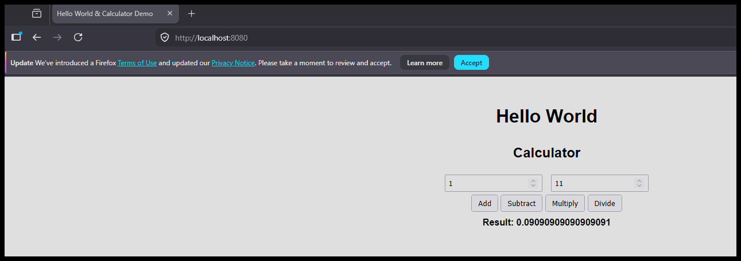

Reflection:
A lot of the challenges were similar to the previous module, I already was familiar with the changes I’d have to make in regards to certain aspects of the code that needed to be changed. After figuring out the parts with A and B that needed to be refactored and going over the test/docker files that needed to be adjusted with the requirements, it was a lot easier to get it running. I didn’t bother changing the tests and looking for 100% completion since that’s what kept the majority of my time in the other one. This one had a lot more issues in regards to dockerhub and making sure the requirements and running worked as intended. Here I managed to get the specific names and code changed so that everything functioned.
Github actions getting it to work and build was the hardest step so I wanted to make sure that worked with the green checkmark and pushed to docker as well. After getting those issues solved, adding the readme was easier.

