Registration:
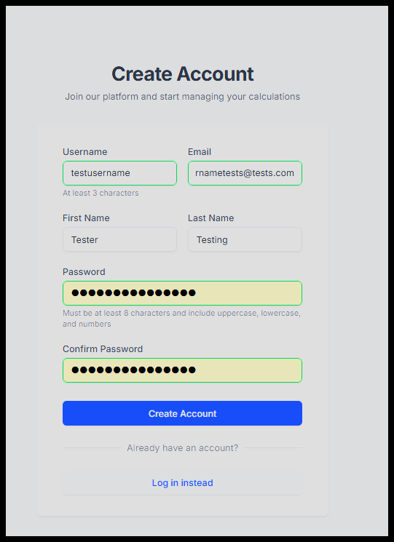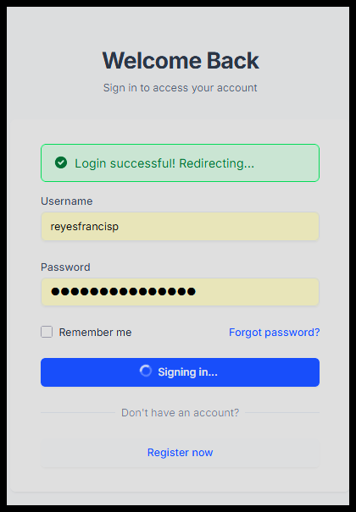
Calculation:
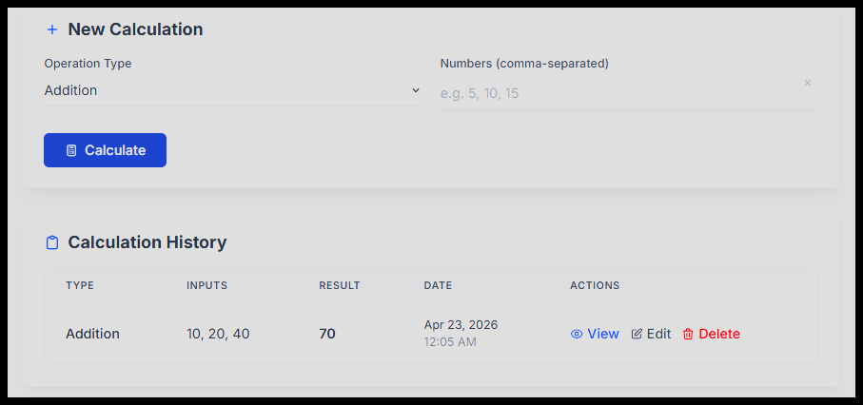

Updating Table:
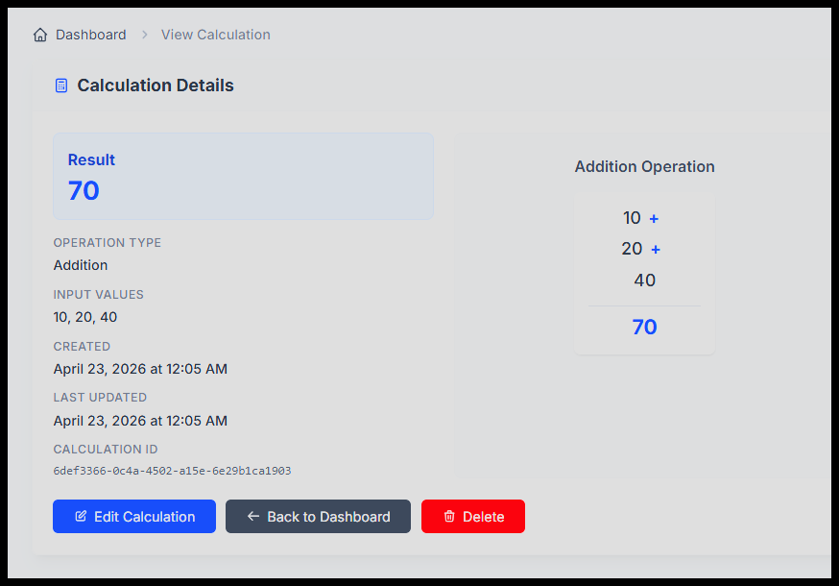
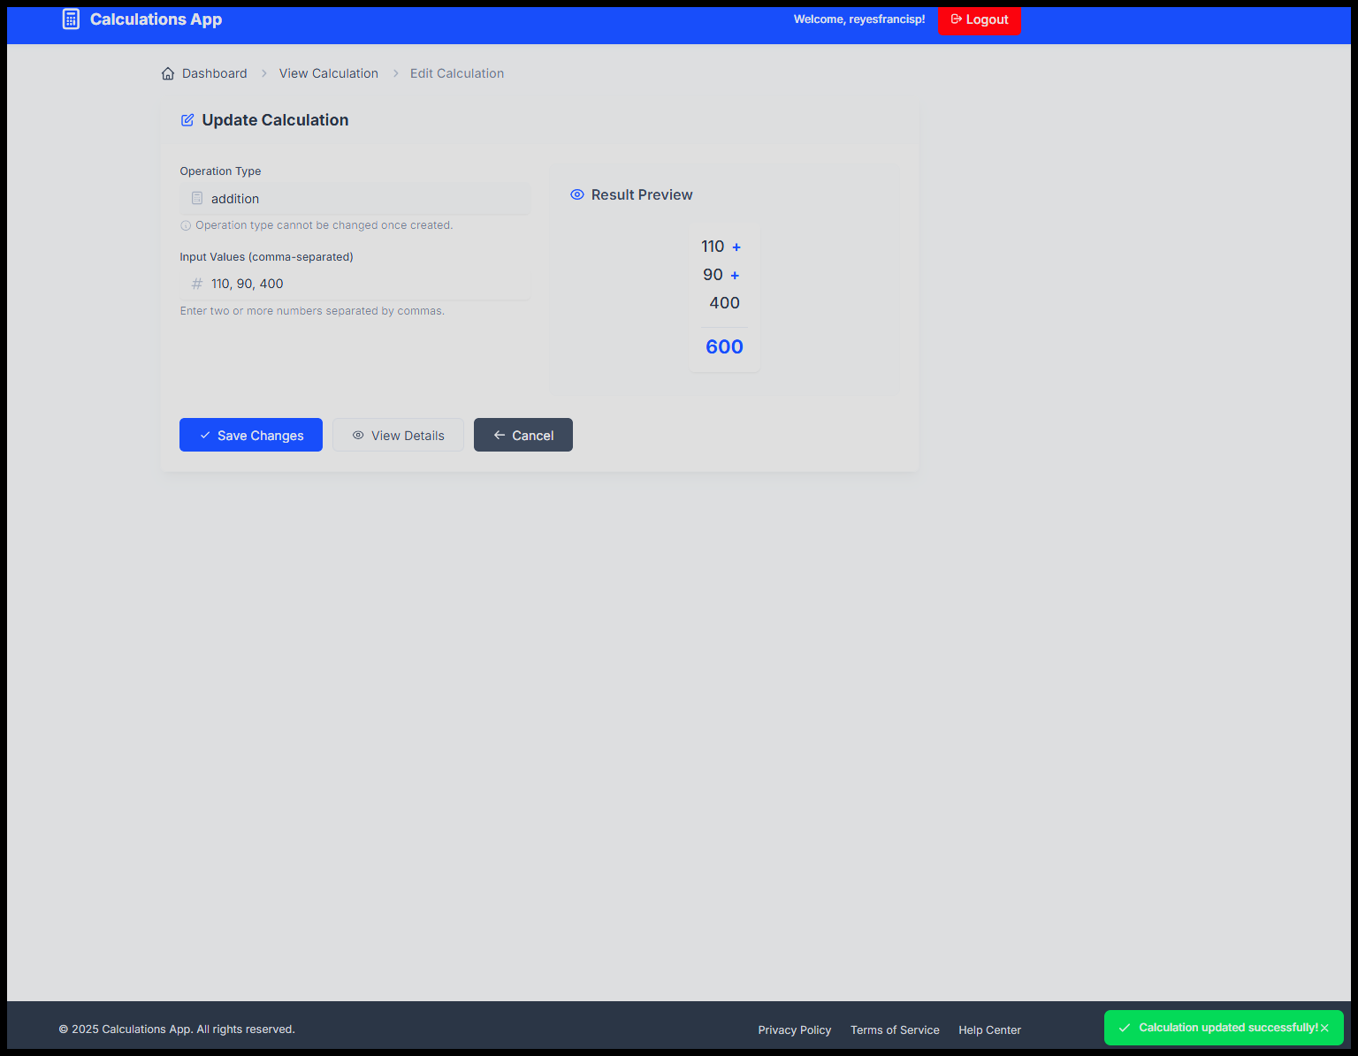

Delete:
Before:
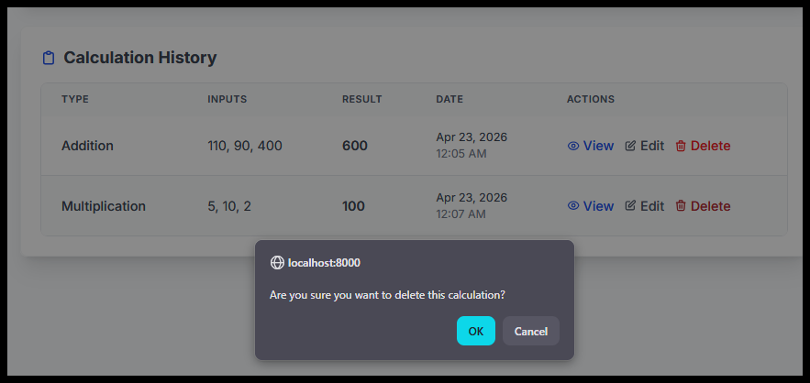
After:
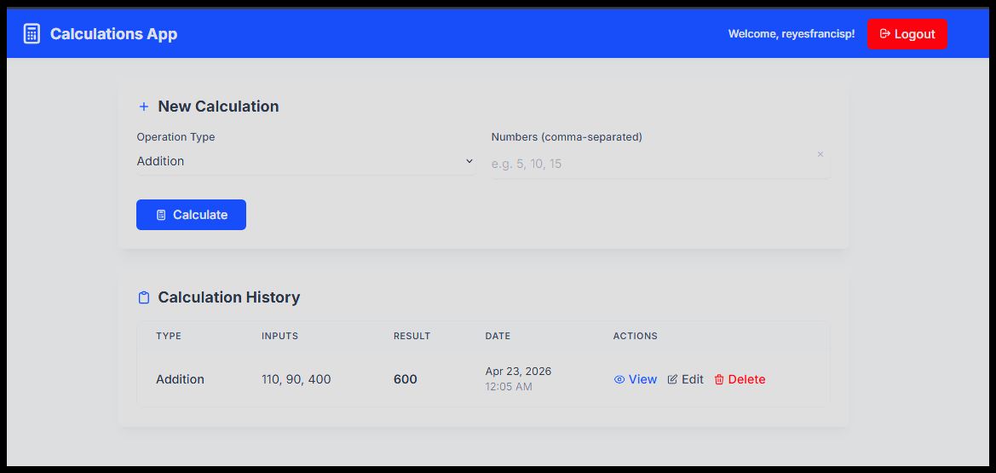
Github Actions:
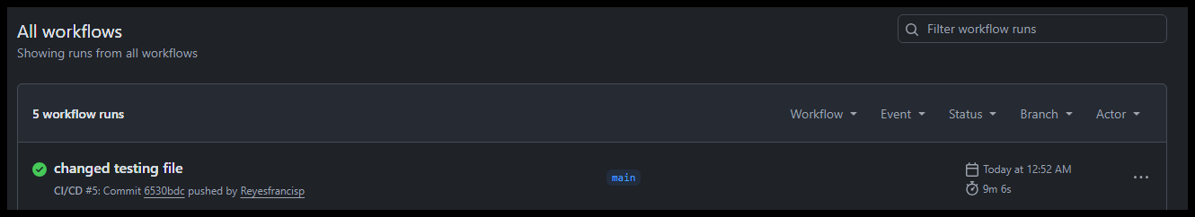

Docker:
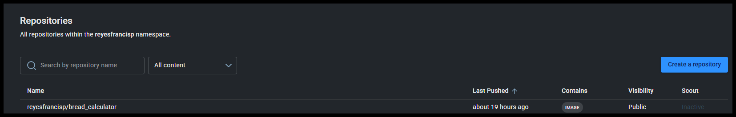
Reflection:
I was able to learn a lot about the docker program and get reacquainted with my front-end and back-end programming skills. I was able to look at the code and see that the testing parts were working before adding some code to test the bread application. A lot of the things that I did for the previous modules made this easier to compile and run correctly. I was able to do a lot of the testing locally on localhost for checking the application to see if everything was working properly which it was. The hardest part was probably taking everything I’ve learned and applying it to the current module before starting on the final project.

