Github actions:
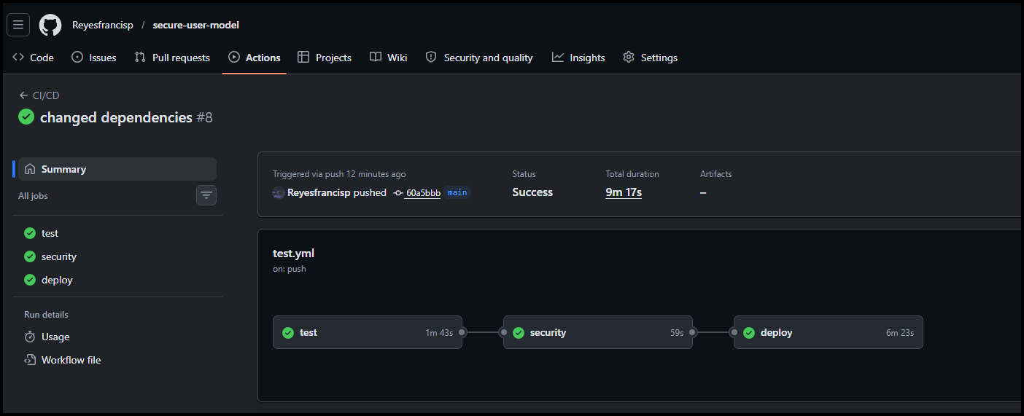

Docker image:

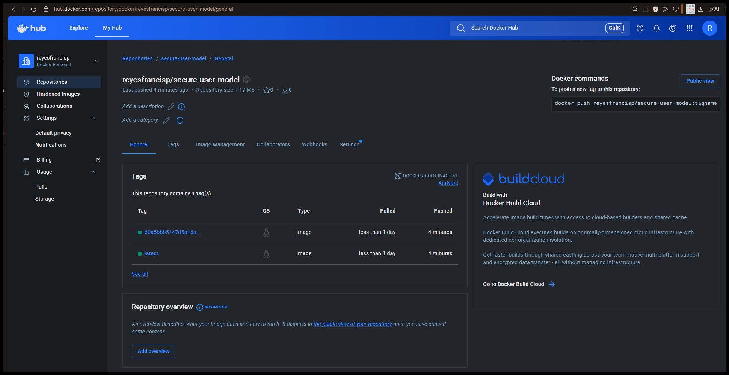

Reflection:
Developing and testing the secure FastAPI application locally was smooth, but deploying it through GitHub Actions was much harder. My first problem came during End-to-End testing. Even though tests ran perfectly on my laptop, the pipeline failed because the GitHub runner installed the Playwright Python package but not the Chromium browser or Linux dependencies. I had to update the workflow to install these before running tests.
Next, there were issues running the test with the code, causing false test failures. I switched from using Python assert statements to Playwright's expect() function, which waits for the page to update. This fixed the issue.
Finally, the Trivy security scanner blocked deployment because of a critical vulnerability in the h11 package. Updating h11 broke my build due to a dependency conflict with httpcore. I solved this by keeping the stable version and using a .trivyignore file to acknowledge the known issue while allowing deployment. There were many issues but I was able to debug and solve it so that it would run through pytest with test coverage as well as making sure it ran through the github end.
Overall, this project showed me how different cloud deployments are from local development.

