FAKTORIAL //10!

#include <stdio.h>

#include <stdlib.h>

void main()

{

int f,n;

for (int n = 1; n<= 10; n++)

{

f = 1;

for (int i = 1; i <= n; i++)

{

f *= i;

}

printf("%2d! = %d\n", n, f);

}

printf("\n");

system("Pause");

}

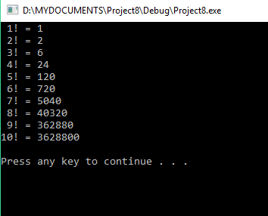

ARMSTRONG NUMBER

#include <stdio.h>

#include <stdlib.h>

#include <math.h>

void main()

{

while (1==1)

{

int n, d1, d2, d3;

printf("Enter any 3-digit number: ");

scanf_s("%d", &n);

if (n >= 1000 || n < 100)

{

printf("ERROR!\n");

break;

}

int i2 = n;

for (int i = n; i >0; i--)

{

d1 = n % 10;

d2 = n / 10 % 10;

d3 = n / 100;

}

if (pow(d1, 3) + pow(d2, 3) + pow(d3, 3) == i2)

printf("%d is an ARMSTRONG number\n", i2);

else

printf("%d is not an ARMSTRONG number\n", i2);

printf("\n");

}

system("Pause");

}

}

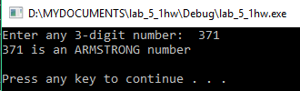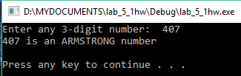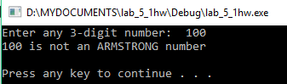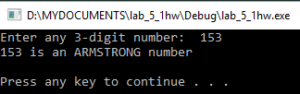

Stars

#include <stdio.h>

#include <stdlib.h>

void main()

{

int n;

printf("Enter the number of stars: ");

scanf_s("%d", &n);

for (int k = 1; k <= n; k++)

{

for (int i = 1; i <= k; i++)

printf("*");

printf("\n");

}

for (int k = n; k >= 1; k--)

{

for(int i=k;i>=1;i--)

printf("*");

printf("\n");

}

printf("\n");

system("Pause");

}

