clc;
clear;
close all;
data = importdata('input2.txt', ' ') ;
N= data(1);
for i=1:N
A(i,1)=data(4*i-2);
A(i,2)=data(4*i-1); % obstacle
A(i,3)=data(4*i);
A(i,4)=data(4*i+1);
end
S=[data(N*4+2),data(N*4+3)];
F=[data(N*4+4),data(N*4+5)];
start=S;
final=F;
plot([S(1),F(1)],[S(2),F(2)],'ro','LineWidth',2);
hold on
M=data((N+1)*4+2);
robat=zeros(M,2);
for i=1:M
robat(i,1)=data((N+1)*4+2*i+1);
robat(i,2)=data((N+1)*4+2*i+2); % yall Robat
end
V=zeros(2,M);
modified_point=transpose(robat(1,:));
for p=1:M
t=transpose(robat(p,:)-robat(1,:)); % vector V
V(:,p)=transpose(t);
end
k=0; % polynomyial
B=A;
L=1;
while size(B,1)~=0 % recognize obs
value=true;
k=k+1;
obs{k}{1}=[B(1,1);B(1,2)];
obs{k}{2}=[B(1,3);B(1,4)];
R(L,:)=[B(1,1);B(1,2)];
L=L+1;
R(L,:)=[B(1,3);B(1,4)];
L=L+1;
c1=B(1,1);
c2=B(1,2);
c3=B(1,3);
c4=B(1,4);
r=3;
B(1,:)=[];
while value==true && size(B,1)~=0
for j=1:size(B,1)
if (c3==B(j,1)) && (c4==B(j,2))
obs{k}{r}=[B(j,3);B(j,4)];
c1=B(j,1);
c2=B(j,2);
c3=B(j,3);
c4=B(j,4);
R(L,:)=[B(j,3);B(j,4)];
L=L+1;
B(j,:)=[];
r=r+1;
break
elseif c3==B(j,3) && c4==B(j,4)
obs{k}{r}=[B(j,1);B(j,2)];
c1=B(j,3);
c2=B(j,4);
c3=B(j,1);
c4=B(j,2);
R(L,:)=[B(j,1);B(j,2)];
L=L+1;
B(j,:)=[];
r=r+1;
break
elseif j==size(B,1)
value=false ;
end
end
end
s=size(R,1);
R(s,:)=[];
L=L-1;
end
n_obs=size(obs,2);
min_point=zeros(1,n_obs);
for i=1:n_obs % formation all new point for each obstacle and seperate X_min
min_x=1000;
edj=size(obs{1,i},2)-1;
for j=1:edj
for k=1:M
new_point{i}(:,(j-1)*4+k)=obs{1,i}{1,j}+V(:,k);
if min_x>new_point{i}(1,(j-1)*4+k)
min_x=new_point{i}(1,(j-1)*4+k);
min_point(i)=(j-1)*4+k;
end
end
end
end
for i=1:n_obs
n_con=size(new_point{i},2) ;
q1=new_point{i}(:,min_point(i));
qL=q1-[1;0];
qc=q1;
j=1;
con{i}(1)=min_point(i);
Poly{i}(:,1)=q1;
while con{i}(j)~=min_point(i) || j==1
alpha_min=360;
for k=1:n_con
qi=new_point{i}(:,k);
v=qi-qc;
v=cat(1,v,0);
u=qL-qc;
u=cat(1,u,0);
cos=(dot(u,v))/(norm(u)*norm(v));
K=[0;0;-1];
sin=(dot(cross(u,v),K))/(norm(u)*norm(v));
alpha=atan2(sin,cos);
if alpha<0
alpha=2*pi+alpha;
end
if alpha==0
alpha=2*pi;
end
if alpha<alpha_min
alpha_min=alpha;
next=k;
end
end
j=j+1;
qL=qc;
qc=new_point{i}(:,next);
con{i}(j)=next;
Poly{i}(:,j)=new_point{i}(:,next);
end
obs{i}=polyshape(Poly{i}(1,:),Poly{i}(2,:));
plot(obs{i});
hold on
end
k=1;
for i=1:size(con,2)
for j=1:size(con{i},2)-1
Y(k,:)=[new_point{i}(1,con{i}(j)),new_point{i}(2,con{i}(j)), new_point{i}(1,con{i}(j+1)),new_point{i}(2,con{i}(j+1))];
k=k+1;
end
end
A=Y;
N=k-1;
A=int64(A);
Warning: Polyshape has duplicate vertices, intersections, or other
inconsistencies that may produce inaccurate or unexpected results. Input data
has been modified to create a well-defined polyshape.
Warning: Polyshape has duplicate vertices, intersections, or other
inconsistencies that may produce inaccurate or unexpected results. Input data
has been modified to create a well-defined polyshape.
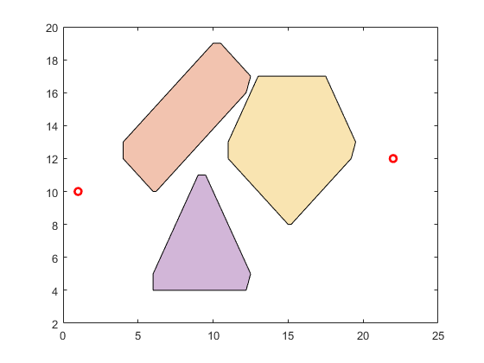
Published with MATLAB® R2021b

