CLINICAL GENOMICS REPORT: WHOLE EXOME SEQUENCING (WES)
Project Title: Genetic Evaluation of Developmental Delay and Manifestations in an Affected Family
Author: Reyhaneh Foroughi
Affiliation: International Genomics Fellowship between the Genomics Research Laboratory (Iran) and the Helix Institute of Medical and Biological Sciences (USA)
Project Duration: June 22, 2026 – September 22, 2026

Analysis Type: Clinical Whole Exome Sequencing (WES) & Variant Prioritization

CLINICAL INFORMATION & PEDIGREE ANALYSIS
- Proband: Individual III-1 (indicated by the arrow in the pedigree).
- Family History: The proband was born to non-consanguineous parents (II-1 and II-2). The pedigree shows three affected children across both sexes (two females [III-1, III-4] and one male [III-7]) alongside three unaffected siblings.
- Clinical Indications & Phenotype:
  - Intellectual Disability (mild-to-moderate / trainable)
  - Global Developmental Delay (GDD)
  - Strabismus (ocular deviation)
- Inheritance Pattern Assessment: The involvement of both male and female offspring born to unaffected parents strongly indicates an Autosomal Recessive (AR) mode of inheritance. In the absence of documented parental consanguinity, causative variants may present either as compound heterozygous alleles or as homozygous mutations resulting from remote ancestral consanguinity.
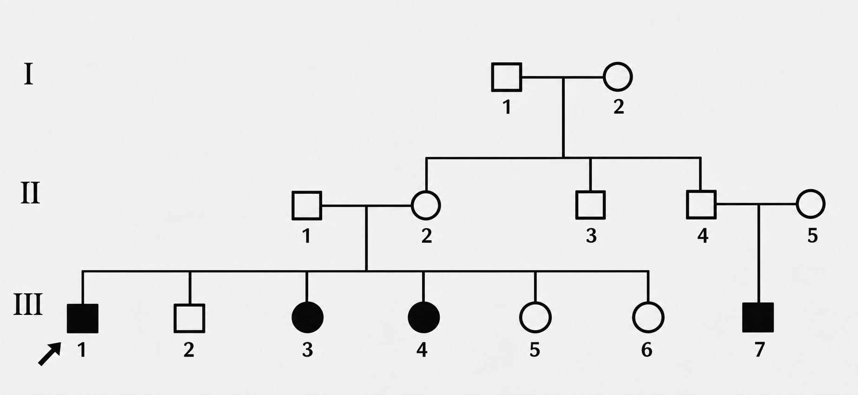

2. METHODOLOGY: WHOLE EXOME SEQUENCING (WES)
- Exome Capture & Sequencing: Whole Exome Sequencing was performed on genomic DNA extracted from the proband. Exonic targets covering approximately 1–2% of the human genome (encompassing >85% of known disease-causing mutations) were captured via hybrid-enrichment platforms and sequenced on a high-throughput NGS platform with high mean target coverage (>100×).
- Bioinformatics Pipeline & VCF Generation: Raw sequencing reads (FASTQ) underwent quality control, adapter removal, and alignment to the reference genome (GRCh38/hg38) using BWA-MEM. Duplicate reads were flagged with Picard, followed by Base Quality Score Recalibration (BQSR). Single-nucleotide variants (SNVs) and small indels were called using GATK HaplotypeCaller to produce a standard Variant Call Format (VCF) file.

3. VARIANT FILTRATION & PRIORITIZATION STRATEGY
Variants within the VCF file were systematically filtered and prioritized through the following protocol:
- Quality & Depth Filtering: Retained variants with PASS flags, read depth \ge 10\times, and balanced allele ratios.
- Population Frequency Filter: Filtered against public population databases (gnomAD and 1000 Genomes Project). Common polymorphisms were removed, retaining rare variants with a minor allele frequency (MAF) < 0.01 (< 1\%).
- Genomic Consequence: Focused on protein-altering coding variants (missense, nonsense, frameshift) and canonical splice-site junctions (\pm 1, 2 bp).
- ACMG/AMP Classification & ClinVar Evaluation: Candidate variants in both identified genes were evaluated using ACMG/AMP clinical guidelines and queried against ClinVar. Variants identified in both SYNE1 and NBN are currently classified as Variants of Uncertain Significance (VUS) in ClinVar and under ACMG guidelines. Detailed phenotypic matching, scientific literature reviews, and familial co-segregation studies are therefore required to clarify their pathogenicity.
- Phenotypic Concordance via OMIM: Filtered candidate genes were cross-referenced against OMIM records correlating with cognitive impairment, developmental delay, and strabismus.

4. CANDIDATE GENES EVALUATION & SCIENTIFIC EVIDENCE

A. Candidate Gene 1: SYNE1 (Spectrin Repeat Containing Nuclear Envelope Protein 1)
OMIM Identifiers: Gene: *608441 | Associated Phenotype: Spinocerebellar Ataxia, Autosomal Recessive 8 (SCAR8 / ARCA1) – #610743; Emery-Dreifuss Muscular Dystrophy; Autosomal Recessive Cognitive Delay
- Clinical Classification: The identified variant, c.7324C>T, is classified as a Variant of Uncertain Significance (VUS) based on ACMG/AMP guidelines and ClinVar entries.
- Biological Function: SYNE1 encodes nesprin-1, a nuclear envelope protein that anchors the outer nuclear membrane to the actin cytoskeleton (LINC complex). It is critical for nuclear positioning, neurogenesis, and the structural integrity of neuronal and neuromuscular junctions.
- Phenotypic Correlation & Evidence:
  - Although classical SYNE1 mutations lead to adolescent- or adult-onset ataxia, modern exome cohort studies demonstrate that the phenotypic spectrum includes early-onset global developmental delay, intellectual disability, and prominent oculomotor abnormalities, specifically strabismus and oculomotor apraxia.
  - Cerebellar and cranial nerve circuit disruption secondary to defective nesprin-1 function provides a biological basis for the cognitive delay and strabismus observed in the affected siblings.

B. Candidate Gene 2: NBN (Nibrin)
- OMIM Identifiers: Gene: *602667 | Associated Phenotype: Nijmegen Breakage Syndrome (NBS) – #251260
- Clinical Classification: The identified variant, c.633T>A, is classified as a Variant of Uncertain Significance (VUS) based on ACMG/AMP guidelines and ClinVar entries.
- Biological Function: The NBN gene encodes nibrin, an essential component of the MRN complex (composed of MRE11, RAD50, and NBN). The MRN complex serves as a primary sensor of DNA double-strand breaks (DSBs), coordinating DNA repair pathways and cell-cycle checkpoint activation.
- Phenotypic Correlation & Literature Support:
  - Autosomal recessive NBN defects lead to Nijmegen breakage syndrome, which is classically associated with microcephaly, immunodeficiency, radiosensitivity, and a predisposition to lymphoid malignancies. From a neurodevelopmental perspective, affected individuals consistently show neuropsychomotor developmental delay and mild-to-moderate/trainable intellectual disability.
  - Regarding the ocular phenotype, strabismus has been established in the literature as an associated feature. Specifically, Maraschio et al. (2001, Journal of Medical Genetics, 38: 113–117) documented a patient with a homozygous NBN mutation (a 25-bp deletion in exon 8: 900del25). Clinical examination revealed:
"Physical examination showed a 'bird-like' face with strabismus, downward slanting palpebral fissures, large and low set dysmorphic ears, and a high palate..." The patient also presented with significant neuropsychomotor developmental delay.
  - This evidence confirms that strabismus combined with developmental delay and trainable cognitive impairment falls within the expanded clinical spectrum of NBN deficiency.

Recommended Actions:
Sanger Sequencing & Familial Segregation Analysis: Because both candidate variants are currently classified as VUS, validate each variant via Sanger sequencing in the proband (III-1) and test the parents (II-1, II-2), affected siblings (III-4, III-3), and unaffected siblings (III-2, III-5, III-6) to verify strict co-segregation with the disease phenotype.

