Reporte de la Situación Problema
Equipo 4
2026-08-19
Table of contents

Etapa 1. Conociendo el negocio
Cambio prueba
library(maps)
map('world')
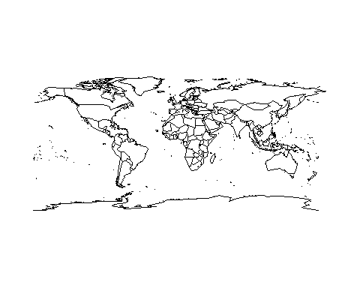
Para esta primera etapa, empezaremos por cargar las librerías que necesitamos y establecemos algunas opciones de configuración:
library(tidyverse)
library(here)
library(readxl)
options(scipen = 999)
Ahora cargamos los datos que nos proporcionó el Socio Formador. Para los datos del 2024 tenemos:
calidad_aire_2024_tbl <- read_excel(here("data", "BD 2024.xlsx")) %>%
glimpse()
Rows: 8,784
Columns: 16
$ `Fecha y hora` <dttm> 2024-01-01 00:00:00, 2024-01-01 01:00:00, 2024-01-01…
$ `CO (ppm)` <dbl> 2.08, 2.07, 2.36, 2.11, 1.94, 1.79, 1.59, 1.53, 1.65,…
$ `NO (ppb)` <dbl> 10.5, 10.5, 16.9, 13.6, 8.5, 7.4, 7.4, 7.0, 8.4, 6.1,…
$ `NO2 (ppb)` <dbl> 23.3, 23.4, 30.0, 26.6, 20.6, 16.3, 14.2, 12.3, 19.8,…
$ `NOX (ppb)` <dbl> 33.8, 33.9, 46.9, 40.1, 29.2, 23.6, 21.5, 19.2, 28.2,…
$ `O3 (ppb)` <dbl> 13, 13, 7, 7, 13, 15, 21, 22, 18, 37, 42, 45, 45, 48,…
$ `PM10 (ug/m3)` <dbl> 81, 81, 84, 132, 93, 62, 42, 26, 29, 40, 28, 28, 30, …
$ `PM2.5 (ug/m3)` <dbl> 60.00, 60.52, NA, 64.69, 44.13, 28.90, 16.64, 12.57, …
$ `PRS (mmHg)` <dbl> 724.5, 724.5, 724.6, 724.7, 724.7, 724.7, 724.7, 725.…
$ `RAINF (mm/h)` <dbl> 0, 0, 0, 0, 0, 0, 0, 0, 0, 0, 0, 0, 0, 0, 0, 0, 0, 0,…
$ `RH (%)` <dbl> 58, 58, 61, 62, 53, 55, 42, 43, 48, 43, 35, 33, 36, 3…
$ `SO2 (ppb)` <dbl> 2.9, 2.9, 3.2, 3.2, 3.2, 2.9, 3.2, 2.9, 3.7, 6.2, 6.4…
$ `SR (kW/m2)` <dbl> 0.000, 0.000, 0.000, 0.000, 0.000, 0.000, 0.000, 0.00…
$ `TOUT (ºC)` <dbl> 14.26, 14.28, 13.50, 13.18, 14.62, 13.96, 16.39, 15.9…
$ `WSR (km/h)` <dbl> 5.8, 5.9, 3.7, 7.1, 8.4, 7.6, 9.7, 9.6, 5.8, 5.2, 6.3…
$ `WDR (azimutal)` <dbl> 290, 289, 291, 291, 297, 292, 283, 291, 223, 164, 163…
Para los datos del 2025 tenemos:
calidad_aire_2025_tbl <- read_excel(here("data", "BD 2025.xlsx")) %>%
glimpse()
Rows: 4,344
Columns: 16
$ date <dttm> NA, 2025-01-01 00:00:00, 2025-01-01 01:00:00, 2025-01-01 02:00:…
$ CO <chr> "ppm", NA, "0.18", "0.18", "0.19", "0.18", "0.17", "0.17", "0.17…
$ NO <chr> "ppb", NA, "2.6", "2.8", "3.1", "2.8", "2.6", "2.6", "3", "8.1",…
$ NO2 <chr> "ppb", NA, "7.5", "13.5", "15.1", "12.8", "4.8", "4.2", "9.80000…
$ NOX <chr> "ppb", NA, "10.1", "16.2", "18.100000000000001", "15.6", "7.4", …
$ O3 <chr> "ppb", "36", "37", "26", "22", "24", "33", "36", "21", "9", "9",…
$ PM10 <dbl> NA, 104, 58, 79, 66, 48, 46, 35, 41, 42, 43, 43, 80, 51, 47, 47,…
$ PM2.5 <dbl> NA, 31.00, 30.84, 49.92, 45.87, 35.65, 31.14, 27.43, 25.33, 28.4…
$ PRS <chr> "mmHg", NA, "725.1", "725.1", "725.1", "725.1", "725.5", "725.9"…
$ RAINF <chr> "mmh", NA, "0", "0", "0", "0", "0", "0", "0", "0", "0", "0", "0"…
$ RH <chr> "%", NA, "66", "66", "74", "76", "86", "87", "85", "86", "84", "…
$ SO2 <chr> "ppb", NA, "4.0999999999999996", "4.3", "4.0999999999999996", "4…
$ SR <chr> "kW/m2", NA, "0", "0", "0", "0", "0", "0", "0", "6.0000000000000…
$ TOUT <chr> "°C", NA, "17.62", "16.579999999999998", "15.5", "15.03", "14.32…
$ WSR <chr> "km/h", NA, "10.7", "5.3", "5.3", "5", "8.6999999999999993", "7.…
$ WDR <chr> "Azimutal", NA, "136", "255", "250", "181", "91", "104", "263", …

