Which of the following is NOT an input to the Plan Communications process?

Organizational process assets

Information gathering techniques v

Project scope statement

Enterprise environmental factors

Which of the following statements is true regarding the Project Management Knowledge Areas?

They include Initiation. Planning. Executing. Monitoring and Controlling. and Closing v

They consist of nine areas that bring together processes that have things in common.

They consist of five processes that bring together phases of projects that have things in common.

They include Planning. Executing. and Monitoring and Controlling processes because these three processes are commonly interlinked.

You can identify project milestones by:

Assigning a duration of zero days to the milestone task. v

Any of the other answer.

Choosing the appropriate task on the task list and applying boldface.

Indenting the task on the task list.

When a project manager is engaged in negotiations. nonverbal communication skills are of:

Major importance. v

Importance to ensure he wins the negotiation.

Importance only when cost and schedule objectives are involved.

Little importance.

A project manager has a problem with a team members performance. What is BEST form of communication for addressing this problem?

Informal written communication

Informal verbal communication v

Formal written communication

Formal verbal communication

Given this portion of the network diagram to the right, whats the LF of activity F?

11

10 v

16

17

[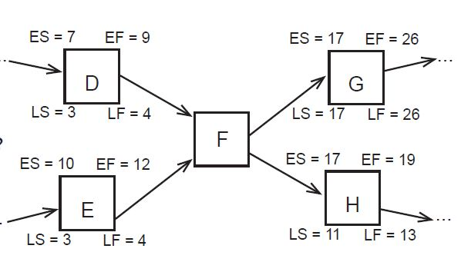](https://www.examprofessor.com/accounts/exams/22542/722074_28155274-5056-A028-F36CDD34E54A9D6D.JPG)

Youre a project manager for a construction project. Youve just finished creating a list of all of the people who will be directly affected by the project. What process group are you in?

Executing v

Monitoring & Controlling

Planning

Initiating

Given the network diagram below, whats the critical path?

Start-A-B-C-End v

Start-E-D-C-End

Start-E-F-G-End

Start-A-D-G-End

[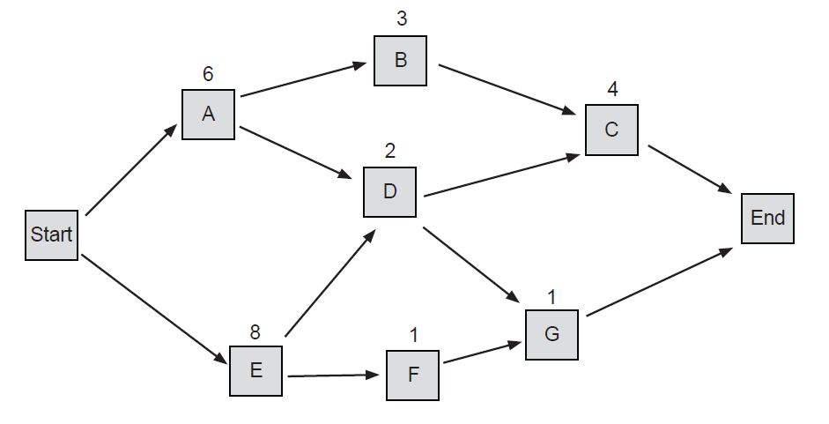](https://www.examprofessor.com/accounts/exams/22542/722083_2819507C-5056-A028-F3F0864FAD7FC5AF.JPG)

A project manager is having trouble securing programmers for her project. Every time she asks the programming manager for resources for her project he says they're all assigned to other work. So she is constantly having to go over his head to overrule him. Which type of organization is she working for?

Functional

Strong Matrix v

Weak Matrix

Projectized

Which of the following are tools and techniques of the Identify Stakeholder process?

Stakeholder analysis and expert judgment v

Stakeholder analysis expert judgment and stakeholder register

Stakeholder analysis

Stakeholder analysis stakeholder management strategy and expert judgment

What is one of the most important skills a project manager can have?

Negotiation skills

Influencing skills

Communication skills v

Problem-solving skills

Given this portion of the network diagram to the right what's the ES of activity F?

9

10

12

13 v

[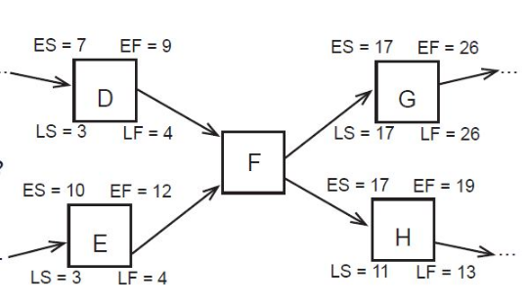](https://www.examprofessor.com/accounts/exams/26441/859281_B0F7429D-9F7B-413D-A7762B15EAF30FB4.PNG)

Which communication process is in the Monitoring & Controlling process group?

Manage Stakeholder Expectations

Report Performance v

Plan Communications

Distribute Information

Given the network diagram below what's the critical path?

Start-A-B-C-End

Start-A-D-G-End

Start-E-D-C-End v

Start-E-F-G-End

[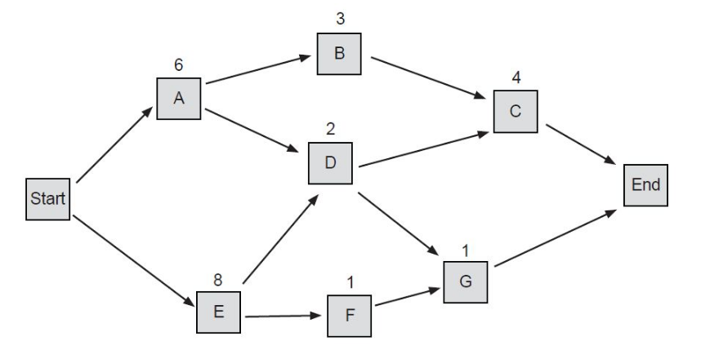](https://www.examprofessor.com/accounts/exams/26441/859291_B9228681-D947-4E71-B0FAA1456606F6EA.PNG)

Which of the following statements is true regarding the Project Management Knowledge Areas?

They include Initiation Planning Executing Monitoring and Controlling and Closing v

They consist of nine areas that bring together processes that have things in common.

They consist of five processes that bring together phases of projects that have things in common.

They include Planning Executing and Monitoring and Controlling processes because these three processes are commonly interlinked.