Threadfin links B-cell receptor families to germinal-centre cell-state distributions
Chen Zhu
Department of Microbiology and Immunology, Peter Doherty Institute for Infection and Immunity, The University of Melbourne, Melbourne, Australia
Draft 5, 9 October 2026. Additional authors, corresponding-author details, funding and declarations require author confirmation. This draft follows the formatting and numbered-reference conventions of the supplied progress-review document.

Abstract
Germinal-centre B cells can share a receptor family while occupying different expression states. Threadfin summarises these captured state distributions using receptor-excluded expression profiles, context adjustment and sampling-dependent shrinkage. Applications to model-antigen and Plasmodium responses distinguish clone membership, state occupancy and measured division history without equating an expression map with a lineage tree. We then test the framework beyond BCR-defined families. In lineage-barcoded mouse haematopoiesis, a separate day-2 expression model predicts later observed state composition for 172 eligible barcodes, with modest improvements over RNA means on some endpoints. Longitudinal profiles of 124,534 cells with unambiguous paired TCRs from ten patients retain same-clone state similarity relative to patient-, interval- and capture-matched comparisons. Independent reporter readouts favour simple RNA means over Threadfin on the division endpoint, whereas disjoint-cell validation shows that shrinkage reduces low-capture profile estimation error by 27% when two cells are sampled. These complementary tests support sampling-aware descriptions of clone-state distributions and identify where additional representation complexity helps. They do not establish BCR differentiation direction, complete developmental potential or clinical response prediction.

Introduction
The GC reaction couples receptor evolution to changing B-cell states. A selected light-zone cell can enter a proliferative burst, whereas cells associated with antibody-secreting and memory outputs express different programmes. Experimental reporters and direct sorting resolve parts of this process (1, 2, 3). An expression snapshot alone, however, does not establish whether a cell will divide again, leave the GC or participate in a later recall response.
A BCR-defined clone provides an additional unit of observation: a family of cells whose receptor sequences support common ancestry within one individual. Its captured cells may favour a particular state or span several states. This family-wide distribution cannot always be represented by a single average cell. It also separates two relationships that are often confused: related cells within a BCR family, and distinct families with similar expression profiles.
We developed Threadfin to ask which states clones occupy, what independently measured properties explain those distributions, and what persists when the same clone is sampled again. The expression embedding excludes receptor genes; clone membership is established separately from sequence. A clone UMAP therefore visualises similarities between captured state distributions rather than inferring ancestors or descendants from transcriptional proximity.
Existing tools already link repertoire information to expression. Benisse and BiGCN learn joint representations; clone2vec summarises whole-clone variation from expression neighbourhoods, including sparsely sampled clones (4, 5, 6). CoMBCR also co-learns paired receptor and expression representations for cell-level functional tasks (7). Repertoire workflows such as Dandelion, Scirpy and Platypus provide complementary annotation and joint analysis (8, 9, 10). Threadfin therefore focuses on an auditable GC workflow: sequence-defined membership, sampling-adjusted state profiles, profile reliability, conditional controls and measurements supplied by the original experiments. A clone embedding alone is not the claimed contribution.
Here we concentrate on datasets with strong biological anchors: two GC reporter cohorts from a model-antigen/vaccine study (1), a direct GC/plasma-cell sort study (2), a time-resolved Plasmodium infection with an anti-malarial intervention (11), and repeated human GC sampling after mRNA vaccination (12). One non-GC marrow/blood study checks receptor identity across terminal-state sorts (13). Other tested datasets document coverage rather than carrying the main biological claims. This organisation distinguishes an interpretable association from a demonstrated fate mechanism.

Results

Clone interpretation requires separate receptor, state and sampling records
Figure 1 defines the biological questions. Sequence similarity within a donor supports clonal membership. Expression identifies a captured cell's state. A clone profile describes the distribution of those states relative to the cells sampled beside that clone, with reliability determined by captured size and estimated within-clone resemblance. Similar clone profiles indicate similar behaviour of different families, not a common ancestor of those families.
This distinction changes the reading of a clone map. A cluster of GC-dominated profiles is a set of families with related GC-state distributions; it does not identify a lineage that will remain in the GC. A family with both GC and plasmablast cells demonstrates co-observed states within a sequence-defined relationship; it does not identify which cell produced the other. A reliable state-retention estimate requires separate snapshots of the same donor's family. We use different experiments for these different questions.
Figure 1 makes this integration explicit in one concept diagram. A compact three-cluster scRNA-seq map describes cellular expression states, while membrane BCR, paired heavy/light contigs and separately rooted receptor-family trees illustrate the sequence information. RNA-cluster colours and receptor-family colours encode different memberships; they are not matched one-to-one. Both measurements connect through the extended fin filaments of a cartoon threadfin fish, which represents integrated clone embeddings. Its double-peak sketch illustrates RNA distributions; the Fréchet-mean label describes the unshrunk mean of RNA feature vectors under squared feature-space distance. The implemented profiles additionally use context adjustment, reliability-dependent shrinkage and projection; this is not an optimal-transport solver. Two further filaments connect to complementary patterns. The upper pseudo-UMAP links cycling, selection-associated and output-like family states, motivating the model-antigen GC analysis in Figure 2. A gold outline highlights the selection node. Its dashed return to cycling marks a recycling hypothesis; snapshots alone cannot distinguish progression from return. The lower, more linear map uses a vivid blue–teal–amber–rose gradient to illustrate continuous cycling-to-output profile variation, motivating Figure 3's maturation questions without transferring a selection-node interpretation to infection data. All clone dots are circles, with synthetic captured-cell counts controlling their area. Larger central dots are a compositional choice, not a rule connecting UMAP centrality to clone size. Every coordinate, count and tree branch is illustrative: the studies are not pooled, and no phylogeny or temporal trajectory is estimated by this diagram. The default numerical profiles use RNA kernel features with context adjustment and reliability-dependent shrinkage.
Profile reliability prevents very small repertoires from yielding unsupported programme claims. The direct NP-OVA GC/plasma-cell dataset contains 884 captured cells, 762 with a called receptor, and 388 cells in 113 expanded clones. Only three profiles reach reliability 0.5. Its coherence test is not significant (p=0.224), and programme inference is declined. The direct sort labels remain useful for descriptive clone examples, without validating a future-fate model (Supplementary Figure 1). The centroid-based exploration shown next uses 377 donor-restricted V–D–J receptor groups with at least one captured cell from the same cohort. Descriptive state bias in that map is kept separate from reliability-filtered programme inference.

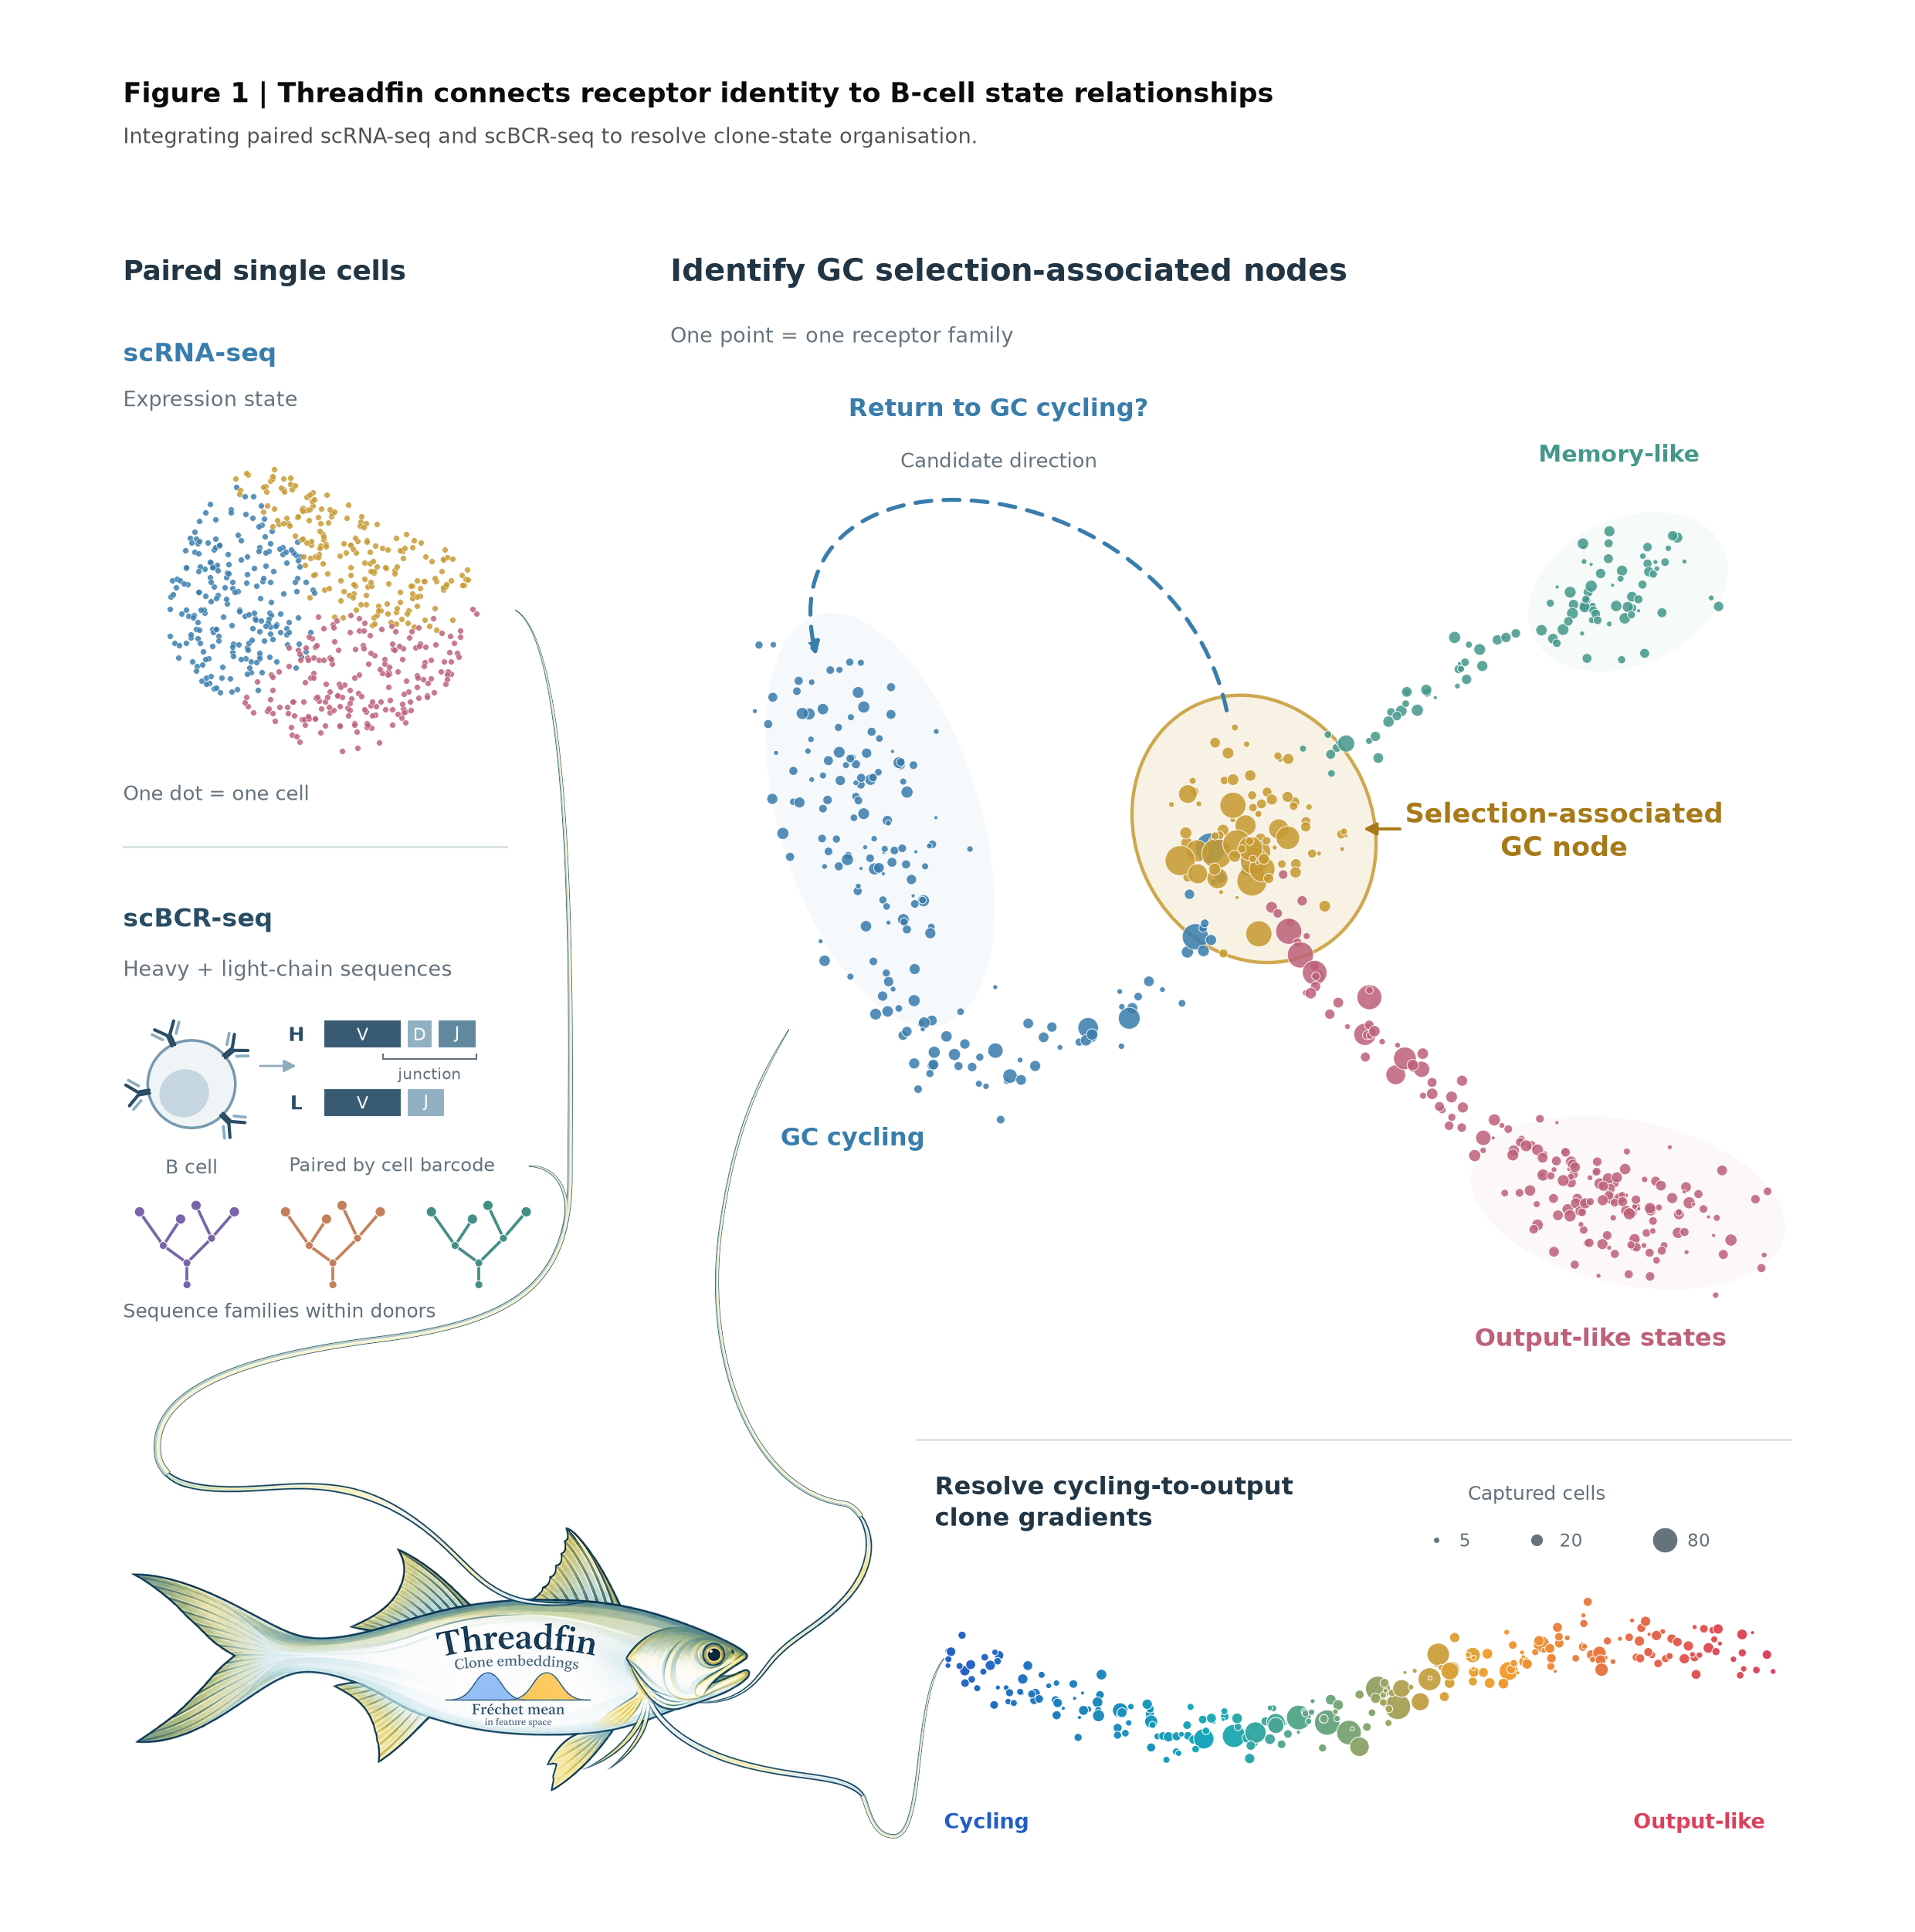

Figure 1 Threadfin connects receptor identity to B-cell state relationships. Paired inputs and integration (left): the compact three-colour scRNA-seq cloud illustrates expression-state clusters. Original membrane-BCR and heavy/light V(D)J-contig glyphs depict receptor sequencing. Three separately rooted miniature trees, each with a different family colour, illustrate sequence relationships within distinct receptor families; they are neither measured phylogenies nor ancestry links between families. Their colours encode receptor membership, not RNA-state labels, and no one-to-one correspondence between RNA clusters and receptor families is imposed. Threadfin defines families within donors using IGH V/J and junction similarity, with optional light-chain refinement. A cartoon threadfin fish represents integration: the paired measurement paths join an incoming fin filament, and two outgoing filaments connect the resulting conceptual landscapes. The filaments are workflow connectors, not biological lineage edges. The belly's double-peak sketch represents RNA distributions. Its Fréchet-mean label describes the unshrunk averaging stage: the mean of a family's RNA feature vectors minimises squared feature-space distances. The default kernel profiles additionally use context adjustment, reliability-dependent shrinkage and projection; the drawing does not imply an optimal-transport solver. The user-approved fish illustration is an AI-generated PNG based on a supplied fish reference, embedded with its transparent background and original aspect ratio. Scientific plots and receptor schematics remain vector artwork. The workflow connections are drawn as tapered fin extensions, with pale gold and blue-green shading matched to the fish. Branched GC landscape (upper right): every circle denotes one illustrative family. Colour indicates its dominant captured RNA state, and point area is proportional to a synthetic captured-cell count. Some central families are drawn larger to illustrate expansion; central position does not imply greater clone size in empirical embeddings. A gold outline and aligned label emphasise the selection-associated node relevant to Figure 2's model-antigen GC analysis; the outline is an annotation, not a confidence region. The dashed return to cycling is a candidate recycling mechanism, not an estimated trajectory. Co-occupancy alone cannot distinguish forward progression from return, and direction requires independent lineage or informative temporal evidence. No memory-to-GC re-entry or future fate is demonstrated. Continuous landscape (lower right): a separate, more linear pseudo-UMAP illustrates gradual clone-profile variation relevant to Figure 3's GC/output and maturation questions. A vivid blue–teal–amber–rose gradient represents an illustrative balance of cycling and output-associated programmes; intermediate colours indicate intermediate profiles, not separate categorical states. It introduces neither a selection node into infection data nor a temporal direction. All coordinates, counts, tree branches and compositions in this figure are synthetic. The maps are alternative patterns, not aligned samples or a pooled analysis; different mice are not linked into a single clonal time course. Map neighbourhoods represent profile similarity, not ancestry between families. Figure 2B's historical centroid reconstruction remains distinct from the default kernel-profile workflow illustrated here.

In controlled GC models, clone reclustering distinguishes captured GC and output state biases
The independent day-14 NP-OVA GC/output-sort dataset, GSE246382, samples light-zone, dark-zone, Myc-positive light-zone and plasma-cell compartments (2). Figure 2B shows a newly calculated reconstruction of the historical clone-embedding workflow. Its 377 points are donor-restricted productive IGH V–D–J receptor groups, retaining at least one captured cell and covering 762 receptor-called cells from 11 mice. This historical-style receptor grouping differs from the 487 stricter same-mouse V/J/junction-sequence families used by the main case-study pipeline: 83 of the 377 V–D–J groups contain more than one distinct junction nucleotide sequence. Accordingly, these points are receptor groups and are not assumed to be individual sequence-defined clonal lineages.
The cell UMAP is reconstructed from the notebook code; group centres are means of those cell coordinates, accumulated in float64 by the package. Euclidean UMAP embeds the rows of their pairwise distance matrix (40 neighbours, min_dist 0.65, seed 123), followed by a Scanpy graph on group coordinates (15 neighbours) and Leiden at resolution 0.3 (seed 0). Colours denote clone_cluster and point area is proportional to captured cell count. This display was chosen through an exploratory comparison of inputs and layout parameters. It retains one 15-neighbour graph component and six Leiden groups across seven UMAP seeds (0/1/7/42/99/123/2024), with median pairwise adjusted Rand index 0.877 (range minimum 0.701). The minimum local neighbourhood trustworthiness across those seeds is approximately 0.994. It is not the most stable tested configuration: the historical 20-neighbour/min_dist 0.4 donor-restricted V–D–J control has median adjusted Rand index 0.989. All 164 computed maps and the seed comparisons are retained; no cluster-count target was used as a success criterion.
Post-clustering annotation identifies captured GC and output-associated states (Supplementary Figure 8B–E). Clusters 0 and 1 have mean group-level LZ fractions of 65% and 74%, respectively, with DZ fractions of about 26%. Cluster 3 has 80% Myc-positive-LZ capture and the highest group-averaged Myc RNA (1.36 log-normalised units); cluster 2 has 97% plasma-cell capture and higher Prdm1/Xbp1/Jchain expression. Cluster 5 mixes Myc-positive-LZ (50%) and plasma-cell (29%) capture, while the larger receptor groups in cluster 4 collect cells across all four measured compartments. These observations support descriptive GC-state annotations, including a selection-associated Myc-positive-LZ region. The RNA markers reuse the expression measurements and are not independent validation. Neither the two-dimensional connections nor these annotations establish a temporal junction, two future fates or co-occupancy by one verified sequence-defined clone. This exploratory map is separate from v4 reliability-filtered programme inference and its non-significant coherence result in this sparsely sampled dataset. Selection/output interpretation is restricted to this model-antigen GC application.
The original notebook also preserves a Top2a-coloured clone map (Supplementary Figure 8A). Public GSE180920 day-7/day-14 count and metadata files were retrieved and checked, and the notebook explicitly contains a concatenation of those two timepoints. Nevertheless, its non-sequential interactive history does not bind this saved image to a complete input chain; its exact cohort/day remains unresolved. It is shown as a separate historical output and excluded from GSE246382 biological conclusions. The archived report fork remains an accessible reference, not the source of the new Figure 2B points or marker values.
The model-antigen reporter study, GSE287123, provides independent measurements of recent GC-cell division history (1). The NP-OVA cohort uses a 36-hour H2B-mCherry dilution window before day-14 lymph-node collection. The two RBD vaccine cohorts add antigen-probe binding or light/dark-zone gates. These are separately sequenced sort libraries and independent protein/mRNA cohorts (Figure 2A). The RBD cell map supplies measured-gate context (Figure 2C); the corresponding family maps show mCherry-low fraction and V-region mutation frequency on the same saved coordinates (Figure 2D,E). These 381 reliable families use donor-private IGH junction sequence similarity, rather than the broader V–D–J grouping used in the independent GSE246382 reconstruction. The kernel-profile UMAP retains 15 neighbours, min_dist 0.1, spread 1 and seed 0; the two studies' coordinates are not aligned.
Reconstruction reproduced the RBD default coordinates to within 4.8×10⁻⁷. Across 85 UMAP settings, the linear association of map coordinates with the measured division fraction remained modest but stable (R²=0.142–0.170). SHM had a weaker global linear association (R²=0.008–0.040), while local association was still detectable under 70 of the 85 configurations at nominal p≤0.05. A weak global SHM gradient is therefore not evidence that mutation history is unrelated to expression state. These exploratory donor-stratified permutation tests are not corrected for parameter selection and do not resolve gate-specific library effects. The maps illustrate biological associations, without establishing an advantage over simpler family expression summaries.
The biological interpretation depends on the timescale of each measurement. H2B-mCherry dilution reports recent division over the 36-hour observation window, whereas V-region mutation frequency measures accumulated sequence divergence. The original reporter study identified mutation-free expansion and regulated mutation per division using additional sequence and experimental evidence (1). Our two colour overlays do not estimate that rate. They show that captured proliferative state and accumulated receptor history provide partly distinct information, without identifying a new mechanism.
We tested this interpretation outside the two-dimensional map. Among all 1,414 expanded RBD families, median capture was three cells; the 381 families displayed after reliability filtering had a median of eleven. Conditioning on mouse, capture size and the additional binding/zone gate retained a positive dark-zone/cycling RNA association with division fraction in nine of ten mice (median partial rank correlation 0.320; Supplementary Figure 16). This module reuses the RNA input and the association was weaker in the mRNA arm. For 218 families with at least two cells in each division gate within the same additional sort gate, we compared mean SHM between the low and high mCherry fractions. The equal-mouse difference was +0.083 percentage points in the protein arm and −0.050 percentage points in the mRNA arm, with descriptive mouse-bootstrap intervals spanning zero in both arms. These data do not establish absence of a relationship, but do not support a consistent monotonic SHM increase with recent division. Intermediate mCherry cells were not sampled in this comparison, so captured gate fractions are not in-vivo population proportions. Division gate and sequencing library remain confounded.
Clone identity explains 9.3% and 14.5% of expression variation in the NP-OVA and RBD datasets, compared with within-library shuffled values of 3.5% and 4.6% (Supplementary Figure 1). Both cohorts lack a significant discrete programme split at the tested resolution: the result supports continuous profile variation, without proving that all GC reactions must be continuous. The centroid view and these context-adjusted profiles answer different descriptive questions and use different clone representations.
Measured division history accounts for 17.6% and 8.0% of profile variation in the two cohorts. The association survives stricter within-library comparisons (16.0% in NP-OVA; 11.8% and 11.6% in the independent RBD protein and mRNA arms). Dark-zone occupancy adds information, whereas antigen binding and mutation frequency explain less of the global clone-profile variation. The interpretation is a bias towards division-associated states, not a prediction that every member of the family will divide or return to selection.
Related cells can occupy both division gates or both GC zones (Supplementary Figure 2). In RBD experiments, clone-state retention is 0.47 across division gates, 0.53 across probe-binding status and 0.51 across LZ/DZ sorts. These are cross-gate comparisons of the captured family; they do not observe a round trip of one cell through the selection cycle.
The sequence record also differs from current state within a clone. Previously completed, independently constructed mutation-tree analyses found no detectable within-clone relationship between SHM distance and expression distance in the two adequately powered reporter cohorts (923 tested clones). That null is restricted to those datasets and the calibrated effects detectable there; smaller GC/output datasets cannot exclude modest relationships. Clone-wide bias and within-family mutation history should therefore be reported separately.

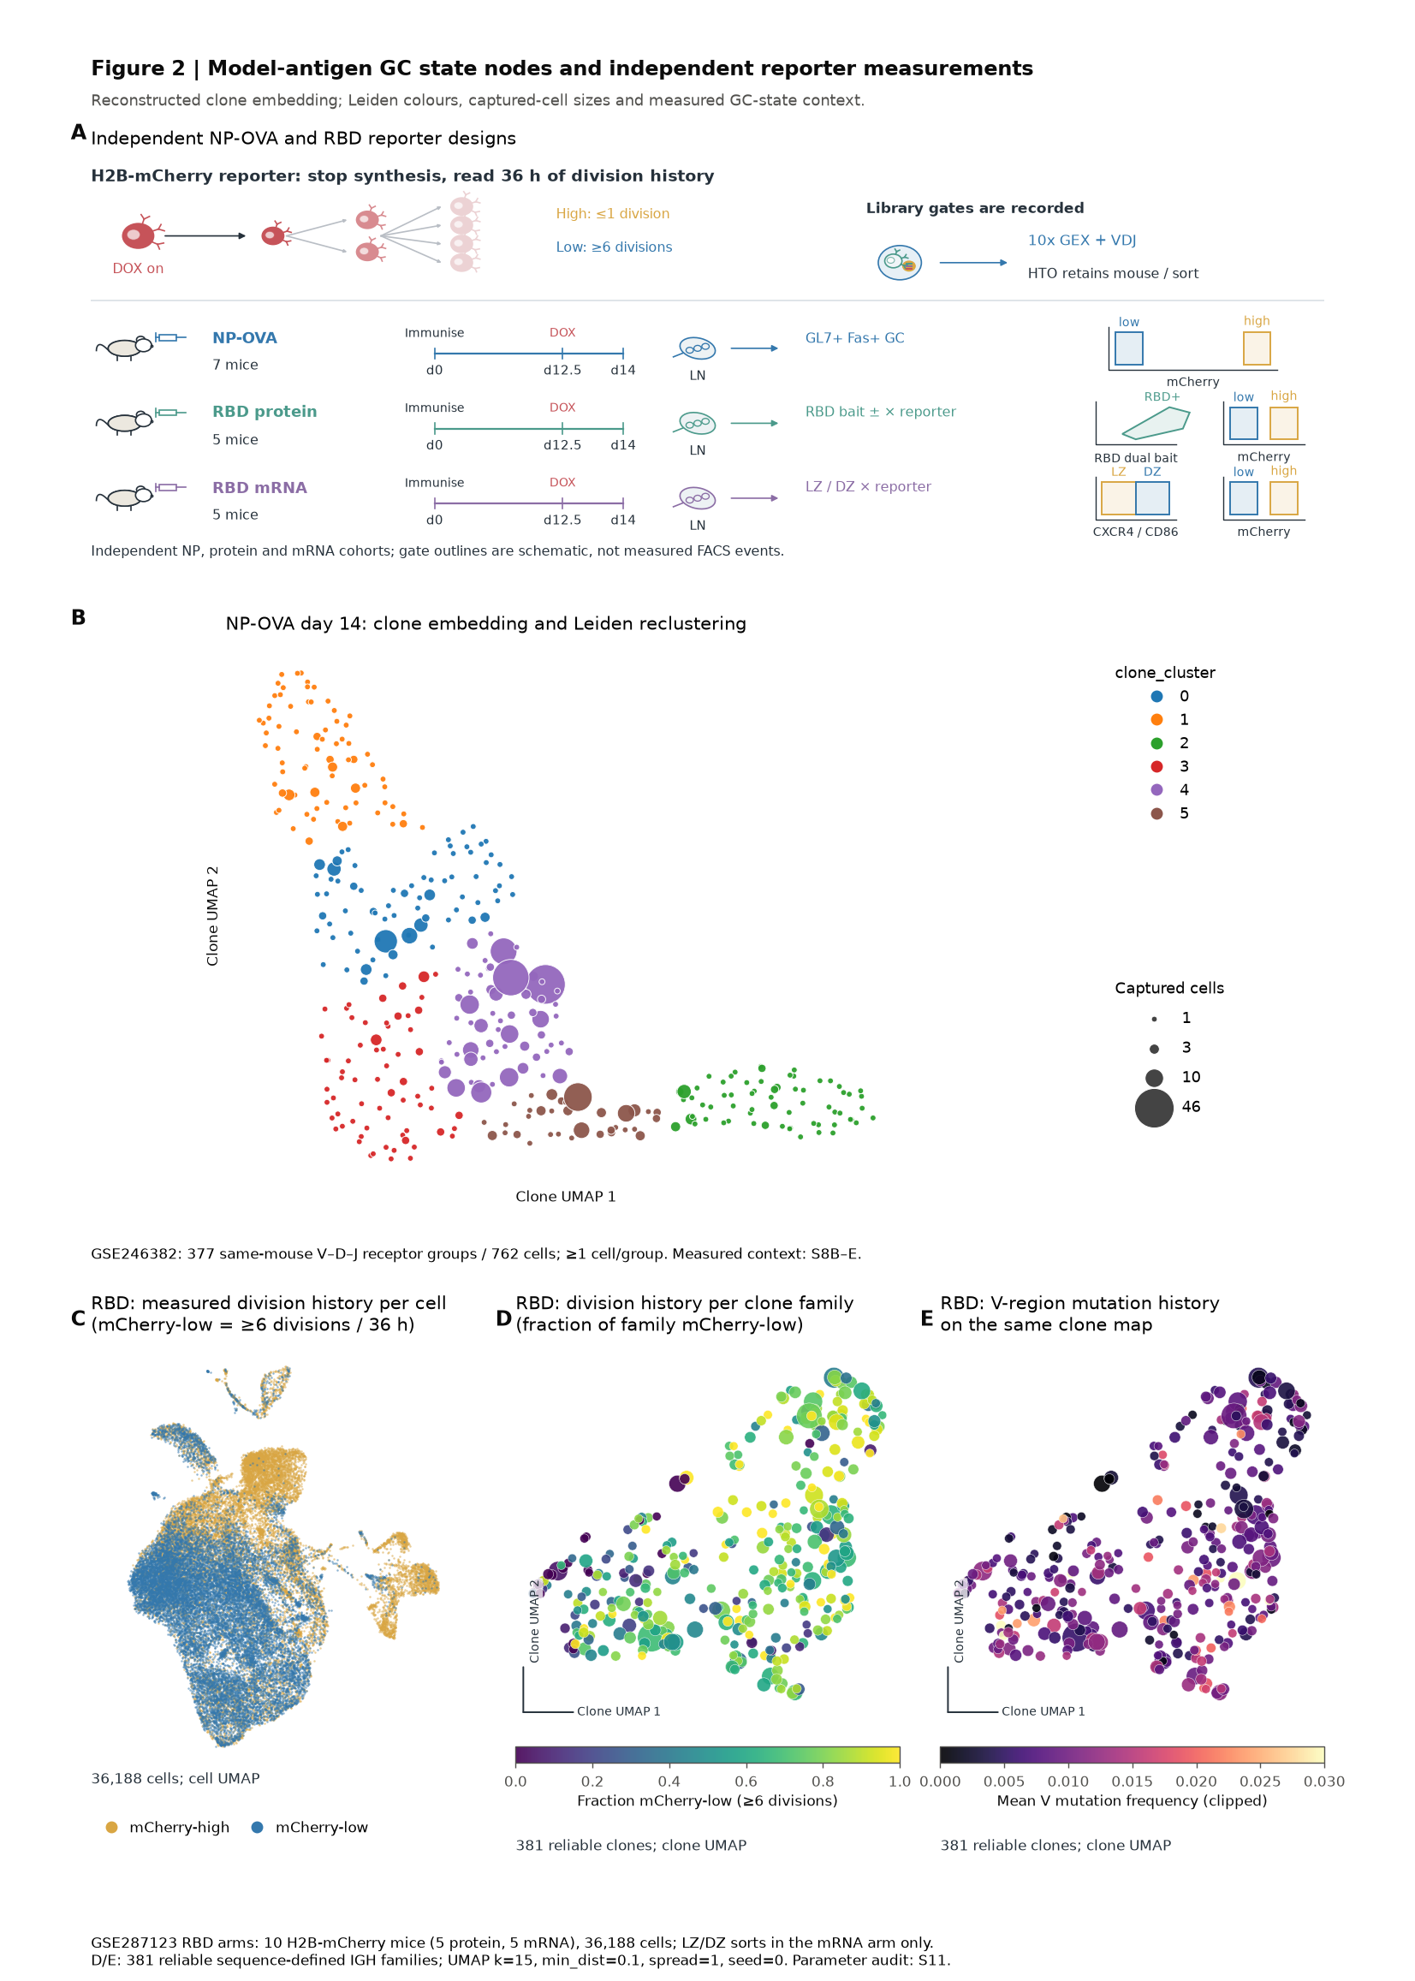

Figure 2 Model-antigen GC state nodes and independent reporter measurements. A, Designs of the independent NP-OVA and RBD cohorts of the GSE287123 H2B-mCherry reporter study. Division history, antigen-probe binding and GC-zone gates are measured labels from separate libraries/cohorts. B, Newly calculated GSE246382 NP-OVA day-14 embedding of 377 donor-restricted productive IGH V–D–J receptor groups (≥1 captured cell; 762 cells). These historical-style groups can merge distinct junctions: 83 contain multiple junction nucleotide sequences. They are distinct from the stricter 487 same-mouse sequence families retained in the parameter audit. Colour denotes Leiden clone_cluster; point area is proportional to captured-cell count. The reconstructed cell-UMAP group centres supply Euclidean distance-matrix rows to UMAP (40 neighbours, min_dist 0.65, seed 123), then Scanpy neighbours (15) and Leiden (resolution 0.3, seed 0). The display retains one 15-neighbour graph component and six clusters across seven seeds; median pairwise adjusted Rand index is 0.877 (minimum 0.701). Selection considered continuity and local fidelity; the historical k=20/min_dist=0.4 control is more seed-stable (median 0.989). Measured gates annotate LZ/DZ-associated regions (clusters 0/1), a Myc-positive-LZ-associated region (cluster 3: 80% Myc-positive LZ) and a plasma-cell-associated region (cluster 2: 97% PC); the other groups retain mixtures (S8B–E). Percentages are equally weighted means of receptor-group compartment fractions. Gates are not used to construct the graph; marker RNA reuses the expression data. The map does not establish temporal direction, two future fates or shared clonal ancestry within every V–D–J group. C, GSE287123 RBD reporter cell UMAP (36,188 cells from ten mice, five per vaccine arm), coloured by the measured mCherry-high or mCherry-low gate. D,E, The same 381 reliable (reliability ≥0.5) donor-private IGH sequence families, coloured by captured mCherry-low fraction (at least six divisions in the 36-hour window; D) or mean V-region mutation frequency (E; colour scale clipped at 0.03). Family membership uses V/J and junction nucleotide sequence similarity within each mouse, rather than B's broader V–D–J grouping. Coordinates are the saved kernel-profile UMAP (15 neighbours, min_dist 0.1, spread 1, seed 0); point size increases with captured-cell count. The 85-setting audit supports a stable division association and a weak global linear SHM association, while retaining detectable local SHM structure. A flat-looking colour map does not establish absence of association. mCherry dilution measures recent divisions, whereas mean V mutation frequency measures accumulated divergence; neither their difference nor their correlation estimates mutation per division. Supplementary Figure 16 audits within-mouse associations, matched family/gate SHM contrasts and reliability-filtered capture coverage. Only extreme mCherry gates enter this comparison. Reporter and sort labels are external measurements; gate-specific libraries remain a potential confound. Coordinates are not aligned across the two studies. Selection/output interpretation is restricted to model-antigen GC and does not establish future fate or superiority over simpler family expression summaries.

Plasmodium reveals same-mouse GC/output-state relationships, not cross-day cell trajectories
The infection study provides biological complexity and an intervention (11). Early samples cover the splenic B-cell landscape. Later samples enrich IgD-low B cells and include an IgD-high naive spike-in, with separate infected saline, anti-malarial and uninfected mice (Figure 3A). The experiments overlap at days 10 and 14 but remain distinct cohorts and sampling regimes. Each mouse is sampled terminally; there is no longitudinal tracking of an individual mouse's clone from an early to a late day.
Author annotations identify GC, plasmablast (PB) and memory-like expression states. Threadfin relates those labels to BCR families within each day and mouse. Across early samples, 39 families contain both GC and PB cells, two contain GC and memory-like cells, and 14 contain memory-like and PB cells. Across the later experiment, the corresponding family counts are 145, 33 and 22. These are observed co-occupancies, not measured lineage transitions. The very sparse early GC/memory-like overlap limits claims about early-memory relationships to the GC.
The early-infection clone map (Figure 3B) shows PB-biased profiles, while the enlarged later-infection map (Figure 3C) displays GC-, PB- and memory-enriched family regions against the cell-state context in Figure 3D. The later display retains the selected 50-neighbour, min_dist 0.5 UMAP; neighbourhoods represent profile similarity rather than ancestors or descendants. Pure-state family clustering is an expected consequence of shared expression, rather than an independent biological discovery.
Within 329 early families whose captured cells are all annotated PB, distance from the two-dimensional centre of GC-enriched families is negatively associated with the dark-zone/cycling module score (Figure 3E). Of ten mice with at least five such families, all ten show a negative within-mouse correlation (median Spearman ρ=−0.596). Day 7 contributes only one family, compared with 227 at day 10 and 101 at day 14. This check supports within-annotation variation beyond a pooled difference between dates. Because the module and embedding reuse RNA, the relationship is descriptive: it does not independently establish maturation time, a GC origin or recent GC output. A threshold on two-dimensional distance is not treated as a validated origin classifier.
Later-infection samples continue to contain GC-enriched families through day 42 (Figure 3F). The fraction of reliable families with at least 50% GC cells is calculated separately for each mouse and treatment arm, using 1,174 families from 36 infected mice. This denominator excludes the nine families from four naive control mice retained in the 1,183-family display in Figure 3C. Points are mice and lines connect group medians; the analysis describes captured repertoire composition. Different terminal mice and different early/later sampling regimes preclude interpreting these maps as persistence of the same family across days, directed GC output or a causal treatment response.
Conservative sequence matching asks how much of this observation depends on merging similar heavy-chain sequences into one family. Exact heavy/light receptor groups observed in both states provide an identity-consistency check; the control requires unambiguous productive heavy and light chains and does not allow a missing light chain to stand in for a match. Exact matching loses legitimate SHM-diverged relatives and is consequently a sensitivity analysis, not a gold-standard definition of every GC family (Supplementary Figure 3).
The primary co-occupancy statistic uses all families with at least two captured BCR-bearing cells as a fixed denominator. Mouse-specific label permutations preserve family size and state totals; a second null also preserves totals within each observed heavy-chain isotype. This tests whether family membership adds state-association information beyond those measured sampling properties. GC-bearing conditional fractions and a three-cell minimum are secondary sensitivity analyses. Mice, rather than their cells, supply biological replicate estimates. The accompanying source analyses retain per-mouse deviations from the isotype-preserving null with a fixed all-family denominator; these tests are distinct from the reliable-family composition displayed in Figure 3F and do not assign an output direction.
The choice of sampling control changes the biological reading. In the late saline arm, 132 of 868 expanded families jointly contain GC and PB cells. The equal-mouse mean observed rate is 11.91%, compared with 6.48% under a mouse-only null and 17.37% when the null also preserves per-cell isotype. Thus the apparent positive deviation from the mouse-only expectation reverses after conditioning on isotype composition. Early infection likewise has an equal-mouse observed rate of 3.86% versus 8.82% under the isotype-preserving null. The late drug arm has 4.48% observed versus 5.73% expected. These are descriptive mouse-averaged comparisons, not a pooled treatment test. They do not establish consistent excess GC–PB mixing beyond measured isotype composition. Instead, most sampled families favour separated states while a minority supply receptor-linked cross-state candidates.
Those candidates include exact paired-heavy/light groups: 11 early and 41 late groups share GC and PB states; zero early and eight late groups share GC and memory-like states. They demonstrate that some observed sharing survives stringent identity matching. Counts under the two definitions have different eligible denominators and are not compared as equivalent detection rates. Exact identity strengthens selected membership examples, without turning those examples into directed transitions or proving an enrichment.
This analysis adds a receptor-linked view to the authors' temporal cell-state map. Clone maps and expression signatures alone could recapitulate annotation; the additional question is whether particular pairs of states occur in the same sequence-defined family, survive stricter sequence matching and exceed an appropriately constrained sampling expectation. Only the latter tests add evidence about clonal organisation. None establishes memory GC re-entry.
The treatment arms are shown by day and mouse in Figure 3F and Supplementary Figure 3. Differences are interpreted within the late experiment, with three infected mice per arm/day. Uninfected controls and naive spike-in cells are not treated as additional infected replicates. The dataset does not supply clone-specific future outcomes or affinity measurements; it prioritises families for such experiments rather than replacing them.

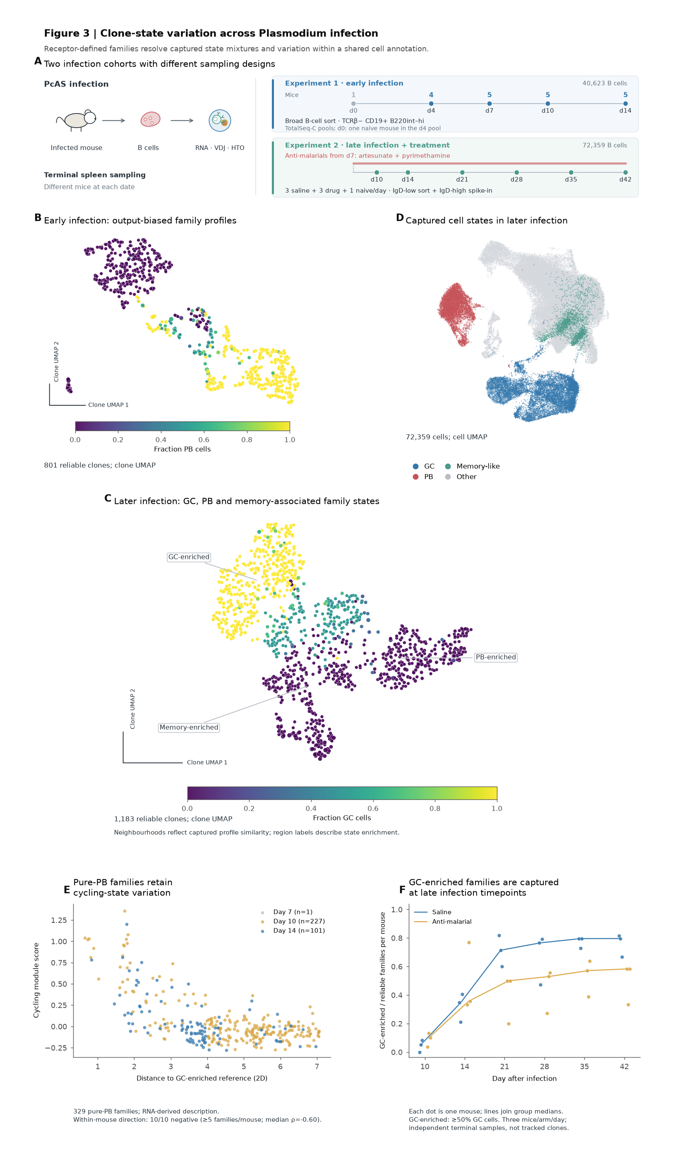

Figure 3 Clone-state variation across *Plasmodium* infection. A, Compact design of the distinct early and later PcAS infection cohorts. Early samples broadly capture B cells; later samples enrich IgD-low B cells and include saline and anti-malarial arms, naive spike-in cells and uninfected controls. Each mouse is sampled terminally. B, Early-infection map of 801 reliable families, coloured by captured plasmablast (PB) fraction. C, Central, enlarged map of 1,183 reliable later-infection families, coloured by captured GC fraction. Saved coordinates use UMAP with 50 neighbours, min_dist 0.5, spread 1 and seed 0; the sampled pair-distance rank correlation to the original family features is 0.856 (default display, 0.764). Region labels describe GC-, PB- or memory-enriched profiles. B and C use separate cohorts and are not an aligned temporal trajectory. Point size increases with captured-cell count. D, Later-infection cell UMAP, containing 72,359 cells and coloured by annotated GC, PB, memory-like and other states. E, Cycling-state variation within 329 early families whose captured cells are all annotated PB. The x-axis is distance in the saved two-dimensional map to the mean coordinates of 66 reliable families containing at least 50% GC cells; the y-axis is the family dark-zone/cycling RNA module score. Day 7 contributes one family, day 10 contributes 227 and day 14 contributes 101. Within each of ten mice with at least five eligible families, the association is negative (median Spearman ρ=−0.596). Coordinate distance and module score reuse RNA information and describe captured state variation; they do not independently validate maturation time or GC origin. F, Per-mouse fraction of reliable families containing at least 50% GC cells, shown separately for saline and anti-malarial arms. The denominator is all reliable families within that mouse, without a UMAP-distance threshold. Dots represent 36 mice (three per arm/day); lines connect group medians. These mice contribute 1,174 families; the nine families from four naive control mice included in C are excluded from F. Differences in captured composition across terminal samples do not track a family across days or by themselves estimate a causal treatment effect. These maps describe family-state organisation, not ancestry, GC re-entry, selection nodes or future fate.

Lineage barcodes test early-state associations with later observations
To separate clone-state visualisation from temporal validation, we reanalysed the public in-vitro LARRY data used by Clonotrace (14, 15). The 130,887-cell input contains 49,302 cells with a unique lineage barcode. We estimated 7,575 expanded clone-day profiles in a common receptor-excluded RNA space. Figure 4B shows the author-provided SPRING cell landscape: a force-directed display of a cell-neighbour graph (16). Figure 4C summarises each clone-day cell distribution as a Threadfin profile, with the same author state labels used for biological interpretation. The comparison makes the change of analysis unit explicit: from individual cell states to the state composition of many sampled clones. Barcode-colouring on SPRING can already reveal where a clone's cells lie; the paired maps demonstrate interpretability, not an advantage over SPRING. The quantitative tests below assess whether estimated clone profiles add value over simple summaries. Lines connect the same known barcode across measured days; their direction is supplied by sampling dates and known barcode identity.
For prediction, we built a second expression representation using day-2 cells only. Neither future cells nor their state annotations entered that representation. Among 1,401 expanded day-2 barcodes, 172 also had at least four day-6 cells and were eligible for the fixed comparison. The later target was the observed fraction of cells in each author-annotated state, not a complete assessment of developmental potential. All methods used the same three repeated five-fold barcode partitions and training-fold-only ridge tuning.
The median fold R² for day-6 neutrophil fractions was 0.199 for Threadfin kernel profiles, 0.163 for RNA means and 0.110 for concatenated RNA means and variances; corresponding monocyte values were 0.163, 0.099 and 0.058 (Figure 4D,E). The mean-plus-variance baseline adds a simple measure of within-clone spread using the same 30 early-cell PCs and identical readout folds. Absolute-error differences were smaller: for monocyte fractions, kernel-profile MAE was 0.227 versus 0.225 for RNA means. Thus early profiles contain information about later captured composition, but the added value over a simple RNA mean is modest and depends on the endpoint. Adding per-PC variance alone did not improve this baseline; that result does not isolate the contribution of the kernel from shrinkage, smoothing or regularisation. Repeated folds are not independent biological replicates, and eligibility selects a small subset of the observed early barcodes.

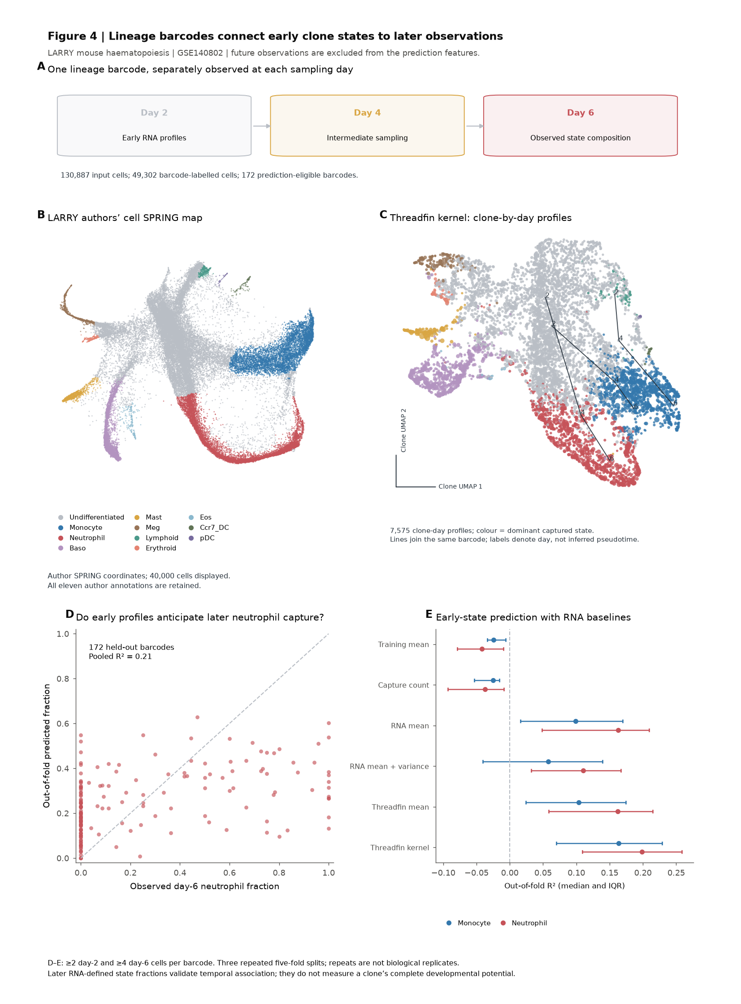

Figure 4 Lineage barcodes connect early clone states to later observations. A, The public LARRY in-vitro sampling design, with day-2, day-4 and day-6 observations. B, Author SPRING coordinates, showing a deterministic sample of 40,000 of 130,887 cells coloured by author state annotations; all annotated states are retained in the source data. C, Threadfin kernel UMAP of 7,575 expanded clone-day profiles from 49,302 uniquely barcode-labelled cells. Colour denotes the dominant captured state and point area increases with capture count. Three example barcodes are selected by the largest minimum capture count across all three days; lines join known barcode identities, and labels give sampling day. D, Day-6 neutrophil fraction versus out-of-fold prediction from day-2-only kernel profiles for 172 eligible barcodes, using the first five-fold partition. R² is computed across pooled out-of-fold predictions. E, Median and interquartile range of fold R² over three repeated five-fold partitions for six representations/controls and two observed state fractions. The RNA mean-plus-variance baseline concatenates clone means and population variances of the same 30 early-cell PCs. All methods use identical barcode folds and train-only nested ridge tuning. The unsupervised early-cell representation is transductive but excludes future cells. Repeats are not independent biological replicates; observed state composition is not complete developmental potential. The original dataset and Clonotrace study are cited in the main text.

Longitudinal paired TCRs distinguish clone identity from changing state
We next analysed all ten public processed patient objects in GSE266219 (17, 15). This analysis tests generality of the representation; it does not reconstruct the eight-patient clinical-response selection in the Clonotrace paper. Of 195,685 exported TCR-annotated cells, 124,534 had exactly one TRA and one TRB CDR3 amino-acid sequence. Exact paired sequences within patients define biological clones, with separate profiles for each observed cycle. Patient-level centring retains temporal variation; cycle is not removed as a nuisance covariate.
The analysis produced 10,428 expanded clone-cycle profiles (Figure 5A–C). Expression-module colours describe a cytotoxic-to-memory-associated continuum, using the same expression measurements that constructed the profiles. These colours are descriptive rather than independent validation. Original cycle labels, including cycles 3, 5 and 7 where present, were retained.
For 29 eligible patient–adjacent-observed-cycle comparisons, we compared the same biological clones with different target clones within patient, interval and target capture-count bin. All methods used identical pairs with at least four cells at both dates. The median across patient-level median same/null distance ratios was 0.608 for kernel profiles, 0.637 for Threadfin mean profiles and 0.660 for RNA means (Figure 5D). Each representation retained same-clone similarity, with no basis for calling this signal unique to Threadfin. Within-clone module changes varied across patients and intervals (Figure 5E). These observations support longitudinal state descriptions, but expansion, contraction and migration can also change the captured blood distribution. An audited clinical-response mapping is required before testing treatment response associations.

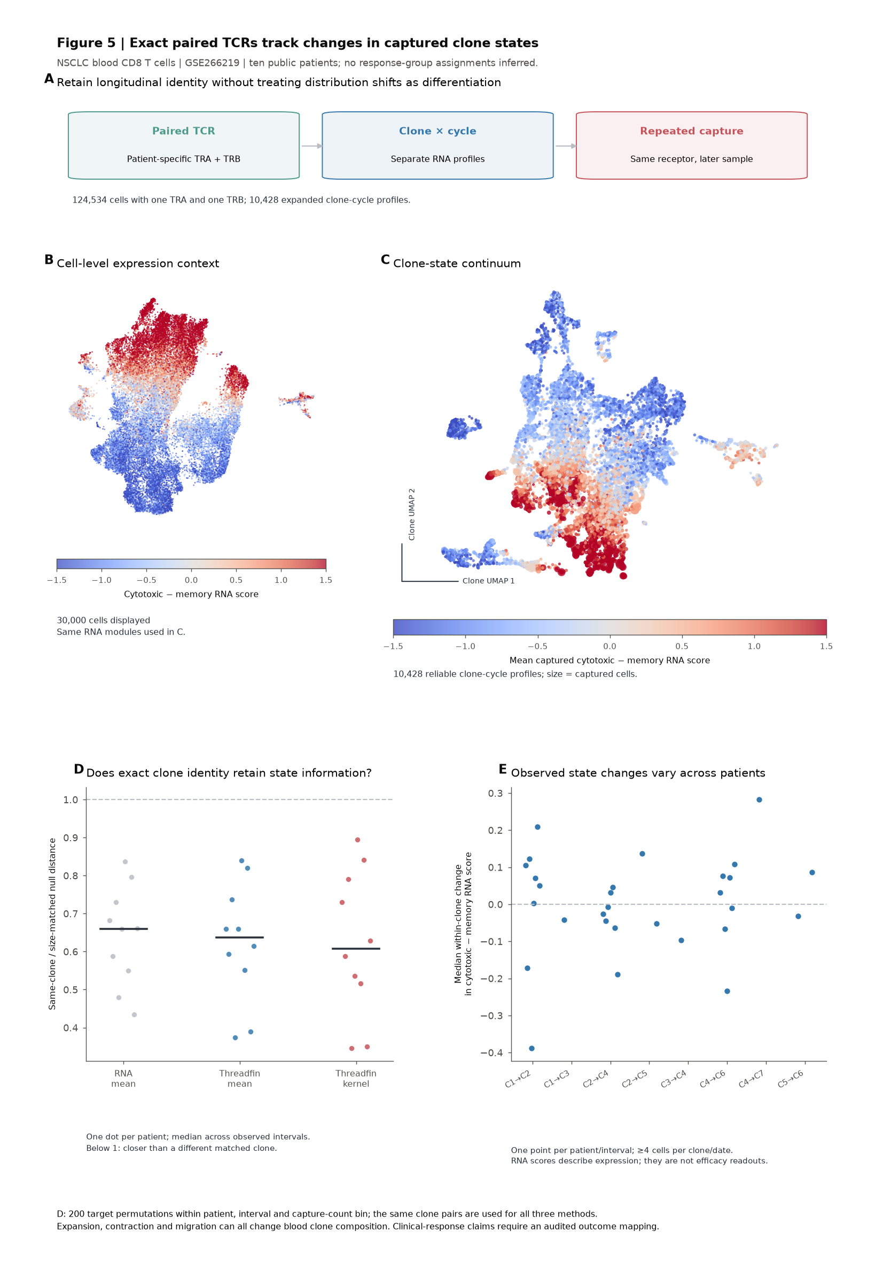

Figure 5 Exact paired TCRs track changes in captured clone states. A, Public GSE266219 reanalysis of ten patients, retaining 124,534 cells with a unique paired TRA/TRB CDR3 amino-acid sequence and 10,428 expanded clone-cycle profiles. This cohort is distinct from the eight-patient response-group selection in Clonotrace. B, A deterministic 30,000-cell UMAP display coloured by the difference of cytotoxic and memory RNA-module scores. C, The kernel-profile UMAP with corresponding clone-averaged RNA scores, using patient context adjustment without cycle removal. Point area increases with capture count; all 10,428 profiles meet the model reliability threshold of 0.5. D, Same-clone distance divided by a size-matched different-clone null, calculated in feature space. Targets are permuted 200 times within patient, observed cycle interval and log2 capture-count bin without fixed points. All methods use identical pairs with at least four cells at both dates. Each dot is one patient's median across eligible intervals; the horizontal tick is the median across patients. E, Median within-clone change in cytotoxic-minus-memory score per patient and interval. Cycles are retained as recorded, including 3, 5 and 7. RNA modules reuse the input expression; they do not independently validate fate or clinical response. Expansion, contraction and migration may each alter captured blood composition.

Captured-state readout differs from repertoire-network refinement
Published tools address several related tasks: repertoire annotation, joint sequence/expression representation, clonotype networks, CSR dynamics and whole-clone state descriptions. We record their native capabilities and published validation separately from measured performance. CoNGA, Ibex, scRepertoire and sciCSR address distinct receptor/expression or class-switch tasks (18, 19, 20, 21). We avoid assigning zero to an inapplicable output (source comparison). Benisse (4), BiGCN (5) and clone2vec (6) are run through their official models; encoder-only outputs or external proxy implementations are not substituted for these methods.
The controlled readout uses fixed donor-private families and a common receptor-excluded PCA100 input. Seven representations are compared with a training-mean control, retaining raw and donor-centred RNA centroids as essential baselines. Representations are unsupervised and transductive; whole-mouse folds withhold the measured labels only from the downstream ridge model. The endpoint is the fraction of captured family cells in the measured mCherry-low gate, not future fate, clonal ancestry or an affinity value.
In the completed NP–OVA comparison, all methods represent the same 373 expanded families across seven mice. Median mouse-wise absolute error in gate fraction is 0.197 for Threadfin mean profiles and 0.207 for kernel profiles, versus 0.314 for the training-mean control. Raw and donor-centred RNA centroids achieve 0.161 and 0.165, respectively; clone2vec, BiGCN and Benisse achieve 0.238, 0.291 and 0.314. These measurements evaluate a specific captured-state readout. Ordinary RNA means outperform Threadfin on the primary division endpoint, and sequence-native tools need not be optimal for this task. The comparison does not establish a universal method ranking. Profile reliability and repeated-state comparisons require separate validation. The size-threshold sensitivity retains at least five measured cells per family (Supplementary Figure 7).
The completed RBD comparison retains 1,414 reporter-eligible families across 10 label-held-out mice. Median mouse-wise absolute error is 0.225 for Threadfin mean profiles and 0.235 for kernel profiles; raw and donor-centred RNA means yield 0.201 and 0.214. Benisse, BiGCN and clone2vec yield 0.337, 0.324 and 0.237, respectively, compared with 0.334 for the training-mean control. These values describe the prespecified captured reporter-fraction readout, not an overall tool ranking.
The reporter gate is associated with physical sequencing library in these experiments. Whole-mouse label holdout retains shared libraries and a transductive representation; the comparison cannot separate reporter biology from all library effects or establish independent-library generalisation.
We therefore also tested the sampling estimator without a biological-label prediction task. Calibration and evaluation used disjoint LARRY biological barcodes, with 250 evaluation clone-day-well profiles and disjoint reference cells. At 2, 4 and 8 query cells, shrinkage reduced pooled kernel-mean squared error by 27.2%, 14.2% and 6.5%, respectively (Figure 6E,F). This is evidence for denoising under this sampling design, not for absolute calibration of the reliability number or for improved fate prediction. Smoothing was disabled; the shared RNA preprocessing remains transductive.

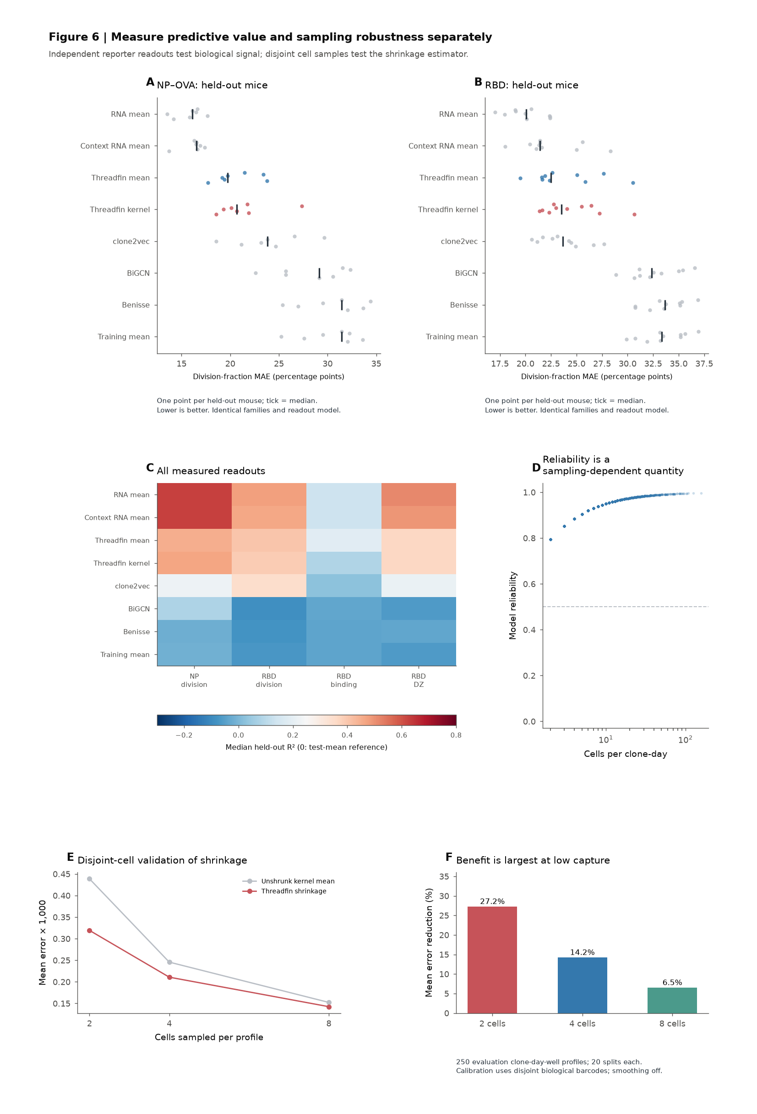

Figure 6 Predictive value and sampling robustness are distinct method properties. A,B, Whole-mouse-held-out mCherry-low gate-fraction error in the NP–OVA and RBD reporter datasets. Each point is a mouse, and ticks give medians; lower MAE is better. All eight methods/controls retain the same eligible families and downstream readout procedure, with at least two measured cells per family. Representations are transductive and reporter labels are held out from the supervised model. C, Median mouse-wise R² for every measured readout at that same capture threshold. A value of zero is the constant-test-mean reference, not a permutation-derived chance level. The readout and its units are specific to this benchmark; RNA means remain the strongest division-fraction baseline. D, Sampling-dependent kernel-profile reliability in the LARRY clone-day analysis, with the 0.5 display threshold. E, Mean squared error of an unshrunk kernel mean and the Threadfin shrunken estimate against disjoint reference cells. Biological barcodes are split between calibration and evaluation; evaluation uses 250 clone-day-well profiles containing at least 16 cells, 20 random splits per profile and 2, 4 or 8 query cells. The reference uses a disjoint half of the cells and smoothing is disabled. F, Reduction in pooled mean error: 27.2%, 14.2% and 6.5% at 2, 4 and 8 query cells. Repeated splits and different dates/wells from one barcode are not independent biological replicates. This experiment measures estimator denoising, not absolute calibration of reliability or future fate prediction. Native comparison implementation and execution scope remain in Supplementary Figure 7.

Repeated human GC sampling tests clone persistence over a longer response
The vaccination cohort repeatedly samples draining lymph nodes and blood from the same participants (12). This differs from the terminal Plasmodium design: a BCR family can genuinely be observed at multiple dates in one person. Supplementary Figure 9 shows the study design, captured GC/output compartments and an independent spike-positive receptor label on the clone map.
GC-dominated and antibody-secreting profiles are distinct in this dataset. The restored binding-enrichment plot compares author-identified Spike-positive families within expression programmes against other families from the same donor (Supplementary Figure 9D). It reports binding-label odds rather than quantitative affinity. The sequence crosswalk maps every Threadfin family to one author clone, with 623 author clones subdivided into multiple Threadfin families. Labels propagated into such subdivisions are not new independent binding experiments (Supplementary Figure 6). Two of four candidate programmes meet bootstrap stability 0.75; programme names are not treated as guaranteed discrete fates.
Individual families with GC cells at three or more non-pooled dates illustrate repeated GC-containing membership. We select these examples by measured presence and captured size, not by a visually interesting UMAP location. Bars display the recorded cells, including dates without captured members; absence in a sample is not proof of biological extinction.
The corrected clone-state retention estimate is 0.25 across dates (420 families; 95% interval 0.20–0.31), compared with approximately zero across LN/blood snapshots (159 families). This shows that family membership and current compartment are different pieces of information. It does not establish whether a memory cell entered a later GC or whether a particular GC cell produced a blood plasmablast. A study with prime/boost and fate mapping can address those directions directly (22).
The GC mutation trend is also shown explicitly (Supplementary Figure 9G). We average within family/date SHM, take a median across families for each donor/label, and give each donor equal weight. Only donors represented in both label groups at that date contribute (1, 1, 8, 6 and 4 donors at the five dates, respectively); the shaded range is the donor interquartile range. The first two points therefore have no across-donor replication. Later samples have different captured families and sometimes different donors, so the curve is not a paired estimate of maturation within the same family. The comparison group is not identified as Spike-positive, rather than uniformly assayed negative. The source paper includes functional antibody experiments, but our current paired-cell input does not supply a quantitative affinity for every Threadfin family. Neither binary binding labels nor SHM estimate affinity.

Receptor-defined families explain expression organisation across tested models
Across twelve dataset analyses, clone identity is associated with more expression variation than the 95th percentile of a within-library shuffled baseline in eleven analyses (Supplementary Figure 15B). The direct NP–OVA PC/GC dataset is the exception (p=0.224). These are separate dataset analyses, not twelve independent studies: the two reporter cohorts share a publication, and the two infection datasets are separate experiments from one study. The comparison excludes receptor genes from the expression embedding and preserves library composition and family sizes under shuffle. It measures captured clonal expression organisation, rather than antigen specificity, future fate or a benefit over another integration method.
The biological interpretation depends on the experimental anchor and sampled repertoire (Supplementary Figure 15A,C). Only 3 of 113 expanded families in the direct PC/GC study reach profile reliability 0.5, compared with 69 of 373 NP reporter families, 381 of 1,414 RBD reporter families and 4,429 of 8,435 human vaccination families. Library-stratified signal does not guarantee that individual profiles are informative enough for programme inference. Clonal resemblance of GC, cycling, light-zone, antibody-secreting, memory-associated and interferon modules varies between models (Supplementary Figure 15D). Those modules reuse the profile-building expression matrix; expression-matched gene backgrounds aid interpretation but do not turn module agreement into independent biological validation.

Non-GC tests distinguish receptor identity from terminal-state annotation
Outside the GC-focused argument, the marrow/blood model (13) supplies the clearest measured-gate check (Supplementary Figures 5 and 14). A GEO manifest corrects donor identities and retains 15 single-donor, single-tissue libraries from seven donors, excluding five pooled or mixed libraries. The analysis contains 115,144 cells, 78,883 paired receptor records and 9,783 expanded families. Within pure marrow plasma-cell and memory-cell gates, unique productive exact heavy/light receptors are shared in 225/862 eligible repeated-receptor groups for donor 1681 and 31/677 for donor 1684; marrow PC–blood memory sharing is 124/1,012 and 115/934. These are identities across captured gates, without implying transdifferentiation or a direction of differentiation. Influenza blood, influenza lung, EBV-infected tonsil organoids, tonsil and COVID-19 blood data provide additional tested coverage (1,997, 114, 6,923, 670 and 83 expanded families, respectively). Their clonal expression signal is included in Supplementary Figure 15, whereas individual maps remain in the separate tested-dataset folder. Exploratory transcriptomic states and variable sampling designs in those datasets do not establish independent fate mechanisms. Thus one non-GC anchor supports interpretation of common receptor identity, while the remaining analyses document where the workflow has been tested.

Discussion
Threadfin's useful biological output is a description of clone-level state bias and breadth, anchored to separately established sequence membership and experimental labels. The reporter models show that expression distributions record division-associated GC state alongside a family-average receptor history. The infection model asks which GC/output-like states are co-observed in the same mouse's families. Lineage barcodes test early-to-later state associations, paired TCRs test longitudinal state retention, and the human GC cohort adds repeated membership. The marrow validation shows that common receptor identity can coexist with distinct measured terminal-state gates.
These are different strengths of inference. Co-observed related cells support shared clonal organisation. Repeated same-donor capture supports persistence. Neither is equivalent to an observed parent–offspring relationship. Memory re-entry into GC requires evidence of prior memory identity and later GC participation; direct fate mapping and recall experiments illustrate the necessary design (22). Plasmodium samples from different terminal mice cannot supply that history, however persuasive an embedding may appear.
The package complements receptor annotation, SHM phylogenies and cell-state analysis. Sequence-only analysis cannot describe transcriptional breadth when several family members have identical sequences; expression-only analysis cannot establish a family link. This complementarity is meaningful without claiming that no other combined workflow could calculate an occupancy table. A claim of superior future-fate prediction would require a held-out outcome, matched competitors and an independent validation cohort; it is not made here.
Existing whole-clone methods, including clone2vec and the Clonotrace preprint, already support continuous clone descriptions and clone-associated gene analysis (6, 15). Clonotrace compares smoothed clone densities and relates clone profiles to measured temporal observations. Using its public datasets does not by itself reproduce its method or establish a direct performance comparison. Our Figure 4 contrasts cell and Threadfin clone representations; neither panel is an official Clonotrace output. The incremental contribution claimed here is the combination of an explicit receptor-family definition, context-adjusted profiles with reliability, matched sampling controls and GC experiments with measured biological anchors. This is distinct from claiming a universally superior representation; the completed NP reporter test favours ordinary RNA family means on its selected endpoint. Additional independent experiments would be needed to establish predictive advantages of the full state-distribution representation.
The model-antigen GC map provides a concrete exploratory application: clone reclustering organises Myc-positive-LZ-associated and plasma-cell-associated family state biases using the same measured compartments as biological anchors. Its value is in defining selection/output hypotheses that can be tested with lineage tracing or independently measured output. The earlier report's fork provided the motivation, but the present acceptance criterion is state interpretability, not reproduction of that silhouette. Neither a chosen UMAP preset nor a marker heatmap establishes two actual fates. The current same-mouse clone calls prevent receptor-gene reuse across mice from creating artificially large families, and the limited reliable-profile coverage remains explicit. This GC-specific interpretation does not apply to the marrow/blood non-GC validation, which tests receptor identity across measured terminal-state gates.
Several limitations constrain the biological interpretation. Receptor recovery is incomplete and may depend on cell state. Sparse captured families understate phenotypic breadth. Heavy-chain similarity can merge unrelated receptors; paired-light and exact-sequence controls reduce one source of uncertainty but lose SHM-diverged family members. Alternative family callers and lineage models address different assumptions (23, 24, 25, 26). Large-scale paired-chain data document chain-mixed groups and naive-like pseudo-clonal clusters under heavy-chain-based inference (27); exact paired-chain controls cannot establish the sensitivity or specificity of every primary family call. Pre-sorting constrains which state combinations are observable. Author memory-like annotations are not functional recall measurements. Expression signatures provide interpretation rather than external validation. Antigen specificity and affinity cannot be inferred from generic GC/PB/memory programmes.
The next decisive experiment is to test candidates ranked by robust same-family GC/output co-occupancy or GC state bias against independently measured antigen binding, recall or lineage tracing. The public-data results provide a reproducible way to choose those candidates and a precise account of what remains unknown.

Methods

Data and sampling design
Raw paired RNA/BCR files were obtained from GSE287123, GSE246382, GSE286215, GSE195673/Zenodo 5895181 and GSE253857. Loader metadata records donor, library, measured gates, time and tissue. The marrow mapping is committed in case_studies/bone_marrow_sample_manifest.tsv; pooled and mixed libraries are excluded by default. Plasmodium experiments are kept separate and (day, HTO mouse) defines the biological individual. Treatment comes directly from the deposited late-experiment metadata. The early d0 control is one naive mouse incorporated in the d4 HTO pool; d4 therefore has four infected mice. The late experiment has three treated, three saline and one naive mouse per sampling date. The source study's anti-malarial regimen includes artesunate and pyrimethamine; the deposited label Artesunate is retained in source tables.

Clone membership and expression profiles
The case-study pipeline selects productive heavy chains and defines families within actual donors using V/J gene calls, junction length and normalised junction Hamming-distance single linkage. The automatic threshold is a density valley when identifiable, with an explicit fallback. This is a sequence-defined relationship and does not use expression proximity. Primary family calls use heavy chains; conservative exact heavy/light analyses are reported separately.
Counts are normalised and log-transformed. Immunoglobulin V/D/J and constant region genes are excluded from highly variable gene selection before the 30-component expression embedding. Harmony is applied only when the case configuration specifies a batch key. The package describes a family's captured expression distribution using random Fourier features, centres it against its sampling context and estimates profile reliability from captured size and variance components. Figure maps reuse saved coordinates. Their two-dimensional distance is not used as evidence of ancestry or a future fate.

Model-antigen centroid reclustering and historical provenance
case_studies/reproduce_gc_legacy_embedding.py reconstructs the legacy-input comparison; case_studies/run_gc_reclustering.py retains the earlier restricted 49-family control. Both align the GSE246382 MTX/features/barcodes and deposited mouse/compartment metadata to the frozen 884-cell table and its same-mouse sequence-defined family calls. Cell identities, mouse labels, compartments and the original at-least-500-expressed-gene QC are checked. Raw counts and source-table hashes accompany the results. Threadfin constructs a receptor-excluded 3,000-HVG, 30-component PCA from log-normalised counts for the separately retained PCA analysis. The primary clone-embedding run instead reconstructs the notebook's executed cell pipeline (normalise to 10,000 counts, log1p, flag 5,500 highly variable genes without subsetting, regress total counts and mitochondrial percentage, scale, PCA with the Scanpy default highly-variable mask, 15-neighbour graph on 40 components, UMAP min_dist 0.5, seed 0) and groups deposited productive TRUST4 IGH calls into donor-restricted V–D–J receptor groups retained at at least one captured cell (377 groups, 762 cells). These groups can merge distinct junctions within a mouse; pooled cross-mouse V–D–J groups are diagnostic controls only. It follows notebook cell 27: pairwise Euclidean centroid distances, UMAP on distance-matrix rows as Euclidean features (40 neighbours, min_dist 0.65, spread 1, learning_rate 1, seed 123), then Scanpy neighbours on clone UMAP (15) and Leiden (resolution 0.3, seed 0). Gate labels and post hoc marker summaries are not supplied as clustering covariates. Marker genes can contribute to the underlying RNA embedding. The full parameter grid (10–80 UMAP neighbours × min_dist 0.1–0.85), seven seeds, three family definitions, two cell bases and the all-genes sensitivity run are saved with requested/effective parameters, source hashes and package versions. Selection is exploratory and considers layout continuity and local fidelity; it is not an optimisation for six groups or maximal seed stability. Median adjusted Rand index is 0.877 for the display and 0.989 for the historical k=20, min_dist=0.4 donor-restricted V–D–J control across seven seeds. New clone coordinates are computed; Supplementary Figure 8B reuses the reconstructed cell coordinates with actual measured gates. The original notebook's processed objects and IgBLAST tables are absent, so deposited TRUST4 calls serve as an independently recorded receptor-call source; exact reproduction of the historical coordinates is not claimed, and cross-mouse pooled VDJ groupings are reported as diagnostics only.
tf.clonotype_recluster provides cohesive (20 neighbours, resolution 0.3, min_dist 0.1), continuous (20, 0.1, 0.4) and discrete (10, 0.8, 0.05) starting configurations. All use spread 1 and learning_rate 1. Explicit values override the preset; neighbour counts cap at retained clone count minus one. By default, Leiden uses original clone distances and UMAP embeds them as precomputed; display controls leave that partition unchanged. The primary figure explicitly uses embedding_mode="distance_profiles" and cluster_on="embedding" to match the notebook geometry and Scanpy graph. In this mode, display parameters can affect the clustering; the graph and UMAP neighbour counts are specified independently; cluster_random_state=0 separates graph/Leiden randomness from UMAP random_state=123. Presets are not learned biological classes and do not force a desired topology. The default filter is at least three cells; strictly greater than three requires min_clone_size=4. Centroid exploration remains separate from v4 sampling-adjusted profiles and programme validation.
Figure 2B colours unsupervised Leiden clone clusters. For their annotation, measured-compartment fractions and log-normalised Myc/marker RNA are computed over member cells, then averaged equally across families within each cluster. Supplementary Figure 8D shows this cluster-level marker heatmap. GC-identity, cycling and plasma-cell modules are means of per-gene cell-standardised log RNA, using the recorded covered genes. These reuse the transcriptome and provide descriptive state interpretation; they are not held-out fate outcomes. No plot arrows assign temporal direction.
Supplementary Figure 8A preserves notebook cell 33 output 0 from commit 57a9565 with all saved data points and legends. Source hashes and provenance limits are recorded in paper/figure_plan/assets/legacy_gc_provenance.json. GSE180920 has 3,542 day-7 and 19,757 day-14 deposited cells; count-column and metadata-cell IDs are checked in order, and Top2a is present. Its notebook contains explicit day-7/day-14 RNA and BCR concatenation, but non-sequential execution and missing original processed objects/receptor calls prevent an exact attribution of the saved Top2a plot. The older GSE246382 report panels are retained separately as a historical reference. Their notebook uses UMAP on distance-matrix rows followed by Scanpy neighbours of clone-UMAP coordinates. Executed clone filtering (at least one cell) and Leiden resolution (0.3) differ from report methods (>3 cells, 0.1), so they are not represented as a verified present-package rerun.

Reporter labels, programmes and retention
Measured reporter/probe/FACS labels are compared with profiles separately from expression signatures. Within-library label checks address pre-sorted sampling in the reporter cohorts. Programme splitting is tested against a single-group model. Its Gaussian null does not repeat the complete community, tree and resolution selection, so its split p-values are approximate and do not establish family-wise error control. Bootstrap stability is reported rather than treating every clustering as a stable biological category. Clone-state retention compares separate same-family snapshots against same-donor random-family comparisons, correcting sampling noise. Its intervals resample clones and do not replace donor-level population uncertainty. Full existing algorithms are specified in `docs/METHODS.md`.
Mouse module scores use capitalisation-adjusted gene symbols, with per-dataset coverage recorded; this is not a curated, gene-by-gene orthologue analysis. Coverage is recorded for each signature. Clone-averaged scores and programme scores reuse normalised expression and are descriptive; their agreement with an expression-derived programme is not counted as independent validation.

Conditional biological interpretation of Figure 2
We audited all 1,414 expanded RBD families and the 381 reliability-filtered displayed families from the committed cell and family tables. Within each mouse, we computed Spearman correlations of division fraction with RNA modules or mean V mutation frequency. Partial rank correlations residualized both ranked variables against ranked log capture count and the additional measured gate fraction (RBD binding in the protein arm, DZ in the mRNA arm). At least eight families and variation in both measurements were required. For paired SHM, we retained family-by-additional-gate strata with at least two measured cells in each mCherry extreme. We averaged stratum differences within family and family differences within mouse; uncertainty was described by 10,000 mouse bootstrap resamples within each arm (seed 20261008). The five mice per arm limit interval precision. These exploratory tests do not remove physical-library confounding or estimate mutation per division.

Public lineage-barcode and longitudinal TCR validation
For GSE140802/GSM4185642, author-normalised cell-by-gene expression, lineage membership and row-matched metadata were downloaded from GEO. Input dimensions were 130,887 cells by 25,289 genes; 49,302 cells had exactly one of 5,864 barcode labels, with no ambiguous multi-barcode rows. The expression matrix contains normalised positive values, not raw integer UMI counts. We rescaled total expression to 10,000 per cell, applied log1p, selected 3,000 receptor-excluded variable genes, scaled with clipping at 10 and computed 30 PCs with seed 0. The descriptive all-time map uses barcode-labelled cells and no context subtraction. Each barcode-day is a distinct profile, requiring at least two cells. Kernel profiles use 256 random Fourier features, median-distance bandwidth, 15-neighbour smoothing and 30-component profile reduction; mean profiles are unsmoothed. UMAP uses 15 neighbours, min_dist 0.3 and seed 0. Author SPRING coordinates are used only for the cell-context panel.
The prediction model is independently preprocessed from day-2 cells only, including unlabelled cells as expression context. Barcode-level targets are day-6 state fractions for barcodes with at least two early and four later cells. Unsupervised early PCA and profiles are transductive across the eligible barcodes; no day-6 cells or labels enter them. Three five-fold outer partitions (seeds 100–102) hold out biological barcode identities from the supervised readout. A StandardScaler–ridge pipeline is tuned over alpha 0.1, 1, 10 and 100 using three training-only inner folds. Predictions are clipped to [0,1] and normalised to sum to one. RNA means, concatenated means and population variances of the same 30 PCs (ddof=0), log capture count, Threadfin mean/kernel profiles and training-fold outcome means use identical outer partitions. Saved tables contain each out-of-fold prediction and fold assignment.
For the shrinkage check, biological barcodes are deterministically split by SHA256 parity into calibration and evaluation sets. Calibration cells alone determine the PCA-space centring, kernel bandwidth, feature centring and variance components; the common descriptive RNA PCA remains transductive. The 256-feature kernel is unsmoothed. Evaluation units are barcode-day-well profiles with at least 16 cells. For each of 20 random splits, one half provides the disjoint reference mean, while 2, 4 or 8 cells from the other half provide the unshrunk mean and the shrunken estimate. Error is the mean squared difference across kernel features. Reported error reduction is one minus the ratio of pooled mean shrunken to unshrunk error; it is not the average of per-profile ratios. Shared barcodes across dates/wells are not independent biological replicates, and this test does not calibrate the absolute reliability scale.
For GSE266219, all ten official processed patient objects were downloaded and exported from Seurat with explicit cell-name alignment and the intersection of 17,178 gene symbols. Temporary inspection files are excluded by the exact filename pattern. Only cells with one TRA and one TRB CDR3 amino-acid sequence enter the analysis. Canonical paired-chain strings are patient-private clone identifiers; author clonotype IDs are audited but do not define cross-cycle identity. Original PtCycle labels provide the cycle numbers. Receptor-excluded 30-PC RNA preprocessing uses the same normalisation settings and no Harmony; profiles are centred by patient, with cycle preserved. Cell UMAP displays a deterministic sample of 30,000 analysed cells. Mean per-gene z scores define cytotoxic (NKG7, PRF1, GZMB, GNLY, CTSW), memory (IL7R, CCR7, TCF7, LEF1, LTB), activation (IFNG, FOS, EGR1, CD69, TNFRSF9) and cycling (MKI67, TOP2A, TYMS, STMN1) modules; these are expression descriptions.
Longitudinal comparisons require at least four captured cells per clone-cycle. For each patient's consecutive observed cycles, target identities are permuted 200 times within floor(log2 target cell count) bins, using derangements without fixed points. Singleton bins are excluded. Distances are Euclidean distances in each method's feature space, not UMAP distances; method comparisons retain exactly the same clone pairs. Ratios compare the median observed same-clone distance with the median permuted median distance. Figure 5D first takes the median across eligible intervals within each patient. No response categories are inferred from patient numbers.

Display-parameter and within-state analyses
The RBD parameter audit reconstructs the family features before comparing 85 UMAP settings. Global linear R² fits each readout to an intercept and the two map coordinates. The local readout averages the ten nearest labelled families, excluding the focal family. The saved field knn_r2 is a legacy name for explained variance, calculated as one minus residual variance divided by readout variance; unlike standard predictive R², it does not penalise mean prediction bias. Local excess is observed explained variance minus its mean under 200 donor-stratified label permutations. These exploratory tests are not held-out-mouse predictions and do not adjust for choosing among display parameters. Pair-distance faithfulness is a Spearman correlation over sampled family pairs in the feature space and the two-dimensional map.
For Figure 3E, pure-PB families contain only PB-labelled captured cells. Euclidean distance uses their saved early-map coordinates and the mean coordinates of reliable families with GC fraction at least 0.5. Within-mouse Spearman correlations are summarised for mice with at least five pure-PB families. Figure 3F uses the same 0.5 GC-fraction threshold without any coordinate-distance rule, dividing by all reliable families in each infected mouse and displaying treatment arms separately. The figure script regenerates the family- and mouse-level source tables with the normal drawing workflow.

Same-mouse state sharing
case_studies/clone_state_sharing.py records GC/PB/memory-like counts within each captured family. The primary rate counts jointly occupied families among all families with at least two captured BCR-bearing cells, fixing the denominator under permutation. The secondary GC-containing rate conditions on observed GC membership and is explicitly labelled. Three-cell sensitivity is reported.
For each mouse, 1,999 state-label permutations preserve family sizes and the mouse's state totals. A second null permutes within per-cell heavy-chain isotype strata. This controls measured isotype/state composition but not annotation error, state-dependent receptor recovery or unmeasured biology. Per-mouse estimates are retained; no cell-level replicate treatment test is used in the main argument. Undefined conditional denominators remain missing and their coverage is recorded, rather than replacing missing estimates with zero.
Exact controls require productive, unambiguous receptor calls. Families are replaced by exact reported IGHV/IGHJ/junction groups within the mouse; the paired-light variant also requires a unique exact light-chain signature. Exact shared-group counts test identity consistency and are not assigned an uncomputed sampling-null p value. The marrow pure-gate check separately requires a unique productive heavy/light pair and compares only verified donor-matched pure gates.

Software implementation and input validation
Threadfin is a Python package using AnnData and Scanpy for expression data and preprocessing (28); Harmony is available for a supplied batch variable (29). Users may provide a precomputed cell embedding or construct one from finite non-negative counts while excluding receptor genes. Input checks report missing metadata columns, incomplete donor/sample grouping labels, invalid matrix dimensions and incompatible BCR barcodes in English, with concrete correction steps. Missing measured state, probe or time labels remain missing observations rather than being converted to negative calls. Unit tests, wheel-installation tests and documented tutorials accompany the implementation. The tested environment and exact verification scope are recorded separately from the biological results.

Native-method comparison and held-out labels
The two reporter cohorts use the same paired cells and receptor-excluded, library-size-normalised/log-transformed PCA100 input for all applicable methods. The saved sequence-defined families are held fixed within actual mice. Raw and donor-centred RNA family centroids distinguish context adjustment from profile modelling. Threadfin mean/kernel profiles use donor context, a minimum of two cells, and seed 0; the kernel uses 256 Fourier features, 30 components and its 15-neighbour default. clone2vec 0.1.1 uses the native clone-neighbour graph (k=15) and Skip-Gram (30 dimensions, maximum 500 iterations, seed 0), without any reporter-derived cell composition in the model input.
Benisse uses its pretrained encoder and full official R graph model with the README configuration. Reversible cell aliases address R column-name conversion. BiGCN uses its native exact V–CDR3AA–J nodes and three official processing/graph/ training scripts; two audited CLI fixes retain the requested node count and dataset. Neither model's equations are replaced. Their native nodes are mapped back to cells and then averaged with cell-count weights within the fixed families. Only fully represented families enter the common intersection.
Benisse returns squared latent distances. A complete cell-weighted family kernel retains that geometry for prediction; a 30-component MDS representation is saved only for audit and is not used in the benchmark. Other representations contribute their full native dot-product kernels. The same linear-kernel ridge readout uses training-fold centring, training-trace normalisation and an intercept. Alpha is selected among 0.1, 1, 10, 100 and 1,000 in nested whole-mouse training folds; the outer mouse's labels are never used in that choice. All native unsupervised representations nevertheless see its unlabelled cells, so this is a label-held-out transductive readout, not an inductive unseen-mouse model.
Targets use only measured gate labels; unmeasured RBD/zone gates stay missing. The primary threshold requires two measured cells and the sensitivity requires five. Folds require at least 20 training and three test families. Errors are reported per mouse with equal mouse weighting; predictions are unbounded ridge estimates and not calibrated probabilities. Configuration, complete-family coverage, ID hashes, label denominators, fold prevalence, model versions and measured execution scope accompany the source tables. These are single native model configurations; BiGCN's official entry point does not set a fixed seed. Saved outputs reproduce the readout, but no repeated-training superiority or end-to-end package speed ranking is claimed. Whole-mouse folds retain shared sort libraries: mCherry gates coincide with physical library groups in these inputs, so residual library effects can accompany the measured biology. This is not an independent-library generalisation test, and captured gate fractions are not population-level fate or division probabilities. The full protocol is in BENCHMARK_DESIGN.md.

Figure selection and reproducibility
Clone examples are selected by co-observed labels and descending captured size, with deterministic ID ordering, not embedding location. Repeated human GC examples require at least three separate non-pooled dates with GC members. The figure audit records selected IDs and source paths. The main and focused supplementary figures regenerate with python paper/figure_plan/make_biology_figures.py; weaker exploratory datasets are rendered into paper/figure_plan/tested_datasets/.

Data and code availability
All analysed data are public through the accessions above. The reproducible analysis, source tables, figure generators and draft manuscript are available at Threadfin. Source-study experimental findings are credited to their original publications. The new public-data analysis does not introduce unpublished functional or lineage-tracing outcomes.

Author contributions
To be confirmed by the final author group.

Acknowledgements and funding
To be confirmed by the authors; the reuse of public data does not imply endorsement by the original study authors.

Competing interests
To be confirmed by the authors.

References
1. Merkenschlager J, Pyo AGT, Silva Santos GS, Schaefer-Babajew D, Cipolla M, Hartweger H, et al. Regulated somatic hypermutation enhances antibody affinity maturation. Nature. 2025;641(8062):495-502. doi:10.1038/s41586-025-08728-2.
2. ElTanbouly MA, Ramos V, MacLean AJ, Chen ST, Loewe M, Steinbach S, et al. Role of affinity in plasma cell development in the germinal center light zone. J Exp Med. 2024;221(1):e20231838. doi:10.1084/jem.20231838.
3. Nakagawa R, Toboso-Navasa A, Schips M, Young G, Bhaw-Rosun L, Llorian-Sopena M, et al. Permissive selection followed by affinity-based proliferation of GC light zone B cells dictates cell fate and ensures clonal breadth. Proc Natl Acad Sci U S A. 2021;118(2):e2016425118. doi:10.1073/pnas.2016425118.
4. Zhang Z, Chang WY, Wang K, Yang Y, Wang X, Yao C, et al. Interpreting the B-cell receptor repertoire with single-cell gene expression using Benisse. Nat Mach Intell. 2022;4(6):596-604. doi:10.1038/s42256-022-00492-6.
5. Liu X, Huang J, Zhao S, Wang S, Wei G, Liu Y, et al. BiGCN Learns B Cell Functional States by Integrating Single‐Cell Transcriptomes and BCR Repertoires. Small Methods. 2026;10(5):e01919. doi:10.1002/smtd.202501919.
6. Isaev S, Erickson AG, Adameyko I, Kharchenko PV. Clonal embeddings allow exploratory analysis of lineage-resolved single-cell data. bioRxiv [Preprint]. 2026;2026.04.30.720820. doi:10.64898/2026.04.30.720820.
7. Zou Y, Luo J, Li S. CoMBCR: Co-Learning Multi-Modalities of BCRs and gene expressions. Bioinformatics. 2026;42(3):btag115. doi:10.1093/bioinformatics/btag115.
8. Suo C, Polanski K, Dann E, Lindeboom RGH, Vilarrasa-Blasi R, Vento-Tormo R, et al. Dandelion uses the single-cell adaptive immune receptor repertoire to explore lymphocyte developmental origins. Nat Biotechnol. 2024;42(1):40-51. doi:10.1038/s41587-023-01734-7.
9. Sturm G, Szabo T, Fotakis G, Haider M, Rieder D, Trajanoski Z, et al. Scirpy: a Scanpy extension for analyzing single-cell T-cell receptor-sequencing data. Bioinformatics. 2020;36(18):4817-4818. doi:10.1093/bioinformatics/btaa611.
10. Yermanos A, Agrafiotis A, Kuhn R, Robbiani D, Yates J, Papadopoulou C, et al. Platypus: an open-access software for integrating lymphocyte single-cell immune repertoires with transcriptomes. NAR Genom Bioinform. 2021;3(2):lqab023. doi:10.1093/nargab/lqab023.
11. Skinner OP, Asad S, Moreira ML, Lee HJ, Williams CG, Ruan Z, et al. A temporal map of B cell diversification mechanisms in mice. Nat Immunol. 2026;27(7):1502-1516. doi:10.1038/s41590-026-02563-x.
12. Kim W, Zhou JQ, Horvath SC, Schmitz AJ, Sturtz AJ, Lei T, et al. Germinal centre-driven maturation of B cell response to mRNA vaccination. Nature. 2022;604(7904):141-145. doi:10.1038/s41586-022-04527-1.
13. Ferreira-Gomes M, Chen Y, Durek P, Rincon-Arevalo H, Heinrich F, Bauer L, et al. Recruitment of plasma cells from IL-21-dependent and IL-21-independent immune reactions to the bone marrow. Nat Commun. 2024;15(1):4182. doi:10.1038/s41467-024-48570-0.
14. Weinreb C, Rodriguez-Fraticelli A, Camargo FD, Klein AM. Lineage tracing on transcriptional landscapes links state to fate during differentiation. Science. 2020;367(6479):eaaw3381. doi:10.1126/science.aaw3381.
15. Fu Y, Mathew D, Wang M, Chen XE, Lin KZ, Schaff D, et al. Deciphering Cell Fate and Clonal Dynamics via Integrative Single-Cell Lineage Modeling. bioRxiv [Preprint]. 2025. doi:10.1101/2025.09.01.673503.
16. Weinreb C, Wolock S, Klein AM. SPRING: a kinetic interface for visualizing high dimensional single-cell expression data. Bioinformatics. 2018;34(7):1246–1248. doi:10.1093/bioinformatics/btx792.
17. Mathew D, Marmarelis ME, Foley C, Bauml JM, Ye D, Ghinnagow R, et al. Combined JAK inhibition and PD-1 immunotherapy for non-small cell lung cancer patients. Science. 2024;384(6702):eadf1329. doi:10.1126/science.adf1329.
18. Schattgen SA, Guion K, Crawford JC, Souquette A, Barrio AM, Stubbington MJT, et al. Integrating T cell receptor sequences and transcriptional profiles by clonotype neighbor graph analysis (CoNGA). Nat Biotechnol. 2022;40(1):54-63. doi:10.1038/s41587-021-00989-2.
19. Borcherding N, Sun B, DeNardo D, Brestoff JR. Ibex: Variational autoencoder for single-cell BCR sequencing. bioRxiv [Preprint]. 2022;2022.11.09.515787. doi:10.1101/2022.11.09.515787.
20. Yang Q, Safina KR, Nguyen KDQ, Tuong ZK, Borcherding N. scRepertoire 2: Enhanced and efficient toolkit for single-cell immune profiling. PLoS Comput Biol. 2025;21(6):e1012760. doi:10.1371/journal.pcbi.1012760.
21. Ng JCF, Montamat Garcia G, Stewart AT, Blair P, Mauri C, Dunn-Walters DK, et al. sciCSR infers B cell state transition and predicts class-switch recombination dynamics using single-cell transcriptomic data. Nat Methods. 2024;21(5):823-834. doi:10.1038/s41592-023-02060-1.
22. Mesin L, Schiepers A, Ersching J, Barbulescu A, Cavazzoni CB, Angelini A, et al. Restricted Clonality and Limited Germinal Center Reentry Characterize Memory B Cell Reactivation by Boosting. Cell. 2020;180(1):92-106.e11. doi:10.1016/j.cell.2019.11.032.
23. Ralph DK, Matsen FA. Likelihood-Based Inference of B Cell Clonal Families. PLoS Comput Biol. 2016;12(10):e1005086. doi:10.1371/journal.pcbi.1005086.
24. Balashova D, van Schaik BDC, Stratigopoulou M, Guikema JEJ, Caniels TG, Claireaux M, et al. Systematic evaluation of B-cell clonal family inference approaches. BMC Immunol. 2024;25(1):13. doi:10.1186/s12865-024-00600-8.
25. Hoehn KB, Lunter G, Pybus OG. A Phylogenetic Codon Substitution Model for Antibody Lineages. Genetics. 2017;206(1):417-427. doi:10.1534/genetics.116.196303.
26. Weber LL, Reiman D, Roddur MS, Qi Y, El-Kebir M, Khan AA. Isotype-aware inference of B cell clonal lineage trees from single-cell sequencing data. Cell Genomics. 2024;4(9):100637. doi:10.1016/j.xgen.2024.100637.
27. Wang H, Wang K, Xu Q, Cai L, Huang C, Chen L, et al. Large-scale paired chain BCR analysis reveals antibody clonal family inference bias and enhances resolution with machine learning. PLoS Comput Biol. 2026;22(3):e1014077. doi:10.1371/journal.pcbi.1014077.
28. Wolf FA, Angerer P, Theis FJ. SCANPY: large-scale single-cell gene expression data analysis. Genome Biol. 2018;19(1):15. doi:10.1186/s13059-017-1382-0.
29. Korsunsky I, Millard N, Fan J, Slowikowski K, Zhang F, Wei K, et al. Fast, sensitive and accurate integration of single-cell data with Harmony. Nat Methods. 2019;16(12):1289-1296. doi:10.1038/s41592-019-0619-0.

Supplementary Information

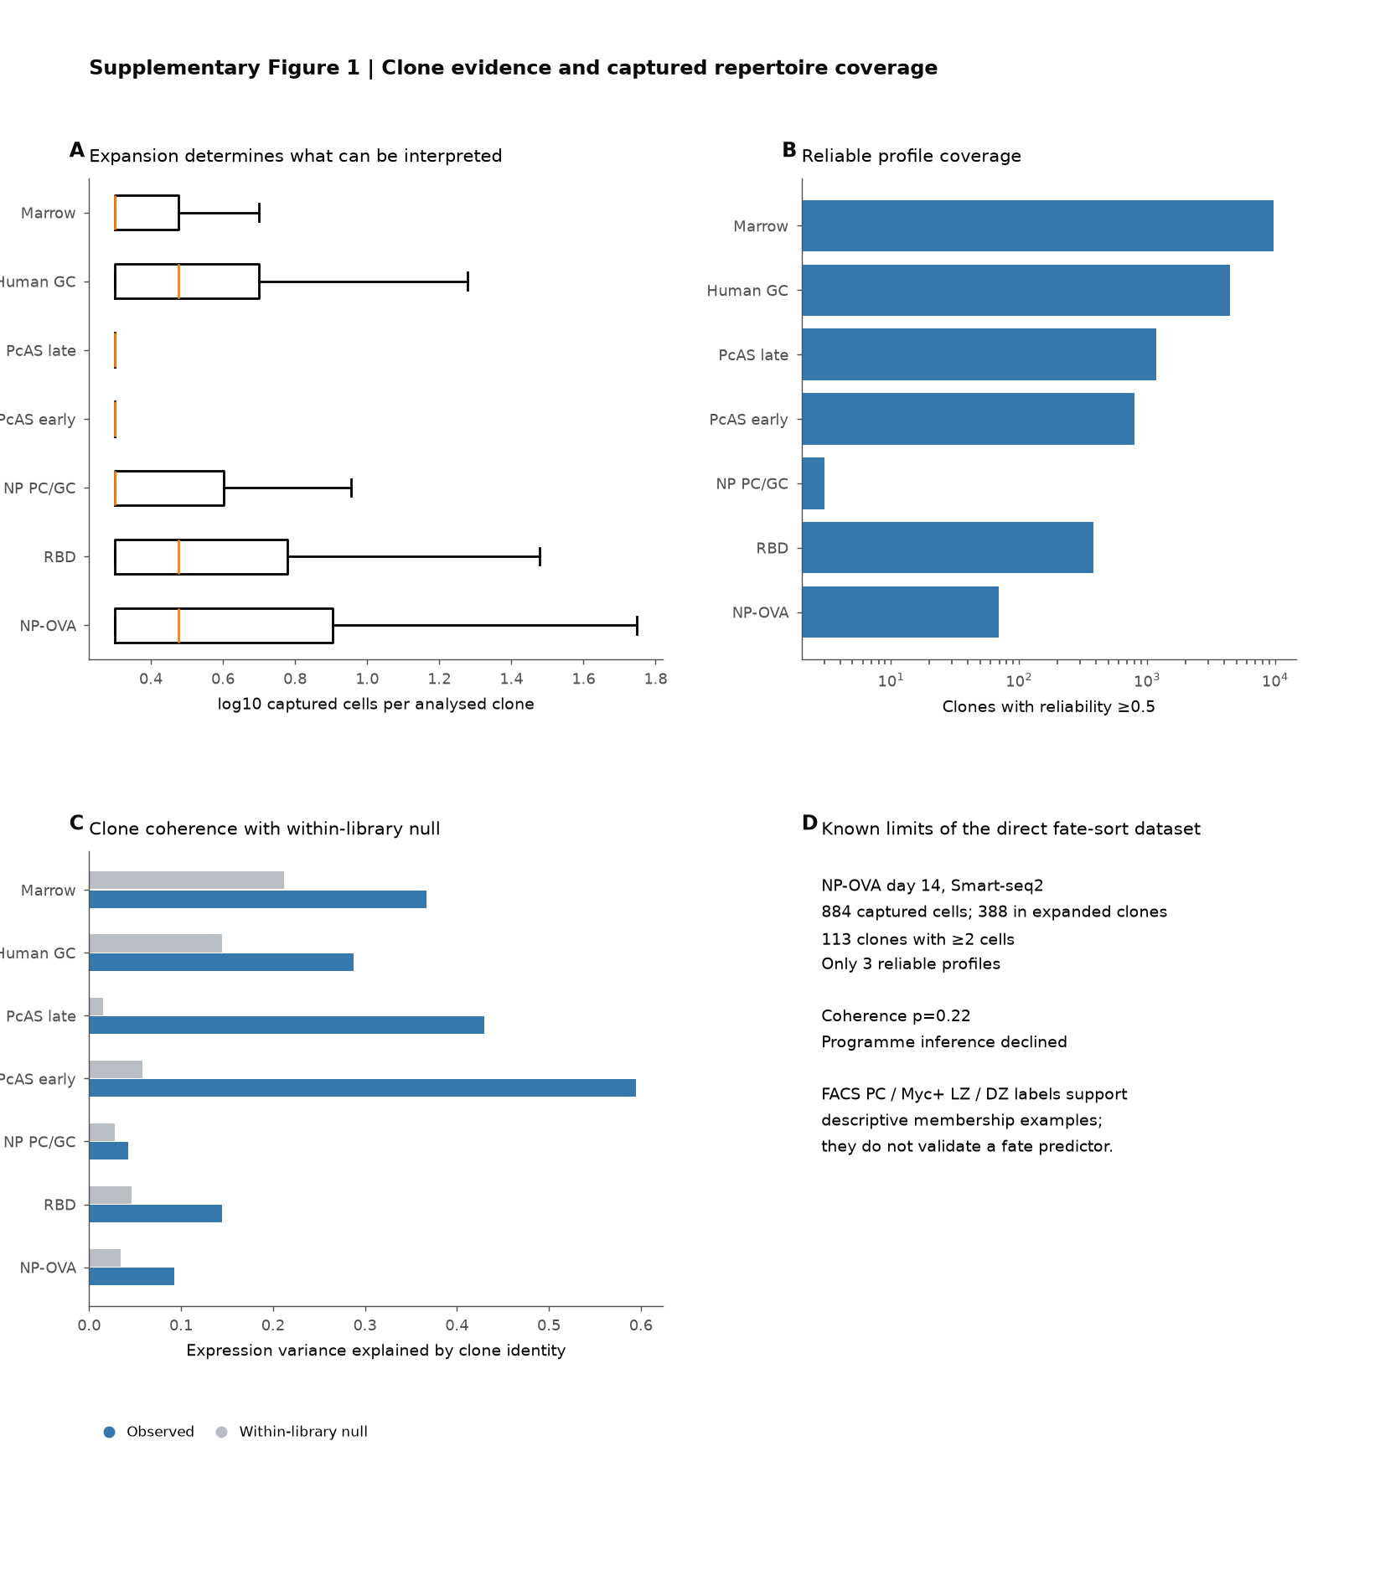

Supplementary Figure 1 Clone evidence and captured repertoire coverage. A, Distribution of captured cell counts per analysed family across the principal datasets. B, Number of families meeting the profile-reliability threshold (at least 0.5). C, Observed clone coherence and the corresponding within-library null. D, Sampling limits of the direct NP–OVA fate-sort dataset: its FACS labels support descriptive membership examples, whereas the small number of reliable profiles and non-significant coherence test preclude programme inference or validation of a fate predictor.

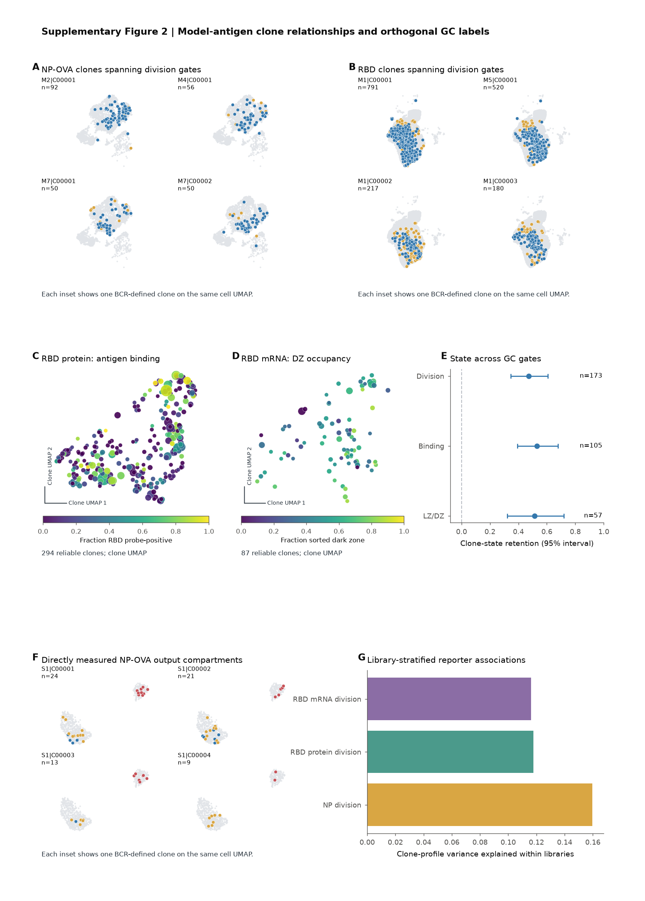

Supplementary Figure 2 Model-antigen clone relationships and orthogonal GC labels. A,B, Predeclared large NP–OVA (A) and RBD (B) families containing cells from both division gates, displayed on the shared cell UMAP for each experiment. C, RBD-protein cohort clone map coloured by the fraction of RBD-probe-positive cells. D, RBD-mRNA cohort clone map coloured by the fraction of dark-zone-sorted cells. E, Clone-state retention across division, RBD-binding and GC-zone gates, with 95% intervals. F, Directly measured NP–OVA output compartments in predeclared clone examples. G, Library-stratified association of division-gate occupancy with clone-profile variation in the NP–OVA reporter, RBD protein and RBD mRNA libraries. The orthogonal labels are separate experimental measurements; none establishes a lineage direction or an affinity value.

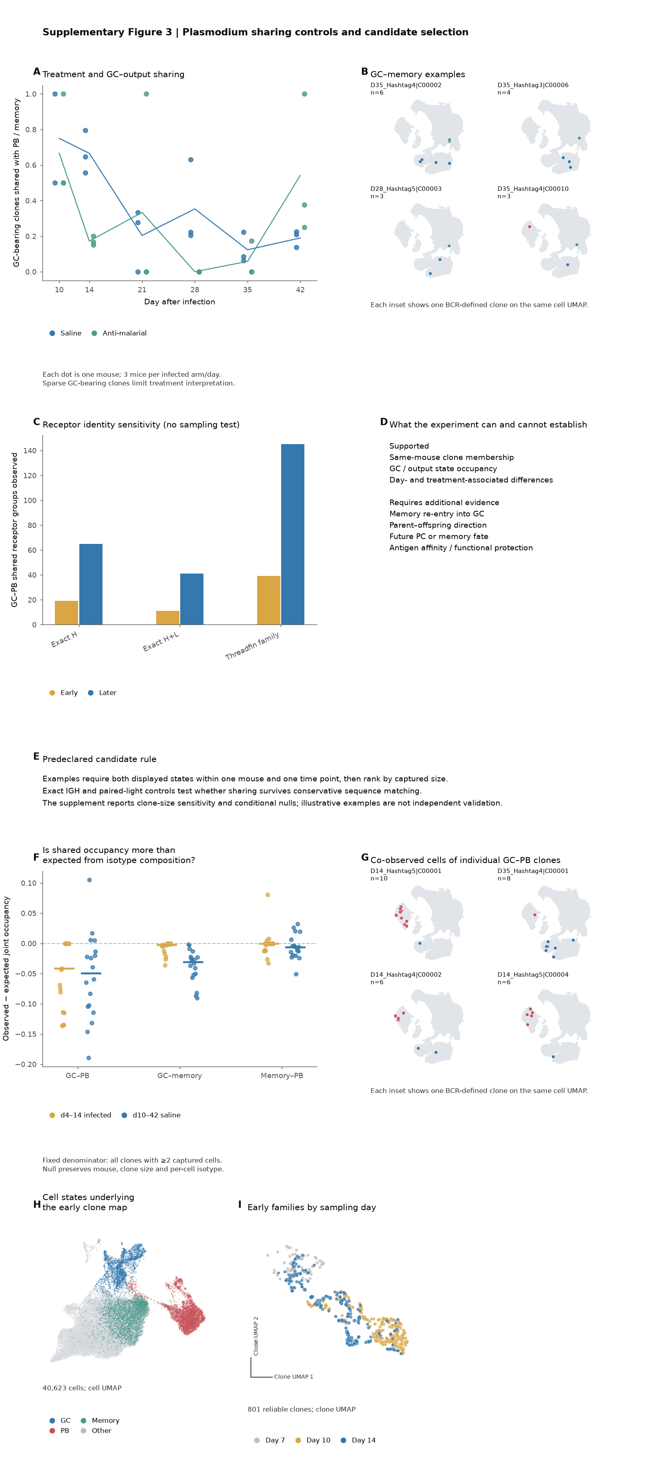

Supplementary Figure 3 *Plasmodium* sharing controls and candidate selection. A, Per-mouse time course of the fraction of GC-bearing families also captured in PB or memory states, shown separately for saline and anti-malarial arms. B, Predeclared GC–memory family examples. C, Observed GC–PB shared receptor groups under exact heavy-chain, exact paired heavy/light-chain and Threadfin-family definitions, shown without a sampling test. D, Supported and unsupported biological interpretations. E, Candidate selection and control rules. Shared receptor identity and captured state co-occupancy do not establish GC re-entry, parent–offspring relationships, future fate, antigen affinity or functional protection.

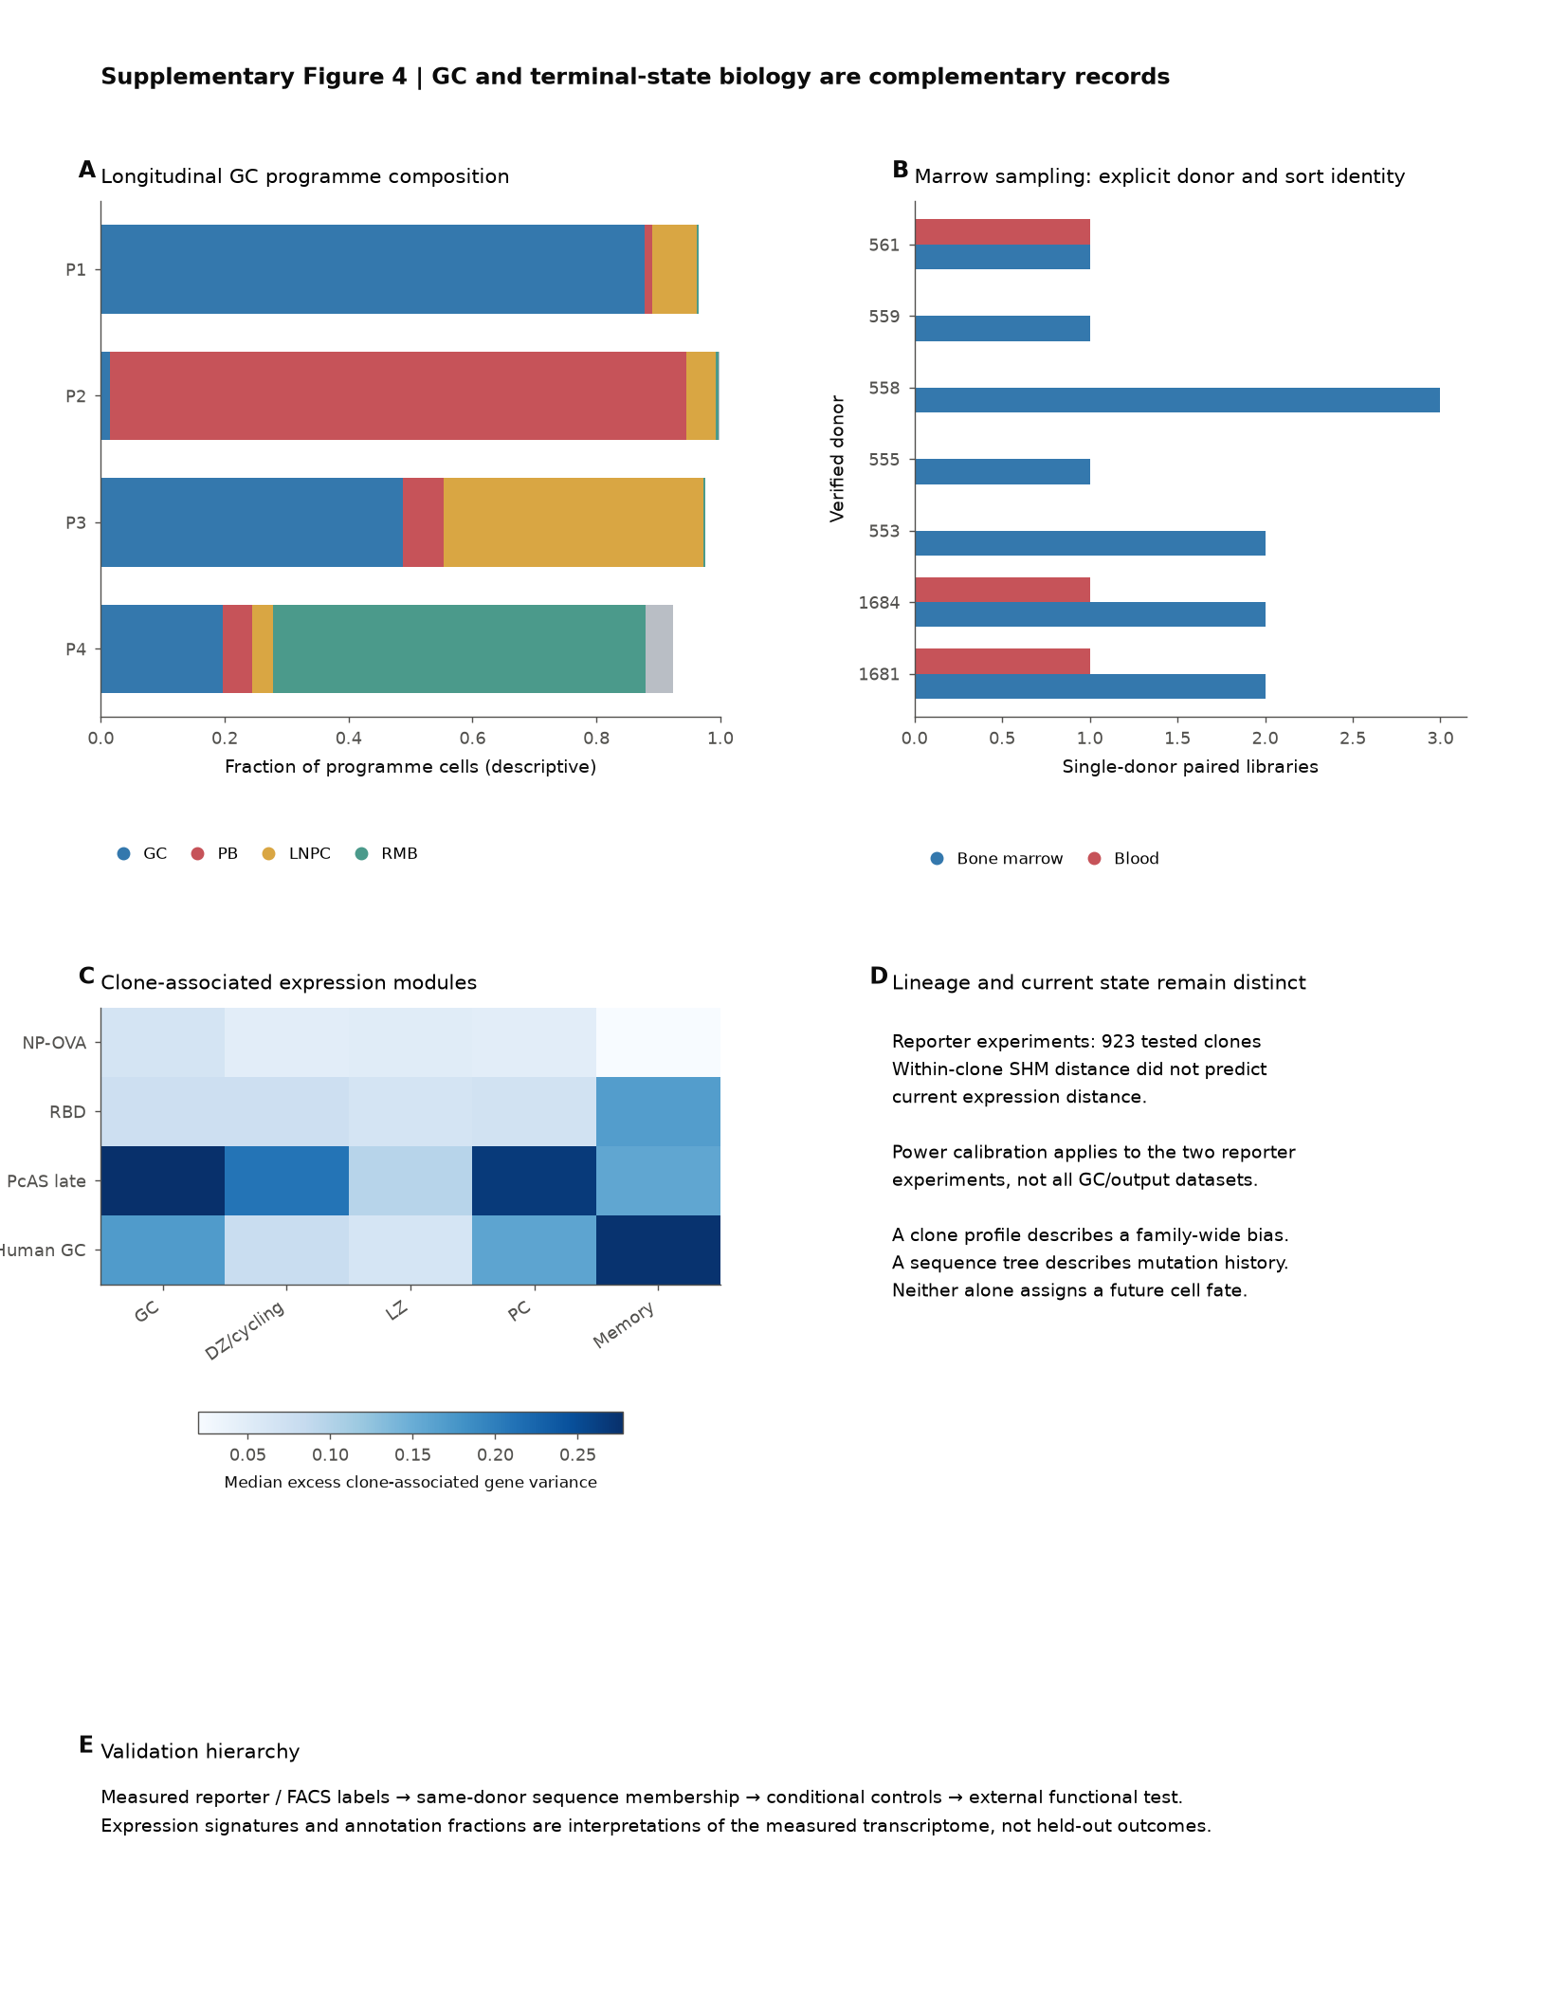

Supplementary Figure 4 GC and terminal-state biology are complementary records. A, Longitudinal composition of the human GC dataset by captured state. B, Verified single-donor marrow and blood library counts used for the marrow analysis. C, Median excess clone-associated variance for GC, cycling, light-zone, plasma-cell and memory expression modules across selected datasets. D, Sequence mutation history and current expression state provide different records: the calibrated reporter analysis did not detect a within-family association between SHM distance and expression distance. This null is limited to its tested cohorts and detectable effect sizes. E, Hierarchy of evidence from measured reporter/FACS labels through same-donor receptor membership and conditional controls to external functional tests.

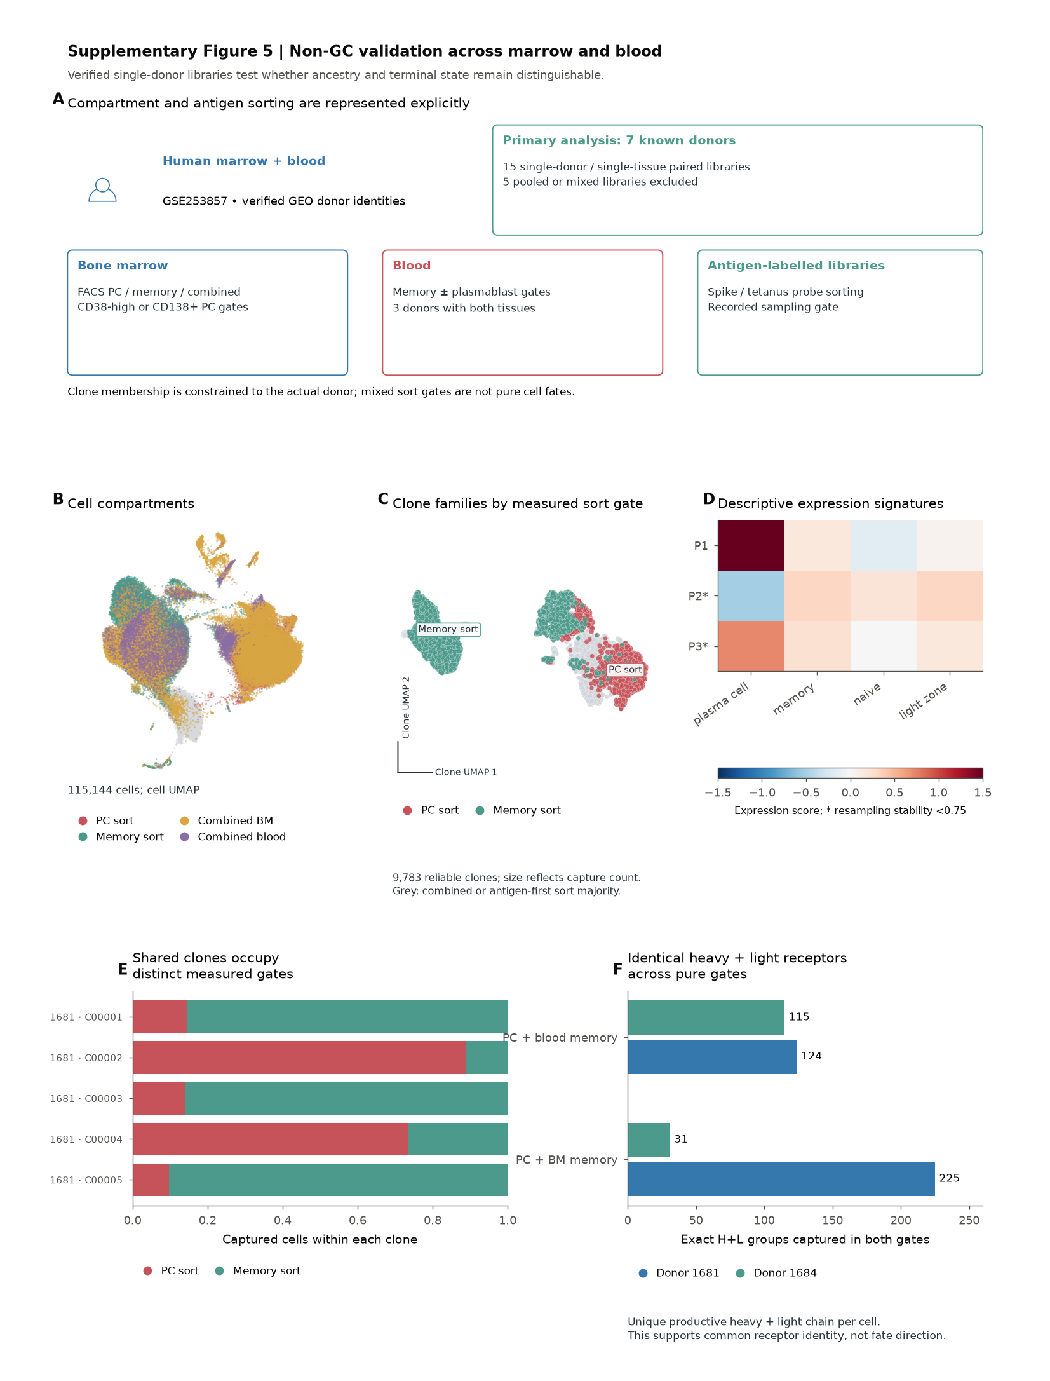

Supplementary Figure 5 Non-GC validation across marrow and blood. A, Marrow/blood study design, including verified donor identity, tissue and sort gate. Pooled or mixed libraries are excluded from the primary analysis. B, Cell UMAP coloured by measured plasma-cell, memory-cell and combined sort gates. C, Reliable family map coloured by dominant measured pure sort gate. D, Descriptive expression signatures of marrow/blood programmes. E, Large predeclared families captured in both pure plasma-cell and memory-B-cell gates. F, Exact productive paired heavy- and light-chain receptor groups captured in both pure gates for donors 1681 and 1684. Shared receptors support common receptor identity across captured gates; they do not establish differentiation direction.

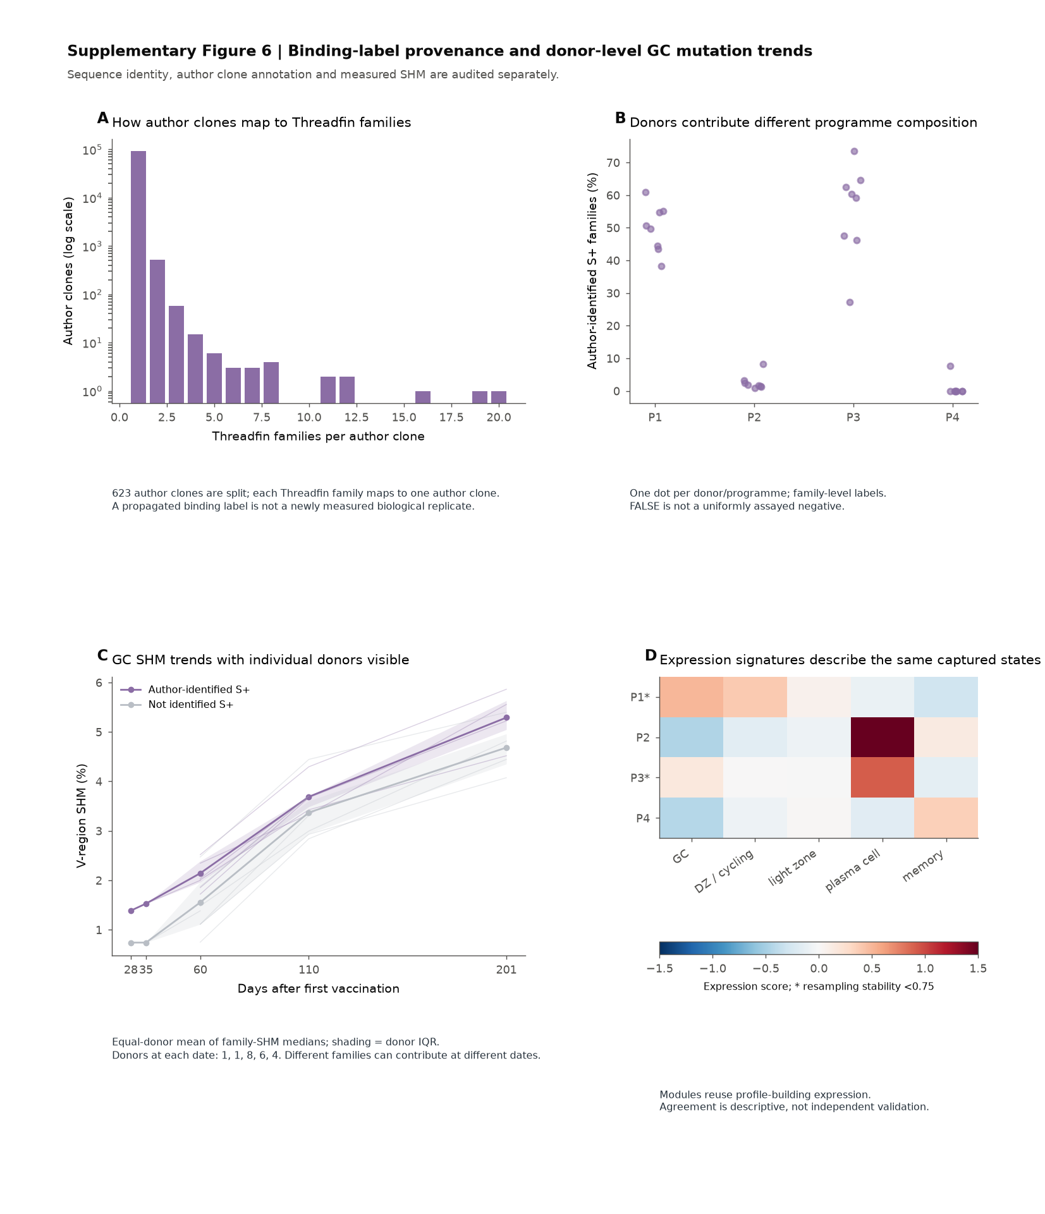

Supplementary Figure 6 Binding-label provenance and donor-level GC mutation trends. A, Crosswalk from author-defined clones to Threadfin IGH families. The histogram reports the number of Threadfin families per author clone. An author clone can be split into multiple sequence-defined families, whereas each Threadfin family maps to one author clone; propagated binding labels are therefore not newly measured biological replicates. B, Donor-specific composition of expression programmes by author-identified Spike-positive families. Each point is one donor/programme proportion among families with known labels. A FALSE call is not equivalent to a uniformly assayed antibody negative. C, The GC SHM comparison from Supplementary Figure 9G with individual donor trajectories shown. Lines retain the equal-donor donor-median summary; the availability of donors and contributing families varies across dates. D, Expression-module signatures of the same captured human-family states. These scores reuse the expression data used to construct the profiles, so they describe composition and are not independent validation.

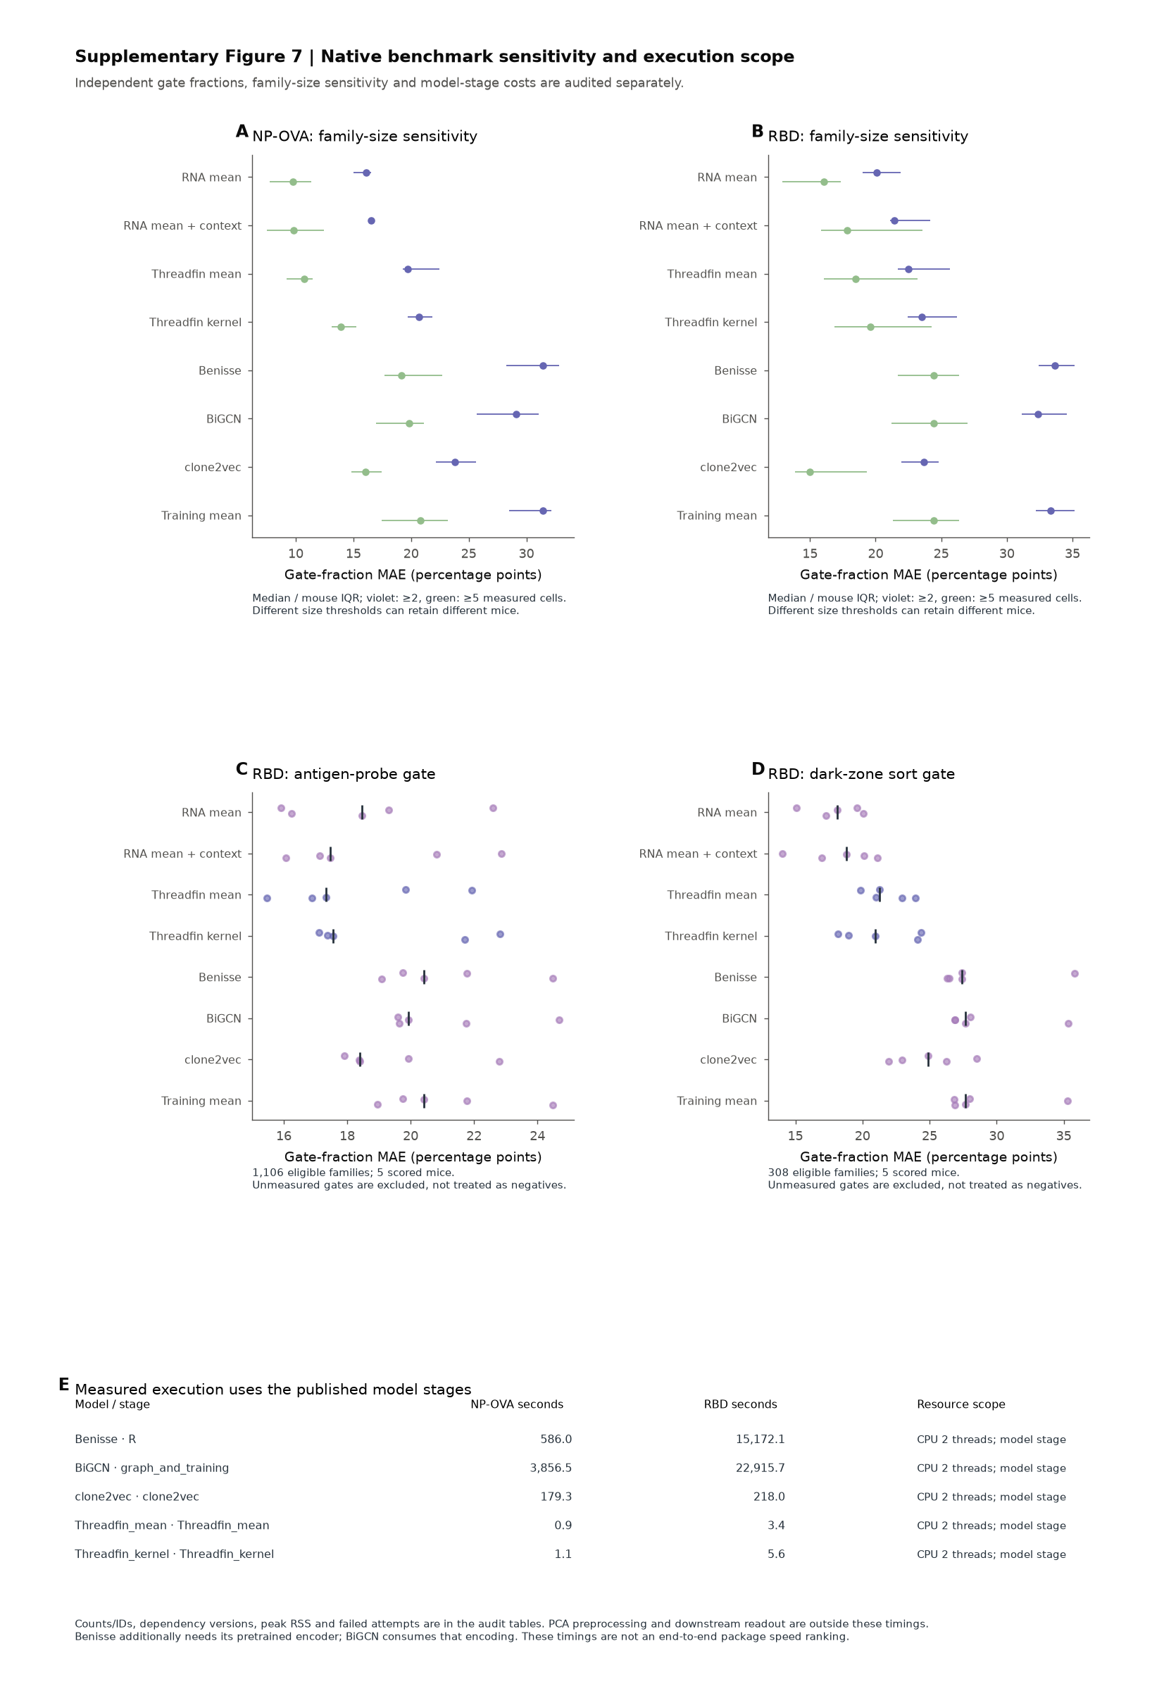

Supplementary Figure 7 Native benchmark sensitivity and execution scope. A,B, NP–OVA and RBD division-gate readout at thresholds of at least two or five measured cells per family. Points and intervals are the mouse-level median and IQR; stricter thresholds may retain different families and mice. C,D, RBD antigen-probe and dark-zone sort gate fractions, calculated among measured cells only, with whole-mouse held-out labels. E, Measured native model-stage times on two CPU threads. PCA preprocessing and downstream readout are excluded; Benisse additionally requires its pretrained encoder, which BiGCN also consumes. Different stage scopes and allocations prevent an end-to-end package speed ranking. Per-fold target prevalence, coverage, versions, ID hashes, peak command RSS and the official-model adapters accompany the source tables. Training uses one documented native configuration; BiGCN's upstream entry point has no fixed seed, so the comparison does not quantify repeated-training variability.

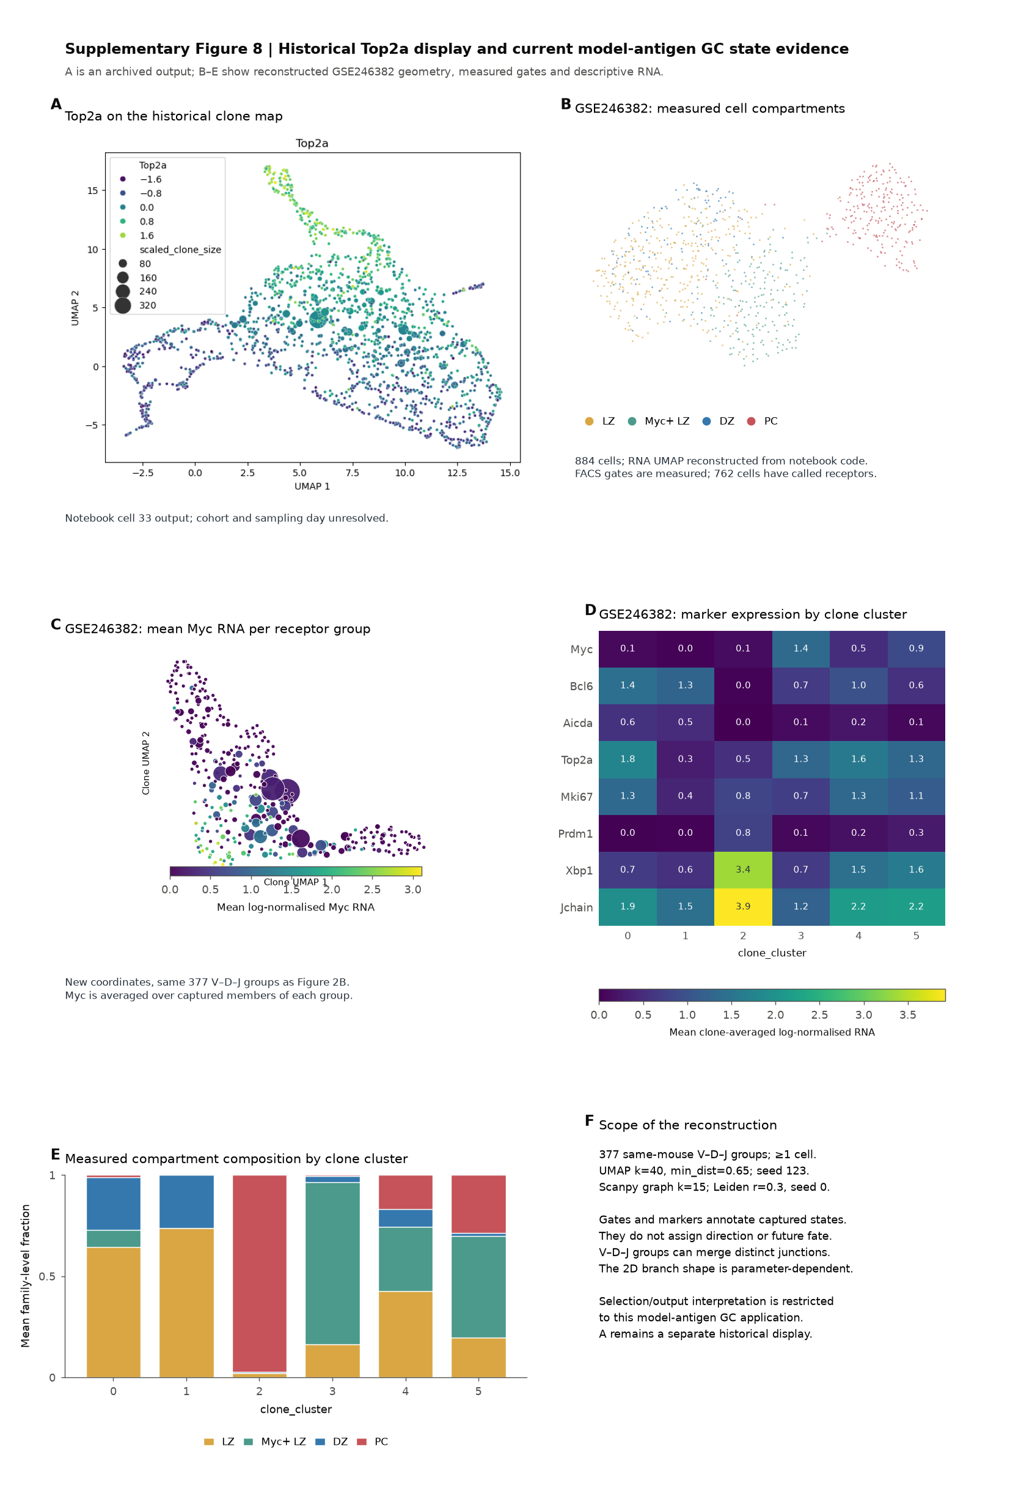

Supplementary Figure 8 Historical Top2a display and current model-antigen GC state evidence. A, Original Top2a-coloured clone map saved in notebook cell 33 output 0 at commit 57a9565. Points, expression values and scaled-size legend are preserved. Public GSE180920 day-7/day-14 counts and metadata have been verified, and the notebook contains explicit concatenation of those timepoints. The saved plot cannot be bound to a complete original input chain, so its exact cohort/day remains unresolved. It contributes no GSE246382 fate evidence. B, GSE246382 cell coordinates reconstructed from the executed notebook code, coloured by actual measured FACS compartments (884 cells; 762 with called receptors); no clone label transfer is used. C, New clone coordinates and mean log-normalised Myc RNA for the same 377 V–D–J receptor groups as Figure 2B. D, Log-normalised marker RNA averaged first over member cells, then equally over families within each unsupervised clone_cluster. Myc describes the Myc-positive-LZ-associated state, Bcl6/Aicda GC identity, Top2a/Mki67 cycling and Prdm1/Xbp1/Jchain the PC-associated state. The values describe reused RNA and do not independently validate future fate. E, Measured compartment composition by clone_cluster: mean family-level fractions of the four measured gates. F, Execution scope: exploratory parameter comparison followed by measured-state annotation; the primary map has six Leiden clusters across seven seeds, with variable boundaries (median pairwise ARI 0.877). V–D–J grouping can merge distinct junction sequences. Cluster 3 is GC selection-associated, cluster 2 is output-enriched and the remaining clusters retain within-group mixtures. These are descriptive state groups, not validated programmes. The historical Top2a panel is separate from the new GSE246382 analysis, and no differentiation direction or non-GC selection/output mechanism is assigned.

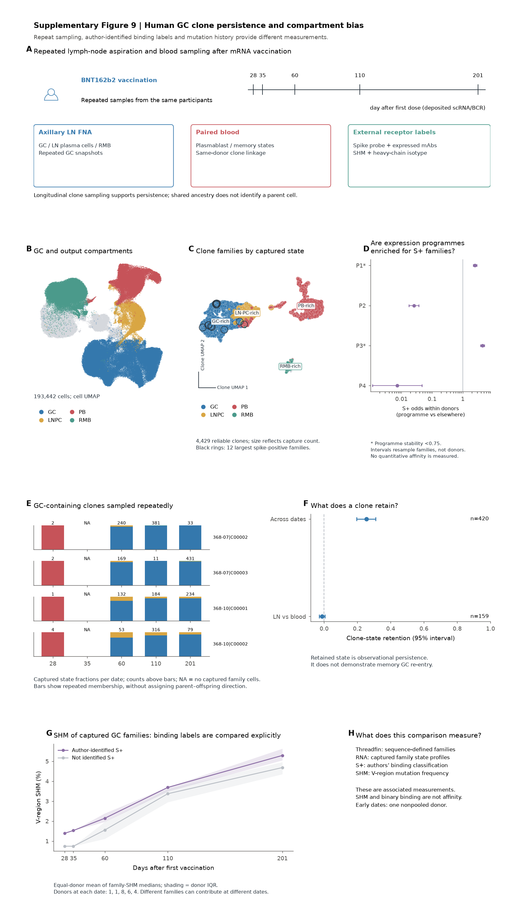

Supplementary Figure 9 Human GC clone persistence and compartment bias. A, Repeated lymph-node and blood sampling after vaccination. B,C, Cell and family maps by captured state. D, Within-donor author-identified Spike-binding label enrichment across expression programmes; binding classification is not quantitative affinity. E, Repeated capture of GC-containing families, with per-date state composition and missing capture distinguished. F, Observational state retention across sampling dates and tissues. G, GC-only family SHM summaries with donors weighted equally and donor variability shown. H, Distinct interpretations of RNA, receptor identity, binding labels and mutation history. Repeated capture does not establish memory GC re-entry.

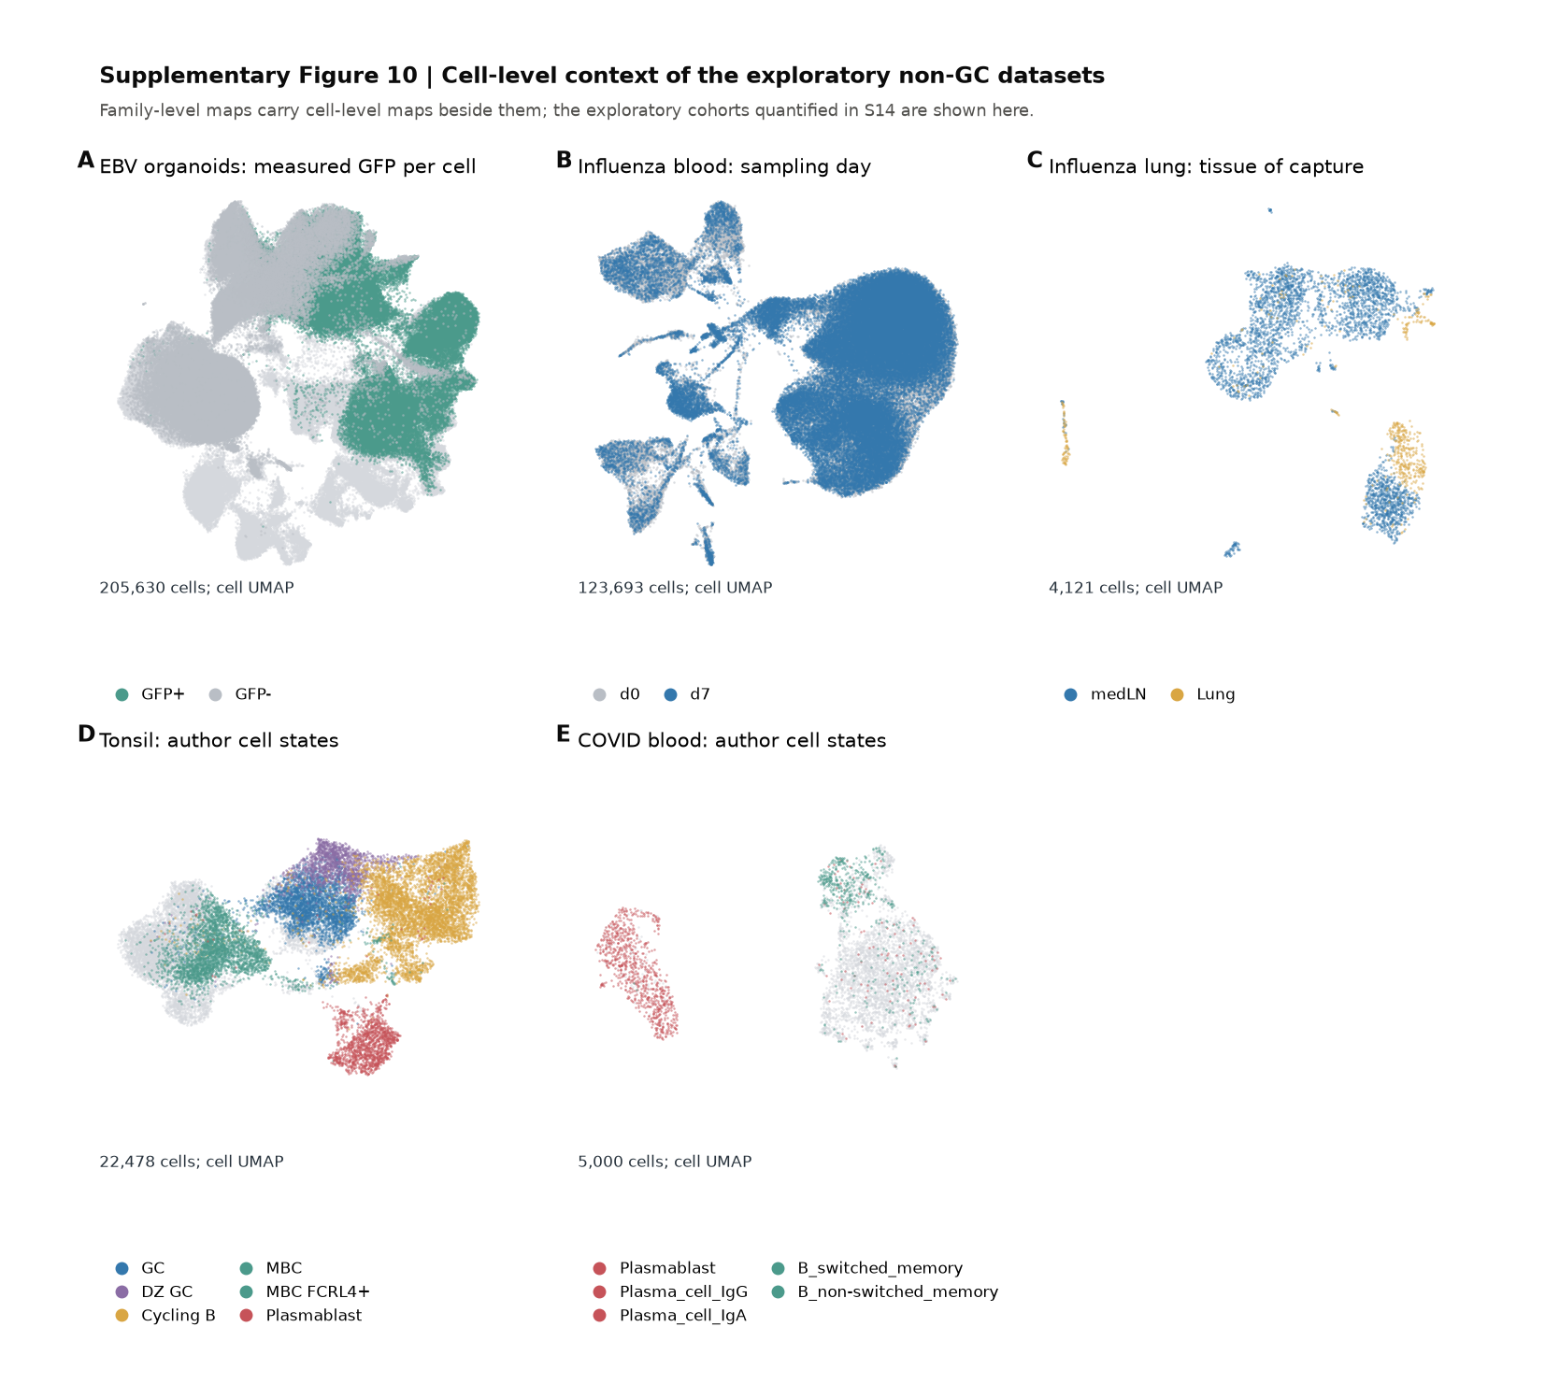

Supplementary Figure 10 Cell-level context of exploratory non-GC datasets. Author cell-level context beside the exploratory family analyses: A, EBV-infected tonsil organoids, coloured by measured GFP label; B, influenza blood by date; C, influenza lung by tissue; D, tonsil by author state; E, COVID blood by author state. These cohorts provide coverage rather than independent lineage/fate validation. Corresponding family-level quantitative results are in Supplementary Figures 14 and 15.

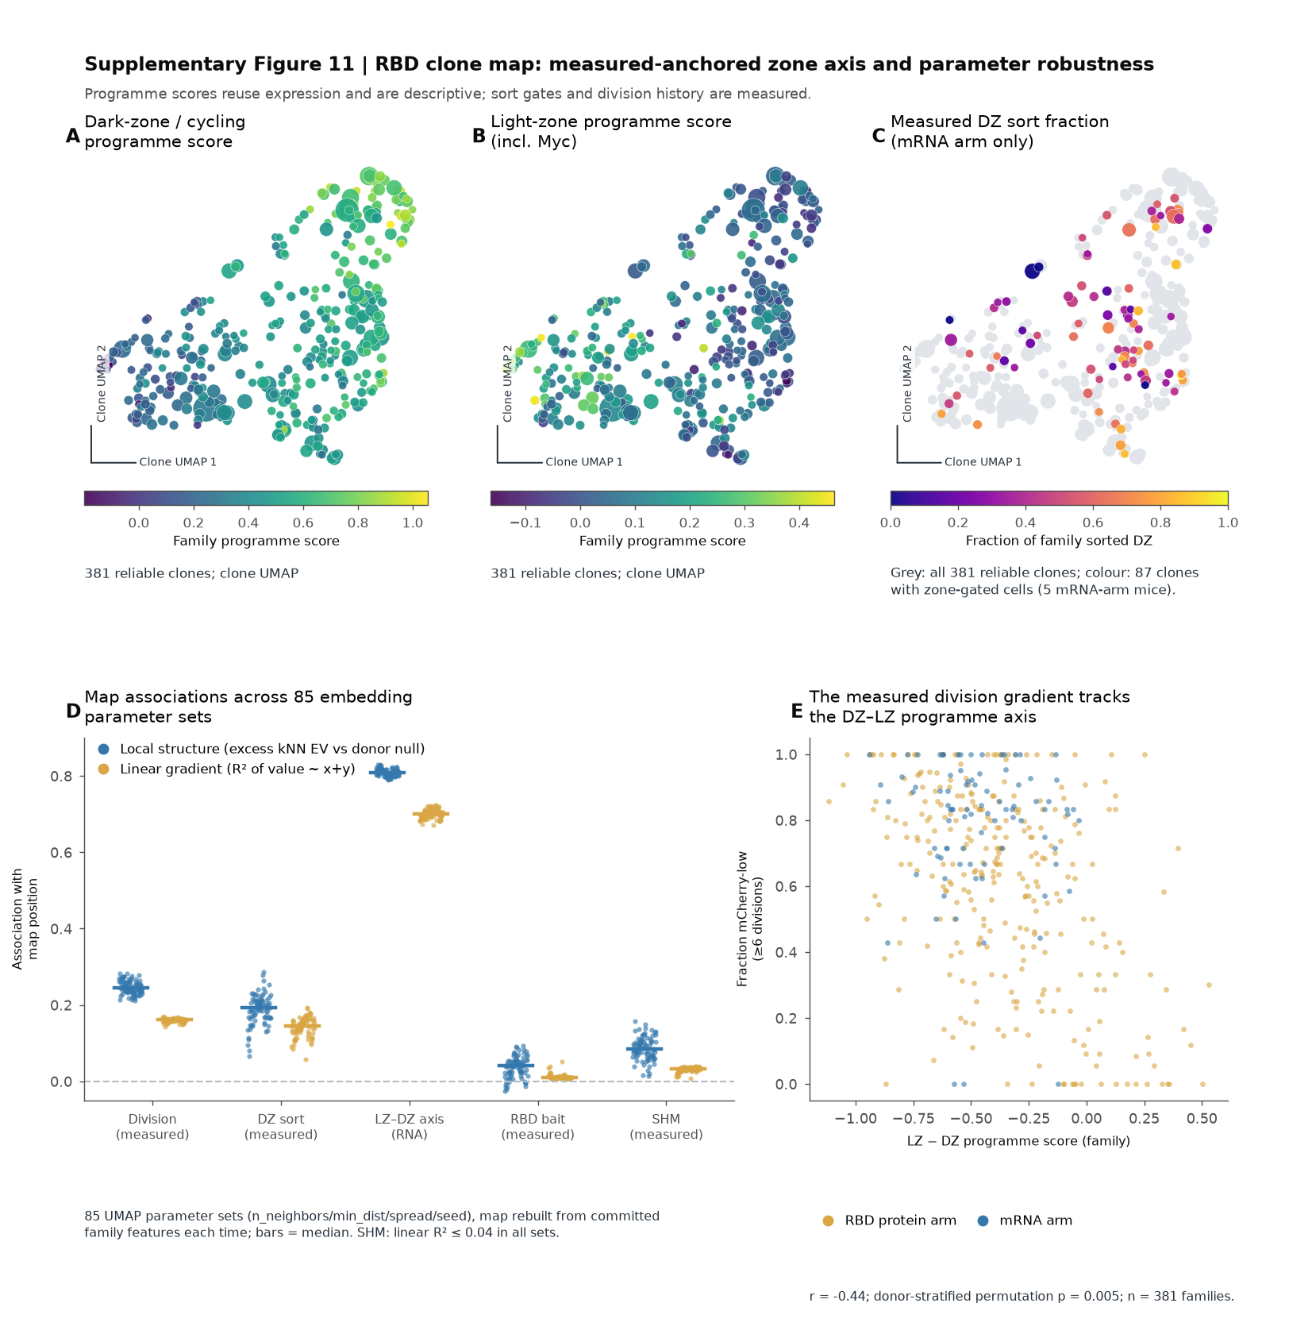

Supplementary Figure 11 RBD state annotations and display-parameter sensitivity. A,B, Expression-derived dark-zone/cycling and light-zone scores on the same reliable-family coordinates. C, Measured dark-zone sort fraction where available. D, Local association above the donor-preserving null and global linear association across 85 UMAP settings. The local statistic is explained variance (EV), not standard predictive R²; the linear statistic is R². E, Measured division fraction versus the expression-derived LZ-minus-DZ score. RNA modules describe the input data. The parameter audit is a sensitivity analysis, not biological optimisation of the main display.

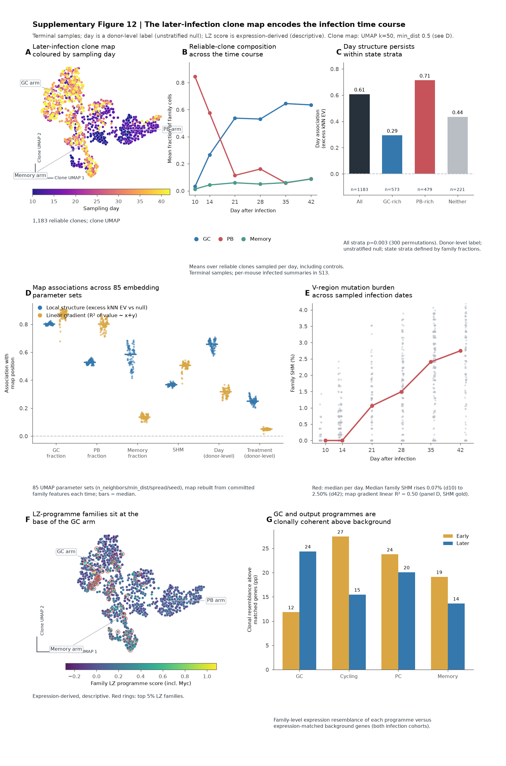

Supplementary Figure 12 Sampling-time and expression context of the later-infection map. The later PcAS clone map is displayed with sampling-day, cell-state and expression annotations and parameter sensitivity controls. All days represent terminally sampled mice; family identities are not tracked between mice or dates. RNA scores are descriptive. Day is a donor-level label, so unstratified day-label association does not establish within-mouse progression. Detailed source selections and coordinate hashes are recorded in the figure audit.

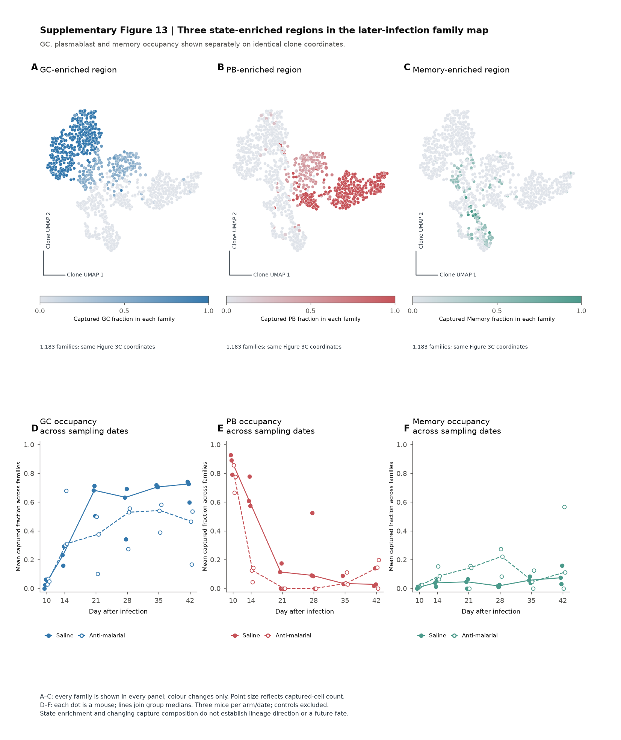

Supplementary Figure 13 All three state-enriched regions in the later-infection clone map. A–C, The same 1,183 reliable families at the identical Figure 3C coordinates, coloured separately by GC, PB and Memory captured-cell fractions. Every family appears in every map; only colour changes. Point area increases with capture count. D–F, Within-mouse equal-family mean state fractions across six infection dates, with each mouse shown individually and treatment medians connected. The 36 infected mice contribute 1,174 reliable families; controls are excluded from these time curves. State enrichment does not prove differentiation direction, GC origin or a future fate.

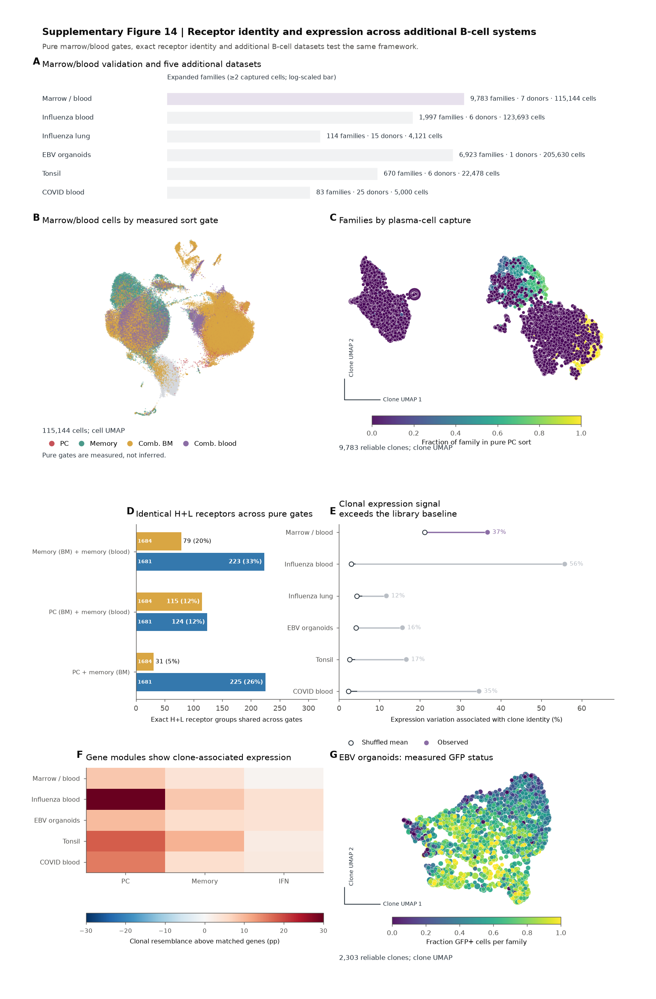

Supplementary Figure 14 Receptor identity and expression across additional B-cell systems. A, Marrow/blood validation and five additional B-cell datasets. B, Marrow/blood cells by measured sort gate. C, Reliable family profiles coloured by captured pure-PC-sort fraction. D, Exact productive heavy-plus-light receptor identities shared across pure marrow/blood gates within verified donors. E, Observed clonal expression signal compared with within-library shuffles. F, Descriptive clonal resemblance of PC, memory and interferon expression modules. G, Measured GFP status on the EBV-infected tonsil-organoid family map; GFP is not an antigen-binding measurement. Gate identity and receptor identity provide different evidence from RNA-module agreement.

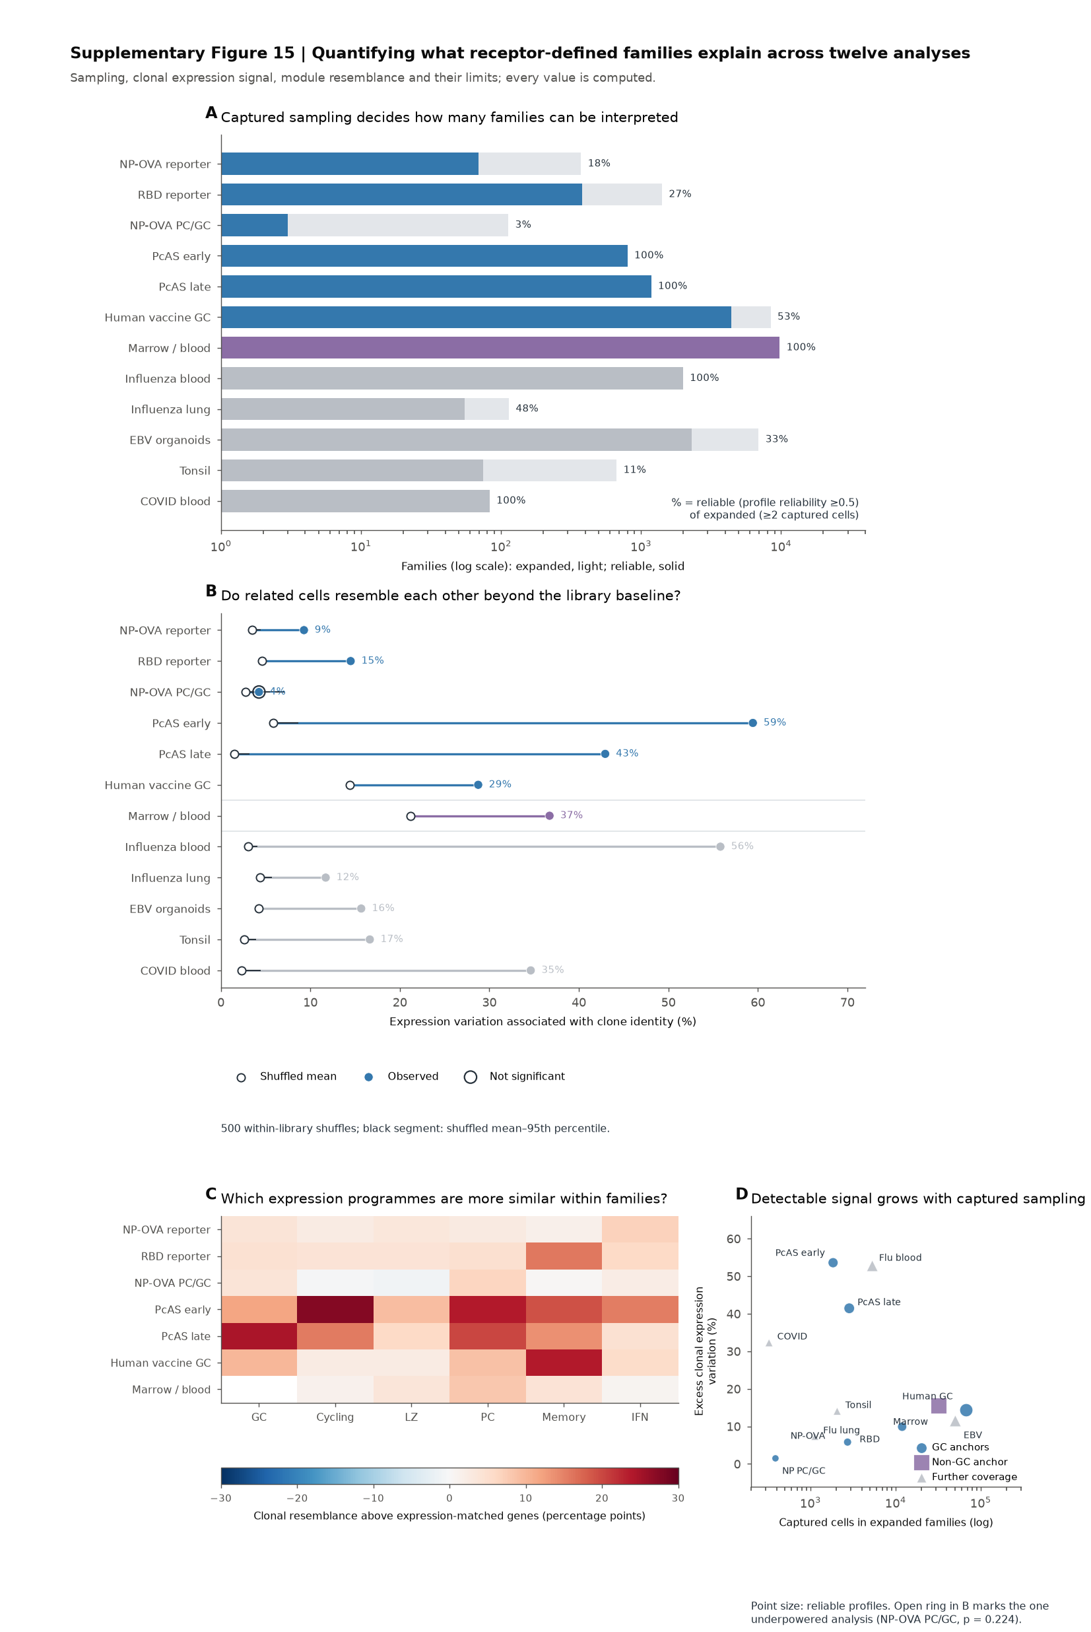

Supplementary Figure 15 Clonal expression signal across twelve dataset analyses. A, Expanded families and reliable-profile coverage. B, Observed expression variation associated with clone identity compared with 500 within-library shuffles; the open ring marks the underpowered NP–OVA PC/GC analysis. C, Expression-module resemblance above expression-matched genes in the seven anchor analyses. D, Sampling depth and excess clonal expression signal. Twelve analyses are not twelve independent studies, and RNA-module resemblance is not orthogonal fate validation.

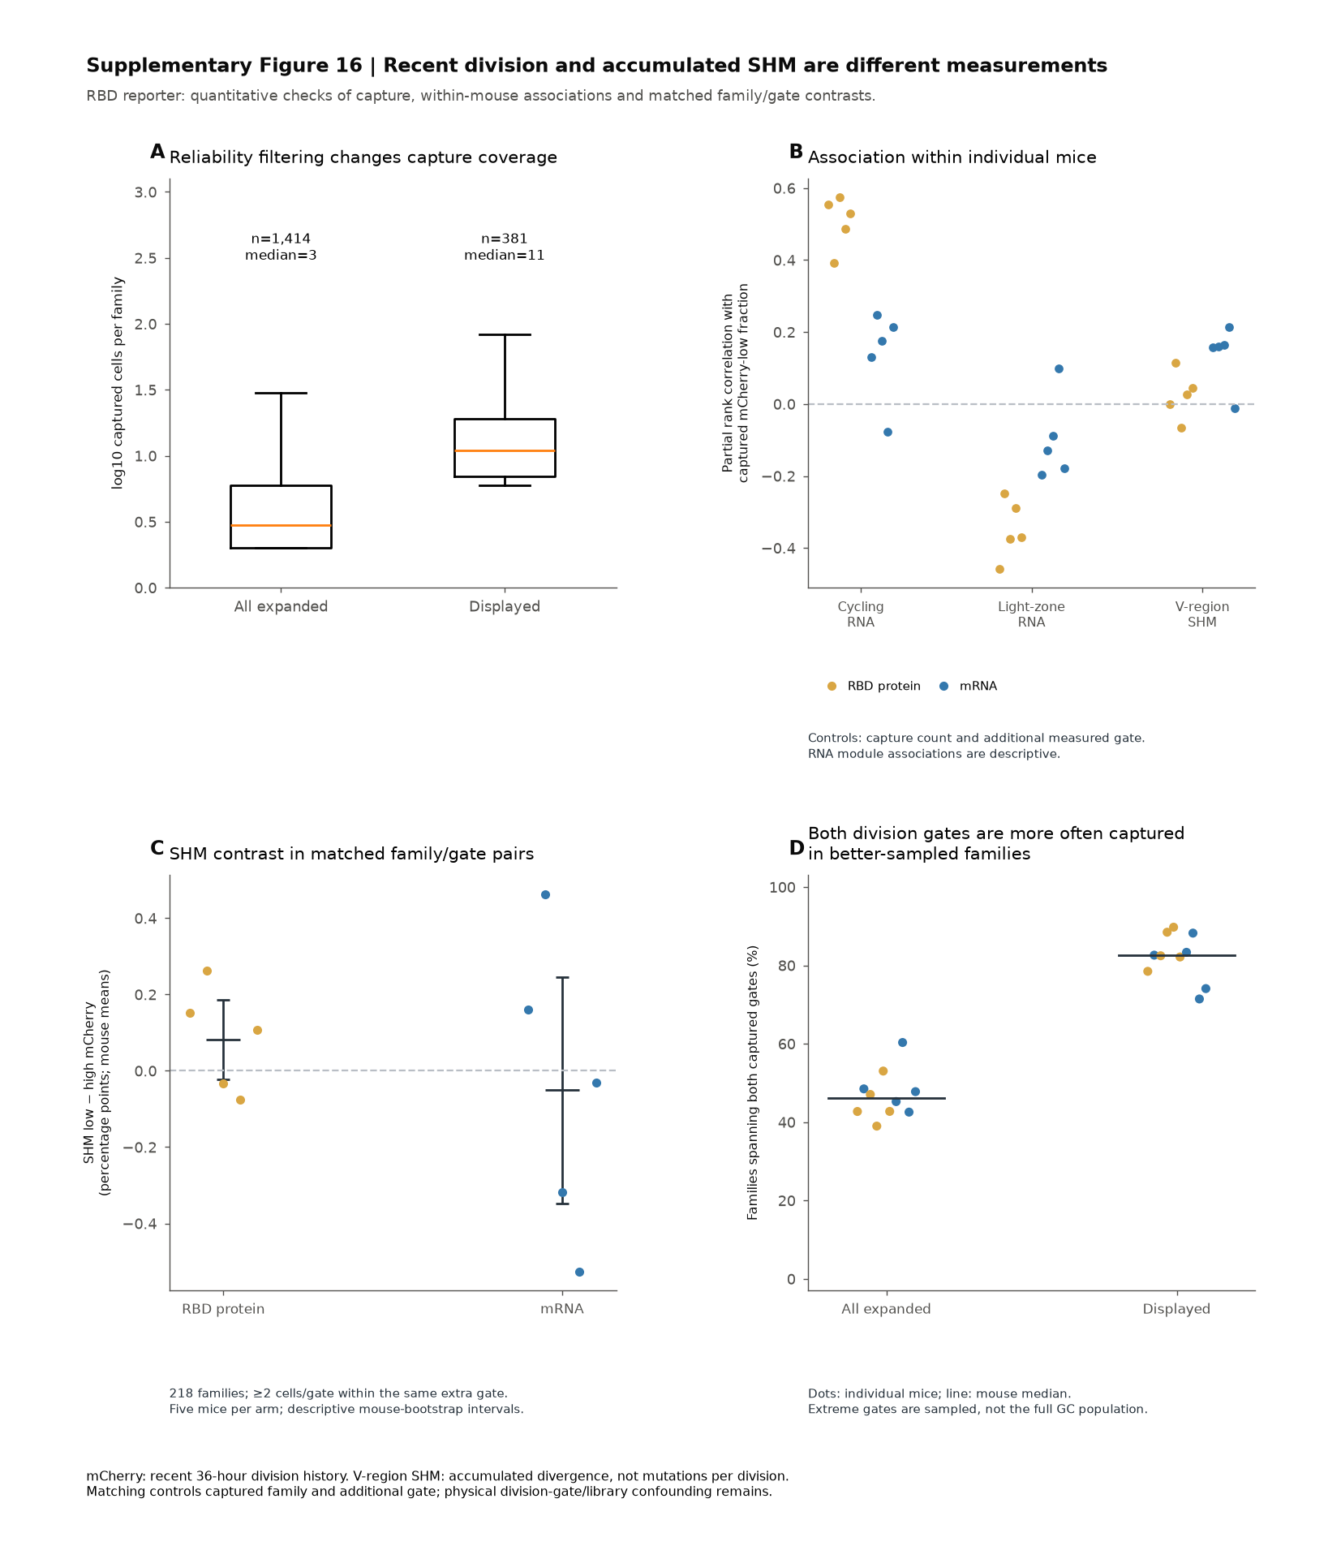

Supplementary Figure 16 Quantitative boundaries of the RBD reporter interpretation. A, Capture counts of all 1,414 expanded families and the 381 displayed reliable families. Medians are three and eleven cells, respectively. B, Per-mouse partial rank association between captured mCherry-low fraction and dark-zone/cycling RNA, light-zone RNA or mean V mutation frequency. The rank residuals account for captured family size and the additional measured gate (binding or zone). Points are mice, colours identify the two experimental arms, and every expanded family with measurements contributes. RNA modules reuse the profile inputs. C, SHM difference between mCherry-low and mCherry-high cells within the same family and additional gate, requiring two cells per extreme. Stratum differences are averaged within family, then equally across families within mouse. Points are individual mice; bars are equal-mouse means and lines are descriptive 95% mouse-bootstrap intervals. There are 185 eligible protein-arm families and 33 mRNA-arm families, five mice per arm. D, Fraction of families spanning both captured division gates among all expanded and reliability-filtered families. Reliable-profile display selects better-sampled families and does not estimate unsorted GC population prevalence. No result estimates mutations per division, affinity, future fate or an advantage over RNA means. Physical sequencing-library confounding remains.

