Requirements
- Create a GitHub account and join the GitHub Classroom (10 points)
  - For section A- Teacher-Otep-classroom-cc111-a
  - For section B- Teacher-Otep-classroom-cc111-b
- A computer installed with XAMPP, Git and Github Desktop

Tasks
- Finish the Git and GitHub Fundamentals Assignment. (10 points)
Exam
- Download the source folder from the github repository and place it inside users/xampp/htdocs (5 points)
- Change the logo with your own original logo in svg format. (5 points)
  - Add a mouse event on the logo that shall hide the sections with the class ‘content’ when clicked. (5 points)
- Apply the same styling to the contents of other sections. Use the content of ‘create’ section as your basis. (10 points)
- Add the following UX design. 10 points
Click button | Shows section | Hides section
Create | ‘create’ | ‘home’, ‘read’, ‘update’ ,and ‘delete’
Read | ‘read’ | ‘home’, ‘create’, ‘update’ ,and ‘delete’
Update | ‘update’ | ‘home’, ‘create’, ‘read’ ,and ‘delete’
Delete | ‘delete’ | ‘home’, ‘create’, ‘read’ ,and ‘update’

- Add a function for the ‘Clear Fields’ button to clear the contents of all text and number inputs. (5 points)
- Database
  - Create a schema named ‘dbstudents’,
  - Create a table called students with the following description
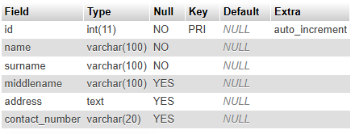
  - Inside includes folder, edit db.php to match your configuration settings.
- On index.php, section ‘read’, show here all the records in the table students (10 points)
- On index.php, section ‘update’, create a form to select 1 student by ID from the table students. You should be able to update the record of the selected student. (20 points)
- On index.php, section ‘delete’, create a form to facilitate deletion of a student in the students table. (20 points)

