BERT-Based Requirement Classification for Agile Backlog Management
[NAME]
[DEPARTMENT]
[INSTITUTION]
[CITY, COUNTRY]
[EMAIL]

Abstract—Product backlogs mix feature requests, quality constraints, defects and chores, and few teams label them consistently. Quality requirements tend to surface late, when they are costly to fix. This paper asks whether BERT-family encoders can classify backlog items reliably enough to support refinement. We synthesise 35 sources and propose a two-level framework whose confidence gate sends uncertain items to the Product Owner. In a comparative experiment on PROMISE NFR (625 requirements, 15 projects), we compared TF-IDF baselines with a partially frozen DistilBERT under random 10-fold and project-held-out splits. On the seed-42 random split, DistilBERT matched a linear SVM on functional versus non-functional classification (macro-F1 0.901 vs. 0.916, not significant) and beat it on four frequent quality classes (0.919 vs. 0.832). On unseen projects every score fell; DistilBERT led clearly: 0.751 versus 0.589–0.638 for the baselines on the first task and 0.813 versus 0.696–0.718 on the second, significantly in every seed (McNemar p ≤ 0.017) before multiple-comparison correction, yet it found only 56% of the functional requirements in unseen projects. Published BERT scores on PROMISE reach 0.94–0.99 F1 but rest on one small, dated corpus, often without project-level splits. We conclude that BERT classifiers suit refinement assistance better than autonomous labelling.
Index Terms—requirements classification, BERT, DistilBERT, non-functional requirements, agile, product backlog, user stories, PROMISE NFR
I. Introduction
In Scrum the Product Backlog is the single, ordered source of work for a team, and the Product Owner is accountable for keeping it in order [1]. In practice the backlog is messier than that one sentence suggests. In a grounded-theory study of eight projects and 56 interviews at Pivotal, Sedano et al. [2] found that the backlog acts as an informal model of the work still to be done, and that it serves as a boundary object shared by the different roles on a team rather than as a requirements specification. User stories are an increasingly popular way to write these items; Lucassen et al. [3] surveyed 182 practitioners and interviewed 21 more, and found the Connextra template (“As a ⟨role⟩, I want ⟨goal⟩, so that ⟨benefit⟩”) to be the dominant format.
Consider a typical story: “As a user, I want to reset my password through an e-mailed link so that I can regain access to my account.” On the surface it is functional. Read carefully, it also carries security obligations: the link must expire, it must work only once, and the response must not reveal whether an e-mail address is registered. If the team tags the story only as a feature, those constraints are easily missed until a penetration test or an incident exposes them. Dalpiaz et al. [4] formalised this observation by annotating requirements with separate functional and quality aspects, so that a single item can carry both. Van Can and Dalpiaz [5] analysed 1,636 backlog items from 14 projects and found that requirement-related content is labelled inconsistently and that one item often contains several requirements at different levels of granularity.
Automatic classification of requirements text has a long history. It started with indicator-term classifiers trained on student specifications [6] and moved through feature-engineered support vector machines [7], [8] and convolutional or recurrent networks [9], [10]. Since BERT appeared [11], fine-tuned transformers have become the default, and NoRBERT showed that transfer learning helps most on projects not seen during training [12], [13]. Yet three gaps remain. First, most results on FR/NFR classification come from the PROMISE NFR corpus [14], 625 “shall” statements written for 15 student projects in the mid-2000s, or from its extensions, not from agile backlogs. Second, scores are reported under very different protocols, so a 0.99 in one paper and a 0.87 in another cannot be compared directly. Third, few of the studies we reviewed say what a team should do with a predicted label, or how to handle the predictions a model is unsure about.
This paper addresses those gaps with four contributions:
1) a critical synthesis of 35 sources, with the reported results collected in a single comparison table (Table I) that keeps each study's dataset and protocol visible;
2) a two-level classification framework (Figs. 1–3) that connects predicted labels to backlog refinement, the Definition of Done and sprint planning, and that routes uncertain items to a human through an explicit confidence gate;
3) a small comparative experiment that we ran ourselves on PROMISE NFR, comparing DistilBERT with three TF-IDF baselines on identical random and project-held-out folds over three seeds, with every hyper-parameter and limitation stated and a script that reproduces every number;
4) a discussion of deployment challenges and threats to validity, summarised in Table V.
Section II reviews related work, Section III presents the framework, Section IV reports our experiment and the literature results separately, Section V discusses challenges and validity, and Section VI concludes.
II. Related Work
A. Datasets and Label Schemes
The PROMISE NFR dataset was created by Cleland-Huang et al. [6] and later shared through the PROMISE repository [14]. It contains 255 functional requirements and 370 non-functional ones, the latter spread over eleven quality classes ranging from usability (67 items) to portability (one item). Lima et al. [15] enlarged it to 969 requirements (444 functional, 525 non-functional) in PROMISE_exp, but kept the same style of text. Dalpiaz et al. [4] relabelled more than 1,500 requirements from PROMISE and seven industrial documents with independent functional and quality aspects. That relabelling matters. It shows that the binary FR/NFR split, which most papers take for granted, forces an annotator to discard information whenever a requirement constrains behaviour and quality at the same time.
B. Classical and Deep-Learning Classifiers
Kurtanović and Maalej [7] combined lexical and syntactic features with a support vector machine and used under- and over-sampling to counter class imbalance. They reported precision and recall of up to about 92% for the FR/NFR distinction on PROMISE NFR, with security and performance among the best-recognised quality classes. Dalpiaz et al. [4] replaced the large feature space with 17 interpretable features derived from dependency parsing. Their classifier fitted the training data slightly less well than a reconstruction of the Kurtanović and Maalej model, but it generalised better to other datasets and its decisions could be explained. To us this is the more useful result for practice, because a Product Owner is more likely to trust a tag whose cause can be shown. Dias Canedo and Cordeiro Mendes [8] compared bag-of-words, TF-IDF and chi-squared features with logistic regression, SVM, multinomial Naive Bayes and k-nearest neighbours on PROMISE_exp. TF-IDF with logistic regression gave the best F-measure: 0.91 for FR/NFR (tied with the SVM), 0.74 for the NFR classes and 0.78 overall. These are the same feature and model families as our baselines in Section IV.
Neural models followed. Rahman et al. [9] compared recurrent variants on PROMISE NFR and reported that an LSTM reached a validation precision of 0.973, recall of 0.967 and F1 of 0.966, ahead of GRU and CNN models. Rahimi et al. [10] combined LSTM, BiLSTM, GRU and CNN models in an ensemble on a 17-class PROMISE variant that also labels functional subtypes, and reported 92.56% accuracy for one-phase classification. Their two-phase variant reached 95.7% for the binary step and 93.4% for the multi-class step. Two reviews put this stream in context: Binkhonain and Zhao [16] catalogued machine-learning methods for identifying non-functional requirements, and Zhao et al. [17] mapped the wider NLP-for-RE field and documented the gap between research prototypes and tools that practitioners actually use.
A pattern runs through several of these numbers, although not all of them. Some of the highest scores come from small evaluation sets, from validation rather than test data, or from briefly described splits. The F1 of 0.966 reported by Rahman et al. [9] is an average over cross-validation folds of PROMISE NFR's roughly 370 non-functional requirements; on a separately selected test set, the same LSTM averaged an F1 of 0.70. Under random cross-validation, requirements from the same project, often with near-identical wording, fall on both sides of a split. Not every high score fits this pattern, however: Eltahier et al. [18] also report 0.97 on a second dataset, FR_NFR. A high random-fold score says little about how the same model would label a new team's backlog.
C. BERT and Its Variants in Requirements Engineering
BERT pre-trains a bidirectional transformer encoder with masked-language-model and next-sentence objectives, and is then adapted to a downstream task by adding a single output layer and fine-tuning all weights [11]. RoBERTa keeps the architecture but trains longer on more data, drops the next-sentence objective and masks tokens dynamically [19]. DistilBERT applies knowledge distillation to obtain a model about 40% smaller and 60% faster that keeps 97% of BERT's language-understanding performance [20], which makes it a realistic choice for a team without GPUs. Sun et al. [21] studied fine-tuning choices such as layer selection, learning rates and further pre-training, and their recommendations inform the settings in Section IV.
NoRBERT was an early and widely cited application of BERT fine-tuning to requirements classification [12]. On PROMISE NFR it reached an F1 of up to 94% for FR/NFR and an average F1 of 87% on the most frequent quality classes. In an unseen-project setup on a relabelled version of PROMISE it reported an improvement of 15 percentage points over earlier approaches. The authors later released a corrected version, citing a bug in part of the evaluation, in which that improvement is ten percentage points [13]. We regard this correction as one of the most instructive episodes in the field. It shows how much the split protocol can change a headline number, and it was disclosed openly.
Later studies widened the scope. Kici et al. [22] found that DistilBERT outperformed LSTM and BiLSTM baselines on several requirements datasets. Luo et al. [23] reformulated classification as prompt-based cloze filling (PRCBERT). A model fine-tuned on PROMISE and transferred without labels, with self-learning, reached weighted F1 scores of 53.27% on NFR-Review and 72.96% on NFR-SO. Domain-specific work includes aeroBERT, fine-tuned on a corpus of 310 aerospace requirements, which reached an average F1 of 0.83 on a 31-item test set [24], and BERTurk fine-tuned on newly created Turkish requirements, which reached an F-score of about 95% [25]. Alsanoosy [26] assembled 4,908 requirements and reported a binary F1 of 86.93% for a BERT+LSTM hybrid, while Eltahier et al. [18] reported an average F1 of 0.99 on PROMISE and 0.97 on the FR_NFR dataset. Their protocol is stratified 10-fold cross-validation with weighted F1, and hyper-parameters were chosen by ablation on the same data. Read side by side, these results show that the dataset and the split protocol explain more of the variation than the choice of encoder. A score of 0.99 on PROMISE and 0.87 on a corpus eight times larger do not show that one method is better than the other.
D. Zero-Shot, Few-Shot and Large Language Models
Labelling is expensive, so learning from few or no labelled examples is attractive. Alhoshan et al. [27] tested zero-shot classification with pre-trained sentence embeddings and label descriptions. Their best zero-shot F1 was 0.66 for functional and 0.65 for non-functional requirements, against supervised F1 scores of 0.93 for the Kurtanović–Maalej SVM on FR and 0.93 for NoRBERT on NFR, which they took from the original studies. The gap is large but so is the saving: no labelled data at all. SetFit contrastively fine-tunes a sentence transformer on pairs of labelled examples; with eight labelled examples per class on the Customer Reviews sentiment dataset it was competitive with RoBERTa-Large fine-tuned on the full training set [28]. Petrillo et al. [29] applied SetFit and fine-tuned transformers to security-requirements classification on the SecReq dataset. We did not find a study that applies SetFit to PROMISE NFR, although our search was not systematic. The broader shift towards large language models is documented in the review by Hou et al. [30]. For backlogs specifically, van Can and Dalpiaz [5] found that fine-tuned encoder-only models were better suited than prompted generative models to locating requirements in backlog items. This is a useful corrective to the assumption that the largest model is always the right one.
E. Agile Backlog Support
Other work automates neighbouring backlog tasks. Lucassen et al. [31] proposed the Quality User Story framework, with 13 criteria, and the AQUSA tool for detecting defects in story text. Choetkiertikul et al. [32] estimated story points with an LSTM and a recurrent highway network trained on 23,313 issues from 16 open-source projects. Mejía-Domínguez et al. [33] built LOONA for the quality assurance of Spanish user stories: a fine-tuned Spanish BERT classifier flags defective stories, and a confidence threshold decides when a generative model proposes a rewrite. The classifier reached an F1 of 0.91 in 5-fold cross-validation on expert-labelled stories. Prioritisation is the step that ultimately consumes any label, and Hujainah et al. [34] reviewed the techniques, stakeholders and open challenges of requirements prioritisation. None of the studies cited in this subsection feeds requirement-type labels into prioritisation or refinement, and that is the link our framework is meant to provide.

TABLE I
Reported results from the literature (not our experiments). Scores are copied as published; datasets and protocols differ, so rows are not directly comparable.
Study | Data | Approach | Result as reported by the authors | Our remark
[7] | PROMISE NFR | SVM, lexical + syntactic features, sampling | FR/NFR P and R up to ≈92% | Strong classical baseline
[4] | PROMISE + 7 industrial sets (>1,500 items), F/Q aspects | Dependency-parse features (17) | Generalises better than K&M reconstruction | Interpretable; multi-aspect labels
[8] | PROMISE_exp (969) | TF-IDF / BoW / CHI2 + LR, SVM, MNB, kNN | TF-IDF+LR F 0.91 (FR/NFR, tie with SVM); 0.74 (NFR classes) | Same model families as our baselines
[9] | PROMISE NFR | LSTM / GRU / CNN | LSTM (validation): P 0.973, R 0.967, F1 0.966 | Test-set F1 0.70
[10] | PROMISE, 17-class variant | Ensemble of DL models | Acc. 95.7% (binary), 93.4% (multi-class), two-phase | Accuracy only
[12] | PROMISE NFR | NoRBERT (BERT fine-tuning) | FR/NFR F1 up to 94%; frequent NFR avg. F1 87% | Unseen-project gain 15 pp, corrected to 10 pp [13]
[22] | PROMISE NFR and others | DistilBERT | Outperformed LSTM and BiLSTM | Light model
[23] | NFR-Review, NFR-SO | PRCBERT prompt learning | Transferred, no labels: weighted F1 53.27% / 72.96% | Non-SRS text
[27] | PROMISE NFR and others | Zero-shot embeddings | Best F1 0.66 (FR), 0.65 (NFR) | No labels needed
[24] | 310 aerospace requirements | aeroBERT-Classifier | Average F1 0.83 | 31-item test set
[29] | SecReq (623, 3 specifications) | Fine-tuned transformers; SetFit | Best few-shot (SetFit, BERT body, augmented data): Acc. 0.94, F1 0.90 | Security vs. other only
[25] | New Turkish requirements | BERTurk | F-score ≈ 95% | Non-English
[26] | 4,908 requirements | BERT + LSTM | Binary F1 86.93% | Largest corpus here
[18] | PROMISE; FR_NFR | BERT fine-tuning variants | Weighted F1 0.99 (PROMISE), 0.97 (FR_NFR) | Tuned on the evaluation data
[5] | 1,636 backlog items, 14 projects | Encoders vs. generative LLMs | Encoder-only models most suitable | Closest to backlogs

III. Methodology and Proposed Framework
A. Research Approach
The study combines a structured, but not systematic, literature review with a small experiment. In October 2026 we searched IEEE Xplore, the ACM Digital Library, SpringerLink, ScienceDirect, MDPI and arXiv through web search. We used combinations of requirements classification, non-functional, BERT, user story, product backlog, zero-shot and class imbalance. We screened the candidate records and kept 35. A source was kept if it reported a classifier for natural-language requirements, contributed a dataset or model that such work depends on, or described agile backlog practice. Every DOI was checked against Crossref, DataCite or arXiv metadata. Because we did not follow a registered protocol, did not double-screen, and did not snowball exhaustively, we do not claim the coverage of a systematic literature review.
B. Framework Overview
Fig. 1 shows the proposed framework. Items enter from the team's tracker (for example Jira), from a story-writing workshop or from user feedback. A pre-processing step normalises each item: it splits a Connextra story into role, goal and benefit, keeps the “so that” clause because it often signals the quality concern, separates acceptance criteria, and removes personal names. Classification then proceeds in two levels. Level 1 decides whether an item contains a quality concern: FR versus NFR, or F+Q when both aspects are present, as proposed by Dalpiaz et al. [4]. Level 2 assigns the quality class, such as security (SE), performance (PE), usability (US) or operability (O), and is run only for items that Level 1 flags.

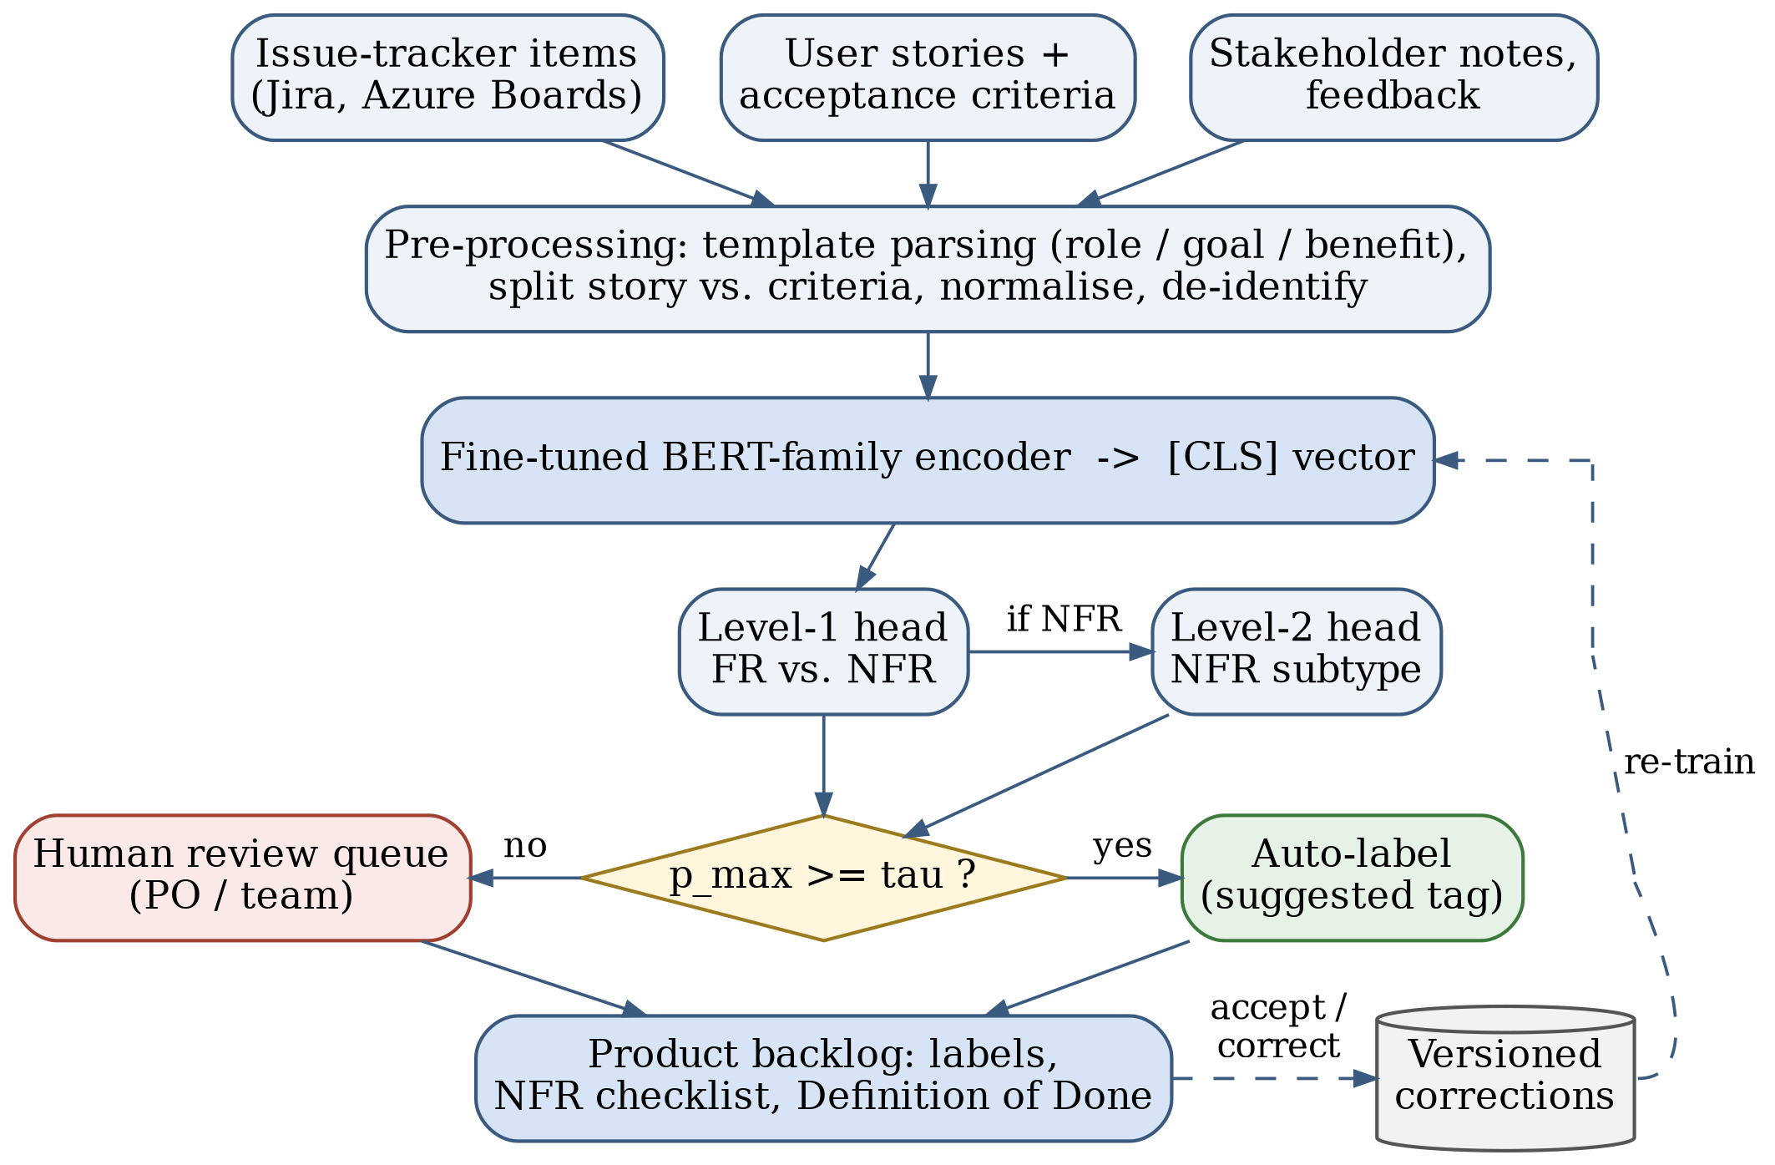
Fig. 1. Proposed framework. Items are normalised, encoded by a fine-tuned BERT-family model and classified at two levels. A confidence gate decides whether a label is applied automatically or sent to the Product Owner, whose corrections feed periodic re-training.

C. Encoder and Training Objective
Any BERT-family encoder fits the framework. We use DistilBERT in Section IV because it runs on a laptop CPU. Fig. 2 traces the running example through the model. The text is tokenised into WordPiece units, the final hidden state of the [CLS] token passes through a small classification head, and a softmax gives a probability for each of the K labels. PROMISE NFR is imbalanced: usability has 67 examples and fault tolerance has 10. The training loss therefore weights each class by its inverse frequency, a common algorithm-level remedy for imbalance that is implemented through a weight or cost scheme [35]:
$L=−\frac{1}{N}\sum_{i=1}^{N}{w_{y_{i}}} logp_{θ}(y_{i}∣x_{i}), w_{c}=\frac{N}{K N_{c}}$ (1)
Here N is the number of training items, N_{c} the number of items in class c and K the number of classes. Re-sampling, as used by Kurtanović and Maalej [7], is an alternative. We prefer weighting because it leaves the data untouched and adds no duplicated sentences that could appear in both training and test folds.
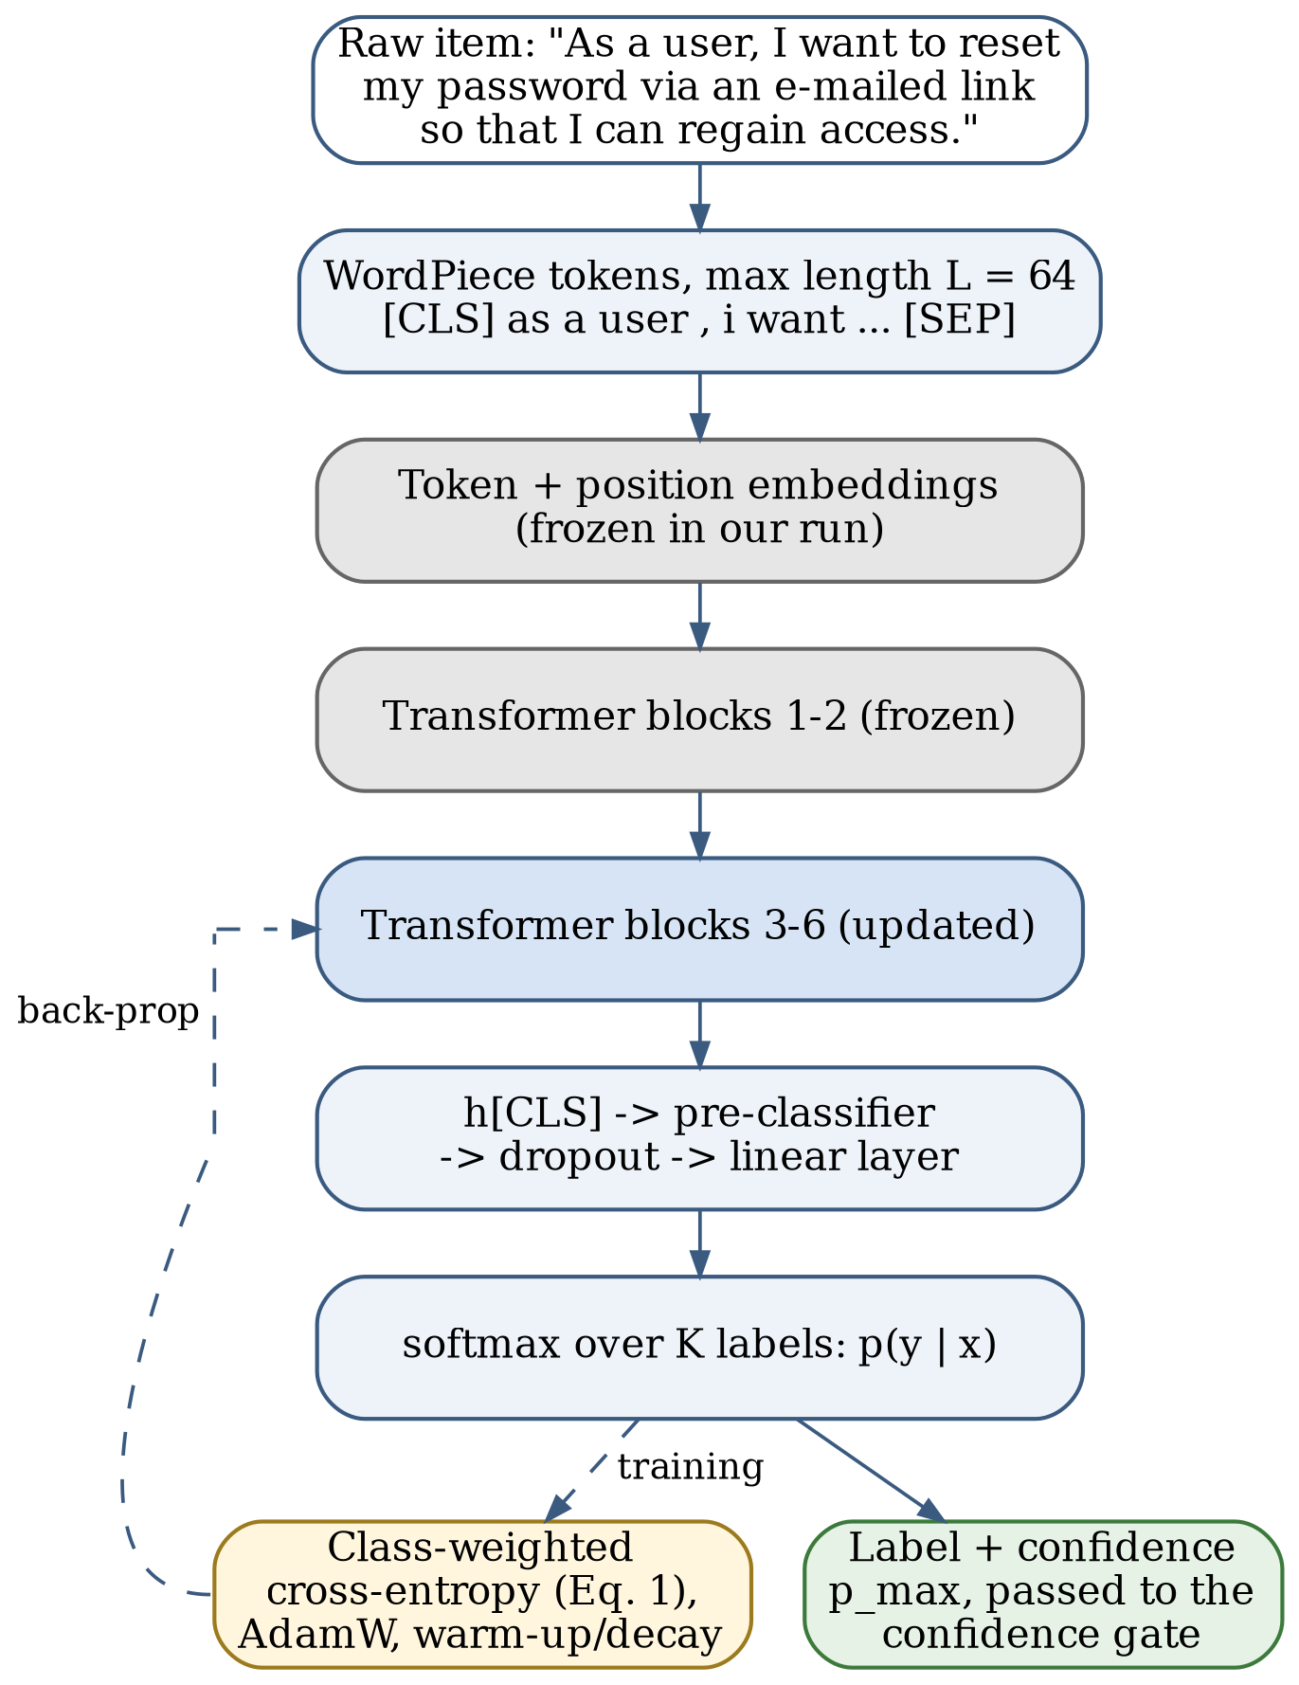
Fig. 2. Fine-tuning pipeline for one backlog item. Grey blocks were frozen in our CPU experiment; the dashed path is used only during training.
D. Confidence Gate
A classifier that is wrong 8% of the time and gives no warning will gradually erode the team's trust in the backlog. The framework therefore applies a label automatically only when the model is confident:
$route(x)=\left\{\begin{matrix}\text{auto-label }\hat{y}, & \max_{c}p_{θ}(c∣x)≥τ \\ \text{Product Owner review}, & \text{otherwise}\end{matrix}\right.$ (2)
The threshold τ in (2) is set on held-out data so that the automatically applied labels reach a precision the team agrees on, for example 0.95. Softmax probabilities from fine-tuned transformers are often over-confident, so a team should check calibration before relying on τ. Items below the threshold appear in the refinement queue with the two most likely labels shown, which turns a silent error into a one-click decision.
E. Integration with the Backlog Workflow
Fig. 3 places the classifier in the Scrum cycle. When an item is created or edited, the tracker sends it to the service, which writes back a label and a confidence value. During refinement the team reviews the low-confidence queue and also checks the high-confidence quality labels, because these carry consequences. A security label, for instance, adds the team's security checklist to the item's acceptance criteria. A performance label prompts the team to state a measurable target, such as “search results appear within 2 s for 95% of queries.” Usability items get an accessibility check. Before sprint planning, the Product Owner can filter the ordered backlog by label and see, for example, that the next three sprints contain no operability work. Ordering stays with the Product Owner [1]; the classifier makes quality work visible but never reorders the backlog.

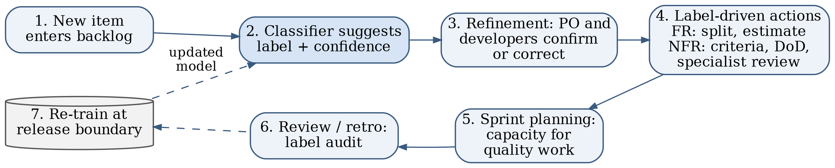
Fig. 3. Classifier-in-the-loop backlog workflow. Corrections made during refinement are logged and used for re-training at release boundaries.

F. Human Feedback and Re-Training
Every label the Product Owner confirms or changes is stored together with the item text, the model version and the confidence. The model is re-trained at release boundaries rather than continuously, so that its behaviour stays stable within a sprint. Two signals tell the team when re-training is due: the share of items routed to review rising above an agreed level, and the precision of automatic labels, measured on a small random audit sample, falling below the target.
IV. Experimental Setup and Results
This section has two parts. Section IV-A reports an experiment that we ran ourselves. Section IV-B summarises results reported in the literature, which we did not reproduce. The two are kept separate throughout, and no literature number appears in our results table.
A. Our Comparative Experiment on PROMISE NFR
Data. We downloaded the PROMISE NFR dataset from its Zenodo record [14] and parsed the ARFF file into 625 labelled requirements from 15 projects. Table II gives the class distribution, together with an agile-style example that we wrote for each class to show what the label means in a backlog. The PROMISE items themselves are “shall” statements, not user stories. We defined two tasks. Task A separates functional (255) from non-functional (370) requirements. Task B classifies the four most frequent quality classes: usability (67), security (66), operability (62) and performance (54), 249 items in total. The seven remaining quality classes have between 1 and 38 examples, too few for a reliable per-class estimate, so we left them out.

TABLE II
PROMISE NFR class distribution (625 requirements, 15 projects) and illustrative backlog items.
Code | Class | n | Task | Illustrative agile item (written by us, not from PROMISE)
F | Functional | 255 | A | “As a user, I want to reset my password via an e-mailed link so that I can regain access.” (F; also carries a security aspect)
US | Usability | 67 | A, B | “As a screen-reader user, I want every form field to have a label so that I can complete checkout.”
SE | Security | 66 | A, B | “As an administrator, I want failed login attempts logged with time and IP so that I can spot attacks.” (F+SE)
O | Operability | 62 | A, B | “As an operator, I want to change the backup schedule without a redeploy.”
PE | Performance | 54 | A, B | “As a shopper, I want search results within 2 s so that I do not abandon the search.”
LF | Look and feel | 38 | A | “As a marketer, I want pages to use the corporate colour palette.”
A | Availability | 21 | A | “As a customer, I want the shop to be reachable 99.9% of the time.”
SC | Scalability | 21 | A | “As the business, we want to serve 10,000 concurrent users at launch.”
MN | Maintainability | 17 | A | “As a developer, I want tax rules in configuration rather than in code.”
L | Legal | 13 | A | “As a data-protection officer, I want users to be able to export their personal data.”
FT | Fault tolerance | 10 | A | “As a user, I want my cart preserved if the payment service fails.”
PO | Portability | 1 | A | “As a user, I want the app to run on Android 12 and later.”

Protocol. We used two protocols, and within each one all models share the same splits. Random: stratified 10-fold cross-validation (scikit-learn), in which requirements from one project fall on both sides of a split. Project-held-out: five folds built with StratifiedGroupKFold using the PROMISE project identifier as the group, so no project contributes to both training and test data. Each protocol was run with seeds 42, 43 and 44, except that random-fold DistilBERT was trained for seed 42 only because of the CPU budget. For each run we pool the out-of-fold predictions and compute per-class precision, recall and F1, their macro averages and accuracy; Table III reports macro-F1 as mean ± standard deviation over seeds. Paired comparisons use exact McNemar tests on the pooled predictions of one seed. We did no hyper-parameter search for any model: the baselines use common defaults and DistilBERT uses the settings below. Tuning on the same folds would have made the comparison look better without making it more honest. Code, splits and every model's out-of-fold predictions are in our reproducibility package.
Baselines. Each baseline uses TF-IDF features over word unigrams and bigrams, with sublinear term frequency and English stop-word removal, fitted inside each training fold. On top of these features we trained multinomial Naive Bayes (α = 0.1), a linear SVM (C = 1, class-balanced weights) and logistic regression (C = 10, class-balanced weights).
DistilBERT. We fine-tuned distilbert-base-uncased [20] with the Hugging Face Transformers library. Settings: maximum length 64 WordPiece tokens (median item length is 21 tokens; 7 of 625 items were truncated), batch size 8, AdamW with learning rate 5×10⁻⁵ and weight decay 0.01, 10% linear warm-up followed by linear decay, gradient clipping at 1.0, five epochs, and the class-weighted loss of (1). The sandbox had two CPU cores and about 2 GB of RAM, so we froze the embedding layer and the first two of the six transformer blocks, which reduced optimiser memory. This departs from full fine-tuning [11], and the numbers below should be read as a lower bound for what DistilBERT can do on this data. One fold took about 236 s to train for Task A and 88 s for Task B.
Results. Table III and Fig. 4 give the results. Random folds. All random-fold numbers in this paragraph come from seed 42, the only seed on which DistilBERT was trained under this protocol; Table III gives the baseline means over three seeds. On Task A the four models finish within 1.5 points of each other. The linear SVM has the highest macro-F1 (0.916) and DistilBERT the lowest (0.901). DistilBERT recognises non-functional requirements well (recall 0.943) but misses more functional ones (recall 0.851; 38 of 255 were labelled NFR). An exact McNemar test on the pooled predictions finds no significant difference between DistilBERT and the SVM (24 items only DistilBERT got right, 32 only the SVM; p = 0.35). Task B tells a different story. DistilBERT reaches a macro-F1 of 0.919, against seed-42 values of 0.832 for the SVM, 0.824 for logistic regression and 0.783 for Naive Bayes (three-seed means in Table III: 0.824, 0.819 and 0.791), and its F1 is at least 0.91 for every class. Here the McNemar tests are significant against all three baselines (30 versus 8 discordant items against the SVM; p < 0.001 in each case), and the differences remain significant after a Bonferroni correction for three comparisons. Over seeds 42–44 the baseline means in Table III are within 0.01 of these seed-42 values.
Project-held-out folds. Holding out whole projects lowers every score (right-hand columns of Table III, and Fig. 4). On Task A each baseline loses at least 27 points of macro-F1 and ends at 0.589–0.638; DistilBERT reaches 0.751 ± 0.003. Most of the loss is in the functional class. Averaged over the three seeds, functional recall falls to 0.28 for the SVM, 0.36 for Naive Bayes and 0.56 for DistilBERT, so even the best model finds only about half of the functional requirements of an unseen project, while non-functional recall stays at 0.93 or above for the baselines. On an unseen project the models therefore label many functional requirements as non-functional. A plausible reason, which we did not test, is that functional requirements are written in each project's domain vocabulary, whereas quality requirements reuse phrases such as “shall be available” or “within 2 seconds” across projects. Task B loses less: the baselines drop by 9–11 points to 0.696–0.718, and DistilBERT reaches 0.813 ± 0.014. Exact McNemar tests (Table IV) favour DistilBERT over every baseline in every seed on both tasks (p ≤ 0.017 before correction); after a Bonferroni correction, one of the 18 comparisons is no longer significant, and the tests assume independent items (Section V-D). The drop should not be read as the effect of project leakage alone, because the two protocols differ in other ways. Five project-held-out folds train on about 80% of the items on average, against 90% for ten random folds (on Task A, 409–600 training items per fold instead of about 562). The folds are also uneven because PROMISE projects differ in size and content: Task A test folds hold between 25 and 216 items, and projects 11–15 contain no functional requirements at all. DistilBERT's confidence scores behaved differently on the two tasks. Averaged over seeds, a threshold of 0.95 would have auto-labelled 89% of Task A items with a precision of only 0.81, well short of the 0.95 target used as an example in Section III-D; on unseen projects the Task A scores were over-confident. On Task B the same threshold met the target (precision 0.99) but auto-labelled only 22% of the items and sent the rest to review.
We read the random-fold contrast between the tasks as follows, although we did not test this explanation. In PROMISE the FR/NFR split is carried largely by surface cues, such as verbs of action versus adjectives of quality, and a bag of n-grams captures these well. Telling usability from operability or security is harder: words such as “user”, “system” and “shall” appear in every class, and each class has only 54–67 examples. This is the situation in which pre-trained representations are expected to help most. The errors also support the F+Q view of Dalpiaz et al. [4]. Several Task A “errors” are debatable. One item requires that all changes to a dispute case be “recorded in the case history”; PROMISE labels it NFR, the model predicted F, and it reads like our audit-log example in Table II. In Task B, a requirement to conform to the Americans with Disabilities Act is labelled usability but was predicted security, and arguably it is a legal requirement as well. Fold-level accuracy varied widely (DistilBERT on random Task B folds: 0.84 to 1.00 over test folds of about 25 items), which is why we report pooled scores.
TABLE III
Our experiment: macro-F1 on PROMISE NFR, mean ± SD over seeds 42–44 of pooled out-of-fold predictions. Random = stratified 10-fold; project = project-held-out 5-fold. Task A: FR vs. NFR (n = 625); Task B: US/SE/O/PE (n = 249). NB = multinomial Naive Bayes; DistilBERT has 2 of 6 blocks frozen. † One seed (42). Best mean per column in bold. Accuracies are in the reproducibility package.
Model | A random | A project | B random | B project
TF-IDF+NB | 0.906 ± 0.003 | 0.638 ± 0.036 | 0.791 ± 0.016 | 0.696 ± 0.009
TF-IDF+LogReg | 0.911 ± 0.003 | 0.589 ± 0.017 | 0.819 ± 0.008 | 0.718 ± 0.011
TF-IDF+SVM | 0.912 ± 0.003 | 0.593 ± 0.012 | 0.824 ± 0.012 | 0.718 ± 0.009
DistilBERT | 0.901† | 0.751 ± 0.003 | 0.919† | 0.813 ± 0.014

TABLE IV
Our experiment: exact McNemar tests of DistilBERT against each baseline on project-held-out folds (pooled out-of-fold predictions of one seed). In all 18 comparisons DistilBERT was right on more of the discordant items. The Bonferroni column multiplies each p-value by three, for the three baselines compared per task and seed. The tests assume independent items (see Section V-D).
Task | Seed | Baseline | p | Bonferroni p
A | 42 | TF-IDF+NB | < 0.001 | < 0.001
A | 42 | TF-IDF+LogReg | < 0.001 | < 0.001
A | 42 | TF-IDF+SVM | < 0.001 | < 0.001
A | 43 | TF-IDF+NB | < 0.001 | < 0.001
A | 43 | TF-IDF+LogReg | < 0.001 | < 0.001
A | 43 | TF-IDF+SVM | < 0.001 | < 0.001
A | 44 | TF-IDF+NB | 0.003 | 0.010
A | 44 | TF-IDF+LogReg | < 0.001 | < 0.001
A | 44 | TF-IDF+SVM | < 0.001 | < 0.001
B | 42 | TF-IDF+NB | < 0.001 | < 0.001
B | 42 | TF-IDF+LogReg | < 0.001 | < 0.001
B | 42 | TF-IDF+SVM | < 0.001 | < 0.001
B | 43 | TF-IDF+NB | < 0.001 | 0.003
B | 43 | TF-IDF+LogReg | 0.017 | 0.051
B | 43 | TF-IDF+SVM | 0.013 | 0.038
B | 44 | TF-IDF+NB | 0.002 | 0.006
B | 44 | TF-IDF+LogReg | 0.006 | 0.019
B | 44 | TF-IDF+SVM | 0.008 | 0.023

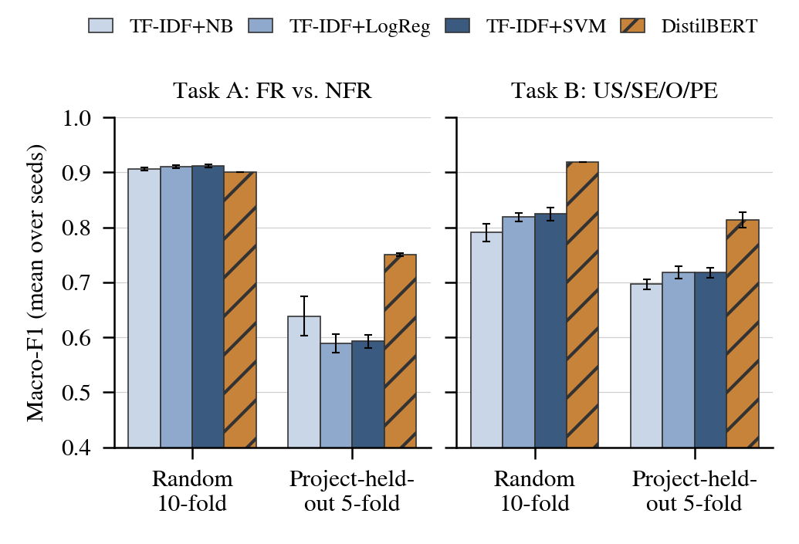
Fig. 4. Our experiment: macro-F1 under random 10-fold and project-held-out 5-fold splits, mean over seeds 42–44 with SD error bars (random-fold DistilBERT: seed 42 only). The y-axis starts at 0.4.
B. Reported Results from the Literature
Table I lists the results reported in the literature. These are the authors' numbers, not ours. On PROMISE NFR the published results bracket our own. For the FR/NFR decision, NoRBERT reports an F1 of up to 94% [12] and Eltahier et al. report 0.99 [18], both above our seed-42 0.901. For the frequent quality classes, our seed-42 DistilBERT macro-F1 of 0.919 is higher than the 87% average F1 that NoRBERT reports. We do not read this as DistilBERT beating NoRBERT. The protocols differ: we used random stratified folds over four classes, and on PROMISE our own project-held-out runs in Table III score well below our random-fold runs, although that gap also reflects smaller training sets. NoRBERT's corrected report also lowers its unseen-project improvement from 15 to 10 percentage points [13], another sign that headline numbers depend on the split. Model capacity differs in the opposite direction: NoRBERT fine-tuned full-size BERT models (base and large) with all layers trainable, whereas we used a distilled model with a third of its blocks frozen. Our seed-42 random-fold TF-IDF+SVM macro-F1 of 0.916 on Task A (three-seed mean 0.912) is close to the roughly 92% precision and recall reported by Kurtanović and Maalej [7] and to the F-measure of 0.91 that Dias Canedo and Cordeiro Mendes [8] report for TF-IDF models on the larger PROMISE_exp, so the classical baseline appears to be reasonably reproduced. The 0.99 reported by Eltahier et al. cannot be placed on the same protocol as ours from the information we used.
V. Discussion
A. What the Evidence Supports
Taken together, the sources support three claims and leave a fourth open. First, fine-tuned transformers are at least as good as feature-engineered models on PROMISE-style text and are better at transferring to unseen projects [12], [13]. Second, the FR/NFR boundary is not crisp: an item can carry both aspects [4], and backlog items mix several requirements in one entry [5]. Third, label-free approaches are possible but still well behind supervised ones [23], [27]. Our own results sharpen this picture. Under random folds, a linear TF-IDF model was as good as DistilBERT for the coarse FR/NFR decision, whereas the transformer was clearly better at separating quality classes. Moving to project-held-out folds lowered every model's score by 15–32 points of macro-F1 on Task A and 9–11 points on Task B; DistilBERT ended ahead of the SVM on both tasks (0.751 vs. 0.593 and 0.813 vs. 0.718); part of the drop may come from smaller training sets and uneven test folds rather than from unseen projects alone. The transformer's advantage is therefore largest where it matters for adoption, on projects it has not seen, which agrees with the unseen-project results of NoRBERT [12], [13]. For a team, one hypothesis follows that we did not test: a cheap linear model may be a reasonable Level 1 classifier only if it is trained on the team's own items. What our results do show is that any model should be checked on those items before its labels are trusted, because random-fold scores overstate how well it will do on a new project. The open question is how well any of these models works on genuine backlog text, where items are terse, informal and full of project jargon.
B. Implications for Backlog Management
For a Scrum team the value lies less in the label itself than in the conversation it starts. Picture a team refining twenty new stories before sprint planning. The classifier tags fourteen with high confidence. It flags “As an administrator, I want to see a log of all login attempts” as functional with a security concern, and it sends three ambiguous items to the review queue. The Product Owner confirms the security tag, so the team adds retention and access rules to the acceptance criteria before the work starts, not after a later audit. Used this way, the classifier supports the Definition of Done and leaves responsibility for ordering and scope with the Product Owner [1]. It also complements story-quality checks such as QUS [31]: one tool asks whether a story is well formed, the other asks what kind of concern it raises.
C. Challenges
Table V summarises the main deployment challenges and how the framework addresses each one. Three need further comment. Imbalance is structural: some quality classes will always be rare, and accuracy can mislead on imbalanced data [35], which is why we report macro-averaged scores. Format shift is the largest unknown: models trained on “The system shall…” sentences meet “As a ⟨role⟩…” stories, bug reports and one-line chores in a real tracker [5]. Label drift follows from the backlog being an informal and evolving model of the work [2]: a team's notion of “operability” may change as its product matures.
TABLE V
Deployment challenges, supporting evidence and mitigations.
Challenge | Evidence | Mitigation in the framework
Class imbalance (PO: 1 item; FT: 10) | [35] | Weighted loss (Eq. 1); macro-F1; merge rare classes
FR/NFR ambiguity, mixed items | [4], [5] | F+Q label; split multi-requirement items
SRS-to-story format shift | [3], [5] | Parse role/goal/benefit; fine-tune on team data
Over-confident predictions | Our Section IV-A (gate analysis) | Confidence gate with calibration check; audit sample
Optimistic random splits | [13]; our Section IV-A | Project-held-out or time-based evaluation before roll-out
Scarce labelled data | [27], [28] | Zero-/few-shot start; active labelling in review
Compute and privacy limits | [20] | Distilled model on-premise; no external API

D. Threats to Validity
Construct validity. PROMISE labels were assigned by students around 2007 [6], and the FR/NFR boundary itself is contested [4]. A model that agrees with these labels has learned one annotation convention, not a ground truth. Internal validity. We used three seeds per protocol, except for random-fold DistilBERT (one seed), no hyper-parameter search, and a partially frozen encoder. A different configuration could change the random-fold Task A ranking, where the difference was not significant, and could narrow or widen the other gaps. The baselines and DistilBERT did, however, share identical folds and pre-processing. External validity. Random 10-fold splits put requirements from the same project into both training and test data. Our project-held-out runs show how much lower the scores are when this is prevented, but the gap is not a pure measure of that leakage: the project-held-out models also train on less data (about 80% of the items instead of 90%), and their test folds differ in size and class mix, with projects 11–15 contributing no functional requirements. The runs also cover only 15 projects of one corpus, with no time order. PROMISE contains English “shall” statements, so our results say nothing direct about user stories or other languages. Conclusion validity. With 249 items in Task B, random test folds hold about 25 items, so fold-level accuracies vary considerably. We therefore report pooled scores, spread over seeds and paired McNemar tests rather than claiming small differences. McNemar's test assumes independent items, but requirements from the same project share authors, vocabulary and templates, so our p-values are likely optimistic. The spread over three seeds is itself only a rough estimate. Finally, the literature synthesis is not a systematic review, and relevant studies may have been missed.
E. Ethical and Practical Considerations
Backlogs can contain customer names, contract details and security weaknesses. Sending them to an external API may breach confidentiality, which is a practical argument for small models that run on-premise. Automation bias is the other risk: if a high-confidence label is never questioned, the team may stop thinking about quality at all. Keeping the label visible but editable, and auditing a sample every release, limits that risk.
VI. Conclusion and Future Work
We set out to judge whether BERT-family classifiers can support agile backlog management. The literature shows steady progress on PROMISE-style text, from indicator terms to NoRBERT, but also a habit of reporting near-ceiling scores under protocols that cannot be compared. Our own small comparative experiment found that on the seed-42 random split a CPU-trained DistilBERT was no better than a linear SVM at separating functional from non-functional requirements (macro-F1 0.901 vs. 0.916) but clearly better at telling the four most frequent quality classes apart (0.919 vs. 0.832). When whole projects were held out, every model lost ground, and the first task changed from a statistical tie to a clear DistilBERT lead: 0.751 against 0.589–0.638 for the baselines, and 0.813 against 0.696–0.718 on the second task. Even so, DistilBERT found only 56% of the functional requirements in unseen projects, and its confidence scores were over-confident on unseen projects for the first task, so a confidence gate needs calibration on the team's own items before it can be trusted. We therefore propose using such models as refinement assistants: they surface quality concerns early and route uncertain items to a person, while ordering and scope remain with the Product Owner.
Four steps would make the evidence stronger. (1) Build an openly licensed corpus of real user stories and backlog items with F/Q aspect labels, so that results stop depending on PROMISE. (2) Make project-held-out and time-ordered splits the standard; our project-held-out runs are a first step, but they cover 15 PROMISE projects and no time order. (3) Compare fully fine-tuned BERT and RoBERTa with few-shot SetFit and zero-shot baselines under one protocol, using label budgets a real team could afford. (4) Run a field study in which a team uses the confidence-gated classifier during refinement, and measure whether quality issues are found earlier.
References
[1] K. Schwaber and J. Sutherland, The Scrum guide, 2020. [Online]. Available: https://scrumguides.org/scrum-guide.html.
[2] T. Sedano, P. Ralph, and C. Péraire, “The product backlog,” in Proc. 2019 IEEE/ACM 41st Int. Conf. Softw. Eng. (ICSE), 2019, pp. 200–211. doi: 10.1109/ICSE.2019.00036.
[3] G. Lucassen, F. Dalpiaz, J. M. E. M. van der Werf, and S. Brinkkemper, “The use and effectiveness of user stories in practice,” in Requirements Eng.: Found. Softw. Qual., ser. Lecture Notes in Computer Science, Springer, 2016, pp. 205–222. doi: 10.1007/978-3-319-30282-9_14.
[4] F. Dalpiaz, D. Dell’Anna, F. B. Aydemir, and S. Çevikol, “Requirements classification with interpretable machine learning and dependency parsing,” in Proc. 2019 IEEE 27th Int. Requirements Eng. Conf. (RE), 2019, pp. 142–152. doi: 10.1109/RE.2019.00025.
[5] A. T. van Can and F. Dalpiaz, “Locating requirements in backlog items: Content analysis and experiments with large language models,” Inf. Softw. Technol., vol. 179, 107644, 2025. doi: 10.1016/j.infsof.2024.107644.
[6] J. Cleland-Huang, R. Settimi, X. Zou, and P. Solc, “Automated classification of non-functional requirements,” Requirements Eng., vol. 12, no. 2, pp. 103–120, 2007. doi: 10.1007/s00766-007-0045-1.
[7] Z. Kurtanović and W. Maalej, “Automatically classifying functional and non-functional requirements using supervised machine learning,” in Proc. 2017 IEEE 25th Int. Requirements Eng. Conf. (RE), 2017, pp. 490–495. doi: 10.1109/RE.2017.82.
[8] E. Dias Canedo and B. Cordeiro Mendes, “Software requirements classification using machine learning algorithms,” Entropy, vol. 22, no. 9, 1057, 2020. doi: 10.3390/e22091057.
[9] M. A. Rahman, M. A. Haque, M. N. A. Tawhid, and M. S. Siddik, “Classifying non-functional requirements using RNN variants for quality software development,” in Proc. 3rd ACM SIGSOFT Int. Workshop Mach. Learn. Techn. Softw. Qual. Eval., 2019, pp. 25–30. doi: 10.1145/3340482.3342745.
[10] N. Rahimi, F. Eassa, and L. Elrefaei, “One- and two-phase software requirement classification using ensemble deep learning,” Entropy, vol. 23, no. 10, 1264, 2021. doi: 10.3390/e23101264.
[11] J. Devlin, M.-W. Chang, K. Lee, and K. Toutanova, “BERT: Pre-training of deep bidirectional transformers for language understanding,” in Proc. 2019 Conf. North Amer. Chapter Assoc. Comput. Linguistics: Human Lang. Technol., vol. 1, 2019, pp. 4171–4186. doi: 10.18653/v1/N19-1423.
[12] T. Hey, J. Keim, A. Koziolek, and W. F. Tichy, “NoRBERT: Transfer learning for requirements classification,” in Proc. 2020 IEEE 28th Int. Requirements Eng. Conf. (RE), 2020, pp. 169–179. doi: 10.1109/RE48521.2020.00028.
[13] T. Hey, J. Keim, A. Koziolek, and W. F. Tichy, “NoRBERT: Transfer learning for requirements classification,” Karlsruhe Institute of Technology (KIT), Tech. Rep., 2022, corrected version. doi: 10.5445/IR/1000150464.
[14] J. Cleland-Huang, S. Mazrouee, L. Huang, and D. Port, Mar. 17, 2007, “nfr” (PROMISE NFR data set), Zenodo. doi: 10.5281/zenodo.268542.
[15] M. Lima, V. Valle, E. Costa, F. Lira, and B. Gadelha, “Software engineering repositories: Expanding the PROMISE database,” in Proc. 33rd Brazilian Symp. Softw. Eng., ACM, 2019, pp. 427–436. doi: 10.1145/3350768.3350776.
[16] M. Binkhonain and L. Zhao, “A review of machine learning algorithms for identification and classification of non-functional requirements,” Expert Syst. Appl.: X, vol. 1, 100001, 2019. doi: 10.1016/j.eswax.2019.100001.
[17] L. Zhao et al., “Natural language processing for requirements engineering: A systematic mapping study,” ACM Comput. Surv., vol. 54, no. 3, pp. 1–41, 2022. doi: 10.1145/3444689.
[18] S. Eltahier, O. Dawood, and I. Saeed, “BERT fine-tuning for software requirement classification: Impact of model components and dataset size,” Information, vol. 16, no. 11, 981, 2025. doi: 10.3390/info16110981.
[19] Y. Liu et al., RoBERTa: A robustly optimized BERT pretraining approach, 2019. doi: 10.48550/arXiv.1907.11692. arXiv: 1907.11692.
[20] V. Sanh, L. Debut, J. Chaumond, and T. Wolf, DistilBERT, a distilled version of BERT: Smaller, faster, cheaper and lighter, 2019. doi: 10.48550/arXiv.1910.01108. arXiv: 1910.01108.
[21] C. Sun, X. Qiu, Y. Xu, and X. Huang, “How to fine-tune BERT for text classification?” In Chinese Comput. Linguistics, ser. Lecture Notes in Computer Science, Springer, 2019, pp. 194–206. doi: 10.1007/978-3-030-32381-3_16.
[22] D. Kici, G. Malik, M. Cevik, D. Parikh, and A. Başar, “A BERT-based transfer learning approach to text classification on software requirements specifications,” in Proc. Can. Conf. Artif. Intell., Canadian Artificial Intelligence Association, 2021. doi: 10.21428/594757db.a4880a62.
[23] X. Luo, Y. Xue, Z. Xing, and J. Sun, “PRCBERT: Prompt learning for requirement classification using BERT-based pretrained language models,” in Proc. 37th IEEE/ACM Int. Conf. Automated Softw. Eng., 2022, pp. 1–13. doi: 10.1145/3551349.3560417.
[24] A. Tikayat Ray, B. F. Cole, O. J. Pinon Fischer, R. T. White, and D. N. Mavris, “aeroBERT-Classifier: Classification of aerospace requirements using BERT,” Aerospace, vol. 10, no. 3, 279, 2023. doi: 10.3390/aerospace10030279.
[25] F. Yucalar, “Developing an advanced software requirements classification model using BERT: An empirical evaluation study on newly generated Turkish data,” Appl. Sci., vol. 13, no. 20, 11127, 2023. doi: 10.3390/app132011127.
[26] T. Alsanoosy, “Requirement classification using transfer learning models,” Arabian J. Sci. Eng., vol. 51, no. 15, pp. 18 047–18 064, 2026. doi: 10.1007/s13369-026-11242-w.
[27] W. Alhoshan, A. Ferrari, and L. Zhao, “Zero-shot learning for requirements classification: An exploratory study,” Inf. Softw. Technol., vol. 159, 107202, 2023. doi: 10.1016/j.infsof.2023.107202.
[28] L. Tunstall et al., Efficient few-shot learning without prompts, 2022. doi: 10.48550/arXiv.2209.11055. arXiv: 2209.11055.
[29] L. Petrillo, F. Martinelli, A. Santone, and F. Mercaldo, “Explainable security requirements classification through transformer models,” Future Internet, vol. 17, no. 1, 15, 2025. doi: 10.3390/fi17010015.
[30] X. Hou et al., “Large language models for software engineering: A systematic literature review,” ACM Trans. Softw. Eng. Methodol., vol. 33, no. 8, pp. 1–79, 2024. doi: 10.1145/3695988.
[31] G. Lucassen, F. Dalpiaz, J. M. E. M. van der Werf, and S. Brinkkemper, “Improving agile requirements: The Quality User Story framework and tool,” Requirements Eng., vol. 21, no. 3, pp. 383–403, 2016. doi: 10.1007/s00766-016-0250-x.
[32] M. Choetkiertikul, H. K. Dam, T. Tran, T. Pham, A. Ghose, and T. Menzies, “A deep learning model for estimating story points,” IEEE Trans. Softw. Eng., vol. 45, no. 7, pp. 637–656, 2019. doi: 10.1109/TSE.2018.2792473.
[33] F. A. Mejía-Domínguez, R. R. Palacio, G. Borrego, S. González-López, and J. A. Del-Puerto-Flores, “LOONA: An LLM assistant for Spanish language user story quality assurance in agile development,” Mathematics, vol. 14, no. 19, 3637, 2026. doi: 10.3390/math14193637.
[34] F. Hujainah, R. B. A. Bakar, M. A. Abdulgabber, and K. Z. Zamli, “Software requirements prioritisation: A systematic literature review on significance, stakeholders, techniques and challenges,” IEEE Access, vol. 6, pp. 71 497–71 523, 2018. doi: 10.1109/ACCESS.2018.2881755.
[35] J. M. Johnson and T. M. Khoshgoftaar, “Survey on deep learning with class imbalance,” J. Big Data, vol. 6, no. 1, 27, 2019. doi: 10.1186/s40537-019-0192-5.

