A Multivariate Statistical Analysis of Female Empowerment

AdriAnne Demski Janelle Jones
Clarion University of PA Spelman College
Clarion, PA Atlanta, GA

Abstract

As women of the world struggle for equality there is a need for ways of measuring progress. We explore the empowerment of women using multivariate statistical techniques such as factor analysis and discriminant analysis. We hope to classify countries into two populations, one where women are empowered and the other where women are not. We simplify this process by reducing the dimensionality of the data from 13 variables to a smaller collection of underlying factors.

We must remember that unless and until women are given their rightful place, no society or country can progress.
-Prime Minister of India IK Gujral

Introduction

How can one determine the advancement of women? In some countries, women’s battle for equality is as old as the country itself. For example, the United States prides itself on having equality for men and women, but is that really the case? What factors characterize a nation where women are treated equally?

This paper seeks to analyze the empowerment of women in different countries using such statistical techniques as factor analysis and discriminant analysis. We examine thirteen characteristics in the general areas of wealth, education and political rights. Factor analysis reduces the dimensionality of the data set from thirteen variables to five. This technique allows us to group variables into a small set of underlying factors. Discriminant analysis creates a model in which countries can be categorized into one of two types: those that empower women and those that do not. An additional statistical technique known as principle component analysis, which also reduces the dimensionality of the data set, is commonly used in practice. However, we will not use this technique here.

We obtain our data from the Human Development Report 2004[2] and The CIA World Factbook [1]. These two sources provide detailed information about the countries we use in our analysis. Table 1 illustrates the variables we use in our analyses.

Table 1: Variables
Original Variable Title | Short Title / Transformation | Comments
GDP per capita | Log GDP | Log 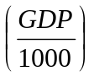 GDP is converted into purchasing power parity terms to eliminate differences in national price levels
Combined gross enrollment in primary, secondary, and tertiary schools | Education Enrollment | % of total enrollment
Seats held by women in parliament | Seats in Parliament | % of total seats in parliament
Female legislators, senior officials, and managers | Power Positions | % of total legislators, senior officials, and managers
Ratio of female to male earned income | Income | Ratio F:M
Female professional and technical workers | Employment | % of total professional and technical workers
Fertility Rate | Log Fertility Rate | Log (Fertility Rate)  Births per woman
Female economic activity rate | Economic Activity Rate | % of total population
Year women received the right to vote | Right to Vote | Number of years since women received the right to vote
Year women received the right to stand for election | Right to Stand for Election | Number of years since women received the right to stand for election
Year the first woman was elected or appointed to parliament | Elected/Appointed | Number of years since the first woman was elected or appointed to parliament
Infant Mortality Rate | Log Infant Mortality | Log (Infant Mortality Rate)
Literacy Rate | Literacy Rate | % of total population

Assessment of Normality

Statistical analysis of a real world data set like the one discussed here is simplified if we begin by verifying whether the data comes from a multivariate normal distribution - in other words assessing normality. If a variable in the data set does not come from a normal distribution then a transformation, such as taking the log of that variable, is necessary. This transformation is chosen so as to force normality of the variable. Discriminant analysis and factor analysis assume multivariate normality of the data. Of course, roughly speaking, a variable is considered to be normally distributed if the probability density function is a bell shaped curve. As we will show, the precision and accuracy of the statistical results depends significantly on how strongly we can assert that the data set comes from the multivariate normal distribution. A commonly used test to assess normality of an individual variable is the Quantile-Quantile plot, also known as the Q-Q plot.

The Q-Q plot displays the ordered data of the x quantiles versus the normal quantiles, where the normal quantiles are what we would expect to see if the observations are normally distributed. We accept the assumption of normality if this plot illustrates a linear relationship. A linear relationship is necessary because, if the random variable x_{i} is normally distributed with mean  and standard deviation , then the collection of theoretical quantiles Z is defined by Z = (x-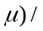. From this equation we obtain x =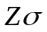+, indicating a linear relationship.

To verify the linearity of a Q-Q plot for x_{i}, we analyze the sample correlation coefficient r_{Q} between x_{i} and z_{i}. This coefficient is defined by
r_{Q} = 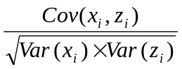,

where x_{i} is a sample quantile, z_{i} is a corresponding normal quantile, and 0 < r_{Q} < 1. The desired conclusion of linearity corresponds to r_{Q} being very close to one. The given sample size and the desired level of significance determine a critical value of r_{Q}. Let ρ be the correlation between x_{i} and z_{i}. The null hypothesis H₀: ρ =1 is rejected if r_{Q} is less than the critical value i.e. we accept H₁: ρ < 1, implying a nonlinear relationship. Linearity is accepted if r_{Q} is greater than or equal to the critical value, leading to a conclusion of normality. For our data set containing a sample size of n = 48 countries and a significance level of , the determined critical value is 0.9768 [Appendix A]. The variables and their corresponding r_{Q} values can be found in Appendix A.

From our list of 13 variables, eight fail to reject H₀: ρ =1 and are considered to be normally distributed. These variables include: education enrollment, seats in parliament, power positions, income, economic activity rate, right to vote, right to stand election, and elected/appointed. The five remaining variables rejected H₀: ρ =1. In order to obtain normality for these variables we perform a transformation. Three of the remaining five variables test normal after a log transformation. These include GDP, fertility rate, and infant mortality rate. Although the data for employment does not test normal, the correlation coefficient is relatively close to the critical value. Finally, literacy rate fails to accept H₀: ρ =1, however due to its importance in our analysis, it is not discarded. As an illustration, Figure 1 is the Q-Q plot of ratio of female to male incomes. It is a plot of the observed values against the normal quantiles for the variable, and it shows the desired linear relationship.
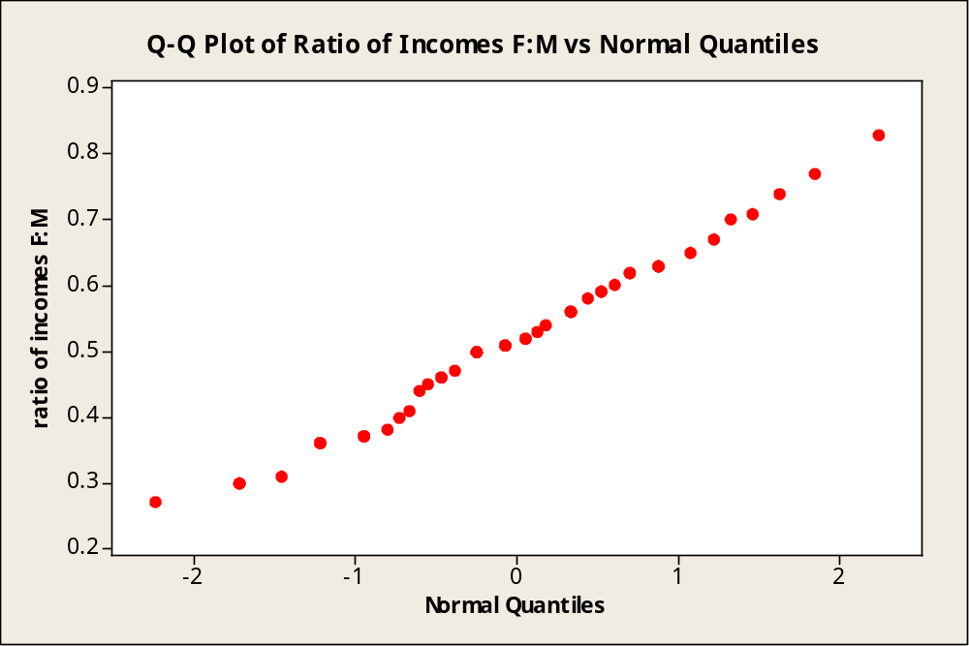
Figure 1

Once we establish that each variable is normally distributed we can assume that the population is at least approximately multivariate normal.

Factor Analysis Theory

Factor analysis (FA) is a multivariate statistical technique used to reduce the dimensionality of the data set [and to approximate the covariance matrix Σ of the observable random vector x]. This process is done by identifying underlying factors. FA provides a factor model which expresses each variable as a linear combination of the m common factors plus the specific factor, or error. The m factors F₁,…, F_{m} are assumed common to each variable, while there are p specific factors ε_{i} which apply only to the i^{th} variable. The FA model is given for i = 1, 2, …, p by
ε_{i}
where λ_{ij} is the factor loading of the i^{th} variable on the j^{th} factor. In other words, λ_{ij} reflects the importance of the j^{th} factor in the composition of the i^{th} variable. The portion of the variance of x_{i} accounted for by the m common factors can be measured by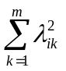 called the communality. The remaining variance of x_{i}, due to the specific factor is called the specific variance, Ψ_{i}.

The assumptions of the m factor model are:
1. F_{j} ~ iid N(0,1)
2. ε_{i} ~ N(0, Ψ_{i}) for i = 1,2,…, p
3. F_{j} and ε_{i} are independent for all j, i

Based on the above assumptions the population covariance matrix Σ can be factored into LL^{T} + Ψ, where Ψ is the diagonal matrix composed of the variance of the unique factors, Ψ_{i}, and L is the matrix of factor loadings λ_{ij}.

In order to significantly decrease the dimensionality, m must be less than p. In theory, we start with m =1 and test for adequacy. We test H₀: Σ = LL^{T} + Ψ using the χ² adequacy test. We reject H₀ if the test statistic is greater than χ²_{α, ν} where α is the level of significance and ν is the number of degrees of freedom given by ½ [(p-m)²-p-m]. The test statistic is given by,
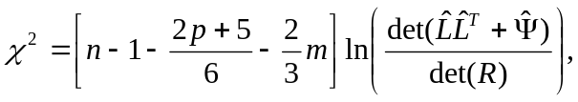
where n is the number of observations. In this equation, 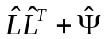is the maximum likelihood estimator of and  is the sample correlation matrix of the variables. If H₀ is rejected, we again test for adequacy at m=2 and continue this process until H₀ can be accepted or until we have exhausted all possible values for m, such that m<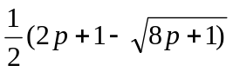. Once a suitable value for m is established, those m factors must be interpreted and labeled. In this way we reduce the dimensionality from p variables to m factors. Sometimes it is difficult to appropriately label these factors. In this case a rotation on the m factor model is useful. This can make relationships more apparent and cause high loadings to increase and low loadings to decrease. Such changes allow for easier labeling.

Factor Analysis Application

Our objective in applying factor analysis to our data is to create an m factor model that recognizes the variation in our 13 variables. The Minitab software is used to create m factor models. For each of the models we complete the χ² test of adequacy. Table 2 shows the degrees of freedom, test statistics, critical values at , and p-values for the m factor models.

Table 2: χ² test of adequacy
m Factor model | Degrees of Freedom | Test Statistic | Critical Value | p-value
4 | 32 | 64.611 | 43.77 | 0.0017
5 | 23 | 20.502 | 35.14 | 0.8896

We want a critical value greater than our test statistic for m factors to accept H₀. This acceptance means that we have enough factors to account for all our variables. From Table 2 we see that for the 4 factor model the test statistic is greater than the critical value at our chosen level. However the 5 factor model gives us a critical value greater than the test statistic. Hence, H₀: Σ = LL^{T} + Ψ is accepted, and the 5 factor model is adequate. Figure 2 illustrates the scree plot for the 5 factor model. The elbow at factor number 6 indicates that only 5 factors are needed.

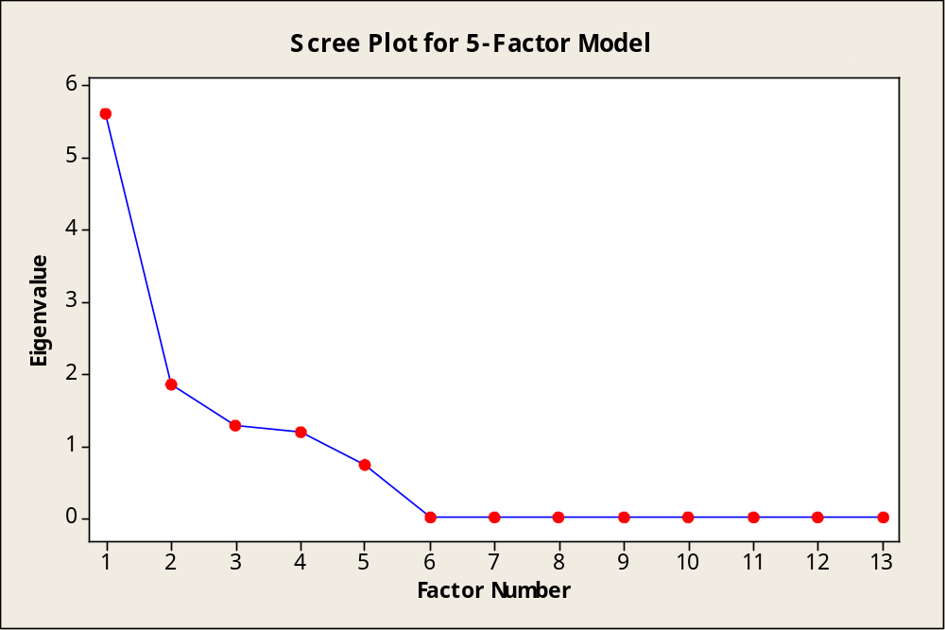
Figure 2

Another indication of whether or not to accept H₀ is the p-value, which is between 0 and 1. The calculated p-value for the 5 factor model is 0.890, which is relatively large. This p-value implies that there is not much evidence against H₀. Table 3 displays the variables and their factor loadings for the 5 factor model.

Table 3: Factor Loadings for 5 Factor Model
Variable | Factor Loading 1 | Factor Loading 2 | Factor Loading 3 | Factor Loading 4 | Factor Loading 5
Log GDP | 0.753 | 0.247 | -0.044 | -0.031 | -0.483
Education Enrollment | 0.483 | 0.485 | -0.266 | -0.083 | -0.543
Seats in Parliament | 0.248 | 0.336 | -0.281 | -0.104 | -0.748
Power Positions | 0.006 | 0.081 | -0.681 | -0.001 | -0.181
Income | 0.135 | 0.289 | -0.126 | -0.755 | -0.180
Employment | 0.144 | 0.153 | -0.729 | -0.256 | -0.022
Log Fertility Rate | -0.828 | -0.256 | 0.285 | 0.121 | -0.046
Economic Activity Rate | -0.034 | 0.056 | -0.095 | -0.993 | 0.040
Right to Vote | 0.248 | 0.876 | -0.174 | -0.178 | -0.183
Right to stand election | 0.279 | 0.913 | -0.218 | -0.151 | -0.089
Elected/Appointed | 0.246 | 0.701 | -0.063 | -0.125 | -0.318
Log Infant Mortality | -0.906 | -0.285 | -0.017 | -0.004 | 0.578
Literacy Rate | 0.612 | 0.234 | -0.656 | -0.022 | -0.113
Variance | 2.9817 | 2.8201 | 1.7655 | 1.7244 | 1.3893
% Variance | 0.229 | 0.217 | 0.136 | 0.133 | 0.107
Cumulative % Variance | 0.229 | 0.446 | 0.582 | 0.715 | 0.822

Based on the magnitudes and signs of the loadings in Table 3, factor labels must be determined. A high loading (positive or negative) between a variable and the factor helps in deciding a label. To ease the labeling process, a rotation is necessary for our data. Minitab is able to perform a varimax rotation which increases high loadings, decreases low loadings, and makes the grouping of variables less complicated.

The first factor has high loadings on Log GDP, Log Fertility Rate, and Log Infant Mortality. Thus, we call this factor the Developed/Developing Factor. This first factor accounts for 23% of the variance in the data set. The second factor has high positive loadings on Right to Vote, Right to Stand for Election, and Elected/Appointed. Based on these variables, this factor is labeled the Women’s Political Rights Factor. This factor also explains an ample portion of the variance with 22%. Our third factor, titled Female Employment and Proficiency, has high negative loadings on Power Positions, Employment, and Literacy Rate and accounts for 14% of the variance. The fourth factor has high negative loadings on only two variables, Income and Economic Activity Rate. Because of the economic aspect of the variables, we identify this factor as the Female Economic Welfare Factor. This factor accounts for 13% of the variance. The final factor, which explains 11% of the variance, is titled Female Education and Governance, and has high negative loadings on Education Enrollment and Seats in Parliament. Overall the 5 factor model is adequate and accounts for approximately 83% of the variance in the data, which is more than acceptable in most social science models.

Discriminant Analysis Theory

Discriminant analysis (DA) is used to classify a vector of observations into previously defined populations denoted by 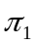 and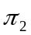. This analysis sets guidelines which can be used to easily determine which population a vector belongs to. For the case of two p-variate populations where 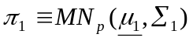 and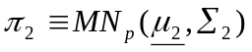, an unclassified observation 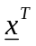=[x₁, x₂, …, x_{p}] can be classified into or by using a classification rule. A training sample from each population is needed to create this classification rule. The training sample consists of random observations from and. The training samples are of size n₁ and n₂, respectively. These sets of observations are also used to estimate the mean and covariance matrices of each population, where 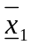 is an estimate of 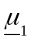 and S₁ is an estimate of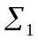for, and similarly for .

We begin DA by determining whether or not the covariance matrices and 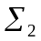 are equal. If they are equal then linear discriminant analysis is applied, otherwise we apply quadratic discriminant analysis. The null hypothesis H₀: = is tested against H₁:≠ , using the unbiased, pooled estimate S_{p} of the common covariance matrix. The estimate is defined by
S_{p} = 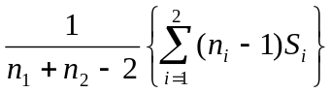.

The test statistic 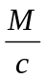 has a χ² distribution under H₀ and is used to determine the equality of the covariance matrices. Here
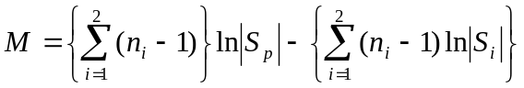
and
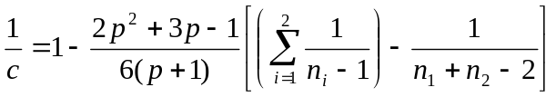.

The null hypothesis H₀ is accepted if < χ²_{p(p+1)/2, α} , where p is the number of variables and α is the significance level. Also, p(p+1)/2 is the degrees of freedom usually denoted by υ.

If the equality of the covariance matrices is established, we can classify using the linear discriminant function. The classification rule for the linear discriminant function is as follows:
classify x into if 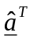x>
classify x into if x <
where 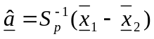 and 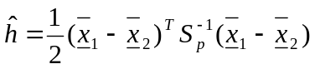.

If the covariance matrices are determined to be unequal, we use the classification rule for the quadratic discriminant function as follows:

classify x into if x^{T}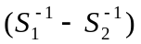x + 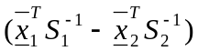x ≥ k,
classify x into if x^{T}x + x < k,
where k = 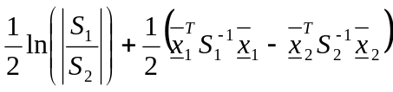 .
Once the observations in the training sample are classified, the apparent error rate (APER) measures the efficiency of the model. The APER is the ratio of misclassified observations to total observations multiplied by 100 to get a percentage. Classification is close to optimal when the APER is relatively small. Another theoretical way to reach optimal classification is to minimize the total probability of misclassification (TPM). In order to calculate the TPM, we must find the Mahalanobis distance, Δ_{p}, between the two populations where

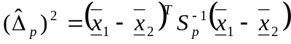,
and then
TPM = 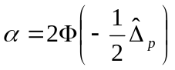.
Let D_{i} be the Mahalabobis distance of x from 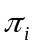where i=1, 2. We classify x into 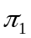 if D₁² is less than D₂². Otherwise we classify x into. This is known as the minimum distance classification rule. The general classification rule for the k population case is to classify x into 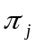 if D_{j}² = Min (D₁², D₂²,… ,D_{k}²).

Discriminant Analysis Application

The classification of the countries is found by applying discriminant analysis (DA). The first step in the application of this analysis is to obtain a training sample and classify the countries in that sample. We explore a few options for classifying the training sample. First, we classify our training sample based on whether a country had or has a female president or prime minister. That is, if a country has had a female in power the country is put into population: women are empowered. If the country has not had a female in power the country is put into population: women are not empowered. However, due to the poor results we obtain using this criterion we are forced to choose a different criterion. Our model is more accurate using the gender empowerment measure (GEM) found in the Human Development Report [2]. The GEM reveals whether women take an active part in economic and political life. After trying both the mean and median as the boundary for the two populations we are satisfied with the results we obtain using the mean. The mean of the GEM is 0.560986. Therefore, we classify the countries into if GEM is greater than 0.560986 and into if GEM is less than 0.560986. For the rest of this discussion, we define a country to be empowered if its GEM is greater than the mean. Once we classify the countries using the above criterion we are able to obtain a training sample for both populations. Both of the training samples contain 15 randomly generated countries. Appendix B lists the countries we use in the training sample. Due to its high correlation with other variables, we omit the infant mortality variable leaving 12 variables.

In order to decide which type of discriminant function we should use, we must first test to see if the two covariance matrices for the two training samples are equal. That is, we test the null hypothesis H₀: 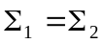 against H₁: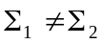 , using the likelihood ratio test. For our data set the test statistic 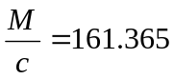 and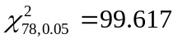. Therefore, since 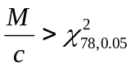 we reject H₀. Since the linear discriminant function assumes, the rejection of H₀ implies the use of the quadratic discriminant function. Table 4 shows how the training sample is classified using the quadratic model.

Table 4: Quadratic Model
 | True Group: Women Empowered | True Group: Women NOT Empowered
Classified into group
Women Empowered | 15 | 0
Women NOT Empowered | 0 | 15
Total N | 15 | 15
N Correct | 15 | 15
Proportion | 1.000 | 1.000
N=30 | N correct = 30 | Proportion Correct = 1.000

We find the apparent error rate (APER) by calculating the ratio of misclassified observations to total observations multiplied by 100 to get a percentage. Using the quadratic model the APER = 0%. In other words, the model correctly classifies all of the countries in the training sample.

Next, we use this model to classify the remaining 42 unknown countries. Appendix C illustrates the results for the remaining countries. We are able to compare the results of the analysis using the same criterion that is used for the training sample. The quadratic model classifies 32 of the 42 countries correctly (by our definition). In other words our quadratic model correctly classifies countries not in our training sample approximately 76% of the time. This model classified Austria as being the most empowered country and Colombia as being the least empowered country.

Although the covariance matrices are not equal, we can still use the linear discriminant function to classify the countries because of the robustness of the DA tests. Table 5 displays the results of the classification of the training sample using the linear discriminant function.

Table 5: Linear Model
 | True Group: Women Empowered | True Group: Women NOT Empowered
Classified into group
Women Empowered | 14 | 0
Women NOT Empowered | 1 | 15
Total N | 15 | 15
N Correct | 14 | 15
Proportion | 0.933 | 1.000
N=30 | N correct = 29 | Proportion Correct = 0.967

Using the linear discriminant function the calculated APER is 3.3%. Again, this shows a good classification model for the training sample. We also use this model to classify the remaining 42 unknown countries. The results are found in Appendix D. In the same way that we compared the quadratic results, we can compare the results of the linear analysis. The linear model classifies 34 of the 42 countries correctly. Thus, our linear model correctly classifies countries not in our training sample approximately 81% of the time. This model classifies Portugal as being the most empowered country and Honduras as being the least empowered country. It is useful to calculate the total probability of misclassification (TPM) in order to get an estimate of the probability of misclassification in our training and test samples. The TPM reflects the overlap of the two populations. If the TPM is high then that indicates a stronger probability of misclassification. The calculated TPM is 8.96%.

Conclusion

Overall, we are satisfied with the results of the 5 factor model provided by factor analysis. The dimensionality of our data is reduced from 13 variables to 5 factors, and the model accounts for more than 80% of the variance in the original variables. Although both the quadratic and linear discriminant functions classify the countries in our training sample effectively, we are not completely satisfied with the results for the unclassified countries. We believe our model can be improved by including data for all the countries in the world -- we were limited to those with complete data available. For future use, our model should also be updated periodically due to the time dependent nature of the variables.

We notice in both the quadratic and linear discriminant functions that the United States is classified as one where women are not empowered. This may come as a surprise to some readers, but this result is primarily due to two of the 13 variables used in our study. Some issues the United States might want to address in order to make progress as a country that supports equality are the number of women that hold seats in parliament and the fertility rate. The number of female seats in Congress was unusually low compared to other countries where women are empowered. Also, compared to these same countries the fertility rate was relatively high. We have used multivariate statistical techniques to explore the empowerment of women in countries here and abroad. How can one define female empowerment? In the United States, which has yet to have a female leader, can women like Hilary Clinton really gain the support of the nation? Our goal is to show that women still have a long journey ahead before they are given their rightful place allowing the country to progress.

Acknowledgements

First and foremost we would like to thank our sponsors NSA and NSF for funding SUMSRI and making this research possible. We would also like to thank Dr. Vasant Waikar for taking the time to teach us the statistics and help in completing our research. We would like to extend a sincere thank you to our Graduate Assistant Shenek Heyward not only for her patience and guidance but for her encouragement as well. We appreciate all of the support from our fellow statistics researchers Monique Owens and Joshua Svenson. In addition, we would like to thank Dr. Tom Farmer for his time and suggestions concerning our writing. Finally we would like to thank everyone who put time and effort into making SUMSRI possible and providing us with an enjoyable educational experience.

Bibliography

[1] CIA World Factbook. (2005). Retrieved July 5, 2005 from
http://www.cia.gov/cia/publications/factbook/index.html

[2] Human Development Report. (2004). Retrieved June 29, 2005 from
http://hdr.undp.org/reports/global/2004/pdf/hdr04_complete.pdf

[3] infoplease. Retreived July 5, 2005 from http://www.infoplease.com/countries

[4] R.A. Johnson and D.W. Wichern, Applied Multivariate Statistical Analysis 5th edition Prentice Hall, Upper Saddle River NJ, 1998.

[5] Reigning Queens and Empresses. Retrieved July 6, 2005 from http://www.guide2womenleaders.com/queens_and_empresses.htm

[6] Women World Leaders. Retrieved July 5, 2005 from http://www.geocities.com/CapitolHill/Lobby/4642/

[7] Women World Leaders. Retrieved July 5, 2005 from
http://www.terra.es/personal2/monolith/00women.htm
Appendix A: Tests for Normality
Variables | Sample Correlation Coefficient (r_{Q})
Log GDP | 0.976
Education Enrollment | 0.989
Seats in Parliament | 0.977
Power Positions | 0.967
Income | 0.995
Employment | 0.958
Log Fertility Rate | 0.973
Economic Activity Rate | 0.993
Right to Vote | 0.981
Right to stand election | 0.992
Elected/Appointed | 0.985
Log Infant Mortality | 0.978
Literacy Rate | 0.823
Note: Critical value = 0.9768
Significance level α = 0.05

Appendix B: Training Sample
Training Sample Population | Training Sample Population
1. Australia | 1. Cambodia
2. Barbados | 2. Dominican Republic
3. Belgium | 3. Ecuador
4. Costa Rica | 4. El Salvador
5. Czech Republic | 5. Georgia
6. Denmark | 6. Japan
7. Iceland | 7. Hungary
8. Ireland | 8. Korea
9. Italy | 9. Lithuania
10. Mexico | 10. Malaysia
11. Namibia | 11. Panama
12. Norway | 12. Peru
13. Poland | 13. Romania
14. Singapore | 14. Turkey
15. Spain | 15. Yemen

Appendix C: Quadratic Classification of Unknown Countries; E = Empowered, N = NOT Empowered; * denotes misclassified countries
Observation | Country | Predicted Group | Squared distance to | Squared distance to
1 | Argentina | E | 63.796 | 1314.930
2 | Austria | E | 45.021 | 1004.782
3 | Bahamas | E | 379.383 | 2191.761
4 | Bangladesh | N | 12005.769 | 145.473
5 | Belize * | E | 69.212 | 1008.391
6 | Bolivia | N | 2266.489 | 573.609
7 | Botswana | E | 244.069 | 488.250
8 | Canada | E | 127.999 | 1690.703
9 | Chile | N | 162.540 | 67.892
10 | Colombia | N | 51.820 | 39.620
11 | Croatia * | E | 138.029 | 3198.395
12 | Cyprus | N | 138.377 | 107.413
13 | Egypt | N | 6284.748 | 210.035
14 | Estonia | E | 54.588 | 153.680
15 | Fiji | N | 3732.247 | 1114.271
16 | Finland | E | 49.789 | 4801.516
17 | Germany | E | 153.875 | 1853.229
18 | Greece * | E | 62.826 | 901.856
19 | Honduras | N | 2936.676 | 421.996
20 | Iran | N | 1721.922 | 62.792
21 | Israel | E | 61.144 | 732.668
22 | Malta * | E | 94.928 | 1154.910
23 | Moldova * | E | 262.499 | 409.203
24 | Mongolia | N | 805.154 | 651.858
25 | Netherlands | E | 46.168 | 2972.901
26 | New Zealand | E | 5382.071 | 7779.590
27 | Pakistan | N | 4182.897 | 860.323
28 | Paraguay * | E | 247.893 | 904.171
29 | Philippines | N | 1988.315 | 159.121
30 | Portugal | E | 175.656 | 1108.219
31 | Russia | N | 52404.969 | 295.755
32 | Slovenia | E | 78.162 | 5054.134
33 | Sri Lanka | N | 1026.621 | 437.885
34 | Swaziland * | E | 84.547 | 604.296
35 | Sweden * | N | 28966.267 | 22909.625
36 | Switzerland | E | 149.758 | 2375.271
37 | Thailand | N | 621.279 | 145.538
38 | Trinidad and Tobago | E | 608.585 | 648.605
39 | United Kingdom | E | 1261.558 | 2368.578
40 | United States * | N | 161066.562 | 2344.630
41 | Uruguay | N | 269.276 | 97.024
42 | Venezuela * | E | 55.403 | 781.313

Appendix D: Linear Classification of Unknown Countries; E = Empowered, N = NOT Empowered; *denotes misclassified countries
Observation | Country | Predicted Group | Squared distance to | Squared distance to
1 | Argentina | E | 13.317 | 21.616
2 | Austria | E | 19.937 | 31.425
3 | Bahamas | E | 14.071 | 36.094
4 | Bangladesh | N | 97.377 | 82.494
5 | Belize | N | 29.534 | 13.477
6 | Bolivia | N | 30.358 | 16.359
7 | Botswana | E | 15.995 | 22.759
8 | Canada | E | 5.692 | 16.026
9 | Chile | N | 17.683 | 8.274
10 | Colombia | N | 14.628 | 7.666
11 | Croatia * | E | 17.795 | 33.613
12 | Cyprus * | E | 11.616 | 12.343
13 | Egypt | N | 45.217 | 34.270
14 | Estonia * | N | 15.893 | 9.889
15 | Fiji | N | 110.568 | 97.693
16 | Finland | E | 7.605 | 22.749
17 | Germany | E | 8.289 | 24.854
18 | Greece * | E | 7.334 | 9.095
19 | Honduras | N | 26.326 | 4.621
20 | Iran | N | 16.194 | 7.263
21 | Israel | E | 12.131 | 14.526
22 | Malta * | E | 18.162 | 25.728
23 | Moldova | N | 63.582 | 52.807
24 | Mongolia | N | 58.263 | 25.492
25 | Netherlands | E | 5.867 | 22.998
26 | New Zealand | E | 47.770 | 66.081
27 | Pakistan * | E | 86.772 | 95.840
28 | Paraguay | N | 37.220 | 18.714
29 | Philippines | N | 51.670 | 39.808
30 | Portugal | E | 5.642 | 9.796
31 | Russia | N | 349.311 | 340.659
32 | Slovenia | E | 20.188 | 37.815
33 | Sri Lanka | N | 54.120 | 30.996
34 | Swaziland | N | 33.506 | 29.883
35 | Sweden | E | 252.368 | 290.989
36 | Switzerland | E | 12.911 | 37.005
37 | Thailand | N | 26.235 | 10.853
38 | Trinidad and Tobago | E | 12.775 | 26.332
39 | United Kingdom * | N | 31.348 | 28.562
40 | United States * | N | 1205.051 | 1187.917
41 | Uruguay | N | 23.924 | 10.957
42 | Venezuela | N | 25.249 | 8.389

