A Multivariate Statistical Analysis of
Substance Abuse in the United States

Josh Svenson and Monique Owens
July 2005

Abstract

Where do the major drug problems occur in this country among the states? How are social and economic factors related to substance abuse in the states? We approach these questions with multivariate statistics. By using factor analysis, we distinguish the underlying factors of a collection of variables related to substance abuse. With discriminant analysis, we design a rule for classifying states as either having a major drug problem or minor drug problem.

Introduction

People use drugs and alcohol to escape from their problems and temporarily uplift their spirits. When this becomes damaging and destructive we call it drug and alcohol abuse. Throughout the country, drug and alcohol abuse has become a problem. In 2003, it was estimated that over 21 million Americans were abusing or addicted to drugs and alcohol.

Using multivariate statistical techniques, we seek to gain a greater understanding of how substance abuse is related to other social and economic factors. We will be using Factor Analysis (FA) along with Discriminant Analysis (DA) to analyze the data set. Factor Analysis will help us understand the relationship between the variables, which will allow us to reduce the dimensionality of our data set. Discriminant Analysis will categorize the states into two groups, one having a major drug and alcohol problem and the other having a minor problem.

We have data from the following: U.S. Census Bureau, National highway Traffic Safety Facts provided by National Highway traffic Safety Administration, National Surveys on Drug Use and Health, and National Survey of Substance Abuse Treatment Services both provided by Substance Abuse and Mental Health Services Administration (SAMHSA). We use the District of Columbia and 48 states out of 50 (excluding Alaska and Hawaii because they are outliers) and concentrate on the following 11 variables:
- percent of total U.S. population (square root)
- percent of total U.S. land (square root)
- cigarette use (percent of population)
- binge drinking (percent of population binge drinking each month)
- illicit drug use (percent of population using marijuana, hashish, cocaine, heroin, hallucinogens, inhalants, or any prescription-type psychotherapeutic used non-medically each month)
- substance abuse treatment centers available (treatment centers per 100,000 residents)
- percent of all fatalities involving a drunk driver
- percent of population between 18 and 24 years of age
- percent of population living below the poverty line
- median household income (in thousands)
- percent of population over 25 that have a high school diploma.
Note that all data is from the year 2003. Complete data tables can be found in Appendix A and Appendix B. These data tables are divided into states with major and minor drug problems. We say a state has a major drug problem if more than 9.4% of the state is abusing or dependent upon drugs and alcohol. A state has a minor drug problem if less than 9.4% of the state is dependent upon drugs and alcohol. Note that 9.4 is the median drug and alcohol abuse and dependency percentage among the states.

Normality Assessment

The techniques used to analyze our data all assume that the data is distributed normally. In order to assess multivariate normality, we will be testing the univariate normality of each variable in the data set. While normal behavior in one dimension does not necessarily imply multivariate normality, it is good enough for most real-world statistical applications[5].

We use Quantile-Quantile plots, or Q-Q plots, to evaluate the normality of each variable in the data set. These plots allow us to compare the relationship between the sample quantiles of a variable and the variables’ associated standard normal quantiles. Let 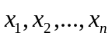 be a sample of size n from some population. We order our sample from smallest to largest so that 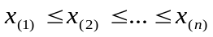. We refer to each 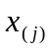 as a sample quantile. Note that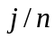 is the proportion of samples less than or equal to . This proportion is usually approximated by 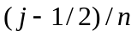 or another similar fraction for analytic convenience [5]. We will use 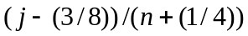, since that is the proportion that Minitab used when approximating the probability levels of our data. Let Z be a standard normal random variable. We choose each 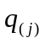 so that 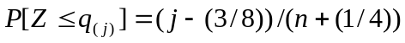. We define the ’s as the standard normal quantiles. We plot each ordered pair 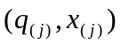 and look for a linear relationship between the two sets of quantiles. If the Q-Q plot appears to be a straight line, then we can assume that the set of data is normally distributed. In figure one, we offer an example of a Q-Q plot being used to test the normality of median household income by state. In this case, we see that the relationship is approximately linear, and we can assume that the data is distributed normally.

Figure 1: Example of a Q-Q Plot
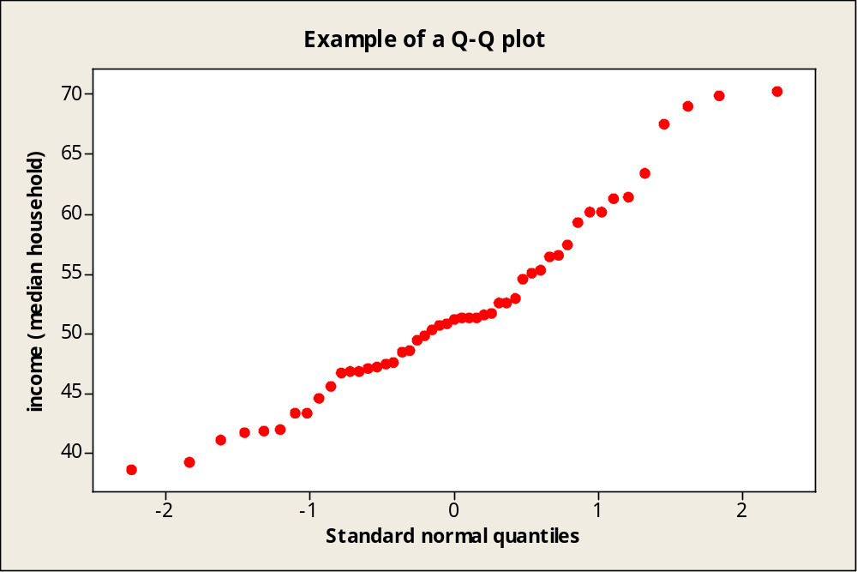

While Q-Q plots may shed some light on the normality of a data set, we prefer a more rigorous method of testing the hypothesis of normality. To this end, we employ a correlation coefficient test for normality. The correlation coefficient of the Q-Q plot is defined as
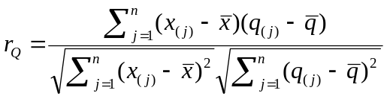.
Note that 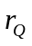 is some fraction between 0 and 1 that assesses the linearity of the relationship between the sample and standard normal quantiles. A number closer to 1 implies a linear relationship. We reject the hypothesis of normality if falls below a certain value corresponding to the desired significance level. The critical points used in this test can be found in Table 4.2 from [5]. For example, consider the median household income data used in the Q-Q plot. Suppose we are testing the hypothesis of normality at the .01 significance level. In this case = .979, and the value corresponding to .01 when n=49 is approximately .965. Since .979 > .965, we do not reject our hypothesis of normality.
Table 1 displays the correlation coefficients of our sets of quantiles for our data set. Notice that we have taken the square root of some of our variables. This is known as a transformation, and we apply transformations in order to increase the normality of our data. For example, before applying a square root transformation, percent of land and percent of population both had correlation coefficients less than .90. While some of the correlation coefficients might not be large enough for the .01 significance level even after the transformations, we can proceed with our data analysis because of the robust nature of multivariate statistical techniques.

Table 1: Correlation Coefficients for Normality Tests
Variable | r_{Q}
% of Population (sqrt) | .958
% of Land (sqrt) | .982
Cigarette Use (% of population) | .975
Binge Drinking (% of population) | .996
Illicit Drug Use (% of population) | .967
Treatment Centers (per 100,000 residents) | .934
% of Traffic Fatalities Involving Drunk Drivers | .963
% of Population age 18-24 | .974
% of Population Living Below the Poverty Line | .972
Median Household Income | .979
% of population over 25 that is a high school graduate | .976

Factor Analysis Theory

The main objective of factor analysis is to reduce the data from its original number of variables to a smaller number of underlying yet unobservable factors. When factor analysis is applied to a set of data, not only must we find these underlying factors, but we also must interpret the factors in a meaningful way.

Let X be multivariate normally distributed with mean 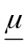 and covariance matrix , and suppose X consists of p random variables. Our goal is to express each observable random variable  as a linear combination of unobservable random variables (known as common factors) and a unique factor, also known as the error. So, if we have m unobservable random variables, the m-factor model is
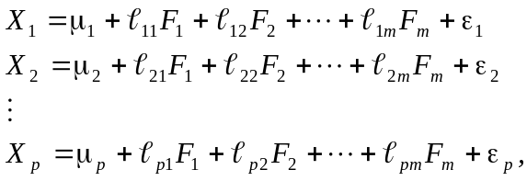
where each 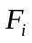 is a common factor, 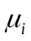is the mean of , and each 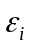is a unique factor. The coefficient 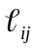 is the loading of the ith variable on the jth common factor. The loading reflects the importance of the jth factor in the composition of the ith variable. In matrix notation, this system of equations is expressed as
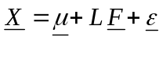,
where L is the 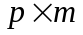 matrix of factor loadings, F is a vector of the common factors, and is a vector consisting of the unique factors.
Now, we make the following assumptions:
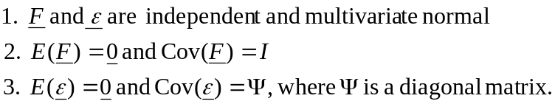
These assumptions, as well as the aforementioned relationship between the observable and unobservable random variables, comprise what is known as the orthogonal factor model with m common factors. Because of these assumptions, it can be shown that 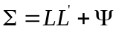.

In practice, is unknown, so L and 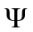 must be estimated from a sample. Using maximum likelihood estimation, we are looking to find estimates and 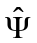. To do this, we maximize the likelihood function
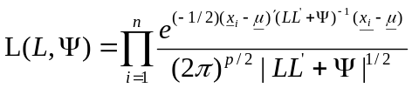.
Since the first partial derivatives do not give explicit solutions, we must use iterative techniques and rely on Minitab or some other statistical software to obtain and . If the solution given is not very helpful in labeling the factors, we can employ factor rotation. To do this, we first recall that a matrix T is orthogonal if 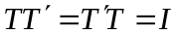. The following statement is then true:
,
where 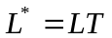. Notice that we have changed our factor loadings without altering the covariance matrix.

We want to be able to test the adequacy of the m-factor model. The null hypothesis is that , and the alternate hypothesis is that is any other positive definite matrix. If we accept the null hypothesis, then the m-factor model is adequate. We employ a likelihood ratio test, and we reject the null hypothesis if 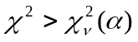, where it can be shown that
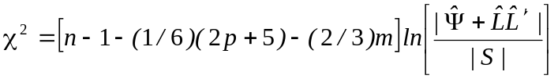
and
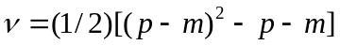.
In the preceding equations, n is the sample size, p is the number of variables, m is the number of common factors, and S is the sample covariance matrix. Since must be positive, it can be shown that 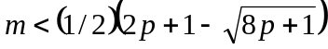. Thus we have an upper bound on the number of common factors. To find an adequate number of common factors, we begin by employing the test of adequacy when 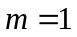. If we do not reject the null hypothesis, then we use one common factor. If we do reject the null hypothesis, we run the test with 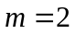 and repeat the same process. We repeat this process until we find an adequate m-factor model.

Factor Analysis Application

Before attempting to interpret our common factors, we run tests to determine which m-factor model is adequate. For all factor models being tested, we employ varimax rotation to make our loadings easier to interpret. Note that m < 7. However, according to the Help Menu of Minitab 14, the maximum likelihood method of extracting factors also places restrictions on the number of factors in our m-factor model. There are 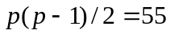 parameters in the correlation matrix, and there are pm parameters in the maximum likelihood factor model. So, if 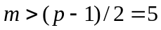, then there are more parameters in our factor model than in the correlation matrix, so the solution is not unique. Therefore, we choose m so that 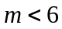. We summarize the test of adequacy for each m-factor model in Table 2.

Table 2: Adequacy Tests of m-Factor Models
Number  of factors | Degrees  of freedom | % of variance  explained | Test  Statistic | p-value
1 | 44 | 23% | 171.02 | 0.00000
2 | 34 | 38% | 116.91 | 0.00000
3 | 25 | 53% | 68.049 | 0.00001
4 | 17 | 62% | 47.495 | 0.00010
5 | 10 | 72% | 19.614 | 0.03312

We overwhelmingly reject the hypothesis that in the first four factor models. We can accept the 5-factor model at the .03 significance level. Ideally, we want the p-value to be greater than or equal to .05. However, while more factors might prove to be significant, they probably will not provide additional insight [5]. Also, we have already explained over 70% of the variance, which is a relatively high amount of variance. So, since we are free to use some judgment in our choice of m, we will use the 5-factor model.
We can use a scree plot as a visual tool for identifying the number of factors we should extract. To draw a scree plot, we first order the 11 eigenvalues of the correlation matrix, and we then number these eigenvalues from 1 to 11. We place the eigenvalues on the vertical axis and their corresponding order (which represent the number of factors) on the horizontal axis. We then plot our pairs of eigenvalues and their factor number, and connect that points. We look for an abrupt change in the graph, known as an elbow. If an elbow occurs at the jth eigenvalue, then this is evidence that we should use a j-1 factor model. Unfortunately, our scree plot (Figure 2) did not turn out to be particularly useful, since there was not much of an elbow until the 9th eigenvalue, which would leave us with a with too many factors. Therefore, we ignore the results from the scree plot and accept the 5-factor model.

Figure 2: Scree plot
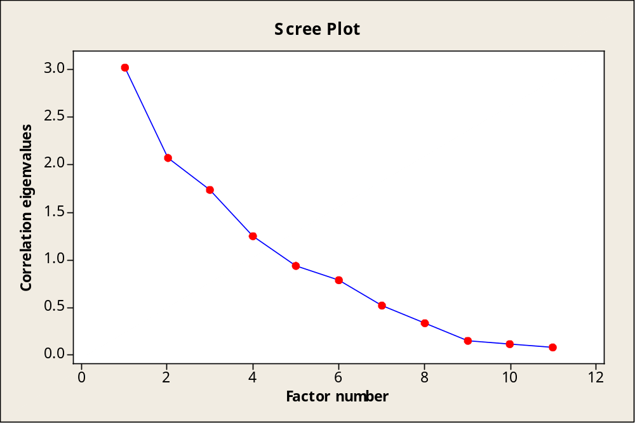

Using Minitab, we compute our factor loadings, which are displayed in Table 3. The final process of our factor analysis is interpreting these factors. Factor 1 has a very high positive loading on the High School Graduates variable, and a very high negative on the variable Poverty. To represent the contrast of these variables we call this factor “Poverty/Education”. Factor 2 has the highest loadings between Income, Poverty, and Cigarette Use, therefore we choose to name this factor “Income/Tobacco”. “Youth/Prosperity”, our third Factor, is influenced by the variables Population age 18-24 and Median Household Income. Factor 4 is “Drug and Alcohol”, since the variables dealing with drinking are high as well as Illicit drug Use. Factor 5 is straightforward with Percent of Population and Percent of Land being interrelated, so we simply name this factor “Size”.

Table 3: Factor Loadings for 5-Factor Model
Variable | Factor 1 | Factor 2 | Factor 3 | Factor 4 | Factor 5
% of Population (sqrt) | -0.27205 | 0.262834 | 0.20786 | 0.151585 | -0.88923
% of Land (sqrt) | 0.027716 | -0.26505 | -0.43425 | -0.02333 | -0.53544
Cigarette Use (% of population) | -0.06279 | -0.64158 | 0.141167 | -0.07411 | 0.095372
Binge Drinking (% of population) | 0.340765 | 0.108668 | -0.11494 | -0.67461 | -0.01244
Illicit Drug Use (% of population) | 0.1744 | -0.04233 | 0.334043 | -0.33736 | 0.144849
Treatment Centers (per 100,000 residents) | 0.36884 | -0.008 | -0.02649 | -0.06785 | 0.319699
% of Traffic Fatalities Involving Drunk Drivers | -0.1823 | -0.08116 | 0.130707 | -0.96547 | 0.104706
% of Population age 18-24 | 0.07803 | -0.04244 | -0.98584 | 0.017474 | 0.141126
% of Population Living Below the Poverty Line | -0.62529 | -0.54712 | -0.25917 | -0.01225 | -0.03892
Median Household Income | 0.284706 | 0.854539 | 0.397859 | -0.16455 | 0.057766
% of Population Over 25 that are High School Graduates | 0.950099 | 0.243375 | -0.07328 | -0.10289 | 0.148743

Discriminant Analysis Theory

Suppose we are given two multivariate populations 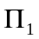 and 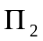. Let 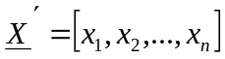 be a set of measurements. The main goal of discrimant analysis is to classify this set of measurements into either or . To achieve our goal, we must derive a linear combination of X known as a discriminant function. This function should separate and as much as possible.
We begin by finding an optimal partition of , the p-dimensional space of X, into subsets 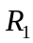 and . Our classification rule assigns x to if x is in , and it assigns x to if x is in . Let 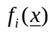be the probability density function associated with 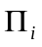. By definition, the optimal partition minimizes the total probability of misclassifying an observation, or TPM. The TPM is defined as 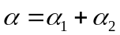, where

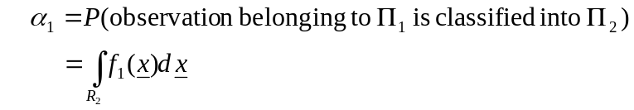
and
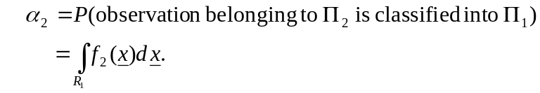
We want to minimize the TPM subject to 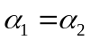. It can be shown that the optimal partition is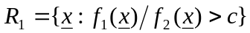 and 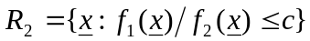, where c is chosen so that . Equivalently, we choose c so that .

Up to this point, we have placed no restriction on the distribution of the populations and . From now on, we assume both populations are multivariate normal with p variables, mean vectors 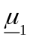 and 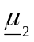 respectively, and the same covariance matrix . Let 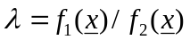 and 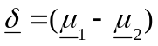. In view of the definition of and , we are interested in the inequality 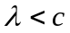 for some appropriate constant c. The assumption of normality allows us to express
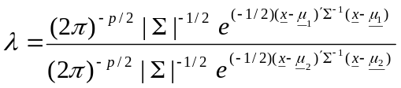,
which is equivalent to
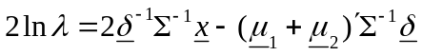.
Thus, the key inequality 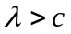 is equivalent to 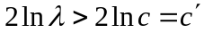, where 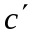is another constant. Because , 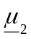, , and are constants, this becomes
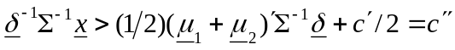
Letting 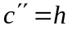 and 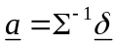 we finally obtain 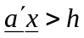. We now have a way of classifying our sets of measurements. If , classify x into ; otherwise classify x into .

Even though we have a strategy for classification, we still need a method of finding the value of h and the minimum value of . Under , 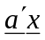 is normally distributed with mean 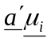and covariance matrix 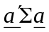. Also, we choose h so that . Using these two facts, we can show that 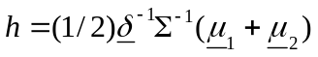. Additionally, is minimized when it is equal to
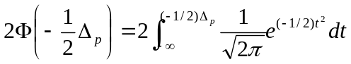.
where 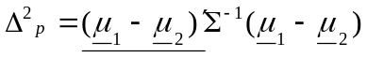.

The above classification rule is equivalent to assigning x to if 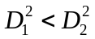 and assigning x to otherwise, where 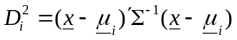. Notice that 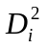 is referred to as the squared Mahalanobis-distance (or M-distance) from x to . This equivalent version is particularly useful if we are dealing with more than two populations. Suppose we want to classify x and our populations are 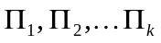. We assign x to if 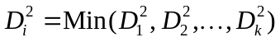. Minitab 14 and many other statistical programs use this rule for classification.

In real-world applications, the population mean vectors and covariance matrix are unknown. Fortunately, we can use sample estimates from training samples from and . If we take two samples of size 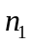 and 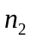 from and respectively, we can use the sample means 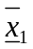 and 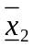 as unbiased estimators for the population means. Also, an estimator for is the pooled unbiased estimate, which is defined as
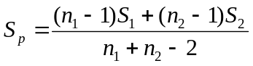,
where 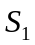 and 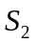 are the sample covariance matrices for the two samples. Classify x into if 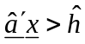 and classify x into if 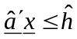, where 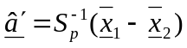 and 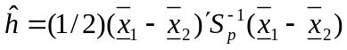. Also, 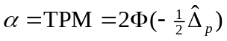, where 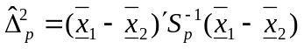. Again, we can classify any sample vector using the square of the M-distance, which is calculated using the sample mean vectors and the pooled unbiased estimate of the covariance matrix.

After finding our classification function we can evaluate the classification function using the apparent error rate, or APER. The APER gives us the percentage of observations in our training sample that are misclassified by our classification function. Let
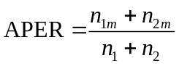,
where 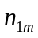 is the number of items misclassified and 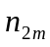 is the number of items misclassified.

Finally, we need a test of the equality of the covariance matrices associated with and . The null hypothesis is 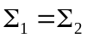, and the alternate hypothesis is 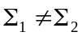. Using the principles of the likelihood ratio test, we can show that we will reject the null hypothesis at the significance level if 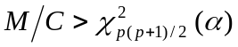, where
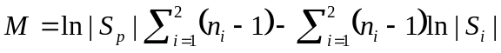
and
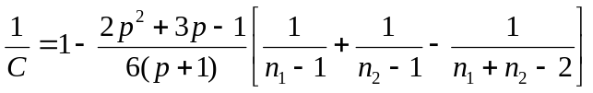

If we reject the null hypothesis, then we can no longer use linear classification. Instead, we must use the much more complicated method of quadratic discriminant analysis. For this classification rule, we allocate to if
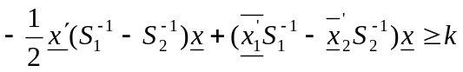,
where
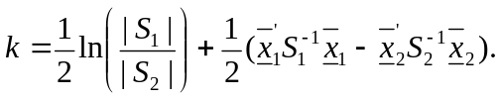
Otherwise, we allocate to .

Discriminant Analysis Application

Recall that we divide the states into two populations based on the percentage of the population that is dependent upon or abusing drugs and alcohol. We get this information from the 2002-2003 National Survey on Drug Use and Health. If this percentage is less than 9.4, the median of our data set, we classify the state as having a minor drug problem. Otherwise, we classify the state as having a major drug problem. Then, in order to run discriminant analysis, we must create two training samples. One training sample will consist of 15 randomly chosen states with a minor drug problem, while the other one will consist of 15 randomly chosen states with a major drug problem. These training samples are outlined in Appendix C and Appendix D.

Our next task is to decide whether or not the two populations share a common covariance matrix. We first calculate the sample covariance matrices 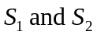, and then use these values to calculate 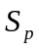, the pooled unbiased estimate of the covariance matrix. Then, by using the test outlined in the theory section, we see that our test statistic is 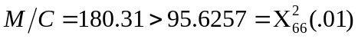. Additionally, the p-value of our test statistic is approximately 0. Therefore, we reject the null hypothesis of the two covariance matrices being equal, and we assume that each population has a unique covariance matrix. This means that we will prefer to use quadratic discriminant analysis as opposed to linear discriminant analysis.
Table 4 displays the results regarding our training sample after running discriminant analysis in Minitab. Since none of the states in our training sample were misclassified, our apparent error rate, or APER, is 0.

Table 4: Summary Of  Quadratic Classification | Actual Group
Table 4: Summary Of  Quadratic Classification |  | Minor drug problem | Major drug problem
Predicted Group | Minor drug problem | 15 | 0
Predicted Group | Major drug problem | 0 | 15

While this result may seem very promising, it should be noted that our main goal is to use our discriminant model to classify states not within the training sample. So, we now attempt to classify our remaining 19 states using the model derived from our training sample. Our results are summarized in Table 5. Notice that a state is assigned to the population with the smaller squared distance. Also, notice that group 1 is the minor drug problem population, and group 2 is the major drug problem population.

Table 5: Predicted Results Using Quadratic Discriminant Analysis
 | State | Predicted  Group | True Group | Squared Distance  To Minor Drug Problem | Squared Distance to  Major Drug Problem
1 | Alabama | 1 | 1 | 30.7 | 53.9
2 | *Tennessee | 2 | 1 | 59.2 | 51.5
3 | Utah | 1 | 1 | 384.3 | 433.8
4 | Kentucky | 1 | 1 | 70.3 | 71.7
5 | Pennsylvania | 1 | 1 | 20.8 | 21.4
6 | *North Carolina | 2 | 1 | 36.5 | 28.1
7 | Connecticut | 1 | 1 | 26.2 | 26.9
8 | Maine | 1 | 1 | 81.3 | 135.3
9 | *New York | 2 | 1 | 66.4 | 29.5
10 | Maryland | 1 | 1 | 19.5 | 38.4
11 | Iowa | 2 | 2 | 80.2 | 34.8
12 | *Washington | 1 | 2 | 12.4 | 97.2
13 | Missouri | 2 | 2 | 60.5 | 13.0
14 | *Idaho | 1 | 2 | 47.8 | 75.9
15 | Vermont | 2 | 2 | 40.6 | 36.2
16 | Nebraska | 2 | 2 | 70.8 | 16.7
17 | North Dakota | 2 | 2 | 182.4 | 33.9
18 | *Rhode Island | 1 | 2 | 79.4 | 118.4
19 | New Mexico | 2 | 2 | 63.7 | 28.6

Our quadratic model is able to correctly classify 13 of 19 states, so it is successful for approximately 68% of the samples. Notice how this value is greatly underestimated by the APER, which only looks at states within the training sample.

Since it is still possible that linear discriminant analysis could be effective, we run linear discriminant analysis in Minitab 14 with the same training samples, and we test our linear discriminant function with the same 19 states not in our training sample. We can also now calculate the total probability of misclassification, or TPM, by using the formula 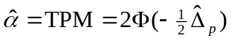. The TPM is approximately .07. In Table 6, we display the results from running discriminant analysis on our training sample.

Table 6: Summary Of  Linear Classification | Actual Group
Table 6: Summary Of  Linear Classification |  | Minor drug problem | Major drug problem
Predicted Group | Minor drug problem | 15 | 1
Predicted Group | Major drug problem | 0 | 14

Since there is one misclassification of our 30 samples, the APER is approximately .03, which is slightly worse than with quadratic discriminant classification. The one state in the training sample that was misclassified as having a minor drug problem is Louisiana. This state is right on the border of the major and minor drug problem group, as the percent of the population abusing or depending upon drugs and alcohol is estimated to be 9.70. Below are the results of our classification of the remaining 19 states. Again, we assign the state to the population with the smaller squared distance. Again, group 1 is the minor drug problem population, and group 2 is the major drug problem population.

Table 6: Predicted Results Using Linear Discriminant Analysis
 | State | Predicted  Group | True Group | Squared Distance  To Minor Drug Problem | Squared Distance to  Major Drug Problem
1 | Alabama | 1 | 1 | 11.3 | 46.1
2 | Tennessee | 1 | 1 | 12.7 | 48.9
3 | Utah | 1 | 1 | 209.8 | 297.6
4 | *Kentucky | 2 | 1 | 35.0 | 31.2
5 | Pennsylvania | 1 | 1 | 8.5 | 10.3
6 | North Carolina | 1 | 1 | 7.7 | 27.2
7 | *Connecticut | 2 | 1 | 16.4 | 16.2
8 | Maine | 1 | 1 | 62.0 | 64.0
9 | *New York | 2 | 1 | 24.3 | 11.7
10 | Maryland | 1 | 1 | 12.9 | 22.8
11 | *Iowa | 1 | 2 | 18.5 | 21.7
12 | *Washington | 1 | 2 | 7.9 | 21.2
13 | Missouri | 2 | 2 | 25.9 | 7.2
14 | *Idaho | 1 | 2 | 21.1 | 52.3
15 | Vermont | 2 | 2 | 23.7 | 23.2
16 | Nebraska | 2 | 2 | 12.4 | 10.6
17 | North Dakota | 2 | 2 | 39.7 | 17.0
18 | Rhode Island | 2 | 2 | 62.6 | 50.9
19 | *New Mexico | 1 | 2 | 18.2 | 23.3

Our linear model successfully classifies 12 of the 19 states not in the training sample. So, it is correct approximately 63% of the time, which is less than the 68% rate of the quadratic model. Since our APER is also higher for linear discriminant analysis, we prefer using the quadratic model for this application.

Why are some states misclassified? If we examine both linear and quadratic discriminant analysis, we see that both methods misclassified New York, Washington, and Idaho. It appears that the main reason for New York’s misclassification is its relatively large incidence of binge drinking (24.27%), especially when compared to other states in the minor drug problem population. The opposite seems to be true for Washington, as it has a relatively small rate of binge drinking (20.94%). Also, notice that Washington is extremely close to the median, as its percentage of populations abusing or depending on drug and alcohol is 9.48. Finally, Idaho is very close to the median as well. Also, despite being a member of the major drug problem population, Idaho has a relatively small percentage of illicit drug users (7.24). While this discussion does not completely explain all of our misclassifications, hopefully it sheds some light on why some misclassifications might be occurring.

Another reason for misclassification could be the nature of the drug and alcohol dependency or abuse percentages. Remember, these values are not actually known, but are estimated in the SAMHSA survey. Each value has an associated 95% confidence interval. For example, Iowa’s estimate is 9.47, and its 95% confidence interval is (8.22, 10.89). Indiana’s estimate is 9.32, and its 95% confidence interval is (8.05, 10.77) [8]. So, even though Iowa has a higher estimate, it could very well be that Indiana actually has a higher percentage of its population addicted to or abusing drugs and alcohol.

Conclusion

We are satisfied with our factor analysis application, since we have successfully reduced the dimensionality from 11 variables to 5 variables while still explaining a significant amount of the variance. Also, we are pleased that all 5 of our variables are readily interpretable.

Our discriminant analysis model, however, does leave something to be desired. While quadratic discriminant analysis yields decent results, we still feel that there is room for improvement. Although we have a low apparent error rate, we feel that we could have done a better job of correctly classifying states not in our training sample. This problem could possibly be alleviated by adding more variables, such as crime rates in the states, law enforcement data, and data regarding substance abuse education in the states.

We also realize that using the total percentage of drug and alcohol dependency is not the only way to create our major and minor drug population data. We could use data based upon the number of people who have checked into substance abuse clinics, as this information is readily available from SAMHSA. While this number might be more precise (since the dependency and abuse information is based on estimates with fairly large confidence intervals), it might not reflect the true nature of drug abuse in that particular state. In our research, we had discovered that a majority of addicts and abusers do not seek treatment. For example, in the United States, over 8 million people are abusing or dependent upon illicit drugs, but less than 2 million drug addicts and abusers receive treatment [8]. Therefore, this number might greatly distort the true nature of the drug and alcohol problem. However, since both methods of dividing the data set into two populations have their drawbacks, future research on this topic could use the number of people seeking treatment to create the major and minor drug abuse populations.

Perhaps one of the most important observations we have made is that drug and alcohol abuse is not a simple problem, but a complex problem that is not easily explained by social and economic factors alone.

Acknowledgements

We would like to thank the National Science Foundation, the National Security Agency, and Miami University for funding SUMSRI and making this research project possible. Also, we would like to thank Dr. Dennis Davenport and Dr. Vasant Waikar for directing this program. We also would like to thank Dr. Waikar teaching us the various multivariate statistical methods in our statistics seminar and guiding us through our research. We also appreciate the help of Shenek Heyward, our graduate assistant for the statistics seminar. We would also like to thank Dr. Tom Farmer for his excellent mathematical writing seminar and his revisions of our paper. We would like to thank all of our fellow SUMSRI students and graduate assistants for their support during our research, particularly our fellow statistics seminar students AdriAnne Demski and Janelle Jones. Finally, we want to thank Bonita Porter for organizing so many of our activities and making the SUMSRI experience an enjoyable one.

Bibliography

[1] Census.gov, Annual Estimates of the Population for the United States and States, and for Puerto Rico: April 1, 2000 to July 1, 2004. Retrieved June 2005 from http://www.census.gov/popest/states/tables/NST-EST2004-01.xls

[2] Census.gov, Educational Attainment of the Population 25 Years and Over, By State, Including Confidence Intervals of Estimates: 2003. Retrieved June 2005 from http://www.census.gov/population/socdemo/education/cps2003/tab13.xls

[3] Census.gov, MEDIAN FAMILY INCOME IN THE PAST 12 MONTHS (IN 2003 INFLATION-ADJUSTED DOLLARS) BY FAMILY SIZE. Retrieved June 2005 from http://www.census.gov/hhes/www/income/medincsizeandstate.xls

[4] Census.gov, State and County Quick Facts. Retrieved June 2005 from http://quickfacts.census.gov/qfd/

[5] Richard A. Johnson and Dean W. Wichern, Applied Multivariate Statistical Analysis (Fifth Edition), Prentice Hall (2002)

[6] National Highway Traffic Safety Administration, Traffic Safety Facts 2003: State Traffic Data. Retrieved June 2005 from http://www-nrd.nhtsa.dot.gov/pdf/nrd-30/NCSA/TSF2003/809773.pdf

[7] Substance Abuse and Mental Health Services Administration, National Survey of Substance Abuse Treatment Services (N-SSATS). Retrieved June 2005 from http://wwwdasis.samhsa.gov/webt/NewMapv1.htm

[8] Substance Abuse and Mental Health Services Administration, State Estimates of Substance Use from the 2002–2003 National Surveys on Drug Use and Health. Retrieved June 2005 from http://oas.samhsa.gov/2k3State/toc.htm

Appendix A: Minor Drug Problem Population Data Tables
Minor Drug Problem | drug and alcohol dependency (used only to divide states into two populations | % of Population (sqrt) | % of land (sqrt) | cigarrette use | binge drinking | illicit drug use
.Alabama | 7.4 | 1.24499 | 1.19771 | 26.43 | 18.1 | 6.62
.New Jersey | 7.59 | 1.72337 | 0.45793 | 23.42 | 21.74 | 6.97
.Mississippi | 7.91 | 0.99499 | 1.15152 | 29.41 | 19.7 | 6.56
.Tennessee | 7.94 | 1.41774 | 1.07944 | 28.03 | 16.55 | 6.7
.Utah | 7.99 | 0.9 | 1.52384 | 16.74 | 15.86 | 6.32
.Kentucky | 8.04 | 1.19164 | 1.05976 | 34.77 | 19.24 | 8.33
.West Virginia | 8.13 | 0.7874 | 0.82505 | 29.52 | 19.33 | 6.61
.Pennsylvania | 8.3 | 2.06155 | 1.12557 | 27.68 | 22.83 | 7.5
.North Carolina | 8.31 | 1.70294 | 1.17346 | 29.69 | 19.31 | 7.92
.Kansas | 8.33 | 0.96954 | 1.52079 | 25.95 | 21.71 | 6.74
.Oklahoma | 8.66 | 1.1 | 1.39327 | 30.28 | 19.01 | 8.58
.Connecticut | 8.8 | 1.09545 | 0.37014 | 23.78 | 23.09 | 8.75
.Florida | 8.8 | 2.41868 | 1.23471 | 23.99 | 21.74 | 8.72
.Maine | 8.81 | 0.67082 | 0.93402 | 26.82 | 21.74 | 9.31
.New York | 8.88 | 2.57099 | 1.15529 | 25.46 | 24.27 | 8.9
.Texas | 8.98 | 2.75681 | 2.72044 | 25.56 | 23.9 | 6.97
.California | 9 | 3.49285 | 2.09971 | 19.36 | 21.25 | 9.01
.Virginia | 9.09 | 1.5906 | 1.05797 | 25.18 | 20.51 | 7.68
.Arkansas | 9.1 | 0.96954 | 1.21322 | 32.84 | 21.76 | 7.78
.Georgia | 9.11 | 1.72627 | 1.27945 | 25.8 | 20.73 | 7.54
.Maryland | 9.19 | 1.3784 | 0.52564 | 23.22 | 21.65 | 7.57
.Oregon | 9.25 | 1.10905 | 1.64733 | 24.96 | 20.52 | 10.84
.South Carolina | 9.26 | 1.19583 | 0.92261 | 26.85 | 22.54 | 7.23
.Delaware | 9.29 | 0.52915 | 0.23495 | 26.09 | 23.71 | 8.74
.Indiana | 9.32 | 1.45945 | 1.00693 | 28.33 | 22.27 | 8.07

Appendix A (continued)
Minor Drug Problem | treatment centers available | Percent of traffic fatalities caused by drunk drivers | % of pop 18-24 | % of Population below Poverty Line | Median household income | % of population over 25 that is a high school graduate
.Alabama | 2.8643 | 41 | 10.0631 | 16.1 | 43.307 | 79.9
.New Jersey | 3.7258 | 37 | 8.5521 | 8.5 | 70.263 | 86.2
.Mississippi | 4.0588 | 37 | 11.1317 | 19.9 | 39.182 | 81.2
.Tennessee | 3.1992 | 37 | 9.7558 | 13.5 | 46.654 | 81
.Utah | 5.0168 | 15 | 13.0971 | 9.4 | 52.481 | 89.4
.Kentucky | 7.6004 | 30 | 9.9528 | 15.8 | 41.898 | 82.8
.West Virginia | 4.6924 | 37 | 9.5191 | 17.9 | 38.568 | 78.7
.Pennsylvania | 3.7589 | 39 | 9.5531 | 11 | 51.339 | 86
.North Carolina | 3.4199 | 36 | 9.6953 | 12.3 | 45.54 | 81.4
.Kansas | 7.8905 | 44 | 10.9478 | 9.9 | 51.157 | 88.6
.Oklahoma | 4.4774 | 38 | 10.9389 | 14.7 | 43.259 | 85.7
.Connecticut | 6.8828 | 45 | 8.8655 | 7.9 | 69.917 | 87.5
.Florida | 3.3825 | 40 | 8.9056 | 12.5 | 47.442 | 84.7
.Maine | 14.4362 | 36 | 9.4478 | 10.9 | 48.541 | 86.6
.New York | 5.8192 | 35 | 9.4928 | 14.6 | 55.309 | 84.2
.Texas | 2.5155 | 47 | 10.6735 | 15.4 | 47.479 | 77.2
.California | 5.1265 | 39 | 10.0188 | 14.2 | 56.53 | 81.1
.Virginia | 2.7833 | 39 | 10.0277 | 9.6 | 60.174 | 87.8
.Arkansas | 2.053 | 41 | 10.1655 | 15.8 | 41.072 | 80.9
.Georgia | 3.0658 | 30 | 10.2114 | 13 | 50.647 | 85.1
.Maryland | 6.549 | 43 | 9.3774 | 8.5 | 69.087 | 87.6
.Oregon | 5.7514 | 40 | 9.7496 | 11.6 | 49.8 | 86.9
.South Carolina | 2.3381 | 50 | 10.2157 | 14.1 | 47.081 | 80.8
.Delaware | 5.7446 | 42 | 10.078 | 9.2 | 61.27 | 88.7
.Indiana | 5.3229 | 31 | 10.139 | 9.5 | 51.338 | 86.4

Appendix B: Major Drug Problem Population Data Tables
Major Drug Problem | drug and alcohol dependency (used only to divide states into two populations | % of Population (sqrt) | % of land (sqrt) | cigarrette use | binge drinking | illicit drug use
.Iowa | 9.47 | 1.00499 | 1.25674 | 26.45 | 26.34 | 6.47
.Washington | 9.48 | 1.45258 | 1.37153 | 23.41 | 20.94 | 9.96
.Ohio | 9.56 | 1.98242 | 1.07592 | 30.48 | 24.4 | 8.04
.Missouri | 9.58 | 1.40357 | 1.39546 | 31.51 | 24.56 | 9.17
.Louisiana | 9.7 | 1.24499 | 1.10973 | 28.27 | 23.77 | 8.07
.Idaho | 9.75 | 0.68557 | 1.52944 | 23.95 | 21.05 | 7.24
.Nevada | 9.75 | 0.8775 | 1.76202 | 30.5 | 20.87 | 10.3
.Vermont | 9.9 | 0.45826 | 0.51137 | 25.43 | 25.51 | 10.96
.Michigan | 10.05 | 1.86279 | 1.2672 | 28.19 | 24.46 | 9.06
.Wyoming | 10.07 | 0.41231 | 1.65677 | 26.81 | 24.93 | 7.51
.Illinois | 10.11 | 2.08567 | 1.25352 | 26.77 | 25.17 | 7.5
.Minnesota | 10.57 | 1.31909 | 1.50017 | 26.87 | 28.07 | 7.59
.Wisconsin | 10.65 | 1.37113 | 1.23907 | 25.75 | 28.98 | 7.48
.Massachusetts | 10.71 | 1.48661 | 0.47074 | 22.42 | 27.22 | 9.28
.Colorado | 10.81 | 1.249 | 1.71231 | 26.76 | 25.75 | 11.12
.New Hampshire | 10.9 | 0.66332 | 0.50349 | 26.17 | 24.02 | 11.15
.Arizona | 11.04 | 1.38564 | 1.79229 | 27.51 | 24.32 | 8.87
.Nebraska | 11.07 | 0.7746 | 1.47414 | 25.93 | 26.26 | 7.67
.North Dakota | 11.6 | 0.46904 | 1.39639 | 27.53 | 31.37 | 7.22
.South Dakota | 11.7 | 0.5099 | 1.46465 | 30.31 | 28.13 | 7.15
.District of Columbia | 11.87 | 0.43589 | 0.04123 | 26.12 | 25.34 | 11.59
.Rhode Island | 11.97 | 0.60828 | 0.17176 | 27.35 | 26.97 | 10.95
.Montana | 12.02 | 0.56569 | 2.02845 | 27.71 | 27.41 | 10.58
.New Mexico | 12.04 | 0.80623 | 1.85219 | 24.05 | 24 | 10

Appendix B (continued)
Major Drug Problem | treatment centers available | Percent of traffic fatalities caused by drunk drivers | % of pop 18-24 | % of Population below Poverty Line | Median household income | % of population over 25 that is a high school graduate
.Iowa | 4.1129 | 33 | 10.7094 | 9.1 | 51.336 | 89.7
.Washington | 5.5616 | 43 | 10.2311 | 10.6 | 56.461 | 89.1
.Ohio | 4.1879 | 37 | 9.8408 | 10.6 | 51.522 | 87.2
.Missouri | 4.1439 | 41 | 10.2406 | 11.7 | 49.441 | 88.3
.Louisiana | 3.6051 | 45 | 11.143 | 19.6 | 41.831 | 79.8
.Idaho | 5.0474 | 37 | 11.2494 | 11.8 | 46.783 | 88.2
.Nevada | 3.7909 | 50 | 8.9881 | 10.5 | 52.502 | 85.6
.Vermont | 5.9741 | 41 | 9.9904 | 9.4 | 52.895 | 88.9
.Michigan | 5.9411 | 37 | 9.8547 | 10.5 | 55.018 | 87.6
.Wyoming | 10.1571 | 38 | 11.2987 | 11.4 | 51.627 | 90.9
.Illinois | 4.6723 | 44 | 9.9135 | 10.7 | 57.385 | 85.9
.Minnesota | 5.0946 | 41 | 10.4098 | 7.9 | 61.417 | 91.6
.Wisconsin | 5.5167 | 46 | 10.4356 | 8.7 | 54.5 | 88.6
.Massachusetts | 5.1399 | 45 | 9.3204 | 9.3 | 67.527 | 87.1
.Colorado | 8.444 | 39 | 9.925 | 9.3 | 59.252 | 88.7
.New Hampshire | 4.811 | 41 | 9.4096 | 6.5 | 63.439 | 92.1
.Arizona | 3.7281 | 42 | 9.9375 | 13.9 | 47.219 | 83.8
.Nebraska | 6.1584 | 41 | 10.9184 | 9.7 | 50.756 | 90.8
.North Dakota | 7.1045 | 50 | 12.0853 | 11.9 | 48.386 | 89.7
.South Dakota | 6.7982 | 48 | 11.2398 | 13.2 | 46.824 | 88.7
.District of Columbia | 9.684 | 50 | 10.4601 | 20.2 | 50.243 | 86
.Rhode Island | 5.297 | 55 | 10.4091 | 11.9 | 60.165 | 81
.Montana | 5.9903 | 49 | 10.6865 | 14.6 | 44.503 | 90.1
.New Mexico | 6.4943 | 45 | 10.8278 | 18.4 | 41.661 | 81.7

Appendix C: Minor Drug Problem Training Sample
State | Drug and Alcohol Dependency
.Georgia | 9.11
.California | 9
.Oregon | 9.25
.Virginia | 9.09
.Kansas | 8.33
.Indiana | 9.32
.Oklahoma | 8.66
.South Carolina | 9.26
.Florida | 8.8
.New Jersey | 7.59
.Arkansas | 9.1
.Delaware | 9.29
.West Virginia | 8.13
.Texas | 8.98
.Mississippi | 7.91

Appendix D: Major Drug Problem Training Sample
State | Drug and Alcohol Dependency
.Louisiana | 9.7
.Michigan | 10.05
.Massachusetts | 10.71
.Arizona | 11.04
.Wisconsin | 10.65
.New Hampshire | 10.9
.South Dakota | 11.7
.Minnesota | 10.57
.District of Columbia | 11.87
.Colorado | 10.81
.Illinois | 10.11
.Ohio | 9.56
.Wyoming | 10.07
.Nevada | 9.75
.Montana | 12.02

Baldwin-Wallace College, Berea, OH 44017; jsvenson@bw.edu
Central State University, Wilberforce, OH 45384; msmo06@hotmail.com

