**Issue1)**

I seemingly have some mistakes on HW3. You haven’t left any comment, though, despite having access.

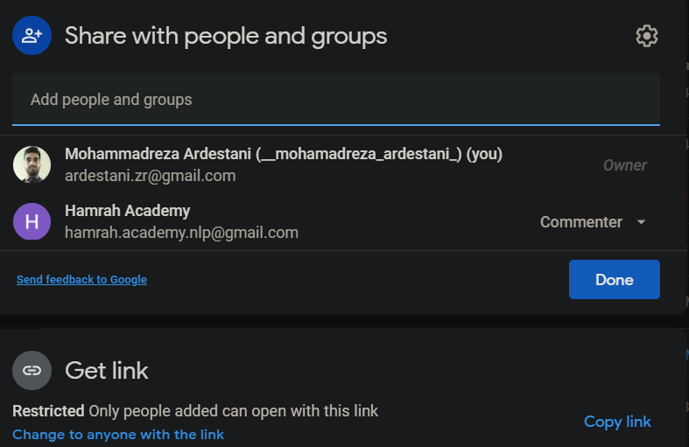

**Issue2)**

Please share the best student’s notebooks of HW3 and HW4. (for learning purposes)

**Issue3)** I believe Quiz4/question2 is wrong.

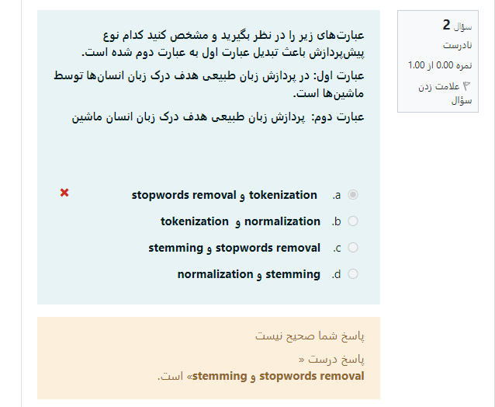

This is stemming result:

['در', 'پرداز', 'زب', 'طبیع', 'هدف', 'درک', 'زب', 'انسان', 'توسط', 'ماشین', 'است.']

The correct answer is “ Lemmatization + Stop removal. “

The closest item to the correct answer is what I have chosen in the above picture.

More detail: Prof. Momtazi’s video lectures

**Issue4)**

Can I report results with Sklearn lib?

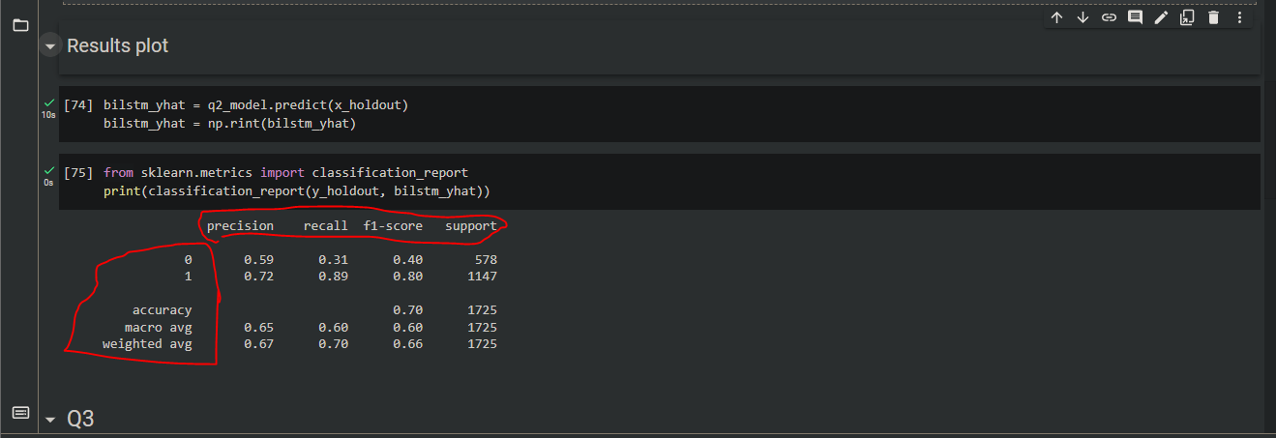

WOULD THIS SUFFICE?

**Issue5)**   
As you know, in machine learning we have an EDA step. I used EDA for parameter tuning but the result does not appear on the downloaded notebook. You need to view my pandas’ profiling results in the google Colab shared notebook.

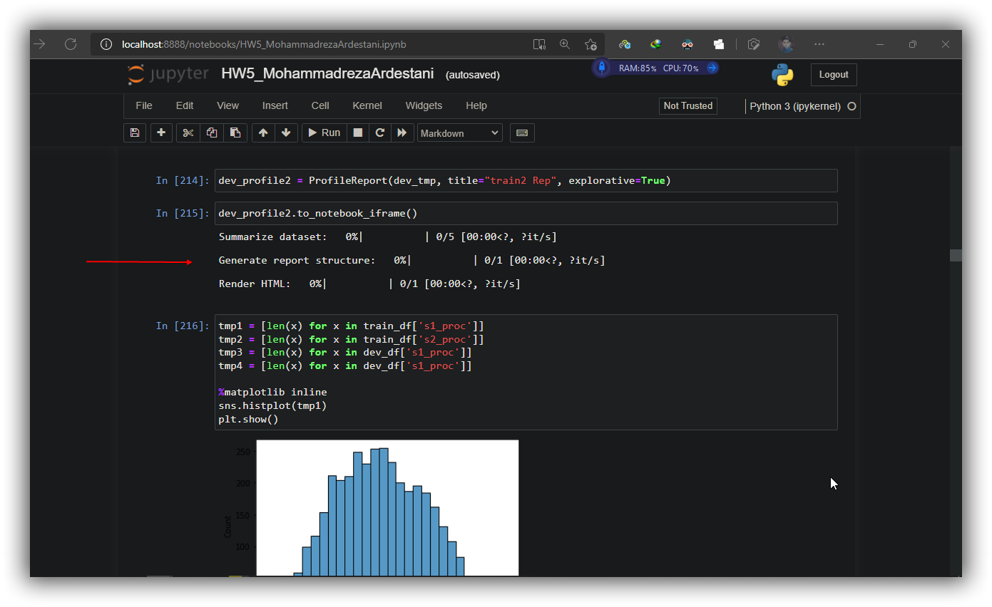

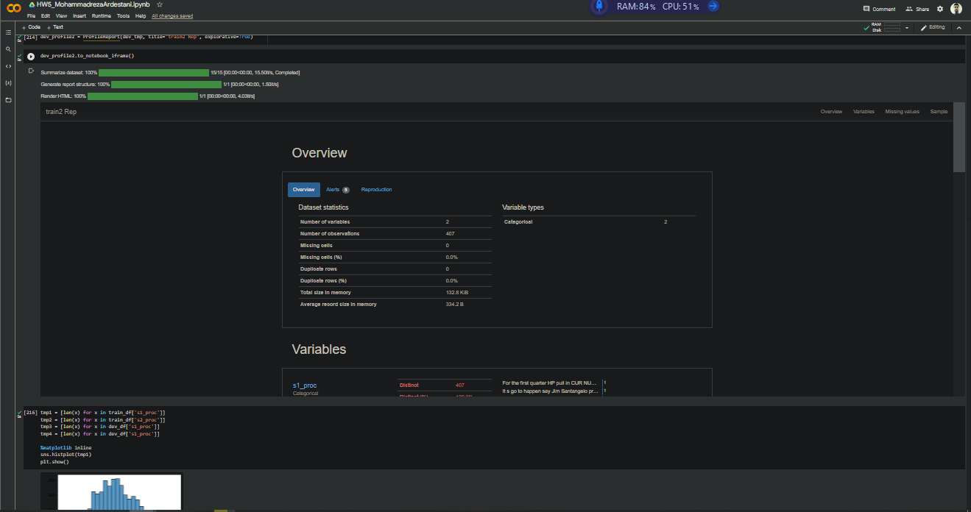

**Issue6)**

**Can we use Gensim lib for finding a skip-gram based embedding model? Or we gotta build from scratch?**

**Issue7)**

Attention weights visualization only for the Bidirectional LSTM model, yeah? Or all models?

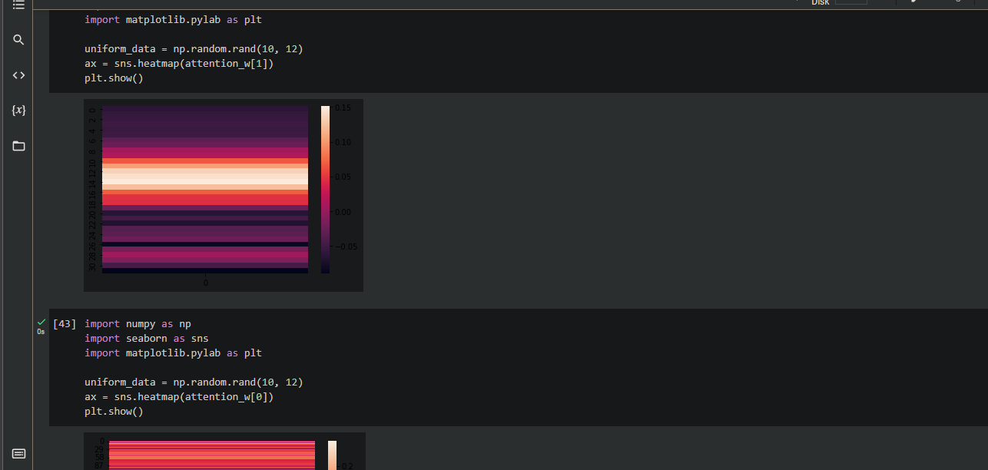

**Issue8)**

**Please let us know if there is any hidden! question or requirements on HW5.**

**Thanks for all the time that you are putting into leading the class.**