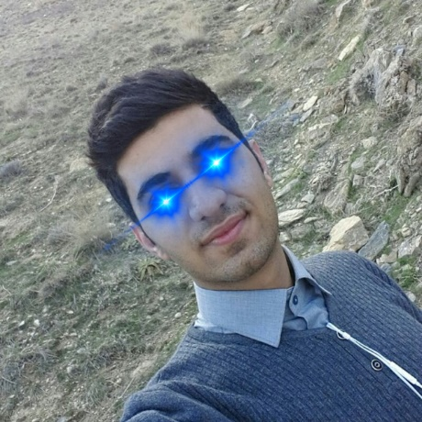

**Master #2**

**Group Members!**

**Master #4**

**Roozbe MM Ahmad Mohammadreza Delgarm Ardestani**