**Web-based Database _ Part I**

**1- a)** Function: A pay stub & HR database system. The HR (Human resource) users can access database to create the monthly pay stub for each employee and also decide to hire some of the candidates and add them to the employees’ database.

**b)** User: Human resource employees.

**c)** Business process flow: The HR users read the candidates profile and decide whether to hire them or not. If rejected, the candidate record will be deleted. If approved, they observe the accepted candidates’ skills and the SSN information and based on those data, they create a new employee record, and then decide which department should the candidate be assigned to.

In addition to that, The HR users can access the salary, deductions and income data to Issue the monthly pay stubs.

**d)**

**YES**

**NO**

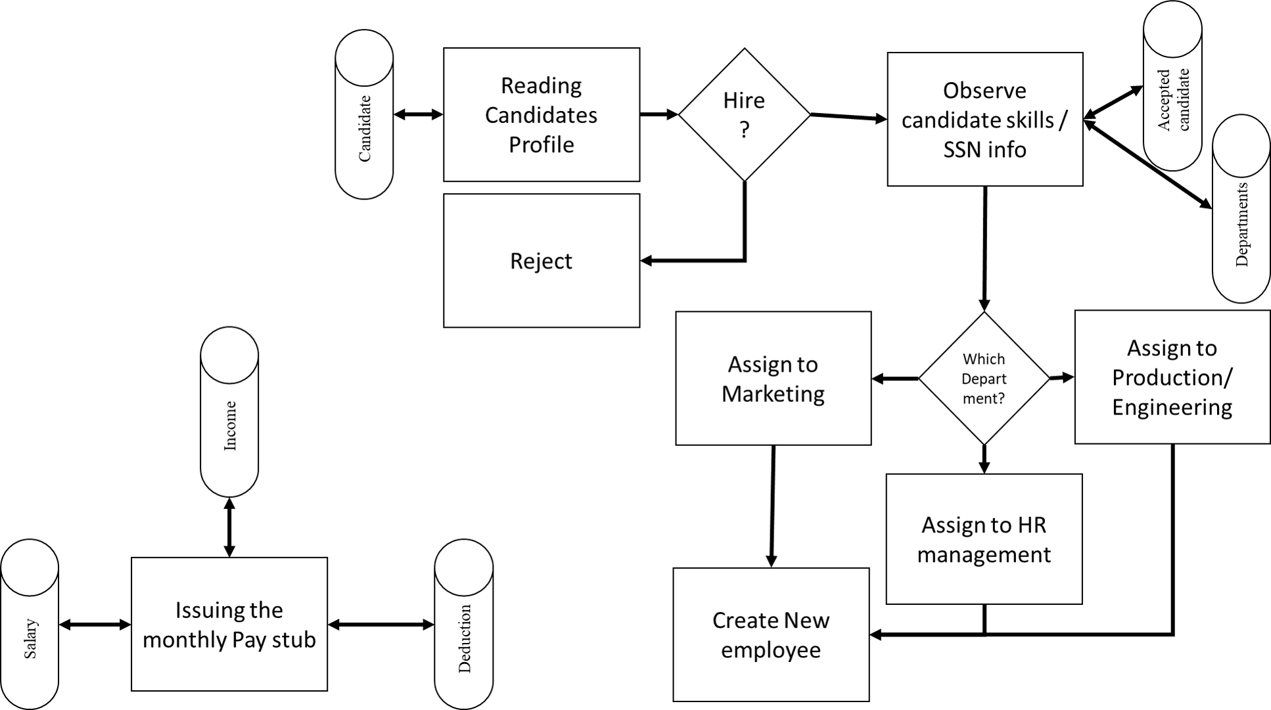

**e)** It is clear that the SSN information can only be accessed when the HR user decided to hire the candidate.

**2)** There are 9 entities. Salary is a weak entity. Income and Deduction are sub-Type entities of Salary Units. Employee is connected to 4 entities (Accepted Candidate, Department, Salary and Employee itself).

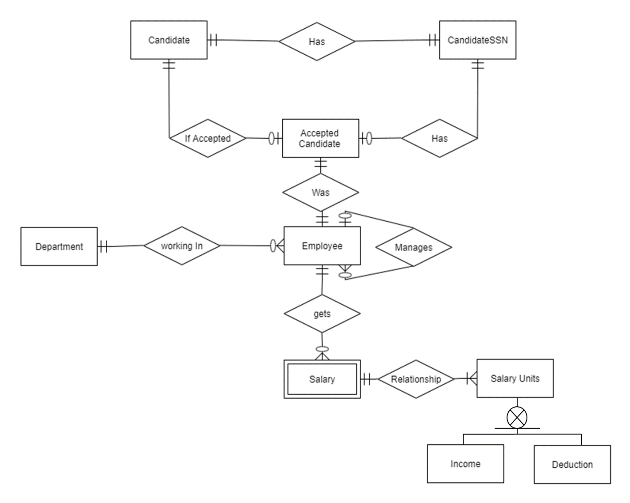

**3)**

**Forms:**

* **Application** **Form**: This form will get a candidate general information (e.g. Major, GPA, Date of Birth, SSN, …) and insert a new record to both Candidate and CandidateSSN tables.
* **Pay stub Form:** The HR user can add Salary units, which can be either an income or a deduction to an employee monthly salary. The monthly salary is calculated according to this equation: (Total incomes added together) – (Total Deductions added together)

**Reports:**

* **Candidate Review Report:** It will show the information of all candidates (Except their SSN). After deciding, the HR user can enter the candidate ID of accepted ones. So that a new record will be added to AcceptedCandidate table.
* **Accepted Candidate Review Report:** It will show the information of all candidates (Including their SSN). After deciding, the HR user can enter the Accepted Candidate ID accompanying the Department number and hiring date. So that a new record will be added to Employee table.
* **Pay Stub Report:** After entering the Employee number, Month and year, a detailed pay stub including each salary units (Incomes and deductions), and the total amount would be shown.

**4-a) Keys:** The Primary Key, Foreign Key and other attributes of each table is shown below:

Primary Keys are shown by underline. ***Foreign keys*** are shown by bold Italic test.

* Candidate (CandidateID [Surrogate Key], Name, Major, LastDegree, GPA, DateofBirth, Sex, YearsExperience, Skills)
* CandidateSSN (SSNID [Surrogate Key], SSN, ***CandidateID***)
* AcceptedCandidate (AccCandidateID [Surrogate Key], ***CandidateID***, ***SSNID***)
* Employee (EmployeeNumber, Name, ***DepartmentNo***, HiringDate, DateofBirth, Sex, ***AccCandidateID***, ***ManagerID***)
* Department (DepartmentNo, DepartmentName)
* Salary (SalaryId [Surrogate Key], ***EmployeeNumber***, Month, Year)
* SalaryUnit (salaryUID [Surrogate Key], **SalaryId**, IsitIncome)
* Income (***salaryUID***, amount, description)
* Deduction (***salaryUID***, amount, description)

**b) Attribute Constraints:**

* All of the tables’ Primary keys would be set to Not-null, Unique.

**c) Domain Constraints:**

* Candidate.LastDegree is among these values: Ph.D., Master, BS.
* Candidate.Sex: Male, Female.
* Employee.Sex: Male, Female.
* Department.DepartmentName: Marketing, HR Management, Production/Engineering

**d) Range Constraints:**

* Candidate.GPA: 0.0 to 4.0
* Salary.Month: 1 to 12
* Salary.Year: 1950 to 2100

**e) Intra_relation Constraints:** None

**f) Referential integrity Constraints:**

* CandidateSSN.CandidateID must exist in Candidate. CandidateID
* AcceptedCandidate.CandidateID must exist in Candidate. CandidateID
* AcceptedCandidate.SSNID must exist in CandidateSSN.SSNID
* Employee.DepartmentNo must exist in Department.DepartmentNo
* Employee.AccCandidateID must exist in AcceptedCandidate. AccCandidateID
* Salary.EmployeeNumber must exist in Employee. EmployeeNumber
* SalaryUnit. EmployeeNumber must exist in Salary.EmployeeNumber
* SalaryUnit. Month must exist in Salary.Month
* SalaryUnit. Year must exist in Salary.Year
* Income.SalaryUID must exist in SalaryUnit. SalaryUID
* Deduction.SalaryUID must exist in SalaryUnit. SalaryUID