Electric Service Restoration Through Python
This document shall serve to explain the use and implementation of the electric service restoration through Python OpenDSS DLL to isolate the fault and restore the distribution network. The service restoration and reconfiguration problem is formulated to optimally determine the PV generation, fault isolation, network configuration, and load pickup for restoration of all loads. Also, it might coordinate DERs with available energy from substations during restoration to recover whole system into normal operation.
Distribution system restoration (DSR) is intended to promptly restore as much load as possible in areas where electricity service is disrupted following an outage. In fact, once a fault is detected and assessed, DSR as a part of DMS (Distribution Management System), is initiated to isolate faulted elements or zones and restore loads of interrupted areas. In this study, a portion of feeder downstream from the faulted area which can be separated from the faulted element or area by opening normally closed switches is called unfaulted out-of-service area. Moreover, reconfiguration for restoration is the process in which the disruption in service to loads is responded through altering the system to restore service to loads. Accordingly, the goal is to isolate fault through opening normally closed switches and energize unfaulted out-of-service areas by closing tie-switches.
Problem Formulation
We have developed a linearized mixed-integer model for the DSR problem incorporating large-scale distribution networks by coordinating bottom-up and top-down restoration strategies. The model is based upon a multi-objective optimization problem to maximize restored loads by considering priorities; while, other objectives such as loss or switching minimization might be included. Moreover, another term related to the operation of switches is also included in the objective function. Therefore, the variables related to the status of switches are integrated and prioritized, so that normally closed switches have higher priority compared to the normally open ones (tie-switches). In other words, it aims to keep network connected as much as close to the normal operation mode. These two terms are being regularized through and for vector optimization. The overall DSR problem is modeled as follows:
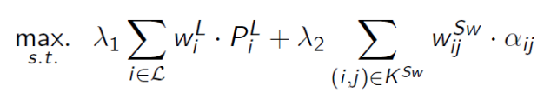  - Security Constraints  - Power Flow equations  - Connectivity constraints, | (1)
where, , and stand for priority and demand of load i, and and show connection status and priority of switch between nodes (i, j). As it is defined in (1), the optimization problem of DSR is subjected to the three sets of constraints including security constraints, power flow equations, and connectivity constraints.
Security constraints guarantee the operational limits of various elements in the distribution networks. These constraints include loads capacity, substation capacity, voltage limit, branch power capacity, and DERs and converters capacities. Detailed formulation and modeling of these constraints are referred to [1]. Moreover, Power flow equations are based upon branch flow model which are developed and generalized for three-phase unbalanced distribution networks in [1]. Furthermore, for simplicity and scalability of the algorithm, power flow equations are being linearized through removing quadratic loss term. Finally, Connectivity constraints include spanning-tree constraints and fault isolation constraints. Spanning tree constraints guarantees radial operation of the distribution networks and fault isolation constraints establish isolation of the faulted elements through operation of the switchable lines.
Implementation
The implementation framework has been developed using Python, OpenDSS, and GUROBI. The main optimization platform for the DSR including objective function and all constraints is built in python. Then, the data for various large-scale networks could be extracted from OpenDSS models using COM interface. The proposed DSR algorithm is validated and implemented on various modified test feeders with different fault scenarios including a large-scale 100k-node network (twelve copies of the IEEE 8500-node network).
Before attempting to run anything in Python, the OpenDSS software must be downloaded and installed and the COM interface must be established. Make sure the “Master.dss” file, which is located in “Test_Network” folder is able to run and solve successfully. Also, users must be able to see the message which indicates the “The OpenDSS Connection Established Successfully” in the Python console. Moreover, users have to setup GUROBI optimization solver and build a connection with the Python in order to solve DSR optimization problem.
The code containing the DSR problem in Python consists of four main modules as:
- OpenDSSInit.py: This module establishes the COM interface connection between OpenDSS and Python and provides some methods for DSS class.
- Functions.py: This module provides various required functions in order to extract and arrange data structure for the test network.
- OpenDSSCkt.py: This module extracts test network data and builds various arrays and lists in order to establish the whole data structure containing all nodes, buses, lines, and etc. of the network. All new PVs and tie-switches can be added by this module
- DSR.py: This module builds the whole DSR optimization problem based on the constructed data structure. The module first defines decision variables and then set up the objective function. Finally, it formulates all set of constraints and consequently build the whole DSR problem. After solving the problem, this module provides a plot function in order to demonstrate a visual plot of the solution considering all switches and faulted lines.
To run this code, users need to run the DSR.py module. Any faulted lines can be added to the FaultedLines list which is found in the DSR module. This list currently contains four faulted lines as:
FaultedLines = ['Line.ln5774453-1', 'Line.ln6047578-1', 'Line.c10_ln5774453-1', 'Line.c3_ln6504020-2']
Furthermore, the code contains four PVs which can be added through OpenDSSCkt.py module as FindPVConnection function. In this function first bus name must be determined and then the capacity of the PV must be specified as “Busm1026706=[1000, 1]”, which shows a PV connection to the bus “m1026706” with 1000 kW capacity. Any substation or Tie-switches can also be integrated through the Tie_Lines.dss file which is located in Test_Network folder.
Accordingly, Figure 1 shows the result of running code for the modified 100k-node network with four faulted lines. In this demonstration, blue arrows show closed switches and yellow ones show open switches. Moreover, green and red dots stand for picked-up and de-energized loads. It is clear that the DSR model separates faulted lines through two sectionalizing switches from upstream and downstream areas of the network. Respectively, in subnetwork 1, a substation (connected with a tie-switch) and two PVs picked up all loads in the unfaulted out-of-service areas. In the subnetwork 4, the fault is on the feeder head; therefore, considering capacity of two existed PVs, some loads are
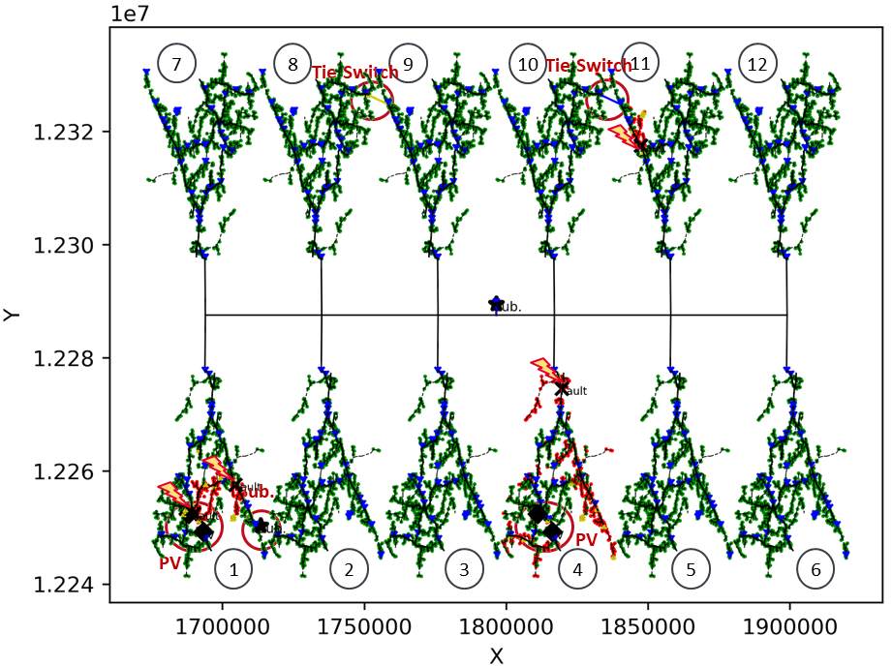
Figure1. 100k-node distribution system with faulted lines, (a) base case network, (b) Network integrated with PVs, substation, and Tie-switches

being restored according to their priority. Finally, a tie-switch between subnetwork 10 and 11 are closed to energized loads downstream of the fault in subnetwork 11. It is worth mentioning that, despite all the operation of switches, the procedure of algorithm prevents the occurrence of any loop in the distribution network which is prohibited by the protection systems.

References:
- R. Roofegari nejad and W. Sun, "Distributed Load Restoration in Unbalanced Active Distribution Systems," IEEE Transactions on Smart Grid, pp. 1-11, 08 January 2019.

