efa_to_run.RMD

# Filter data, remove ids with too many missings, also remove outliers

set.seed(2124)  
res = filter_multi_df_outliers_missing(  
 df=df,  
 value_cols=q_cols)

##   
## iter imp variable  
## 1 1  
## 1 2  
## 1 3  
## 1 4  
## 1 5  
## 2 1  
## 2 2  
## 2 3  
## 2 4  
## 2 5  
## 3 1  
## 3 2  
## 3 3  
## 3 4  
## 3 5  
## 4 1  
## 4 2  
## 4 3  
## 4 4  
## 4 5  
## 5 1  
## 5 2  
## 5 3  
## 5 4  
## 5 5

df = res[["df"]]  
res[["missing_df"]]

## [1] id q1 q2 q3 q4 q5 q6 q7 q8 q9 q10 q11 q12 q13 q14 q15 q16 q17 q18  
## [20] q19 q20 q21 q22 q23 q24 q25 q26 q27 q28 q29 q30 q31 q32 q33 q34 q35 q36 q37  
## [39] q38 q39 q40  
## <0 rows> (or 0-length row.names)

res[["outlier_df"]][["id"]]

## [1] "patient12" "patient17" "patient18" "patient21" "patient51"   
## [6] "patient59" "patient78" "patient84" "patient94" "patient95"   
## [11] "patient105" "patient129" "patient162" "patient167"

# Check EFA assumptions

res = check_efa_assumptions(  
 df=df,  
 value_cols=q_cols,  
 figs_path=NULL)  
res[["barlet_test"]][["p.value"]]

## [1] 0

res[["kaiser_sampling_adequacy"]]

## Kaiser-Meyer-Olkin factor adequacy  
## Call: psych::KMO(r = cor_mat)  
## Overall MSA = 0.84  
## MSA for each item =   
## q1 q2 q3 q4 q5 q6 q7 q8 q9 q10 q11 q12 q13 q14 q15 q16   
## 0.79 0.75 0.73 0.80 0.76 0.70 0.86 0.87 0.82 0.82 0.85 0.74 0.87 0.40 0.86 0.89   
## q17 q18 q19 q20 q21 q22 q23 q24 q25 q26 q27 q28 q29 q30 q31 q32   
## 0.90 0.69 0.73 0.77 0.66 0.92 0.80 0.91 0.82 0.90 0.86 0.81 0.84 0.88 0.87 0.91   
## q33 q34 q35 q36 q37 q38 q39 q40   
## 0.86 0.58 0.89 0.88 0.90 0.80 0.82 0.82

# res[["plt_func"]]()

# Get number of factors using parallel analysis

res = get_factor_num(  
 df=df,  
 value_cols=q_cols,  
 figs_path=NULL)

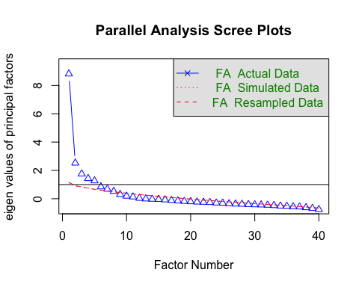

## Parallel analysis suggests that the number of factors = 7 and the number of components = NA

factor_num = res[["kaiser_factor_num_new"]]  
factor_num

## [1] 6

# Fit the EFA with those number of factors and remove items

res = fit_fa_model(  
 df=df,  
 factor_num=factor_num,  
 value_cols=q_cols)  
  
df_filtered = res[["df_filtered"]]  
res[["tuker_lewis_index"]]

## [1] 0.8627073

res[["rmse"]]

## [1] 0.04487648

res[["rejected_items"]]

## [1] "q12" "q14" "q15" "q19" "q21" "q38"

res[["cfi"]]

## [1] 0.9052103

accepted_items = res[["accepted_items"]]

# Fit the EFA using filtered data, this time no item is rejected  
res = fit_fa_model(  
 df=df_filtered,  
 factor_num=factor_num,  
 value_cols=accepted_items,  
 rotate="oblimin",  
 fm="ml")  
res[["tuker_lewis_index"]]

## [1] 0.8627973

res[["rmse"]]

## [1] 0.04067607

res[["rejected_items"]]

## character(0)

res[["cfi"]]

## [1] 0.9115439

res[["factor_item_list"]]

## [[1]]  
## [1] "q35" "q36" "q37" "q39" "q40"  
##   
## [[2]]  
## [1] "q1" "q2" "q3" "q4" "q5" "q6"  
##   
## [[3]]  
## [1] "q7" "q8" "q9" "q10" "q11" "q13"  
##   
## [[4]]  
## [1] "q16" "q17" "q30" "q31" "q32" "q33"  
##   
## [[5]]  
## [1] "q22" "q23" "q24" "q25"  
##   
## [[6]]  
## [1] "q18" "q20" "q26" "q27" "q28" "q29" "q34"