TRUST-BC: A Multicohort Benchmark for Leakage-Free, Calibration-Audited, and Uncertainty-Aware Breast Cancer Prediction Models
Mohammad Amin Shayegan^{1,*} · Reza Abolghasemi^{1,*} · Mohammadreza Salehi¹ · Armaghan Kiarsi²
¹Department of Computer, Shi.C., Islamic Azad University, Shiraz, Iran
²Faculty of Health, Medicine and Society (Oncology), University of Chester, Chester, United Kingdom
*Corresponding authors: Mohammad Amin Shayegan, MA.Shayegan@iau.ac.ir; Reza Abolghasemi, Reza.Abolghasemi@iau.ir

Abstract
Background Machine learning models for breast cancer prediction frequently report accuracies above 97%, yet preprocessing leakage, miscalibration, and mishandled censoring can distort these estimates. We aimed to develop and internally validate TRUST-BC, an open-source template for auditing these problems.
Methods TRUST-BC was evaluated across three public cohorts: Wisconsin Diagnostic Breast Cancer (WBCD; n = 569), Coimbra biomarkers (n = 116), and a Surveillance, Epidemiology, and End Results (SEER) registry extraction (N = 4,024; 3,270 classification, 4,024 survival). The framework combines leakage-free repeated nested cross-validation with principal component analysis (PCA) or random-forest feature selection, an architecture-matched leaky comparator, Nadeau–Bengio corrected inference with equivalence testing, calibration, decision curve analysis, split conformal prediction, subgroup analysis, and a penalised Weibull survival model. Classification models were evaluated once on a 15% held-out partition and the survival model on a 20% test partition.
Results Cross-validated accuracy was 97.08% (95% confidence interval [CI] 95.34–98.82) for WBCD and 71.35% (62.27–80.43) for Coimbra; SEER area under the receiver operating characteristic curve (AUROC) was 0.739 (0.709–0.769). Global scaling and PCA leakage changed performance by at most 0.52 percentage points or 0.001 AUROC. SEER probabilities were overestimated (calibration-in-the-large −0.99), and conformal coverage was 95.26% overall but 69.9% among patients who died. The survival model achieved a concordance index of 0.722 (95% CI 0.675–0.771).
Conclusions Leakage, calibration, and predictive uncertainty behaved differently across cohorts and should be audited per dataset rather than assumed. TRUST-BC provides a reusable template for this purpose.
Keywords Breast cancer · Machine learning · Data leakage · Conformal prediction · Probability calibration · TRIPOD+AI

1 Introduction

1.1 Clinical Motivation and Computational Pitfalls in Oncology Modelling
In 2022, breast cancer was the most commonly diagnosed cancer and the leading cause of cancer death among women worldwide, with about 2.3 million new cases and 670,000 deaths [1]. Supervised machine learning (ML) models, including support vector machines, tree ensembles and gradient boosting [2,3], achieve high discrimination on retrospective tabular oncology benchmarks.
Translation into clinical practice nevertheless remains limited [4], partly because methodological vulnerabilities impair reproducibility across biomedical ML [5]. Four are particularly relevant to oncology workflows [5,6]:
- Parametric and covariance data leakage: scaling and principal component analysis (PCA) are fitted on the entire dataset before splitting, so distributional statistics leak across folds.
- Probability miscalibration: optimisation targets discrimination and neglects calibration [7,8], so predicted probabilities may not match observed event rates.
- Horizon misclassification in registries: when time-to-event data are converted into fixed-horizon targets, patients censored before the horizon are labelled as non-events and deaths after it as events.
- Lack of uncertainty quantification: point probabilities without distribution-free coverage guarantees leave clinicians without safety filters for borderline cases [9].
The Wisconsin Diagnostic Breast Cancer (WBCD) and Coimbra cohorts are diagnostic settings (presence of breast cancer from fine-needle aspirate (FNA) cytology and from routine serum biomarkers), whereas the Surveillance, Epidemiology, and End Results (SEER) registry cohort is a prognostic setting (death from any cause within 5 years of diagnosis). The intended users are clinicians using the models as decision support; here the models serve primarily as test cases for the auditing template rather than as candidates for deployment.

1.2 Related Work and Methodological Deficits in Current Literature
On the WBCD benchmark, reported accuracies often exceed 97%, but unsupervised transforms are seldom fitted within cross-validation loops. Coimbra biomarker models have often relied on unnested or uncalibrated splits [10], SEER studies frequently convert follow-up into 5-year targets without accounting for censoring, and earlier breast cancer survival models in this journal treated survival as a classification task evaluated by cross-validated accuracy [11].
Recent studies, including the re-analysis benchmark of Tadj et al. [12], show growing interest in systematic evaluation, but fold scores are still commonly compared with paired t-tests that ignore the correlation induced by overlapping training sets, inflating the Type I error rate [13]. DeLong’s test [14] compares correlated areas under the receiver operating characteristic curve (AUROCs) on a single test set but does not resolve this problem, and models rarely report uncertainty intervals or triage mechanisms.
Similar methodological concerns have been reported outside oncology [15,16].
Breast cancer outcomes also differ across sociodemographic groups; in the United States, Black women have higher breast cancer mortality than White women despite similar or lower incidence [17]. The Transparent Reporting of a multivariable prediction model for Individual Prognosis Or Diagnosis (TRIPOD)+AI reporting guideline therefore recommends reporting performance in key subgroups [18], which we do for race and age in SEER.

1.3 Objectives and Key Contributions
Unlike single-cohort leakage audits [12], TRUST-BC is an open-source auditing and modelling template that jointly addresses parametric leakage, horizon- and censoring-driven label error, miscalibration and the lack of distribution-free uncertainty quantification across three data archetypes (cytopathological, metabolic and registry). This is a model development study with internal validation (repeated nested cross-validation and a single held-out partition); no external validation was performed.
TRUST-BC combines six components:
- Parametric isolation: standardisation, dimensionality reduction and tuning are encapsulated in the inner folds through scikit-learn pipelines [19].
- Corrected inference: the Nadeau–Bengio corrected resampled t-test [13] with Holm–Bonferroni control [20], Two One-Sided Tests (TOST) for equivalence [21,22] and an architecture-matched leakage contrast.
- Uncertainty quantification: inductive split conformal prediction [23,24] with 95% marginal coverage, flagging ambiguous cases for expert review.
- Calibration and decision analysis: Brier score, expected calibration error (ECE) [25], calibration slope, intercept and calibration-in-the-large, and decision curve analysis (DCA) [26].
- Fixed-horizon labelling and survival modelling: correct 5-year labels for SEER and a penalised Weibull accelerated failure time (AFT) model.
- Transparent reporting: TRIPOD+AI [18] and an author self-assessment against the Prediction model Risk Of Bias ASsessment Tool (PROBAST)+AI [27] (Online Resource 1).
Because these vulnerabilities co-occur, TRUST-BC contributes joint auditing with established but rarely co-implemented safeguards, rather than a claim of superior prediction, in line with [28].

2 Materials and Methods

2.1 Cohort Descriptions, Setting, and Sample Size
We evaluated the framework on three cohorts (Table 1). Participant flow and characteristics by partition are given in Fig. S1 and Table S3 of Online Resource 1, and extended cohort descriptions in Section S10.1.
Table 1 Cohort characteristics, outcome distributions, and deterministic partitions
Cohort | N | D | Clinical endpoint | Class distribution | Development set (85%) | Lockbox (15%)
WBCD | 569 | 30 | FNA malignancy | 357 benign / 212 malignant | 483 (180 events) | 86 (32 events)
Coimbra | 116 | 9 | Breast cancer status (case–control) | 52 controls / 64 cases | 98 (54 events) | 18 (10 events)
SEER (5-year) | 3,270 | 16 | All-cause death within 60 months | 2,812 alive at 60 months / 458 deaths | 2,779 (389 events) | 491 (69 events)
SEER (survival) | 4,024 | 16 | Time to all-cause death | 3,408 censored / 616 deaths | 3,219, 80% (493 events) | 805, 20% (123 events)
- WBCD: n = 569 FNA samples (212 malignant) from a single centre (University of Wisconsin Hospitals, Madison, USA), collected before 1993 [29,30]. Thirty nuclear features were computed from digitised images with operator-initialised tracing, so measurement is partly subjective (Section S10.1) [29].
- Coimbra: n = 116 women (64 with newly diagnosed, untreated breast cancer and 52 healthy controls) recruited at the University Hospital Centre of Coimbra, Portugal, in 2009–2013 [10]. Nine anthropometric and fasting-blood predictors (Section S10.1) were measured [10,30]. Because of the case–control design, probabilities do not transfer to screening, and with an events-per-variable (EPV) ratio of 5.8 this cohort is a small-sample stress test.
- SEER: a public extraction of the National Cancer Institute SEER program [31,32]: N = 4,024 women with infiltrating ductal or lobular carcinoma diagnosed in 2006–2010 (November 2017 submission), after excluding unknown tumour size, unexamined nodes or survival under one month [31,33]. All patients were aged 30–69 years with positive regional nodes (N1–N3), and follow-up extended to 107 months. Twelve predictors gave 16 features after one-hot encoding (EPV 28.6). The 14.0% 60-month all-cause mortality should not be read as population relative survival [17].
Treatment information was unavailable in SEER and not used, so predicted mortality reflects the treatments received by the 2006–2010 cohort; diagnostic samples were obtained before treatment.
Predictors. All available predictors were candidates, except the composite American Joint Committee on Cancer (AJCC) stage in SEER, which was excluded to avoid collinearity with its components. Ordinal staging descriptors were integer coded:
 | $$\text{T}∈\{\text{T1}:1,\text{T2}:2,\text{T3}:3,\text{T4}:4\}, \text{N}∈\{\text{N1}:1,\text{N2}:2,\text{N3}:3\}, \text{Grade}∈\{\text{I}:1,\text{II}:2,\text{III}:3,\text{IV}:4\}.$$ | (1)
This coding assumes linear spacing between categories. SEER predictors were abstracted by certified tumour registrars.
Sample size. The datasets were fixed public cohorts, so EPV [8] is reported only as a conventional check. By the criteria of Riley et al. [34], with Cox–Snell R² derived from the observed C statistic [35], the minimum development sizes were 479 (WBCD), 381 (Coimbra) and 1,645 (SEER), against 483, 98 and 2,779 available (Table S9). The lockboxes contain 32, 10 and 69 events, fewer than the 100 commonly recommended [36,37], so cross-validated estimates are the primary results.

2.2 Outcome Definition, Partitioning, and Missing Data
Outcomes were benign versus malignant diagnosis (WBCD), breast cancer status established by mammography and histopathology (Coimbra) [10], and death from any cause within 60 months (SEER), ascertained by registry linkage with vital statistics; cause of death is not recorded. Outcome assessors were not blinded to predictors, but histopathological and registry outcomes make such influence unlikely.
For the SEER fixed-horizon task:
- Event (y = 1): death at or before 60 months (n = 458).
- Non-event (y = 0): alive with at least 60 months of follow-up (n = 2,654) or death after month 60 (n = 158).
- Excluded: alive with fewer than 60 months of follow-up (n = 754), whose 5-year status is unknown.
This yielded 3,270 patients (458 events). Survival time and vital status were never used as predictors. No dataset had missing values, and no imputation was performed.
Each classification cohort was split into an 85% development set ($D_{\text{dev}}$) and a 15% held-out lockbox ($D_{\text{holdout}}$) by stratified random sampling with a fixed seed (Table 1); split manifests are in the repository. For survival analysis, all 4,024 SEER patients were split into training (80%, n = 3,219) and test (20%, n = 805; 123 events) sets.

2.3 Unified Pipeline Architecture and Parametric Isolation
To avoid selection bias [38], we used outer repeated stratified cross-validation on $D_{\text{dev}}$ (5 folds × 10 repeats for WBCD and Coimbra; 5 × 7 for SEER). In each fold, transformations were fitted only on training instances:
 | $${\tilde{x}}_{i}=\frac{x_{i}-{\hat{μ}}_{\text{train}}}{{\hat{σ}}_{\text{train}}}.$$ | (2)
Features then underwent selection $T_{θ}\left(\tilde{x}\right)$ by method $M∈\{\text{PCA},\text{RF}\}$ (RF: random forest) with target dimension $d=max\left(3,min\left(⌊D/2⌋,50\right)\right)$ (d = 15, 4 and 8 for WBCD, Coimbra and SEER):
 | $$T_{θ}\left(\tilde{x}\right)=\left\{\begin{matrix}W_{d}^{⊤}\tilde{x}, & M=\text{PCA} \\ {\tilde{x}}_{S_{d}}, & M=\text{RF}\end{matrix}\right.$$ | (3)
where W_{d} holds the top-d eigenvectors of the training covariance matrix and $S_{d}$ the features with the highest impurity-based importance in a 100-tree random forest [39]. The output feeds a soft-voting ensemble of balanced logistic regression (LR) and a Platt-calibrated linear support vector classifier (SVC) [40,41]:
 | $$\hat{P}\left(Y=1∣x\right)=1/2\left[σ\left(w_{\text{LR}}^{⊤}T_{θ^{*}}\left(\tilde{x}\right)+b_{\text{LR}}\right)+(1+exp\left(A f_{\text{SVC}}\left(T_{θ^{*}}\left(\tilde{x}\right)\right)+B\right))^{-1}\right]$$ | (4)
where $σ\left(z\right)={\left(1+e^{-z}\right)}^{-1}$, f_{SVC} is the SVC decision function and A,B are Platt parameters. The SVC parameter C ∈ {0.1,1,10} and selector $M$ were tuned by an inner 3-fold search (accuracy for WBCD and Coimbra; AUROC for SEER).
Data preparation, class imbalance and output. Preprocessing was identical for all participants, and quality checks (missing values, ranges and duplicate hashes) are reported in Section S10.2. Class imbalance was handled with balanced class weights without oversampling; because this can worsen calibration-in-the-large and no post hoc correction was applied, calibration-in-the-large is reported. The model outputs a probability, classified at a pre-specified threshold of 0.5. No model updating was performed, and heterogeneity across centres could not be examined.
Fig. 1 summarises the workflow.
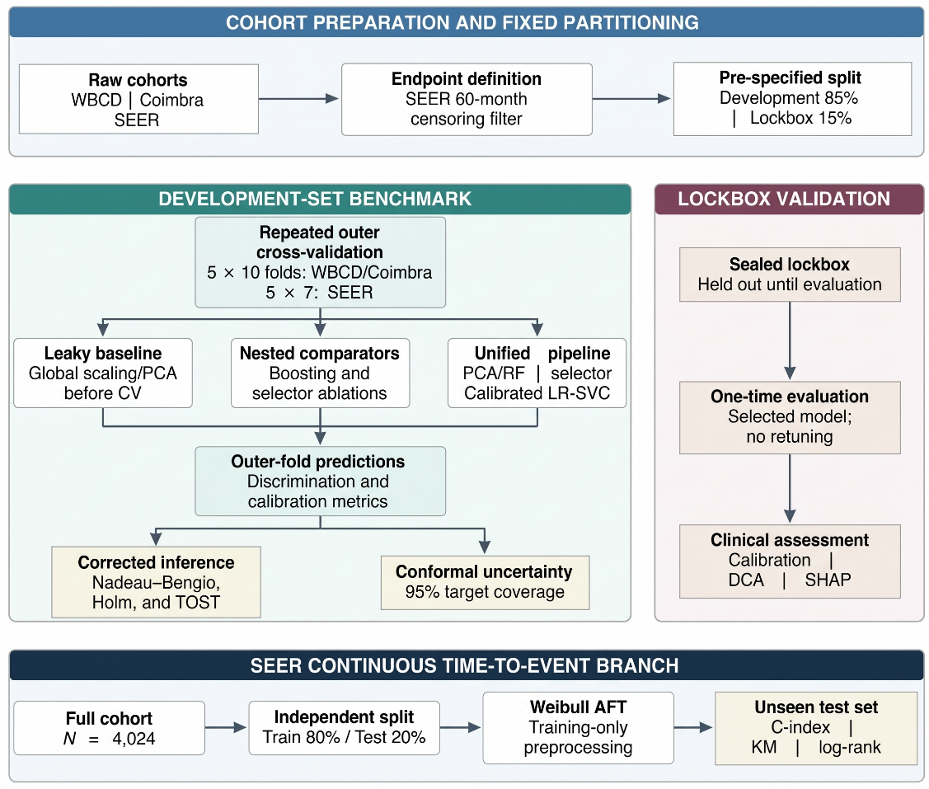
Fig. 1 Schematic overview of the TRUST-BC workflow. The upper lane fixes cohort endpoints (for SEER, the fixed-horizon 60-month label with exclusion of patients censored before 60 months) and partitions before any model development. The central lanes separate repeated nested benchmarking (including the architecture-matched Nested PCA-only comparator) from the sealed lockbox, which is opened once after model selection. The lower lane is the independent SEER time-to-event analysis on the full survival cohort

2.4 Baseline Architectures and Leakage Simulation
The Unified pipeline was compared with tuned XGBoost and LightGBM, nested PCA-only and RF-only ablations, and a leaky baseline that applies scaling and PCA to the whole development set before cross-validation and fits the same ensemble with C = 1. Because the Unified pipeline also selects RF features and tunes C, the Unified-versus-Leaky contrast mixes leakage with adaptive selection; the architecture-matched contrast (Nested PCA-only versus Leaky, which differ only in where scaling and PCA are fitted) isolates leakage and is reported as a post hoc descriptive analysis. Search grids are given in Section S10.3.

2.5 Resampled Statistical Testing, Confidence Intervals, and TOST Equivalence
Fold-wise differences $d_{j}=s_{j}^{\text{A}}-s_{j}^{\text{B}}$ were assessed with the Nadeau–Bengio corrected variance [13]:
 | $${\hat{Var}}_{\text{corr}}\left(\overset{‾}{d}\right)=S^{2}\left(\frac{1}{n}+\frac{n_{\text{test}}}{n_{\text{train}}}\right)=S^{2}\left(\frac{1}{n}+\frac{1}{K-1}\right)$$ | (5)
with n outer folds and K = 5, and $t=\overset{‾}{d}/\sqrt{{\hat{Var}}_{\text{corr}}}$ referred to a t_{n − 1} distribution. Cross-validated 95% confidence intervals (CIs) used the same variance, mean $± t_{n-1,0.975}\sqrt{{\hat{Var}}_{\text{corr}}}$, because naive bootstrapping over correlated folds understates uncertainty. Lockbox CIs used a stratified patient bootstrap (B = 2,000) [42] or Wilson intervals for proportions.
The pre-specified Holm–Bonferroni family [20] comprised five comparisons (XGBoost vs Leaky, LightGBM vs Leaky, Unified vs XGBoost, Unified vs LightGBM and Unified vs Leaky). Equivalence of Unified and Leaky was assessed by TOST [21,22] with pragmatic margins fixed a priori (Δ = 0.02 accuracy; Δ = 0.01 AUROC):
 | $$t_{1}=\frac{\overset{‾}{d}+Δ}{\sqrt{{\hat{Var}}_{\text{corr}}}}, t_{2}=\frac{\overset{‾}{d}-Δ}{\sqrt{{\hat{Var}}_{\text{corr}}}}, p_{\text{TOST}}=max\{F_{t_{n-1}}\left(-t_{1}\right),F_{t_{n-1}}\left(t_{2}\right)\}.$$ | (6)
The same TOST procedure and margins were also applied to the architecture-matched contrast (Nested PCA-only versus Leaky; Section 2.4) and are reported for SEER. This analysis was not pre-specified, is not part of the Holm-adjusted family, and should be regarded as exploratory (post hoc).

2.6 Distribution-Free Conformal Prediction
Split conformal prediction [23,24] used hyperparameters selected once on $D_{\text{dev}}$. In each of 100 iterations, $D_{\text{dev}}$ was split into proper training (60%), calibration (20%) and test (20%) subsets. Nonconformity scores were $s_{i}=1-\hat{P}\left(Y=y_{i}∣x_{i}\right)$; at α = 0.05 the cut-off $\hat{q}$ was the $⌈\left(n_{\text{cal}}+1\right)\left(1-α\right)⌉/n_{\text{cal}}$ empirical quantile, and prediction sets were
 | $$C\left(x_{\text{new}}\right)=\{y∈\{0,1\}:1-\hat{P}\left(Y=y∣x_{\text{new}}\right)≤\hat{q}\}.$$ | (7)
Sets were empty ($\left|C\right|=0$), singleton ($\left|C\right|=1$) or ambiguous ($\left|C\right|=2$). Coverage is guaranteed marginally over exchangeable patients, not per patient or subgroup. For the lockbox, the model was refitted on 80% of $D_{\text{dev}}$ and the remaining 20% used for calibration.

2.7 Probability Calibration and Decision Curve Analysis
Probabilities were evaluated by (i) the Brier score; (ii) ECE over M = 10 bins [25], ECE=m​BmNaccBm-confBm; (iii) calibration slope and intercept from $logitP\left(Y=1∣\hat{p}\right)=β_{0}+β_{1}logit\left(\hat{p}\right)$ (ideal β₁ = 1, β₀ = 0) and calibration-in-the-large (CITL; intercept with $logit\hat{p}$ as offset, negative values indicating overprediction); and (iv) DCA over $p_{t}∈\left[0.01,0.99\right]$ [26], $\text{NB}\left(p_{t}\right)=\frac{TP}{N}-\frac{FP}{N}\frac{p_{t}}{1-p_{t}}$.
The study is reported following TRIPOD+AI [18], with the completed checklists in Table S1 of Online Resource 1; a model card and dataset datasheets are given in Sections S11 and S12. Design choices followed the PROBAST+AI domains [27]; the author self-assessment is given in Table S2.

2.8 Fairness Assessment
In SEER, AUROC, CITL, calibration slope, sensitivity, specificity and conformal coverage were compared by race (White, Black, Other) and age (<50, 50–59, 60–69 years) using out-of-fold predictions and bootstrap CIs. No fairness constraints were applied; race and age were retained as established prognostic factors.

2.9 Penalised Parametric Survival Modelling and Risk Stratification
For SEER time-to-event prediction we fitted a penalised Weibull AFT model (lifelines):
 | $$lnT=μ+β^{⊤}\tilde{x}+σϵ,$$ | (8)
with ϵ following the standard extreme-value distribution and an L2 penalty (λ = 0.1). Harrell’s C-index was computed on the survival test set, with a bootstrap CI (B = 2,000) from an independent re-implementation that reproduced the C-index to within 0.002. Test patients were dichotomised at the training median predicted survival and compared by the log-rank test:
 | χ2=(j​O1j-E1j)2j​V1j. | (9)

2.10 Interpretability
Lockbox attributions used Kernel SHapley Additive exPlanations (SHAP) [43] for WBCD and Coimbra and Monte Carlo permutation Shapley values [44] for 100 SEER lockbox patients.

3 Results

3.1 Participants
WBCD and Coimbra had no exclusions. In SEER, 754 patients with unknown 5-year status were excluded, leaving 3,270 (458 deaths; 158 later deaths counted as 5-year survivors): 2,779 (389 events) for development and 491 (69 events) for the lockbox (Fig. S1). Partitions were well balanced (absolute standardised mean differences ≤0.12 for WBCD and ≤0.08 for SEER; up to 0.38 for the 18-patient Coimbra lockbox; Table S3). 60-month mortality was 23.9% in Black, 13.7% in White and 8.2% in Other-race patients (Table S3b).

3.2 Multicohort Benchmark and Equivalence Results
Cross-validated results are given in Table 2 and Fig. 2.
Table 2 Cross-validated multicohort benchmark (primary metric: accuracy for WBCD and Coimbra, AUROC for SEER)
Cohort | Pipeline | Mean ± SD | 95% CIª | Holm p vs Leaky | Holm p vs Unified | p_{TOST}^{b} | Brier / ECE
WBCD | Leaky baseline | 96.85% ± 1.65 | 95.13–98.57 | – | – | – | 0.024 / 0.020
(n = 569) | Tuned XGBoost | 95.20% ± 2.08 | 93.03–97.37 | 0.4448 | 0.3292 | – | 0.034 / 0.012
 | Tuned LightGBM | 95.82% ± 2.30 | 93.41–98.22 | 0.6642 | 0.6615 | – | 0.033 / 0.016
 | Nested PCA-only | 97.16% ± 1.65 | 95.44–98.88 | – | – | – | 0.023 / 0.018
 | Nested RF-only | 95.94% ± 1.94 | 93.92–97.97 | – | – | – | 0.031 / 0.016
 | Unified | 97.08% ± 1.67 | 95.34–98.82 | 0.6642 | – | 0.0002* | 0.024 / 0.017
Coimbra | Leaky baseline | 62.73% ± 10.70 | 51.56–73.91 | – | – | – | 0.208 / 0.087
(n = 116) | Tuned XGBoost | 75.64% ± 9.72 | 65.49–85.79 | 0.2494 | 0.9897 | – | 0.174 / 0.062
 | Tuned LightGBM | 74.78% ± 10.66 | 63.65–85.92 | 0.2371 | 0.9897 | – | 0.178 / 0.071
 | Nested PCA-only | 63.25% ± 10.88 | 51.89–74.61 | – | – | – | 0.212 / 0.062
 | Nested RF-only | 72.37% ± 8.20 | 63.81–80.93 | – | – | – | 0.183 / 0.062
 | Unified | 71.35% ± 8.70 | 62.27–80.43 | 0.2657 | – | 0.9059 | 0.186 / 0.054
SEER | Leaky baseline | 0.735 ± 0.031 | 0.701–0.768 | – | – | – | 0.131 / 0.149
5-year | Nested PCA-only | 0.735 ± 0.031 | 0.701–0.768 | – | – | – | 0.131 / 0.149
(N = 3,270) | Nested RF-only | 0.741 ± 0.027 | 0.713–0.770 | – | – | – | 0.130 / 0.146
 | Unified | 0.739 ± 0.028 | 0.709–0.769 | 0.5607^{c} | – | 0.2251 | 0.130 / 0.146
Values after ± are standard deviations across outer folds (50 for WBCD/Coimbra, 35 for SEER). Pooled out-of-fold AUROCs for WBCD (0.993) and Coimbra (0.793) are descriptive secondary estimates
ªNadeau–Bengio corrected 95% intervals [13]
^{b}TOST only for the pre-specified Unified versus Leaky comparison (Δ = 0.02 accuracy; Δ = 0.01 AUROC)
^{c}SEER (corrected 5-year label): gradient boosting baselines were not re-run for the corrected endpoint, so the Holm family reduces to the single Unified versus Leaky comparison (unadjusted corrected t-test). Results for all six pipelines under the v1.0 label are in Table S8 in Online Resource 1
*Equivalence established at α = 0.05 (TOST is not part of the Holm-adjusted superiority family)
Fig. 2 Cross-validated benchmark performance distributions across outer folds (A), conformal prediction-set cardinality at 95% target coverage, shown as the mean number of development-set test patients over 100 calibration iterations with SD error bars (B; “Certain” and “Uncertain” denote singleton and ambiguous sets, respectively), and decision curve analysis on pooled out-of-fold predictions (C). Rows: WBCD, Coimbra, and SEER 5-year (corrected fixed-horizon label; gradient boosting baselines not re-run)
On WBCD, Unified was equivalent to Leaky ($p_{TOST}=0.0002$; difference +0.23 percentage points). On Coimbra, Unified exceeded Leaky by 8.62 points (95% CI −1.35 to +18.59; $p_{Holm}=0.2657$) and was comparable to the boosted trees and Nested RF-only. On SEER, equivalence within $±0.01$ AUROC was not established ($p_{TOST}=0.2251$; difference +0.0043).
Architecture-matched leakage contrast. With the architecture held fixed (Nested PCA-only versus Leaky; Table 3), fitting scaling and PCA inside the folds produced no measurable change in any cohort (all 95% CIs included zero); in SEER the two pipelines were equivalent (post hoc p_{TOST} < 0.001). Global scaling/PCA leakage therefore produced no measurable optimism, and the advantage of the Unified pipeline in Coimbra and SEER reflects adaptive RF selection.
Table 3 Leakage and selector contrasts in the cohort-specific primary metric (Nadeau–Bengio corrected intervals)
Cohort (metric) | Nested PCA − Leaky: leakage only (95% CI) | Unified − Leaky: leakage + selector (90% CI) | p_{TOST} (Unified vs Leaky)
WBCD (accuracy, points) | +0.31 (−0.54 to +1.16) | +0.23 (−0.55 to +1.01) | 0.0002
Coimbra (accuracy, points) | +0.52 (−4.68 to +5.72) | +8.62 (+0.30 to +16.94) | 0.9059
SEER 5-year (AUROC) | +0.0000 (−0.0014 to +0.0014) | +0.0043 (−0.0082 to +0.0169) | 0.2251
Calibration. SEER ECE (0.146) resembled that of the leaky baseline (0.149) and exceeded WBCD (0.017) and Coimbra (0.054). SEER probabilities were markedly overestimated on pooled out-of-fold evaluation (mean predicted 28.6% vs observed 14.0%; calibration slope 1.21; calibration-in-the-large −0.99 [95% CI −1.03 to −0.96]; Table 5), the expected effect of class weighting at 14% prevalence: leakage removal alone does not produce calibrated probabilities
Decision curves. For WBCD and Coimbra, net benefit exceeded both default strategies across $p_{t}∈\left[0.10,0.40\right]$ (Fig. 2). For SEER it did so only for p_{t} ≈ 0.09–0.16 and was zero or negative above 0.17 (Fig. 2C), consistent with overprediction and moderate discrimination.
Architecture selection. PCA was selected in 94% of WBCD folds, consistent with collinear morphological features, and RF in 92% of Coimbra and 31/35 SEER folds.

3.3 Conformal Prediction and Lockbox Validation
Diagnostic panels are shown in Fig. 3. Conformal coverage was 96.53% (WBCD), 95.70% (Coimbra) and 95.26% (SEER), consistent with the nominal 95%. Singleton sets comprised 97.40%, 27.70% and 61.92% of predictions and ambiguous sets 0.90%, 72.10% and 38.08%. In SEER, coverage was 99.4% among survivors but only 69.9% among patients who died, so the marginal guarantee concealed under-coverage of the clinically most important class. Lockbox results are shown in Table 4.

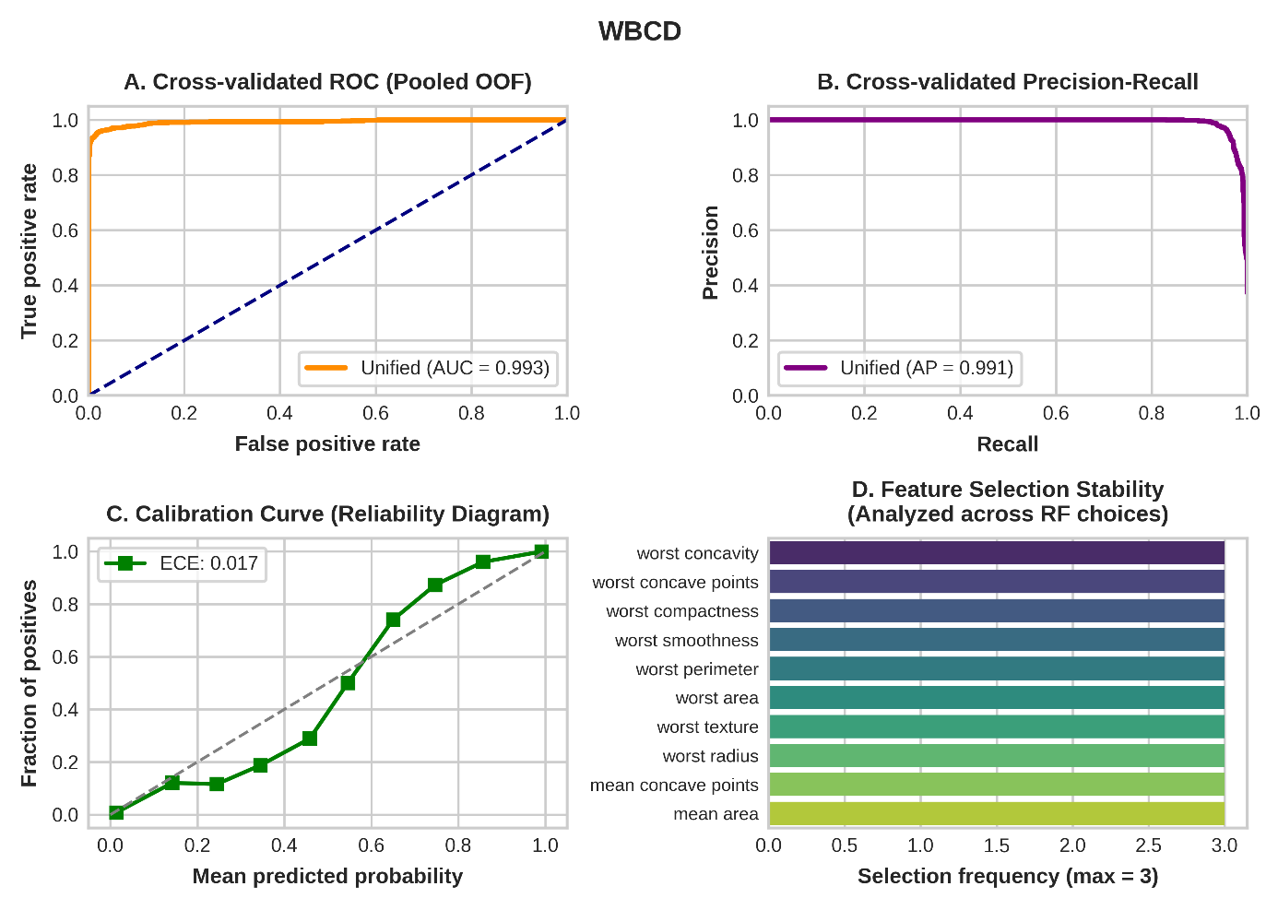
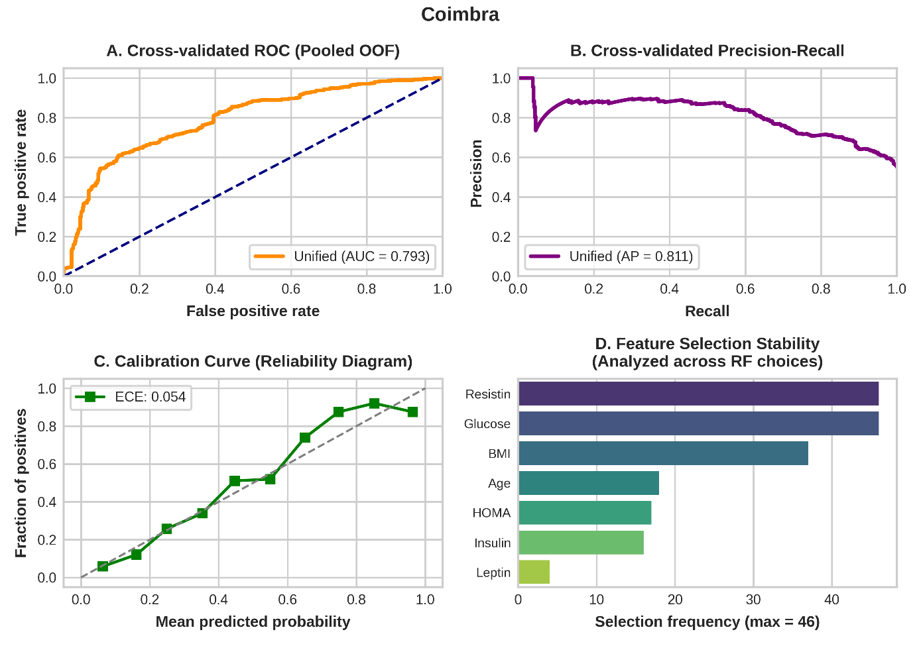

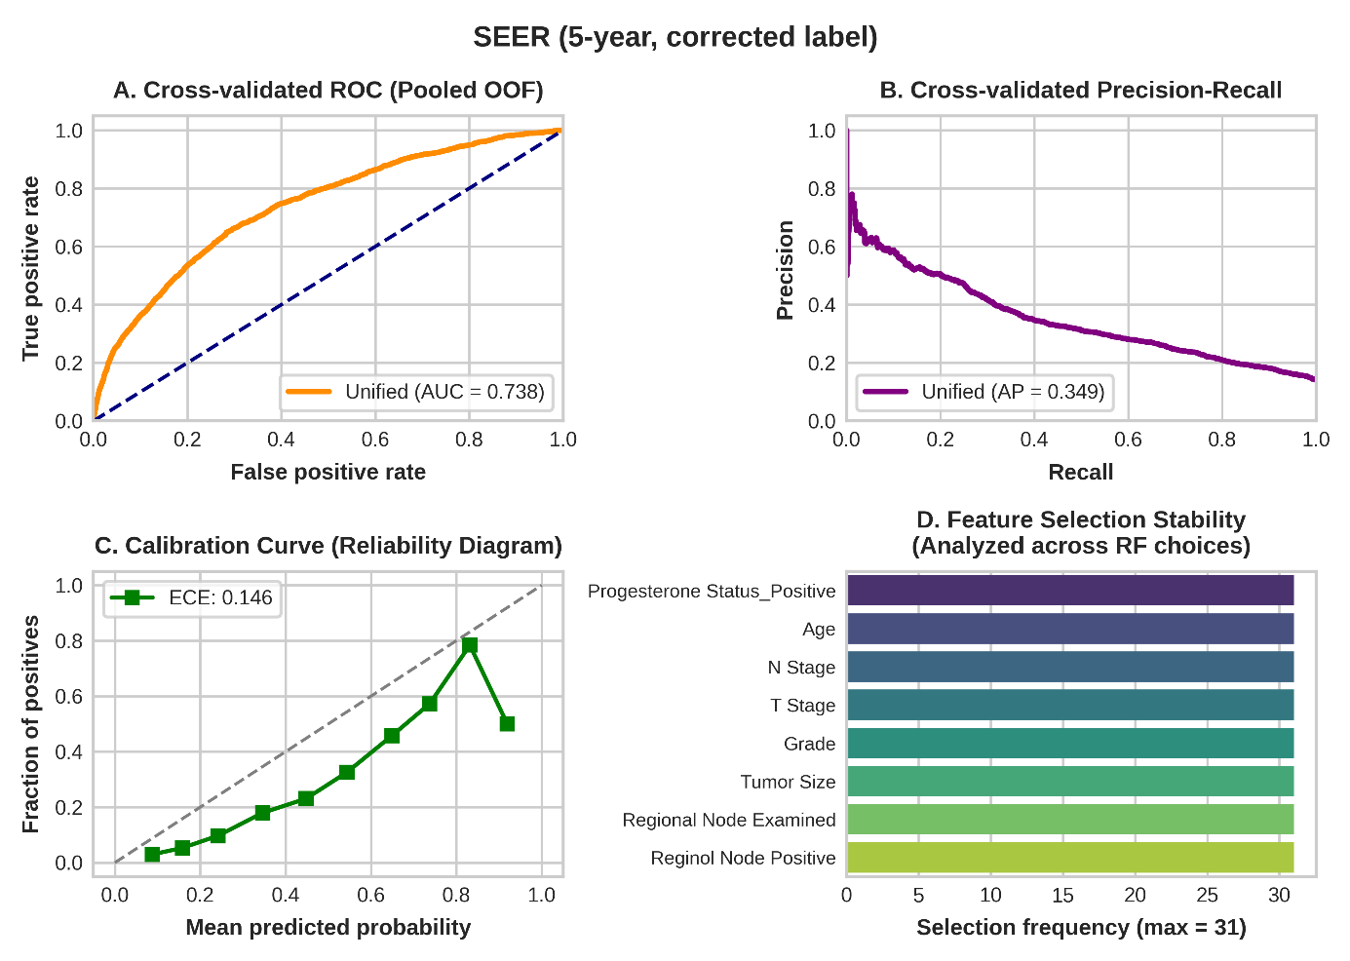
Fig. 3 Clinical diagnostic panels by cohort: (A) pooled out-of-fold ROC curve, (B) precision–recall curve, (C) reliability diagram with ECE, and (D) random-forest feature-selection frequency across the outer folds in which RF was selected. (a) WBCD; (b) Coimbra; (c) SEER 5-year classification cohort (corrected label). Pooled AUROCs for WBCD and Coimbra are descriptive secondary estimates
Table 4 Performance on the held-out lockbox partitions (15%), with 95% CIs
Metric | WBCD (n = 86; 32 events) | Coimbra (n = 18; 10 events) | SEER 5-year (n = 491; 69 events)
Accuracyª | 100.00% (95.72–100.00) | 61.11% (38.62–79.69) | 83.50% (79.96–86.52)
Balanced accuracy | 100.00% | 62.50% | 63.73%
Sensitivity | 100.00% (32/32) | 50.00% (5/10) | 36.23% (25/69)
Specificity | 100.00% (54/54) | 75.00% (6/8) | 91.23% (385/422)
AUROC | 1.000 (1.000–1.000)^{b} | 0.725 (0.450–0.975)^{b} | 0.722 (0.646–0.790)^{b}
Brier score | 0.010 (0.004–0.017)^{b} | 0.234 (0.146–0.334)^{b} | 0.132 (0.121–0.144)^{b}
Calibration slope (β₁) | 14.820^{d} | 0.632 (−0.29 to 9.06)^{c} | 1.03 (0.69 to 1.41)
Calibration intercept (β₀) | 1.784^{d} | 0.257 (−0.14 to 5.58)^{c} | −1.00 (−1.22 to −0.78)
Calibration-in-the-large | – | – | −1.02 (−1.10 to −0.94)
Conformal coverageª | 98.84% (93.70–99.79) | 83.33% (60.78–94.16) | 95.32% (93.07–96.86)
ªWilson intervals
^{b}Stratified bootstrap of patients (B = 2,000); WBCD and Coimbra values from re-created lockbox predictions, which reproduced the reported accuracy, AUROC, Brier score and calibration coefficients exactly
^{c}Stratified bootstrap; with 18 patients (10 events) the recalibration model is unstable and these intervals are extremely wide
^{d}Quasi-complete separation; not interpretable as a calibration diagnostic (see text)
Coimbra lockbox coverage was 83.33% (15/18; 95% CI 60.78–94.16), an imprecise estimate from 18 patients. On the WBCD lockbox, discrimination was perfect; the extreme calibration slope (β₁ = 14.82) reflects quasi-complete separation in logistic recalibration [45,46] rather than miscalibration. The 100% lockbox accuracy reflects a small-sample ceiling effect ($n=86$) rather than leakage (sample-hash overlap 0.00%). On the SEER lockbox, AUROC was 0.722 (0.646–0.790), sensitivity at the 0.5 threshold was 36.23% (25/69), and the calibration intercept confirmed overprediction (slope 1.03).

3.4 Global Model Interpretability
Lockbox attributions (Fig. 4) were dominated by nuclear concavity, texture and perimeter (WBCD), glucose, body mass index and resistin (Coimbra), and progesterone receptor status, N stage, number of positive nodes, age and grade (SEER).
Fig. 4 Shapley attributions on the held-out lockboxes, showing each feature’s direction and magnitude of impact on the predicted probability (colour: feature value). WBCD and Coimbra: Kernel SHAP values from the v1.0 run; SEER 5-year: permutation Shapley values for 100 of the 491 lockbox patients. Only features with non-zero attribution are shown; for SEER these are the eight random-forest-selected features

3.5 Sample-Size and Dimensionality Sensitivity
Learning curves (Fig. 5) showed increasing accuracy for WBCD and Coimbra, with large variance remaining in Coimbra at n = 98, whereas SEER accuracy plateaued from 30% of the data. In SEER, AUROC rose with the number of retained features (0.696–0.722 at d = 4; 0.749 at d = 16), indicating that the pre-specified heuristic discarded some prognostic information, and in Coimbra the selector mattered at low dimension (d = 2: RF 76.50% vs PCA 62.20%; Fig. 6). Details are given in Section S10.4.
Fig. 5 Sample-size sensitivity: bootstrapped learning curves (left) and width of the 95% bootstrap interval (right) across subsample fractions of 30%, 50%, 70%, 85% and 100% of the development set (B = 200). Accuracy is used in all panels for uniformity; AUROC remains the primary SEER metric elsewhere
Fig. 6 Dimensionality sensitivity: mean 3-fold performance by number of retained PCA components or random-forest-selected features

3.6 Fairness Assessment (SEER)
Subgroup results are given in Table 5. Discrimination was similar across races (AUROC 0.738 White, 0.729 Black, 0.765 Other) but declined with age (0.774 for <50 vs 0.699 for 60–69 years). Overprediction was least for Black patients (CITL −0.40; observed 24.4% vs predicted 31.4%) and greatest for Other-race patients (CITL −1.44; 8.6% vs 26.3%), so the model compressed the higher mortality of Black patients and a single recalibration would not correct all groups equally. Sensitivity was lowest for Other-race (22.2%) and Black (25.5%) patients, and coverage ranged from 94.0% to 96.5%. With 51 and 18 events in these groups, estimates are imprecise.
Table 5 Performance of the SEER Unified pipeline by sociodemographic subgroup (per-patient out-of-fold predictions; stratified bootstrap 95% CIs)
Subgroup | n | Events | Observed / predicted (%) | AUROC (95% CI) | CITL (95% CI) | Slope | Sens. / spec. (%) | Coverage (%)
Overall | 2,779 | 389 | 14.0 / 28.6 | 0.741 (0.715–0.767) | −0.99 (−1.03 to −0.96) | 1.21 | 29.8 / 93.2 | –
Race: White | 2,361 | 320 | 13.6 / 28.6 | 0.738 (0.708–0.767) | −1.03 (−1.06 to −1.00) | 1.22 | 30.9 / 93.2 | 95.3
Race: Black | 209 | 51 | 24.4 / 31.4 | 0.729 (0.651–0.800) | −0.40 (−0.51 to −0.28) | 1.02 | 25.5 / 88.6 | 94.0
Race: Other | 209 | 18 | 8.6 / 26.3 | 0.765 (0.661–0.856) | −1.44 (−1.56 to −1.33) | 1.31 | 22.2 / 96.9 | 96.5
Age: <50 | 913 | 108 | 11.8 / 25.2 | 0.774 (0.724–0.818) | −1.01 (−1.06 to −0.95) | 1.35 | 23.1 / 96.1 | 95.6
Age: 50-59 | 955 | 122 | 12.8 / 29.2 | 0.743 (0.691–0.794) | −1.15 (−1.20 to −1.09) | 1.26 | 36.9 / 92.8 | 96.0
Age: 60-69 | 911 | 159 | 17.5 / 31.5 | 0.699 (0.657–0.744) | −0.85 (−0.90 to −0.80) | 1.05 | 28.9 / 90.4 | 94.1

3.7 Survival Stratification (SEER Cohort)
The Weibull AFT model achieved a C-index of 0.722 (95% CI 0.675–0.771) on the survival test set (n = 805; 123 deaths), and stratification at the training median separated high- and low-risk groups (log-rank p = 1.02 × 10⁻⁹; Fig. 7).
Fig. 7 Kaplan–Meier survival stratification on the SEER survival test partition using groups defined by the training-set median predicted survival from the penalised Weibull AFT model

4 Discussion

4.1 Leakage, Architecture Adaptation, and Benchmark Comparison
Tadj et al. audited outcome-dependent leakage from pre-split oversampling [12]; TRUST-BC targets parametric leakage in repeated cross-validation by ensuring that scaling parameters $\left(\hat{μ},\hat{σ}\right)$ and subspace bases W_{d} never cross evaluation partitions. Table 6 compares representative studies with the safeguards used here.
The architecture-matched contrast (Table 3) is the central empirical finding: global scaling and PCA produced negligible optimism in all three cohorts. This is plausible because only unsupervised information leaks—means, variances and principal axes, which are estimated almost identically from 80% or 100% of moderately sized data—whereas outcome-dependent leakage such as pre-split oversampling can inflate AUROC from 0.715 to 0.998 [12]. Leakage risk therefore depends on its type and on the data, and must be measured with a design that isolates it; assuming that any preprocessing leakage inflates every estimate is as unsound as ignoring leakage altogether.
The selector’s choices tracked data geometry: collinear cytomorphometric features favoured PCA, whereas discrete staging variables and metabolic markers favoured RF. In Coimbra, Unified (71.35%) was slightly below Nested RF (72.37%) because validation noise led to PCA in 4 of 50 folds, an expected cost of flexibility in very small samples.
The SEER survival C-index (0.722) was similar to the classification AUROC (0.739), suggesting that discrimination is not an artefact of the 5-year cut-off, although the two analyses share source data and are not fully independent.
Table 6 Methodological and quantitative comparison of representative clinical machine learning studies and reviews
Study | Cohort(s) | Algorithm | CV scheme | Reported metric | Leakage control | Conformal UQ | Calibration
Street et al. (1993) [29] | WBCD | Linear programming | 10-fold (unnested) | Accuracy ≈97.0% | None | No | No
Asri et al. (2016) [47] | WBCD | SVM, NB, C4.5 | 10-fold (unnested) | Accuracy ≈97.13% | None | No | No
Patrício et al. (2018) [10] | Coimbra | SVM, RF | Monte Carlo CV (500 random ≈70/30 splits) | Best-model AUROC 95% CI 0.87–0.91 | None | No | No
Liu et al. (2025) [15] | CVD EHRs (21 studies) | Review and meta-analysis | Not fully reported | Pooled RF AUROC 0.865 | Not evaluated | Not assessed | Not fully reported
Tadj et al. (2026) [12] | SEER (N = 4,023) | SVM; Weibull AFT | Single split (80/20) | AUROC 0.998→0.715 | Pre-split oversampling (row-hash audit) | No | Partial (group calibration at 60 mo; IPCW Brier)
TRUST-BC (present study) | WBCD, Coimbra, SEER | Unified LR–SVC | Repeated nested CV | Accuracy 97.08%, 71.35%; SEER AUROC 0.739 | Parametric & covariance (architecture-matched contrast) | Yes (95%) | Yes (ECE, Brier, CITL, DCA)
CV cross-validation; CVD cardiovascular disease; EHRs electronic health records; NB naive Bayes; SVM support vector machine; UQ uncertainty quantification

4.2 Conformal Uncertainty Quantification for Clinical Decision Support
Conformal prediction converts probabilities into prediction sets with distribution-free marginal coverage [23]. Ambiguous-set rates tracked discriminability, and the 38.08% ambiguous fraction in SEER reflects the intrinsic uncertainty of predicting 5-year mortality from staging and demographics alone; rather than returning an overconfident probability, the framework routes these cases to expert review. Marginal coverage, however, hid 69.9% coverage of deaths versus 99.4% of survivors; class-conditional (Mondrian) conformal prediction would be required if equal coverage of deaths is a clinical requirement.

4.3 Clinical Implementation as a Decision Support System
TRUST-BC is intended as auxiliary decision support rather than autonomous triage and, in the terminology of Oala et al. [28], as an internal quality-control tool for developers. Recent decision-support models in this journal have similarly translated predicted risks into risk-stratified groups for clinicians [48].
- Singleton sets may be presented as higher-confidence predictions, but the guarantee is marginal and clinician confirmation is still required.
- Ambiguous sets prompt further clinical evaluation (e.g., diagnostic mammography or breast ultrasound) rather than automated invasive procedures.
Missing or out-of-range inputs should be flagged for manual review (Section S10.5).

4.4 Comparison with Established Clinical Prognostic Systems
Established tools such as the Nottingham Prognostic Index [49], PREDICT [50] and AJCC staging [51] are externally validated and, for PREDICT, include treatment effects. TRUST-BC does not replace them; it adds conformal uncertainty and a systematic calibration audit to the development workflow.

4.5 Limitations
- Data and design: WBCD and Coimbra are small historical cohorts (Coimbra falls below the Riley minimum sample size and its case–control design overstates discrimination relative to screening), and the SEER extraction lacks treatment, human epidermal growth factor receptor 2 (HER2) status and comorbidity, is restricted to node-positive women aged 30–69 years, and records all-cause mortality.
- Comparators: gradient boosting grids were narrow and not recalibrated, which favours the Platt-scaled pipelines on Brier score and ECE, and deep tabular models (TabNet, FT-Transformer) were omitted because small samples favour regularised ensembles and boosted trees [52].
- Censoring: excluding patients censored before 60 months may bias 5-year mortality and calibration if censoring is informative, which inverse probability of censoring weighting [53] or survival models (as in our survival branch) can address.
- SEER re-analysis and calibration: the v1.0 code release mislabelled 158 late deaths as 5-year events and the corrected labels were re-analysed for the scikit-learn pipelines only (Section S8), while class weighting produced overprediction that requires recalibration before use as absolute risks.
- Evaluation and uncertainty: the lockboxes contain 32, 10 and 69 events; conformal coverage is marginal and assumes exchangeability; and d was fixed by heuristic.
- Validation: utility was assessed only by in-silico DCA, no near-duplicate or temporal leakage audit or external validation was performed, and external validation, for example in the Molecular Taxonomy of Breast Cancer International Consortium cohort, is the most important next step, as models in this journal have failed to generalise externally [54].
A complete list of limitations, including the scope of the fairness analysis and the author-performed PROBAST+AI assessment, is given in Section S10.6.

5 Conclusion
TRUST-BC jointly audits preprocessing leakage, fixed-horizon labelling, calibration and predictive uncertainty. Global scaling/PCA leakage produced negligible optimism in all cohorts, but the audit revealed larger problems that standard reporting would miss: horizon mislabelling (158 of 616 registry deaths), marked overprediction after class weighting, and conformal under-coverage of deaths. Future work should validate the framework in external registries, recalibrate probabilities, use class-conditional conformal prediction, extend leakage audits to near-duplicate and temporal leakage, and evaluate breast-cancer-specific biomarkers in prospective cohorts.

Statements and Declarations
Funding
This research received no specific grant from any funding agency in the public, commercial, or not-for-profit sectors.
Competing Interests
The authors declare no competing financial interests or personal relationships that could have influenced this work.
Ethics Approval
Ethical review was not required because all analyses used publicly available, fully de-identified retrospective datasets.
Consent to Participate
Not applicable. All analyses used publicly available, fully de-identified retrospective datasets.
Consent to Publish
Not applicable.
Data Availability
WBCD and Coimbra are available from the UCI Machine Learning Repository [30]; the SEER research extraction is available from public benchmark archives [31]. Split manifests, fold-level scores, out-of-fold and lockbox predictions, supplementary analyses and evaluation logs are available at https://github.com/RezaAbolghasemi/TRUST-BC-Multicohort-Benchmark (release v1.1).
Code Availability
Source code is available at https://github.com/RezaAbolghasemi/TRUST-BC-Multicohort-Benchmark (release v1.1, MIT licence). The re-analysis scripts in scripts/ regenerate all revised SEER results from the public SEER file.
Software and Computational Environment
The v1.0 analyses were implemented in Python 3.10 with scikit-learn 1.6.1 [19], XGBoost 3.4.1 [2], LightGBM 4.6.0 [3], SHAP 0.52.0 [43], NumPy 2.1.3, SciPy 1.16.3 and lifelines 0.30.3. The v1.1 SEER re-analysis used scikit-learn 1.8.0, NumPy 2.4.4, SciPy 1.17.1 and pandas 3.0.2 on a single CPU; under the original label it reproduced all v1.0 fold-level scores of the four scikit-learn pipelines exactly (Section S8 of Online Resource 1). Machine-level telemetry was not logged for the v1.0 run.
Author Contributions
Conceptualization: Reza Abolghasemi, Mohammadreza Salehi; Methodology: Reza Abolghasemi, Mohammadreza Salehi; Software: Reza Abolghasemi, Mohammadreza Salehi; Data curation: Reza Abolghasemi, Mohammadreza Salehi; Formal analysis: Reza Abolghasemi, Mohammadreza Salehi; Investigation: Reza Abolghasemi, Mohammadreza Salehi; Visualization: Reza Abolghasemi, Mohammadreza Salehi; Validation: Armaghan Kiarsi (clinical review of the cohorts, outcome definitions, predictors and interpretation of the findings); Writing – original draft: Reza Abolghasemi, Mohammadreza Salehi; Writing – review and editing: Mohammad Amin Shayegan, Armaghan Kiarsi; Supervision: Mohammad Amin Shayegan; Project administration: Mohammad Amin Shayegan. All authors read and approved the final manuscript and agree to be accountable for all aspects of the work.
Use of Generative AI and AI-Assisted Technologies
During the preparation of this work, the authors used OpenAI’s ChatGPT (GPT-5.2, accessed via web UI in August 2026) and Anthropic’s Claude (Claude 5 Sonnet, accessed via web UI in September 2026) to assist with English language editing and syntax troubleshooting of Python scripts. Representative prompts included: "Review this Python function for syntax errors and suggest idiomatic scikit-learn implementations." All suggested modifications and code snippets were independently verified, executed locally, and tested against deterministic cross-validation splits and unit tests by the authors. The authors take full responsibility for the final code, analytical pipeline, and manuscript content.
Reporting Guidelines
The completed TRIPOD+AI and TRIPOD+AI for Abstracts checklists are provided in Table S1 of Online Resource 1. An author self-assessment against PROBAST+AI is provided in Table S2 of Online Resource 1.
Protocol and Registration
A formal study protocol was not prepared and the study was not registered. The analysis plan (partitioning scheme, primary metrics, hypothesis-testing family and TOST margins) was fixed in the analysis code before model development and is available in the repository history.
Preprint
A preprint of this manuscript was posted on Zenodo on 23 September 2026 (https://doi.org/10.5281/zenodo.22926051).
Patient and Public Involvement
Patients and members of the public were not involved in the design, conduct, reporting, interpretation, or dissemination of this study.

References
1. Bray F, Laversanne M, Sung H, Ferlay J, Siegel RL, Soerjomataram I, Jemal A (2024) Global cancer statistics 2022: GLOBOCAN estimates of incidence and mortality worldwide for 36 cancers in 185 countries. CA Cancer J Clin 74:229–263. https://doi.org/10.3322/caac.21834
2. Chen T, Guestrin C (2016) XGBoost: a scalable tree boosting system. In: Proceedings of the 22nd ACM SIGKDD International Conference on Knowledge Discovery and Data Mining. ACM, New York, pp 785–794. https://doi.org/10.1145/2939672.2939785
3. Ke G, Meng Q, Finley T, Wang T, Chen W, Ma W, Ye Q, Liu T-Y (2017) LightGBM: a highly efficient gradient boosting decision tree. In: Advances in Neural Information Processing Systems 30. Curran Associates, Red Hook, NY, pp 3146–3154. https://proceedings.neurips.cc/paper_files/paper/2017/hash/6449f44a102fde848669bdd9eb6b76fa-Abstract.html
4. Kubiak JZ (2025) Bridging the artificial intelligence translation gap: from algorithmic promise to clinical reality. J Clin Transl Res 11:1–2. https://doi.org/10.36922/JCTR025330054
5. Kapoor S, Narayanan A (2023) Leakage and the reproducibility crisis in machine-learning-based science. Patterns 4:100804. https://doi.org/10.1016/j.patter.2023.100804
6. Collins GS, Chester-Jones M, Gerry S, Ma J, Matos J, Sehjal J, Tsegaye B, Dhiman P (2025) Clinical prediction models using machine learning in oncology: challenges and recommendations. BMJ Oncol 4:e000914. https://doi.org/10.1136/bmjonc-2025-000914
7. Van Calster B, Nieboer D, Vergouwe Y, De Cock B, Pencina MJ, Steyerberg EW (2016) A calibration hierarchy for risk models was defined: from utopia to empirical data. J Clin Epidemiol 74:167–176. https://doi.org/10.1016/j.jclinepi.2015.12.005
8. Steyerberg EW (2019) Clinical prediction models: a practical approach to development, validation, and updating, 2nd edn. Springer, Cham. https://doi.org/10.1007/978-3-030-16399-0
9. Vazquez J, Facelli JC (2022) Conformal prediction in clinical medical sciences. J Healthc Inform Res 6:241–252. https://doi.org/10.1007/s41666-021-00113-8
10. Patrício M, Pereira J, Crisóstomo J, Matafome P, Gomes M, Seiça R, Caramelo F (2018) Using Resistin, glucose, age and BMI to predict the presence of breast cancer. BMC Cancer 18:29. https://doi.org/10.1186/s12885-017-3877-1
11. Chao C-M, Yu Y-W, Cheng B-W, Kuo Y-L (2014) Construction the model on the breast cancer survival analysis use support vector machine, logistic regression and decision tree. J Med Syst 38:106. https://doi.org/10.1007/s10916-014-0106-1
12. Tadj L, Sufian MA, Hamzi W, Ali M, Ali A, Hamzi B (2026) Auditing data leakage and temporal misalignment in machine-learning prognosis of breast cancer: a reproducible censoring-aware reanalysis. BioMedInformatics 6:60. https://doi.org/10.3390/biomedinformatics6040060
13. Nadeau C, Bengio Y (2003) Inference for the generalization error. Mach Learn 52:239–281. https://doi.org/10.1023/A:1024068626366
14. DeLong ER, DeLong DM, Clarke-Pearson DL (1988) Comparing the areas under two or more correlated receiver operating characteristic curves: a nonparametric approach. Biometrics 44:837–845. https://doi.org/10.2307/2531595
15. Liu T, Krentz AJ, Lu L, Curcin V (2025) Machine learning based prediction models for cardiovascular disease risk using electronic health records data: systematic review and meta-analysis. Eur Heart J Digit Health 6:7–22. https://doi.org/10.1093/ehjdh/ztae080
16. Cai Y-Q, Gong D-X, Tang L-Y, Cai Y, Li H-J, Jing T-C, Gong M, Hu W, Zhang Z-W, Zhang X, Zhang G-W (2024) Pitfalls in developing machine learning models for predicting cardiovascular diseases: challenge and solutions. J Med Internet Res 26:e47645. https://doi.org/10.2196/47645
17. American Cancer Society (2024) Breast cancer facts & figures 2024–2025. American Cancer Society, Atlanta, GA. https://www.cancer.org/research/cancer-facts-statistics/breast-cancer-facts-figures.html
18. Collins GS, Moons KGM, Dhiman P et al (2024) TRIPOD+AI statement: updated guidance for reporting clinical prediction models that use regression or machine learning methods. BMJ 385:e078378. https://doi.org/10.1136/bmj-2023-078378
19. Pedregosa F et al (2011) Scikit-learn: machine learning in Python. J Mach Learn Res 12:2825–2830. https://doi.org/10.5555/1953048.2078195
20. Holm S (1979) A simple sequentially rejective multiple test procedure. Scand J Stat 6:65–70. https://doi.org/10.2307/4615733
21. Schuirmann DJ (1987) A comparison of the two one-sided tests procedure and the power approach for assessing the equivalence of average bioavailability. J Pharmacokinet Biopharm 15:657–680. https://doi.org/10.1007/BF01068419
22. Walker E, Nowacki AS (2011) Understanding equivalence and noninferiority testing. J Gen Intern Med 26:192–196. https://doi.org/10.1007/s11606-010-1513-8
23. Angelopoulos AN, Bates S (2023) Conformal prediction: a gentle introduction. Found Trends Mach Learn 16:494–591. https://doi.org/10.1561/2200000101
24. Vovk V, Gammerman A, Shafer G (2005) Algorithmic learning in a random world. Springer, New York. https://doi.org/10.1007/b106715
25. Guo C, Pleiss G, Sun Y, Weinberger KQ (2017) On calibration of modern neural networks. In: Proceedings of the 34th International Conference on Machine Learning. PMLR 70:1321–1330
26. Vickers AJ, Elkin EB (2006) Decision curve analysis: a novel method for evaluating prediction models. Med Decis Making 26:565–574. https://doi.org/10.1177/0272989X06295361
27. Moons KGM, Damen JAA, Kaul T et al (2025) PROBAST+AI: an updated quality, risk of bias, and applicability assessment tool for prediction models using regression or artificial intelligence methods. BMJ 388:e082505. https://doi.org/10.1136/bmj-2024-082505
28. Oala L, Murchison AG, Balachandran P et al (2021) Machine learning for health: algorithm auditing & quality control. J Med Syst 45:105. https://doi.org/10.1007/s10916-021-01783-y
29. Street WN, Wolberg WH, Mangasarian OL (1993) Nuclear feature extraction for breast tumor diagnosis. In: IS&T/SPIE 1993 International Symposium on Electronic Imaging: Science and Technology, vol 1905. SPIE, Bellingham, WA, pp 861–870. https://doi.org/10.1117/12.148698
30. Dua D, Graff C (2019) UCI machine learning repository. University of California, Irvine, School of Information and Computer Sciences. Breast Cancer Wisconsin (Diagnostic): https://doi.org/10.24432/C5DW2B; Breast Cancer Coimbra: https://doi.org/10.24432/C52P59
31. Namdari R (2019) Breast cancer (SEER) dataset. Kaggle. https://www.kaggle.com/datasets/reihanenamdari/breast-cancer. Accessed August 2026
32. National Cancer Institute (2026) Surveillance, Epidemiology, and End Results (SEER) Program research data. Surveillance Research Program, National Cancer Institute. https://seer.cancer.gov/data/
33. Amartey INA (2024) Ethnic disparities of female infiltrating duct and lobular breast cancer survival by cancer stage: findings from SEER 2006–2010. arXiv:2402.12395. https://doi.org/10.48550/arXiv.2402.12395
34. Riley RD, Ensor J, Snell KIE, Harrell FE Jr, Martin GP, Reitsma JB, Moons KGM, Collins GS, van Smeden M (2020) Calculating the sample size required for developing a clinical prediction model. BMJ 368:m441. https://doi.org/10.1136/bmj.m441
35. Riley RD, Van Calster B, Collins GS (2021) A note on estimating the Cox–Snell R² from a reported C statistic (AUROC) to inform sample size calculations for developing a prediction model with a binary outcome. Stat Med 40:859–864. https://doi.org/10.1002/sim.8806
36. Collins GS, Ogundimu EO, Altman DG (2016) Sample size considerations for the external validation of a multivariable prognostic model: a resampling study. Stat Med 35:214–226. https://doi.org/10.1002/sim.6787
37. Riley RD, Debray TPA, Collins GS, Archer L, Ensor J, van Smeden M, Snell KIE (2021) Minimum sample size for external validation of a clinical prediction model with a binary outcome. Stat Med 40:4230–4251. https://doi.org/10.1002/sim.9025
38. Varma S, Simon R (2006) Bias in error estimation when using cross-validation for model selection. BMC Bioinformatics 7:91. https://doi.org/10.1186/1471-2105-7-91
39. Breiman L (2001) Random forests. Mach Learn 45:5–32. https://doi.org/10.1023/A:1010933404324
40. Platt J (1999) Probabilistic outputs for support vector machines and comparisons to regularized likelihood methods. In: Smola AJ, Bartlett P, Schölkopf B, Schuurmans D (eds) Advances in large margin classifiers. MIT Press, Cambridge, MA, pp 61–74
41. Lin H-T, Lin C-J, Weng RC (2007) A note on Platt’s probabilistic outputs for support vector machines. Mach Learn 68:267–276. https://doi.org/10.1007/s10994-007-5018-6
42. Efron B, Tibshirani RJ (1993) An introduction to the bootstrap. Chapman & Hall/CRC, New York. https://doi.org/10.1201/9780429246593
43. Lundberg SM, Lee S-I (2017) A unified approach to interpreting model predictions. In: Advances in Neural Information Processing Systems 30. Curran Associates, Red Hook, NY, pp 4765–4774. arXiv:1705.07874. https://doi.org/10.48550/arXiv.1705.07874
44. Štrumbelj E, Kononenko I (2014) Explaining prediction models and individual predictions with feature contributions. Knowl Inf Syst 41:647–665. https://doi.org/10.1007/s10115-013-0679-x
45. Albert A, Anderson JA (1984) On the existence of maximum likelihood estimates in logistic regression models. Biometrika 71:1–10. https://doi.org/10.1093/biomet/71.1.1
46. Heinze G, Schemper M (2002) A solution to the problem of separation in logistic regression. Stat Med 21:2409–2419. https://doi.org/10.1002/sim.1047
47. Asri H, Mousannif H, Al Moatassime H, Noel T (2016) Using machine learning algorithms for breast cancer risk prediction and diagnosis. Procedia Comput Sci 83:1064–1069. https://doi.org/10.1016/j.procs.2016.04.224
48. Hernández-Arango A, Arias MI, Pérez V, Chavarría LD, Jaimes F (2025) Prediction of the risk of adverse clinical outcomes with machine learning techniques in patients with noncommunicable diseases. J Med Syst 49:19. https://doi.org/10.1007/s10916-025-02140-z
49. Galea MH, Blamey RW, Elston CE, Ellis IO (1992) The Nottingham Prognostic Index in primary breast cancer. Breast Cancer Res Treat 22:207–219. https://doi.org/10.1007/BF01840834
50. Candido dos Reis FJ, Wishart GC, Dicks EM et al (2017) An updated PREDICT breast cancer prognostication and treatment benefit prediction model with independent validation. Breast Cancer Res 19:58. https://doi.org/10.1186/s13058-017-0852-3
51. Giuliano AE, Connolly JL, Edge SB et al (2017) Breast cancer—major changes in the American Joint Committee on Cancer eighth edition cancer staging manual. CA Cancer J Clin 67:290–303. https://doi.org/10.3322/caac.21393
52. Shwartz-Ziv R, Armon A (2022) Tabular data: deep learning is not all you need. Inf Fusion 81:84–90. https://doi.org/10.1016/j.inffus.2021.11.011
53. Vock DM, Wolfson J, Bandyopadhyay S, Adomavicius G, Johnson PE, Vazquez-Benitez G, O’Connor PJ (2016) Adapting machine learning techniques to censored time-to-event health record data: a general-purpose approach using inverse probability of censoring weighting. J Biomed Inform 61:119–131. https://doi.org/10.1016/j.jbi.2016.03.009
54. Jeong I, Kong S, Kim Y et al (2025) Personalized health prediction AI models using transfer learning and strategic overfitting on wearable device data. J Med Syst 49:45. https://doi.org/10.1007/s10916-025-02180-5

