C.V

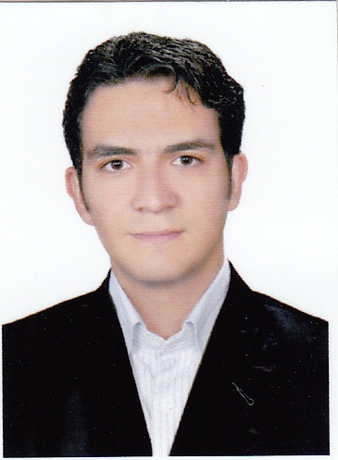 |  |  |  | Personal Information
 |  |  | Mohammad-shirvani nagani | Name and Family
 |  |  | 10/sept/1990 | Date of Birth
 |  |  | single | Marital Status
 |  |  | Isfahan - IRAN | City of Residence
 |  |  |  | Contact Information
27p -Panj Ramazan -Isfahan-Iran |  |  |  | Home Address
 | 0098 31 33378604 |  |  | Home Tel.
 | 0098 9132196100 |  |  | Mobile
Whats app 0098 933 269 9489 |  | Shirvani.mehmet@gmail.com |  | E-mail
Education
Degree University/Town Period (years) Started - Ended
Associate Diploma : tourism services from 2007 to 2008
Bachelor: tourism management from 2009 to 2011
Training and Certification
Certificate Certification Inst. Period (days) Year attended
English and computer courses completed at JAHAD DANESHGAHI
Other qualification gained in relation with tourism
Work Experience
Work in Lorch company at Commercial office . from 2014 to present

Teacher in local school as :management ،language - from 2007 to 2013

A tour leader for incoming and outcoming group of visitors

A translator for businessmen in different exhibition ( Dubai , Istanbul , Tbilisi and baku)
Skills And Abilities
I have a solid / good public relations

Familiar with Proforma generally

Familiar with all of Commercial activity

Familiar with reading different books ( ie. Completed reading 800 books as
marketing، Management، Commercial، etc … (

Compilation (Book Writing and Translating )
author of tempometer book
Computer Skills
ICDL : gained in 2003 at JAHAD DANESHGAHI
Foreign Language
Language Conversation Translation Writing Reading
ENG good good good good
TURKISH (Istanbul) good good good good
France normal normal normal normal
Persian good good good good

