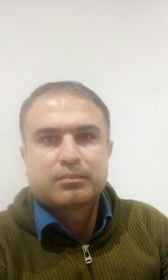

**Yousef Malekpoor Larki**

**Born on 1982/1/5, married, with 1 child**

[**younic911@gmail.com**](mailto:Younic911@gmail.com)**.**

**(+98)9902484518**

**#20,Modarres Av,Izeh,Khuzestan,Iran.**

**Work Experience**

**Quality Control manager and Supervisor of Concrete Laboratory**

**Campboss in National Iranian Drilling Company**

**Sales and Research/ Development Manager of Ispadana Cooperation clothes Production Company**

**Production manager and warehouseman of ISO system in Izeh Zomorod Flour company**

**Manager of Izogam production line and Quality Control in Caravan Company in Erbil,Kurdistan**

**Generator Installer and technical officer in Hydroelectric Power Plant in Mazandran Siah_bishe**

**Technician and operator of Haifu 4D Cryolipolysis and Demodex Parasite Removal, Picushor Laser and Laser Hair Removal in Rose Clinic**

**Education**

**Master of Executive Management at the Isfahan Irico Institute of Industry**

**Bachelor of Physics from the University of Isfahan**

**Bachelor in nuclear Electric power station and equipment of**

**State Engieering Polytechnic University of Armenia**

**Skills**

**Cooking**

**Fastfood**

**Microsoft office**

**Leadership Experience**

**Driving a motorbike, van or truck**

**Additional Information**

**Cooking Persian and Arabic dishes, Shawarma and Donar Kebab,Pizza,Salads**

**Driving instructor**

**English,Armenian,lanuage skill**

**providing the personell food contractor**

**Scub Diving**