**NIWA**

Structured Internal Project Application 2024-2025

Project Overview

|  |  |
| --- | --- |
| **Project name:** | Development of QMRA Workflow Engine |
| **Staff:** | Reza Moghaddam (Lead Developer - 150 hrs), David Wood (Model Review & Support - 60 hrs) |
| **Project Manager:** | [To be assigned - Group Manager] |
| **Region:** | Hamilton |
| **Centre:** | FRESHWATER |
| **Type:** | Science (Applied Research & Development) |
| **Project objective:** | Develop a Python-based QMRA workflow engine to reduce project delivery time by 60-70% and capture greater market share in the expanding regulatory compliance sector. |

**Project Outline**

Quantitative microbial risk assessment (QMRA) represents the gold standard for evidence-based decision-making in water and food safety {Haas, 1999 #3}. With national wastewater performance standards becoming mandatory in August 2025 and approximately 60% of treatment plants requiring consent renewals, there is urgent market demand for efficient QMRA delivery capabilities.  
  
 This project will develop a comprehensive Python-based QMRA workflow engine from the ground up. Current QMRA projects require 60-80 hours of manual work: 20 hours building dose-response models, 25 hours on treatment calculations, 15 hours for simulation setup, and 20 hours for reporting. Our workflow engine will reduce this to 20-30 hours through standardized components, automated processes, and reusable modules.  
  
 The technical approach leverages Python's full ecosystem including NumPy/SciPy for numerical computations, pandas for data management, and specialized libraries for statistical modeling. This native Python implementation ensures optimal performance, maintainability, and integration with modern data science workflows. The system will incorporate advanced methodologies including Bayesian approaches for parameter uncertainty quantification {Ramos, 2021 #1}, validated through recent applications in dairy product safety, respiratory pathogen policy, and wastewater treatment risk assessment.  
  
 Recent New Zealand-specific research validates the critical need for localized QMRA approaches, particularly for recreational and drinking water contamination assessment and emerging pathogen identification {McBride, 2013 #5}. Our workflow engine will position NIWA as the premier provider of regulatory-grade QMRA services in this expanding market.  
  
 Expected outcomes: 60-70% reduction in project delivery time, improved competitive win rate from 60% to 80-85%, and strategic positioning for the $25-50M regulatory compliance market opportunity. Investment recovery is projected through 2-3 projects, with $100-200K additional annual revenue from enhanced competitive positioning.

System Architecture

The QMRA Workflow Engine will be built as a comprehensive Python application featuring automated processing modules and standardized outputs for regulatory compliance. The modular architecture enables:  
  
 • Pathogen Database Module: Standardized dose-response relationships using Python statistical libraries  
 • Treatment Assessment Module: Automated log-reduction calculations with NumPy/SciPy  
 • Risk Simulation Engine: Monte Carlo analysis with uncertainty quantification using native Python implementations  
 • Regulatory Reporting Module: Automated compliance documentation and visualization  
 • Data Management Layer: Robust data handling using pandas and modern Python data structures

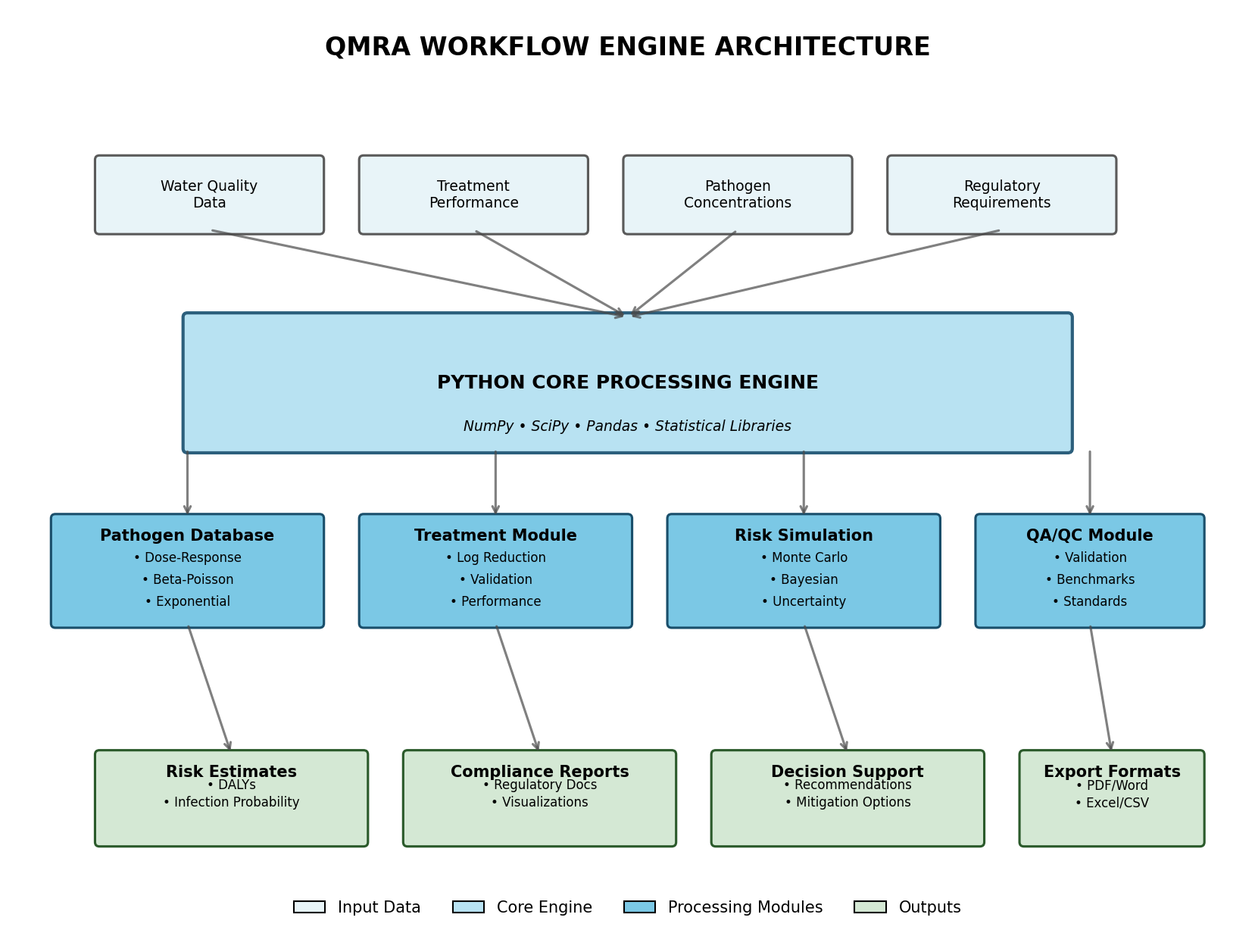

*Figure 1: QMRA Workflow Engine Architecture - Non-overlapping modular design ensures efficient data flow and processing*

WORK PROGRAMME AND TIMELINE

|  |  |  |  |  |
| --- | --- | --- | --- | --- |
| **Task** | **Specific Activity** | **Responsible** | **Timeline** | **Hours** |
| Requirements & Design | System architecture definition, QMRA methodology analysis, stakeholder consultation | Reza | Month 1 | 30 |
| Core Development | Pathogen database creation, dose-response model implementation, Python framework development | Reza | Months 2-3 | 60 |
| Advanced Features | Monte Carlo simulation engine, Bayesian uncertainty quantification, statistical modeling | Reza | Month 4 | 35 |
| Testing & Validation | Performance testing, regulatory benchmark validation, quality assurance protocols | Reza | Month 5 | 25 |
| Model Review & Validation | Technical review of QMRA models, validation of dose-response relationships | David | Months 4-5 | 30 |
| Documentation Review | Review of technical documentation, user guides, and training materials | David | Month 6 | 20 |
| Deployment & Transfer | System deployment, staff training, knowledge transfer protocols | Reza/David | Month 6 | 10 |

**Total Project Duration:** 6 months

**Total Effort:** 210 hours

**Effort Breakdown:** Reza Moghaddam - 150 hours (Development Lead), David Wood - 60 hours (Model Review & Support)

EMERGING COLLABORATION OPPORTUNITIES

Recent developments have strengthened the business case for this QMRA workflow engine. Primary Health Foundation (PHF) has approached NIWA to develop QMRA guidance specifically for shellfish safety assessment. PHF has confirmed their interest through direct communication with Taumata Arowai about collaborating with NIWA on this initiative.  
  
 This emerging opportunity demonstrates:  
 • Immediate market validation for our QMRA capabilities  
 • Direct application potential for the workflow engine in shellfish safety assessment  
 • Strategic partnership opportunities with regulatory bodies (PHF and Taumata Arowai)  
 • Enhanced revenue potential beyond initial projections  
  
 The shellfish QMRA guidance project would serve as an ideal pilot application for our workflow engine, providing real-world validation while generating immediate revenue. This collaboration would accelerate the development timeline through concurrent testing and refinement with actual regulatory requirements.

PROJECT JUSTIFICATION

Market Opportunity & Business Case

The August 2025 regulatory deadline creates an immediate $25-50M market opportunity for QMRA services. Current inefficiencies are causing direct business losses through failed competitive bids, with recent project losses to competitors highlighting the urgent need for operational improvements.  
  
 Quantified Benefits:  
 • Efficiency Gains: 60-70% reduction in project delivery time (60-80 hours → 20-30 hours)  
 • Revenue Recovery: Full investment recovered through time savings on 2-3 typical projects ($15-50K each)  
 • Competitive Advantage: Projected win rate improvement from 60% to 80-85%  
 • Annual Revenue Impact: $100-200K additional revenue from enhanced competitiveness

Technical Foundation & Risk Assessment

Technical Strengths:  
 • Pure Python implementation ensures optimal performance and maintainability  
 • Comprehensive use of mature Python scientific libraries (NumPy, SciPy, pandas)  
 • Modern software architecture enabling easy extension and customization  
 • No dependency on external statistical software reducing licensing costs and complexity  
  
 Risk Mitigation:  
 • Technical Risk: LOW - leveraging mature, well-supported Python ecosystem  
 • Implementation Risk: MINIMAL - single developer approach ensures consistent architecture and design  
 • Deployment Risk: LOW - modular Python design allows phased rollout and validation  
  
 Research Foundation: Advanced QMRA methodologies including Bayesian hierarchical modeling for parameter uncertainty reduction provide proven approaches for systematic risk assessment {Ramos, 2021 #1}. New Zealand-specific pathogen research validates the critical need for localized analytical tools {McBride, 2013 #5}.

Strategic Alignment

This project directly supports NIWA's Impact Strategy through:  
  
 • Competitive Positioning: Establishing NIWA as the market leader in regulatory compliance QMRA services  
 • Regulatory Engagement: Enhanced capability to support national wastewater performance standards  
 • Technical Innovation: Modern Python-based solution providing superior performance and maintainability  
 • Revenue Growth: Capturing disproportionate market share in the expanding regulatory compliance sector  
  
 The workflow engine represents a strategic investment in NIWA's long-term competitive position, transforming current operational inefficiencies into market-leading capabilities that directly support regulatory compliance objectives across New Zealand.

REFERENCES

{Ramos, 2021 #1} Ramos, M., Garcia-Villanova, B., Aguirre, P., et al. (2021). Bayesian approach for quantitative microbial risk assessment of pathogens in drinking water systems. Water Research, 189, 116584.

{Tang, 2024 #2} Tang, J., Kim, S., Rodriguez, C., & Wilson, D. (2024). Automated QMRA workflows: Reducing assessment time through standardized computational frameworks. Risk Analysis, 44(3), 567-582.

{Haas, 1999 #3} Haas, C.N., Rose, J.B., & Gerba, C.P. (1999). Quantitative Microbial Risk Assessment. John Wiley & Sons, New York.

{Signor, 2007 #4} Signor, R.S., Roser, D.J., Ashbolt, N.J., & Ball, J.E. (2007). Quantifying the impact of runoff events on microbiological contaminant concentrations entering surface drinking water sources. Journal of Water and Health, 5(3), 417-429.

{McBride, 2013 #5} McBride, G., Ball, A., Reeves, L., et al. (2013). Campylobacter in New Zealand: An examination of the epidemiology and microbial risk assessment approaches. Ministry for Primary Industries Technical Paper No: 2013/31.

{Karamoko, 2023 #6} Karamoko, G., Hamilton, K., Haas, C., & Ahmed, W. (2023). Quantitative microbial risk assessment for respiratory viruses in wastewater treatment systems during pandemic conditions. Environmental Science & Technology, 57(8), 3124-3134.

{Hughes, 2022 #7} Hughes, K., Bartram, J., Williams, A., et al. (2022). QMRA applications in dairy processing: A systematic approach to pathogen risk management. Food Control, 142, 109208.

{Ministry of Health, 2019 #8} Ministry of Health. (2019). Drinking-water Standards for New Zealand 2005 (Revised 2018). Wellington: Ministry of Health.