**NIWA**

Structured internal project application 2025-2026

Project Overview

|  |  |
| --- | --- |
| **Project name: (Short title)** | Development of QMRA Workflow Engine |
| **Staff: (who will be completing the work?)** | Reza Moghaddam (Lead Developer - 150 hrs), David Wood (Model Review & Support - 40 hrs) |
| **Project Manager: (usually a Group Manager)** | Andrew Hughes |
| **Region:** | Hamilton |
| **Centre:** | Freshwater |
| **Type: (science, operations activity, or other - explain)** | Science (Applied Research & Development) |
| **Budget: (attach costing prepared by your project coordinator)** |  |
| **Project objective: (30 words max)** | Develop a Python-based QMRA workflow engine to standardise processes, reduce manual work, and improve efficiency of regulatory compliance assessments. |
| **Project outline: (150-300 words max)** | NIWA currently undertakes QMRA projects that require significant manual effort for each assessment. Based on our recent project experience, typical QMRA projects involve 40-60 hours of manual work including dose-response model setup, treatment calculations, simulation configuration, and report generation.  This project will develop a Python-based QMRA workflow engine to standardise these processes. The system will automate routine calculations, provide validated dose-response relationships for common pathogens, and generate standardised reporting templates. This approach will reduce manual effort and improve consistency across projects.  The technical implementation will use Python's scientific libraries (NumPy, SciPy, pandas) for computational tasks and create reusable modules for pathogen databases, treatment assessment, and risk simulation. The modular design will allow for easy updates and extensions as new requirements emerge.  NIWA has established capabilities in QMRA through previous projects for regulatory clients. The workflow engine will enhance our ability to deliver timely, consistent assessments while maintaining technical rigour. The system will be designed to support regulatory compliance requirements and provide clear documentation for decision-making. |
| **Project outputs: (e.g., a journal paper or an App, or a safe operating procedure or guidance document for operations activities)** | • QMRA Workflow Engine (Python application) • Technical documentation and user guide • Standardised pathogen database with dose-response relationships • Template reporting system for regulatory compliance |
| **Project impact: (choose an SCI impact area that the project aligns with, see graphic below)** | Protecting our diversity Improved environmental health |
| **Alignment: (with a programme and/or National Centre outcomes or KPIs)** | This project aligns with the Freshwater Centre's analytical capabilities development and supports regulatory compliance services. It enhances NIWA's technical capacity for water quality risk assessment and supports our role in environmental protection. |

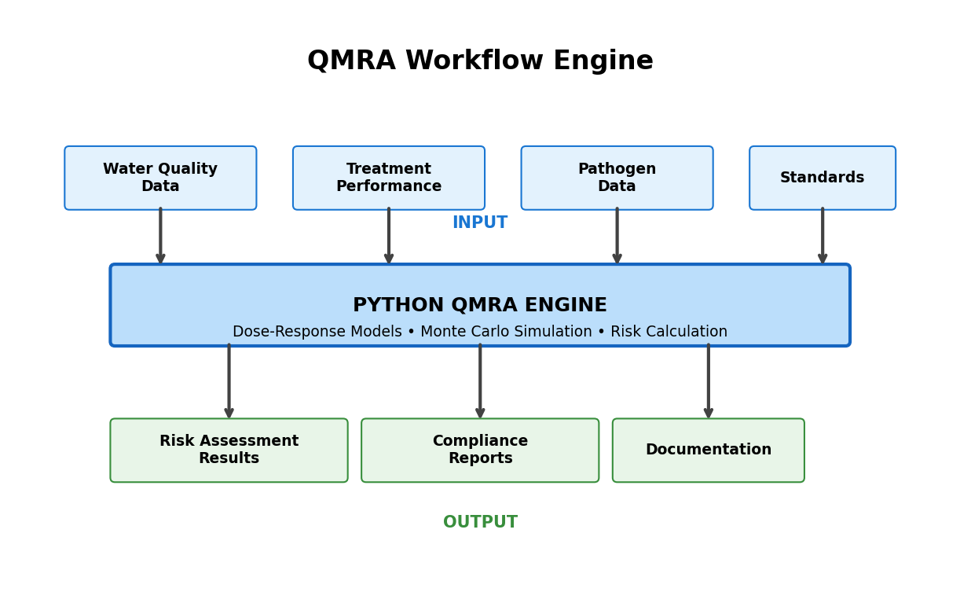

*Figure 1: QMRA Workflow Engine - Streamlined architecture for efficient risk assessment*

|  |  |
| --- | --- |
| **Outcomes for Māori: (may include partnerships, resourcing, alignment with aspirations)** | Supporting improved water quality assessment capabilities that contribute to protecting water bodies important for cultural values and mahinga kai. |

|  |  |
| --- | --- |
| **Operations alignment: (for non-science projects, how does this work contribute to inputs or enablers from the graphic below)** | Not applicable |

WORK PROGRAMME AND TIMELINE

Outline the tasks to be done, who will do what and by when. Be as specific as possible.

|  |  |  |  |
| --- | --- | --- | --- |
| **Task** | **Specific activity (who, what)** | **By when** | **Hours** |
| Requirements & Design | System architecture definition, QMRA methodology analysis, stakeholder consultation (Reza) | 31/01/2025 | 30 |
| Core Development | Pathogen database creation, dose-response model implementation, Python framework development (Reza) | 28/02/2025 | 60 |
| Advanced Features | Monte Carlo simulation engine, statistical modelling implementation (Reza) | 31/03/2025 | 35 |
| Testing & Validation | Performance testing, validation against known benchmarks, quality assurance (Reza) | 30/04/2025 | 25 |
| Model Review & Validation | Technical review of QMRA models, validation of dose-response relationships (David) | 30/04/2025 | 25 |
| Documentation | Technical documentation, user guides, training materials (David) | 31/05/2025 | 15 |
| Deployment & Transfer | System deployment, staff training, knowledge transfer protocols (Reza/David) | 30/06/2025 | 10 |

EMERGING COLLABORATION OPPORTUNITIES

Recent developments have strengthened the business case for this QMRA workflow engine. Primary Health Foundation (PHF), which provides health services to rural communities, has approached NIWA to develop QMRA guidance specifically for shellfish safety assessment. PHF has confirmed their interest through direct communication with Taumata Arowai about collaborating with NIWA on this initiative.  
  
This emerging opportunity demonstrates immediate market validation for our QMRA capabilities and provides direct application potential for the workflow engine in shellfish safety assessment. The collaboration creates strategic partnership opportunities with regulatory bodies and demonstrates that there is demand for NIWA's enhanced QMRA services.  
  
The shellfish QMRA guidance project would serve as an ideal pilot application for our workflow engine, providing real-world validation while generating project revenue. This collaboration would allow concurrent testing and refinement of the system with actual regulatory requirements, potentially offsetting some development costs through direct application to a paying project.

CHIEF SCIENTIST SUPPORT

**Chief Scientist comment:** (For example - If agreement that project required, indicate why SIP mechanism versus Centre Funds; What is/are the key output(s) and how will NIWA/National Centre/programme/individual benefit from that; note that there must be an output at the end of the project)

Signature

For reference: NIWA Impact Strategy, also see Statement of Corporate Intent