QMRA Batch Processing Web Application
Professional Overview

Version 1.2.0 | November 2025
NIWA Earth Sciences New Zealand

Executive Summary
The QMRA Batch Processing Web Application is a standalone tool for quantitative microbial risk assessment (QMRA). It evaluates health risks from pathogenic contamination in water using Monte Carlo simulation, providing evidence-based risk estimates for decision-making.
Key capabilities include multi-site analysis, temporal risk trends, treatment comparisons, and exposure-specific modeling for shellfish and swimming scenarios, with full uncertainty quantification.

1. What is QMRA?

Definition
Quantitative Microbial Risk Assessment (QMRA) is a scientific framework for estimating the probability of infection or illness from exposure to pathogenic microorganisms (bacteria, viruses, protozoa) in water or food.

Core Concept
QMRA combines four key components:
- Pathogen concentration in source water
- Treatment effectiveness (log reduction)
- Environmental dilution or bioaccumulation
- Dose-response relationship (dose to infection/illness)

Risk Calculation
QMRA produces annual infection and illness probabilities per person, which support compliance decisions against WHO guidelines (acceptable risk < 1 in 10,000 annually).

Why QMRA Matters
Traditional methods rely on indicator organisms or single-point assessments. QMRA accounts for scientific uncertainty and variability, enabling risk-based water safety management decisions.

2. Application Overview

Purpose
This web-based application enables users to run multiple QMRA scenarios simultaneously, visualize results, and generate professional reports—without requiring specialized programming knowledge.

Target Users
- Water utility managers
- Environmental health professionals
- Regulatory compliance officers
- Public health researchers
- Wastewater treatment engineers

Five Assessment Modes
- Batch Scenarios: Run 15+ pre-configured scenarios to evaluate multiple conditions
- Spatial Assessment: Map risk across multiple sites with different dilution factors
- Temporal Assessment: Analyze seasonal or time-series risk trends from monitoring data
- Treatment Comparison: Compare multiple treatment technologies and their effectiveness
- Multi-Pathogen Assessment: Simultaneously evaluate 2–6 pathogens to identify dominant risks

3. How It Works

Step-by-Step Process
- Input Data: Upload pathogen concentrations, dilution factors, and scenario parameters (or use examples)
- Configure Parameters: Select exposure routes, treatment LRV, population, and exposure frequency
- Monte Carlo Simulation: Run 10,000 iterations sampling from distributions for all uncertainties
- Risk Calculation: Calculate per-exposure and annual infection/illness risks
- Results & Visualization: View interactive charts, summary statistics, and compliance status
- Download: Export results as CSV, PDF, or complete ZIP package

Exposure Routes (v1.2.0)
- Shellfish Consumption:
- Meal size: 5–800 grams (truncated log-logistic distribution)
- Bioaccumulation Factor: 1–100× (shellfish concentrate pathogens)
- Total exposure: meal size × BAF
- Swimming/Primary Contact:
- Water ingestion rate: 5–200 mL/hour (truncated lognormal)
- Duration: 0.2–4 hours (triangular distribution)
- Total exposure: ingestion rate × duration
- Contaminated Water (Generic):
- Fixed volume or range-based exposure
- Customizable via Method Harmonisation Factor

4. Results Generated

Per-Scenario Output
- Infection Risk (median, 5th, 95th percentile)
- Illness Risk (accounting for symptom development)
- Annual Risk (per person, accounting for exposure frequency)
- Population Impact (expected illness cases per year)
- WHO Compliance Status (COMPLIANT if < 1e-4; NON-COMPLIANT if >= 1e-4)
- Uncertainty Bounds (confidence intervals)

Visualizations
- Risk Overview (horizontal bar chart by scenario)
- Compliance Distribution (pie chart: COMPLIANT vs. NON-COMPLIANT)
- Risk Distribution (histogram of per-exposure probabilities)
- Population Impact (case counts per year)

Download Formats
- Complete results CSV (all scenarios)
- Individual scenario details (CSV/Excel)
- High-resolution plots (PNG, 300 DPI)
- Professional PDF report (with charts and tables)
- Complete package (ZIP with all outputs)

5. Technical Features

Pathogens Supported
- Norovirus (Virus): P(ill|inf)=0.60
- Campylobacter jejuni (Bacteria): P(ill|inf)=0.80
- Cryptosporidium parvum (Protozoa): P(ill|inf)=1.00
- E. coli O157:H7 (Bacteria): P(ill|inf)=0.90
- Salmonella spp. (Bacteria): P(ill|inf)=0.75
- Rotavirus (Virus): P(ill|inf)=0.65

Dose-Response Models
- Beta-Poisson model (Norovirus, Rotavirus)
- Exponential model (Campylobacter, Cryptosporidium, E. coli)
- Alternative models available for comparison

Uncertainty Quantification
All results include 5th, 50th (median), and 95th percentiles to represent optimistic, most-likely, and conservative scenarios. Uncertainties in concentration, treatment effectiveness, dilution, and exposure volumes are automatically propagated.

w6. Key Innovations (v1.2.0)
- Exposure-Specific Modeling: Route-specific distributions for shellfish meal size, BAF, swim rate, and duration
- Infection-to-Illness Conversion: Separate modeling of infection vs. clinical illness with WHO-based parameters
- Method Harmonisation Factor: Account for differences in measurement methods (water vs. shellfish sampling)
- Truncated Log-Logistic Distribution: Realistic right-skewed distribution for shellfish meal sizes
- Population Susceptibility: Age and population-specific factors affecting illness rates
- Population Case Estimates: Expected annual illness cases for public health planning

7. Getting Started

System Requirements
- Windows, Mac, or Linux
- Python 3.8+
- Web browser (Chrome, Firefox, Safari, Edge)
- ~200 MB disk space

Quick Start
- Install dependencies: pip install -r requirements.txt
- Launch application: streamlit run web_app.py
- Select assessment mode from sidebar
- Use example data or upload your own
- Click "Run Assessment" and wait for results
- Download results in preferred format

8. Support & References

Primary References
- WHO (2016). Quantitative Microbial Risk Assessment: Application for Water Safety Management
- Haas et al. (2014). Quantitative Microbial Risk Assessment, 2nd Edition
- U.S. EPA (2019). Method for Assessing Public Health Risk from Waterborne Pathogens
- Wood et al. (2023). From_David R Package – Exposure-Specific QMRA Methods

Documentation
- DISTRIBUTION_PARAMETERS_GUIDE.md – Detailed parameter specifications
- BATCH_PROCESSING_INPUTS_GUIDE.md – Input file format reference
- README.md – Complete feature documentation
- Example files in input_data/ directory

Contact
NIWA Earth Sciences New Zealand
For technical support, review example scenarios and documentation files.

Appendix: Application Screenshots
This appendix contains 6 screenshots from the QMRA Batch Processing Web Application, demonstrating key interface pages and features.

1. Home Page
Main application interface with sidebar navigation

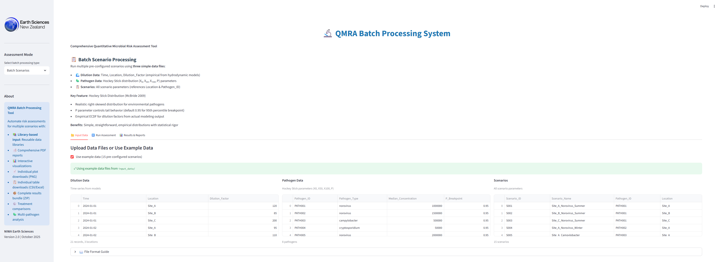
Figure 1: Home Page

2. Batch Scenarios
Batch processing with 15 pre-configured scenarios

Figure 2: Batch Scenarios

3. Spatial Assessment
Multi-site risk assessment with dilution factors

Figure 3: Spatial Assessment

4. Temporal Assessment
Time-series risk analysis from monitoring data

Figure 4: Temporal Assessment

5. Treatment Comparison
Compare multiple treatment technologies

Figure 5: Treatment Comparison

6. Multi Pathogen
Evaluate multiple pathogens simultaneously

Figure 6: Multi Pathogen

