QMRA Batch Processing
Web Application

User Guide & Technical Documentation

Quantitative Microbial Risk Assessment Toolkit
Version 2.0 | November 2025
NIWA - National Institute of Water & Atmospheric Research

Table of Contents
1. Introduction
1.1 What is QMRA?
1.2 Who Should Use This Application?
1.3 Key Features
2. Getting Started
2.1 Launching the Application
2.2 Understanding the Interface
2.3 Production Mode vs Research Mode
3. Assessment Workflows
3.1 Batch Scenarios Assessment
3.2 Spatial Risk Assessment
3.3 Temporal Risk Assessment
3.4 Treatment Comparison
3.5 Multi-Pathogen Assessment
4. Interpreting Results
4.1 Risk Metrics Explained
4.2 Visualizations
4.3 WHO Guideline Compliance
5. Technical Background
5.1 Dose-Response Models
5.2 Beta-Binomial Model (Norovirus)
5.3 Monte Carlo Simulation

1. Introduction

1.1 What is QMRA?
Quantitative Microbial Risk Assessment (QMRA) is a scientific framework for estimating the probability of infection or illness from exposure to pathogenic microorganisms in water, food, or other environmental media.
QMRA integrates four key components:
- Pathogen concentration in the source (e.g., wastewater, surface water)
- Treatment effectiveness (log reduction values)
- Environmental fate and transport (dilution, bioaccumulation)
- Dose-response relationship (probability of infection per organism ingested)
The output is an annual infection or illness probability per person, which can be compared against health-based targets such as the WHO guideline of 10⁻⁴ (1 in 10,000) annual infection risk for drinking water.

1.2 Who Should Use This Application?
This application is designed for:
- Water quality managers and engineers
- Environmental health professionals
- Public health risk assessors
- Regulatory compliance officers
- Researchers in water safety and microbial risk

1.3 Key Features
- ✅ Five specialized assessment workflows for different scenarios
- ✅ Validated Beta-Binomial dose-response model for norovirus
- ✅ Monte Carlo simulation with full uncertainty quantification
- ✅ Interactive visualizations and statistical summaries
- ✅ WHO guideline compliance checking
- ✅ Professional PDF reports and CSV data exports
- ✅ Production Mode ensures validated assessments only

2. Getting Started

2.1 Launching the Application
The QMRA application is a web-based tool running on Streamlit. Follow these steps to launch:
- Step 1: Open a terminal or command prompt
- Step 2: Navigate to the application directory:
cd Batch_Processing_App/app
- Step 3: Launch the application:
streamlit run web_app.py
- Step 4: Your web browser will automatically open to http://localhost:8501

Alternatively, double-click the launch_web_gui.bat file to start the application automatically.

2.2 Understanding the Interface
The application interface consists of two main areas:
- Left Sidebar: Configuration options, production mode toggle, and assessment type selection
- Main Panel: Input parameters, results, visualizations, and download options

Figure 1: Application Home Page
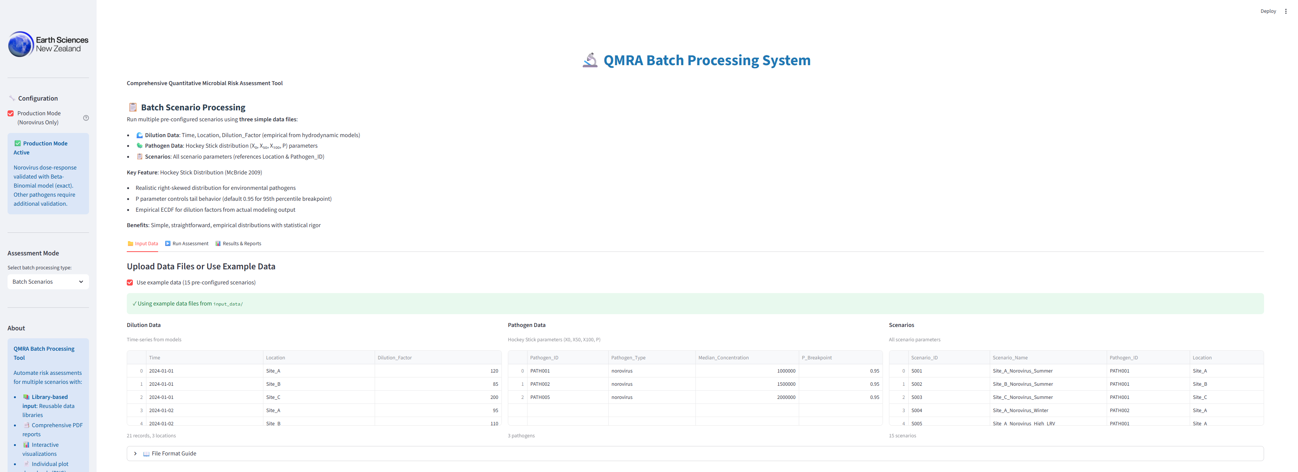

2.3 Production Mode vs Research Mode
Production Mode (Recommended): Restricts pathogen selection to norovirus only, ensuring all risk assessments use the validated Beta-Binomial dose-response model. This mode is enabled by default and aligns with contract deliverables.

Research Mode: Enables all 6 pathogens (norovirus, campylobacter, cryptosporidium, E. coli, rotavirus, salmonella). Non-norovirus pathogens have NOT been validated to the same standard and should be used with caution for research purposes only.

3. Assessment Workflows
The application provides five specialized assessment workflows, each designed for specific use cases. This section provides step-by-step instructions for each workflow.

3.1 Batch Scenarios Assessment
The Batch Scenarios workflow allows you to run multiple pre-configured scenarios simultaneously using a library approach with three CSV input files.

Use Case: Comprehensive risk assessment across multiple locations, time periods, and exposure routes with different parameter combinations.

Input Files Required:
- pathogen_data.csv - Pathogen concentrations and parameters
- scenarios.csv - Scenario configurations (15 scenarios)
- master_scenarios.csv - Linkage between pathogens and scenarios

Steps:
- Select "Batch Scenarios" from the assessment mode dropdown
- Check "Use example data" to load pre-configured scenarios, or upload your own CSV files
- Review the scenario configurations in the data tables
- Click "Run Assessment" to execute all scenarios
- Review results in the summary table and download outputs

Figure 2: Batch Scenarios Assessment Interface

3.2 Spatial Risk Assessment
The Spatial Assessment workflow evaluates risk across multiple geographic sites with different dilution factors (e.g., distance from wastewater discharge).

Use Case: Mapping risk gradients near wastewater outfalls, comparing shellfish harvesting areas, or assessing multiple beach locations.

Steps:
- Select "Spatial Assessment" from the assessment mode dropdown
- Choose pathogen (norovirus in Production Mode)
- Select exposure route (shellfish consumption or primary contact)
- Upload dilution data CSV or use example data (6 sites)
- Configure treatment LRV, exposure frequency, and other parameters
- Click "Run Spatial Assessment"
- Review site-specific risk results and risk gradient visualization

Figure 3: Spatial Risk Assessment Interface

3.3 Temporal Risk Assessment
The Temporal Assessment workflow analyzes risk trends over time using monitoring data (e.g., seasonal variations, before/after treatment upgrades).

Use Case: Evaluating seasonal risk patterns, assessing treatment performance over time, or analyzing long-term monitoring datasets.

Steps:
- Select "Temporal Assessment" from the assessment mode dropdown
- Choose pathogen and exposure route
- Upload temporal data CSV with Date and Concentration columns
- Configure assessment parameters
- Click "Run Temporal Assessment"
- Review time-series risk plot and statistical summaries

Figure 4: Temporal Risk Assessment Interface

3.4 Treatment Comparison
The Treatment Comparison workflow allows side-by-side evaluation of multiple treatment technologies or log reduction values (LRVs).

Use Case: Comparing UV disinfection vs chlorination, evaluating membrane filtration options, or assessing treatment upgrade scenarios.

Steps:
- Select "Treatment Comparison" from the assessment mode dropdown
- Choose pathogen and exposure route
- Define 2-4 treatment scenarios with different LRVs and names
- Configure other parameters (pathogen concentration, dilution, exposure)
- Click "Run Treatment Comparison"
- Compare treatment effectiveness in side-by-side results

Figure 5: Treatment Comparison Interface

3.5 Multi-Pathogen Assessment
The Multi-Pathogen Assessment workflow evaluates multiple pathogens simultaneously to identify the dominant health risk.

Note: In Production Mode, this workflow is restricted to norovirus only. To assess multiple pathogens, disable Production Mode and enable Research Mode.

Steps:
- Select "Multi-Pathogen Assessment" from the assessment mode dropdown
- Select 2-6 pathogens from the multi-select box
- Choose exposure route
- Configure shared parameters (dilution, treatment, exposure)
- Click "Run Multi-Pathogen Assessment"
- Compare pathogen-specific risks in the results table

Figure 6: Multi-Pathogen Assessment Interface
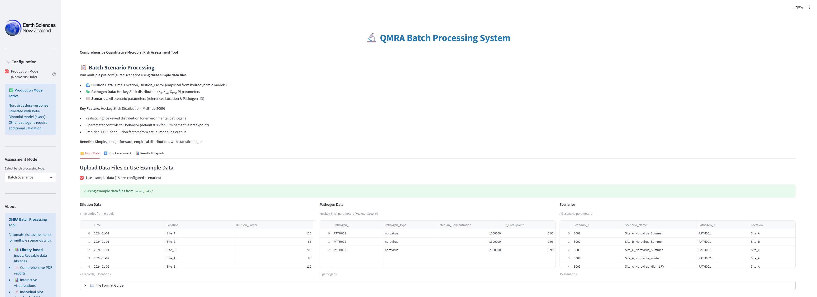

4. Interpreting Results

4.1 Risk Metrics Explained
The application reports several key risk metrics:

- Mean Dose (organisms per exposure): Average number of viable pathogens ingested or inhaled per exposure event
- Infection Probability (per exposure): Probability of infection from a single exposure event (0 to 1)
- Annual Infection Risk: Probability of at least one infection over a year of exposure: 1 - (1 - P_inf)^n
- Illness Probability: Probability of symptomatic illness given infection (infection × illness|infection ratio)
- 95% Confidence Interval: Uncertainty range capturing 95% of simulated outcomes (2.5th to 97.5th percentile)

4.2 Visualizations
The application provides several visualization types:
- Risk Overview Bar Charts: Compare mean risks across scenarios, sites, or time periods
- Uncertainty Distribution Plots: Histograms showing the full range of simulated outcomes
- Time Series Plots: Temporal trends in risk over monitoring periods
- Compliance Status Indicators: Color-coded flags for WHO guideline compliance (green = compliant, red = exceeds)

4.3 WHO Guideline Compliance
The World Health Organization (WHO) recommends an annual infection risk target of 10⁻⁴ (0.0001 or 1 in 10,000) for drinking water and recreational water quality.

The application automatically evaluates compliance:
- ✅ PASS: Annual infection risk < 10⁻⁴ (meets WHO guideline)
- ❌ FAIL: Annual infection risk ≥ 10⁻⁴ (exceeds WHO guideline)

Note: Some jurisdictions may use different risk targets. Consult local regulations and health authorities for applicable standards.

5. Technical Background

5.1 Dose-Response Models
Dose-response models describe the relationship between pathogen exposure dose and the probability of infection. The choice of model depends on pathogen characteristics and mathematical validity conditions.

5.2 Beta-Binomial Model (Norovirus)
For norovirus, this application uses the EXACT Beta-Binomial dose-response model, which is the mathematically correct formulation for highly infectious viruses.

Formula:
P(infection) = 1 - exp[ln Γ(β+dose) + ln Γ(α+β) - ln Γ(α+β+dose) - ln Γ(β)]

Parameters (Teunis et al. 2008):
- α (alpha) = 0.04
- β (beta) = 0.055

Why NOT Beta-Poisson?
The Beta-Poisson approximation is mathematically INVALID for norovirus because it requires β >> 1 (beta much greater than 1). For norovirus, β = 0.055 << 1, making the approximation inappropriate. Using Beta-Poisson would underestimate risk by 2-4× at low doses.

This implementation has been validated against reference Excel spreadsheets (David Wood, NIWA) and produces exact agreement for all test doses.

5.3 Monte Carlo Simulation
The application uses Monte Carlo simulation with 10,000 iterations to quantify uncertainty in risk estimates. Each iteration samples from input parameter distributions (e.g., pathogen concentration, dilution factor) to capture natural variability and measurement uncertainty.

The simulation outputs:
- Mean, median, and percentile estimates (5th, 25th, 75th, 95th)
- Full probability distributions for risk metrics
- Confidence intervals for uncertainty quantification

Appendix: References & Contact

Key References
- Teunis, P.F., et al. (2008). "Norwalk virus: How infectious is it?" Journal of Medical Virology, 80(8), 1468-1476.
- McBride, G.B. (2017). "Bell Island Wastewater Treatment QMRA." NIWA Client Report 2017350HN.
- World Health Organization (2016). "Quantitative Microbial Risk Assessment: Application for Water Safety Management."
- Haas, C.N., Rose, J.B., & Gerba, C.P. (2014). "Quantitative Microbial Risk Assessment" (2nd ed.). John Wiley & Sons.

Technical Support
For technical support, questions, or feedback:

NIWA - National Institute of Water & Atmospheric Research
Hamilton, New Zealand
Website: www.niwa.co.nz

End of User Guide

