Structured internal project application 2025-2026

|  |  |
| --- | --- |
|  |  |
| **Project Overview** |  |
| Project name: (Short title) | Development of QMRA Assessment Toolkit |
| Staff: (who will be completing the work?) | Reza Moghaddam (Lead Developer - 170 hrs), David Wood (Model Review & Support - 40 hrs) |
| Project Manager: (usually a Group Manager) | Andrew Hughes |
| Region: | Hamilton |
| Centre: | Freshwater |
| Type: (science, operations activity, or other - explain) | Science (Applied Research & Development) |
| Budget: (attach costing prepared by your project coordinator) |  |
| Project objective: (30 words max) | Develop a Python-based Quantitative Microbial Risk Assessment (QMRA) assessment toolkit to standardise processes, improve reproducibility and auditability, and reduce manual work for regulatory compliance assessments. |
| Project outline: (150-300 words max) | Earth Sciences New Zealand currently undertakes Quantitative Microbial Risk Assessment (QMRA) projects using @Risk Excel add-in, which is commercial licensed software that has proven problematic and costly. Recent projects have lost up to 80 hours due to security system conflicts within NIWA's firewall environment, requiring client extensions and budget overruns. Based on our project experience, typical QMRA projects involve 40-60 hours of work including dose-response model setup, exposure assessment, dilution modelling integration, simulation configuration, and report generation using @Risk.  This project will develop a Python-based QMRA assessment toolkit following a Minimum Viable Product (MVP) approach, focusing specifically on norovirus exposure scenarios for primary contact and shellfish consumption. The toolkit will replace @Risk dependency, incorporate Earth Sciences New Zealand's dilution modelling capabilities (our key differentiator), and work with engineer-provided log reduction values rather than attempting complex treatment calculations. This focused approach avoids the 'do everything' trap while delivering immediate value.  The Python implementation will develop technical capabilities in QMRA methodology while maintaining our competitive position in the QMRA market. The toolkit will integrate dilution modelling inputs, automate routine calculations, and generate standardised outputs. While Charlotte Jones-Todd has developed an R package, this Python approach provides greater integration with Earth Sciences New Zealand systems and builds internal technical depth essential for our $40-70K QMRA projects that generate additional consenting work opportunities. |
| Project outputs: (e.g., a journal paper or an App, or a safe operating procedure or guidance document for operations activities) | QMRA Assessment Toolkit (Python MVP replacing @Risk dependency) Norovirus exposure models for primary contact and shellfish consumption Dilution modelling integration module (NIWA's key differentiator) Validated dose-response database with engineer-provided LRV inputs Standardised reporting templates for regulatory compliance |
| Project impact: (choose an SCI impact area that the project aligns with, see graphic below) | Protecting our diversity Improved environmental health |
| Alignment: (with a programme and/or National Centre outcomes or KPIs) | This project aligns with Earth Sciences New Zealand's analytical capabilities development and supports regulatory compliance services. It develops our technical capacity for water quality risk assessment and supports our role in environmental protection. The improved reproducibility and auditability will strengthen our credibility with regulatory bodies. |
| Outcomes for Māori: (may include partnerships, resourcing, alignment with aspirations) | Supporting improved water quality assessment capabilities that contribute to protecting water bodies important for cultural values and mahinga kai. The developed QMRA capabilities will support decision-making that considers cultural significance of water resources and traditional food gathering practices. |
| Operations alignment: (for non-science projects, how does this work contribute to inputs or enablers from the graphic below) | Not applicable |

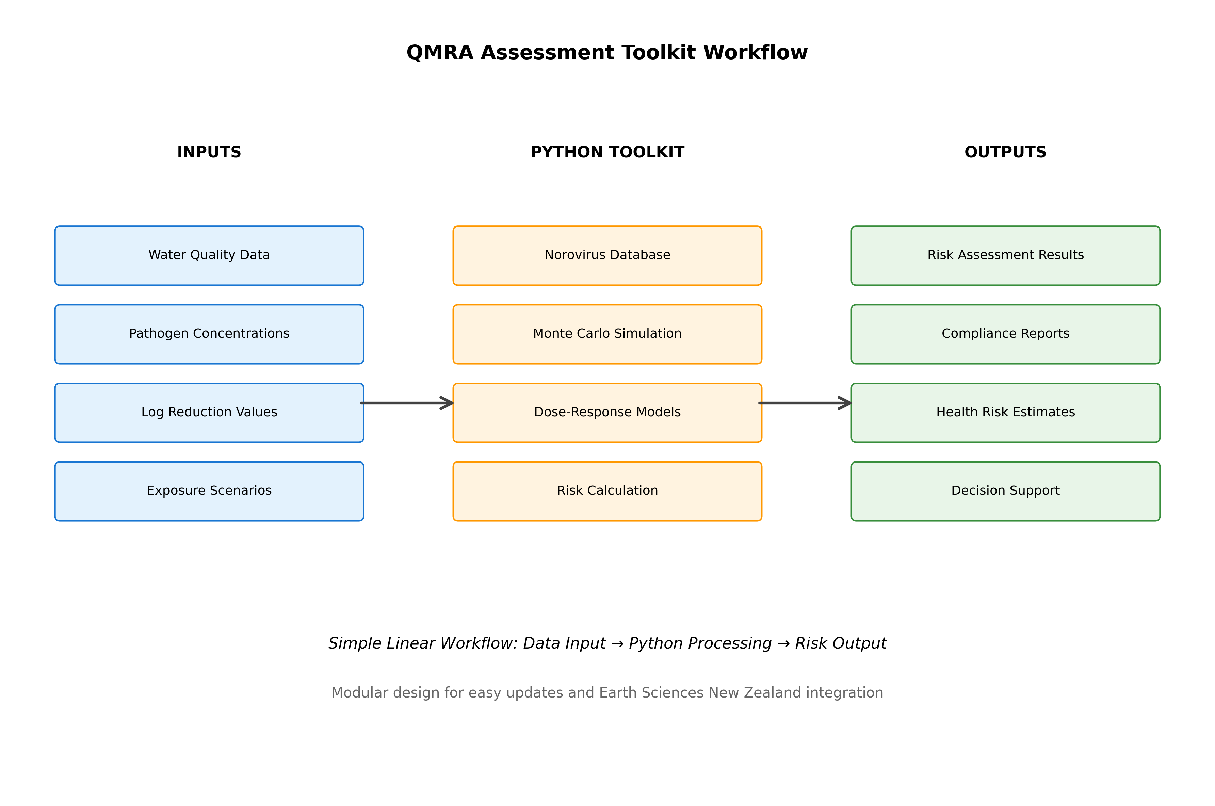

**Figure 1:** QMRA Assessment Toolkit - System Architecture & Workflow

The QMRA Assessment Toolkit processes multiple data inputs through a modular Python-based system. Input data includes water quality measurements, pathogen concentrations, user-defined log reduction values, population demographics, and exposure scenarios. The core processing engine integrates a norovirus pathogen database as the initial proof-of-concept, applies Monte Carlo simulation for uncertainty analysis, and implements validated dose-response models. The system generates comprehensive outputs including risk assessment results, regulatory compliance reports, health risk estimates, and decision support documentation for environmental health protection, while integrating Earth Sciences New Zealand's dilution modelling capabilities.

# WORK PROGRAMME AND TIMELINE

Outline the tasks to be done, who will do what and by when. Be as specific as possible.

|  |  |  |  |
| --- | --- | --- | --- |
| **Task** | **Specific activity (who, what)** | **By when** | **Hours** |
| QMRA Literature Review & Charlotte's R Package Assessment | Review Charlotte Jones-Todd's R package, assess existing QMRA tools, analyse current models and methodologies to avoid reinventing wheel (Reza) | Week 1 | 25 |
| Review Meeting 1 | David to review literature findings and provide feedback on methodology approach (David & Reza) | End Week 1 | 2 |
| MVP Requirements & Design | Define minimum viable product scope (norovirus primary contact + shellfish), system architecture, @Risk replacement strategy (Reza) | Week 2 | 35 |
| Review Meeting 2 | David to review system design and architecture decisions (David & Reza) | End Week 2 | 3 |
| Core Development (Norovirus MVP) | Develop norovirus exposure models for primary contact and shellfish consumption, Python framework replacing @Risk (Reza) | Weeks 3-4 | 45 |
| Review Meeting 3 | David to review core implementation and model accuracy (David & Reza) | End Week 4 | 5 |
| Dilution Modelling Integration | Implement Earth Sciences New Zealand's dilution modelling capabilities integration, our key differentiator in NZ QMRA market (Reza) | Week 5 | 25 |
| Review Meeting 4 | David to review dilution modelling integration (David & Reza) | End Week 5 | 3 |
| Monte Carlo & Uncertainty Analysis | Implement Monte Carlo simulation replacing @Risk functionality, uncertainty quantification for decision support (Reza) | Week 6 | 20 |
| Testing & Validation | Validate against known benchmarks, test @Risk replacement functionality, ensure regulatory compliance outputs (Reza) | Week 7 | 20 |
| Review Meeting 5 | David to review testing results and validation approach (David & Reza) | End Week 7 | 2 |
| QMRA Model Review & Validation | Technical review of implemented models, validation of dose-response relationships and dilution integration (David) | Week 8 | 25 |
| Documentation & Training | Technical documentation, user guides, training materials for @Risk transition, regulatory templates (David) | Week 9 | 15 |
| Deployment & @Risk Transition | System deployment, staff training on new toolkit, transition away from @Risk dependency (Reza/David) | Week 10 | 10 |
| Final Review Meeting | Project completion review and handover (David, Reza & Andrew) | End Week 10 | 3 |

**Table 1:** Work Programme and Timeline for QMRA Assessment Toolkit Development with Regular Review Meetings (Total: 228 hours)

# PROJECT MANAGEMENT AND OVERSIGHT

To ensure project success, a structured collaboration approach has been established between Reza Moghaddam and David Wood with regular oversight from Andrew Hughes as Project Manager.  
  
Weekly Review Meetings: David and Reza will conduct weekly review meetings after each major development phase as outlined in the work programme. These meetings will cover technical progress, methodology validation, and any challenges encountered. David will provide technical guidance on QMRA methodologies and model validation, while Reza will lead the development implementation.  
  
Problem Resolution: Any technical issues or roadblocks will be immediately flagged during weekly reviews. David will provide expert guidance on QMRA-specific challenges, while Andrew Hughes will be consulted for any project scope or resource issues. This ensures rapid problem identification and resolution.  
  
Quality Assurance: David will conduct formal technical reviews at key milestones (literature review, system design, core implementation, dilution integration, and final validation). This staged approach ensures quality control throughout development rather than only at project completion.  
  
Documentation and Knowledge Transfer: All review meetings will be documented with action items and decisions recorded. David will contribute to technical documentation to ensure knowledge transfer and future maintainability of the system.

# EMERGING COLLABORATION OPPORTUNITIES

Earth Sciences New Zealand has completed seven QMRA projects over the past three years, with individual project values of $40-70K. The real business value extends beyond the QMRA work itself, as these projects provide entry into the consenting process and generate additional consulting opportunities, as demonstrated by the Beachlands QMRA follow-on work.  
  
The New Zealand Institute for Public Health and Forensic Science (PHF) has approached Earth Sciences New Zealand to develop QMRA guidance specifically for shellfish safety assessment, providing immediate application for the norovirus shellfish consumption models planned in this toolkit. This collaboration demonstrates market demand and offers real-world validation opportunities.  
  
The @Risk replacement toolkit addresses a critical operational issue. Recent projects have lost up to 80 hours due to @Risk security conflicts within NIWA's firewall environment, requiring client extensions and budget overruns. Moving to our own Python-based solution eliminates this dependency while building internal technical capability essential for maintaining competitive advantage in the changing regulatory environment.

# CHIEF SCIENTIST SUPPORT

**Chief Scientist comment:** (For example - If agreement that project required, indicate why SIP mechanism versus Centre Funds; What is/are the key output(s) and how will NIWA/National Centre/programme/individual benefit from that; note that there must be an output at the end of the project)

**Signature:**

*Updated SIP document addressing RW comments - Generated on 24 September 2025*